ECE421S – Introduction to Machine Learning

Assignment 1

Linear and Logistic Regression

**New Deadline:** **February 6, 2019 @ BA3014, 4:00-5:00 PM EST**

Code Submission: ece421ta2019@gmail.com **February 6, 2019 @ 5:00 PM EST**

General Notes:

* Attach this cover page to your hard copy submission
* For assignment related questions, please contact Matthew Wong (matthewck.wong@mail.utoronto.ca)
* For general questions regarding Python or Tensorflow, please contact Tianrui Xiao (tianrui.xiao@mail.utoronto.ca) or see him in person in his office hours, Tuesdays, 4:00-6:00 PM in BA-3128 (Robotics Lab)

Please circle section to which you would like the assignment returned

Tutorial Sections

|  |  |  |  |  |  |  |
| --- | --- | --- | --- | --- | --- | --- |
| 001 |  |  | 002 | 003 |  | 004 |
| 005 |  |  | 006 | 007 |  | Graduate |

|  |  |
| --- | --- |
| Group Members | |
| Names | StudentID |
| **Andy Linzi Zhou** | **1002296730** |
| **Ryan Do** |  |

# Linear Regression

## Loss Function and Gradient

$MSE_{loss}= \frac{1}{2N}{||xW+b-y||}_{2}^{2}+\frac{λ}{2}{|\left|W\right||}_{2}^{2}$***MSE Loss Equation, Returns total loss***

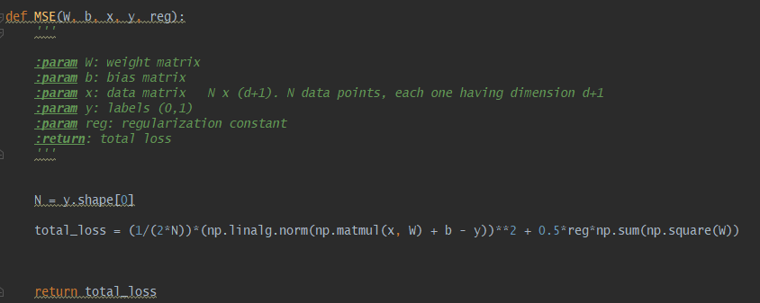

$∇f\left(W\right)= \frac{1}{N}x^{T}(xW+b - y)+ λW$***Gradient with respect to weights***

$$∇f\left(b\right)= \frac{1}{N}\sum_{i=1}^{N}{{(xW+b-y)}_{i}}$$***Gradient with respect to bias scalar***

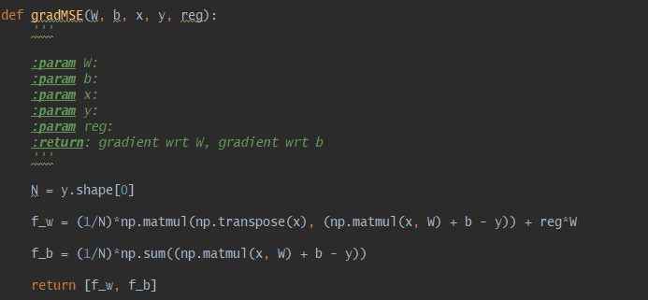

## Tuning the learning rate

|  |  |  |  |
| --- | --- | --- | --- |
| **Learning Rate α** | **Loss Curves** | **Training Time** | **Final Classification Accuracy** |
| **0.005** |  | 00:00:36 | Training Accuracy: 0.68371  Validation Accuracy: 0.67000  Test Accuracy: 0.64138 |
| **0.001** |  | 00:00:32 | Training Accuracy: 0.67429  Validation Accuracy: 0.65000  Test Accuracy: 0.66207 |
| **0.0001** |  | 00:00:33 | Training Accuracy: 0.69086  Validation Accuracy: 0.65000  Test Accuracy: 0.68966 |

The effect of α on the training time isn’t very pronounced. It takes roughly the same time to train since the number of epochs were the same for all three scenarios. The change of α only impacts the rate of convergence towards an optimal solution, not the time it takes to compute the gradients for descent.

The effect of α on the final classification accuracy can be observed. It seems that decreasing α leads to a greater final classification accuracy on the training set. On the other hand, a larger α leads to faster progress but lower accuracy.

## 1.4 Generalization

|  |  |  |  |
| --- | --- | --- | --- |
| **λ** | **Loss curves** | **Accuracy Curves** | **Final Classification Accuracy** |
| **0.001** |  |  | Training Accuracy: 0.68371    Validation Accuracy: 0.67000  Test Accuracy: 0.64138 |
| **0.1** |  |  | Training Accuracy: 0.66743  Validation Accuracy: 0.66000  Test Accuracy: 0.62069 |
| **0.5** |  |  | Training Accuracy: 0.64800  Validation Accuracy: 0.67000  Test Accuracy: 0.61379 |

As regularization increases, the performance of the model on the training and testing set declines. The purpose of regularization is to induce generalization of the model to the validation set. Tuning λ to higher values allows the model to generalize and have good performance on the validation set despite worse performance on the training and testing sets. Tuning λ allows the model to have good generalization abilities even if training performance is not optimal.

## 1.5 Comparing Batch GD with Normal Equation

Analytical solution

$$w={\left(x^{T}x+λI\right)}^{-1}x^{T}y$$

|  |  |  |
| --- | --- | --- |
|  | **Batch GD** | **Normal Equation** |
| **Training MSE loss** | 0.01366 | 0.011582 |
| **Accuracy** | 0.68371 | 0.733143 |
| **Computation Time** | 00:00:36 | 00:00:01 |

# Part 2: Logistic Regression

## 2.1 Loss Function and Gradient

$σ\left(z\right)=\frac{1}{1+e^{-z}}$***sigmoid function***

$\hat{y}\left(x\right)= σ(xW+b)$***logistic y_hat***

$f(x, y, W, λ)= -\frac{1}{N}\left(y\log\left(\hat{y}\left(x\right)\right)+\left(1-y\right)\log\left(1-\hat{y}\left(x\right)\right)\right)+\frac{λ}{2}{|\left|W\right||}_{2}^{2}$***Cross Entropy loss***

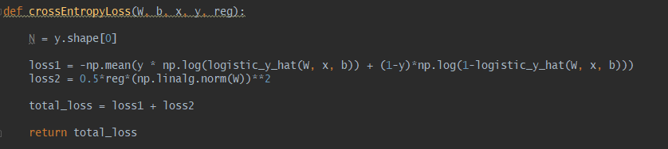

$∇f\left(W\right)=\frac{1}{N}\left(x^{T}\left(\hat{y}\left(x\right)-y\right)\right)+ λW$***Gradient with respect to weights***

$∇f\left(b\right)=\frac{1}{N}\sum_{i=1}^{N}{{(\hat{y}\left(x\right)-y)}_{i}}$***Gradient with respect to bias scalar***

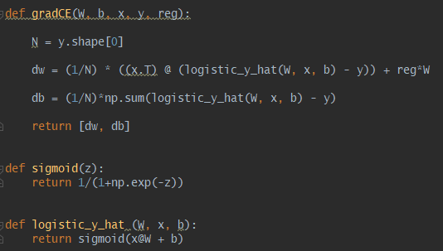

## 2.2 Learning

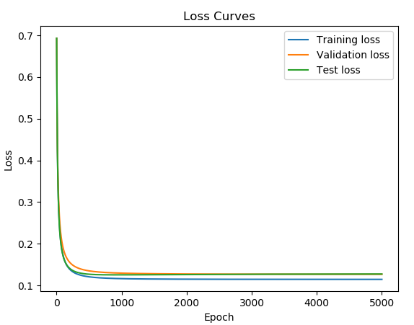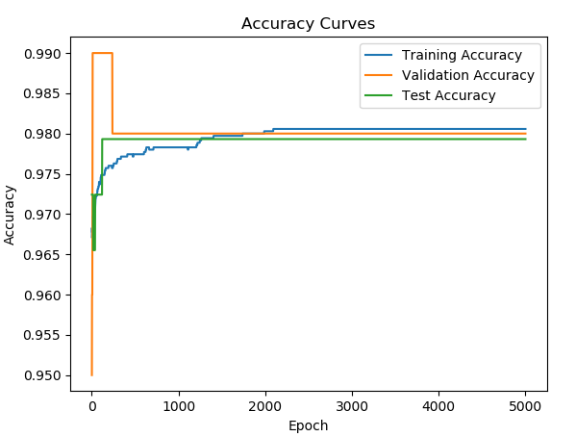

## 2.3 Comparison to Linear Regression

|  |  |
| --- | --- |
| **Cross Entropy** | **MSE** |
|  |  |

The convergence of cross entropy loss is less abrupt than the MSE loss. Also, cross entropy loss converges slower than MSE loss. The convergence behavior of cross entropy is smoother and resembles a continuous, differentiable function that has its derivative approaching zero.