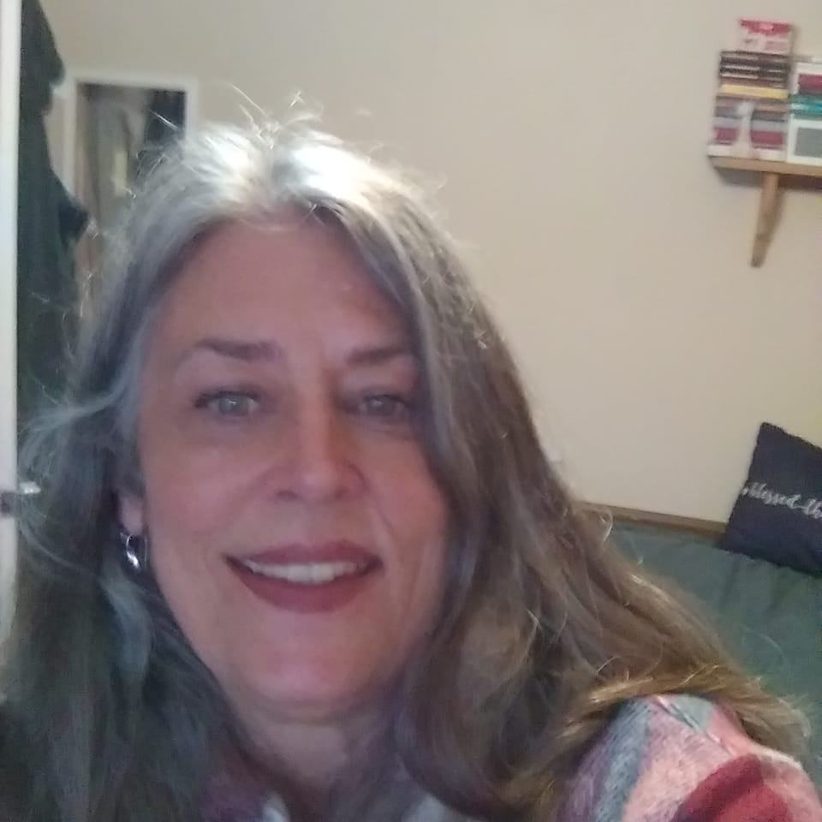 |  | Talisa Wortham
About me  I love helping people and am interested in working as a team member to benefit a business and their clientele.  Contact Information  Phone  (805) 628-6454  Email  twortham51765@gmail.com  Hobbies  Reading  Walking  Gardening |  | EDUCATION  Cal State University Northridge (CSUN)  2013  Bachelor’s degree in fine arts  Graduated with a 4.0, Cum Laude  Moorpark College  2009  Associate degree in fine arts  WORK EXPERIENCE  Ventura Serenity House- Assistant manager /Manager  Approximate 2023- current  Oversee chores of 15 people, answering phones, scheduling intakes, intake new women, drug and alcohol testing, oversee women so that they comply with house rules.  Egg House- Waitress/ cashier  Approximate 2010 Feb 2017.  Honest and accurate cashiering, fast- paced customer service, and trained staff.  Starbucks- Assistant Manager  Approximate to 2009 - 2010.  Able to teach and lead a team of 23 with respect and dignity, banking, reporting and recording skills, preparations, and ordering, cashiering, making drinks fast paced customer service, Trained on Starbucks computer program.  Egg House- Waitress/ Cashier  Approximate 2003 to 2009.  Honest and accurate cashiering, fast- paced customer service, Trained staff.  Chiropractic With Care- Assistant Manager  Approximate 1991-2001  Able to teach and lead a team of 4 people with respect, banking, scheduling team, scheduling patient appointments, filing, answering phones, assisting with patient needs. bel

