I didn’t get a chance to complete this, I started a little late but here’s what I have with the time constraint. Here’s some explanations of the work that is included in this allotted time.

1. Typically for databases this small, you could use EF but I opted not to because this would’ve slowed me down a little bit more because as I stated in the original interview, I haven’t worked on this too much.
2. The query handlers would’ve returned a result similar to the one below:  
   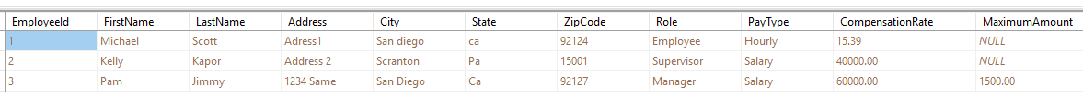
   1. I would use a mapper to map this result into the domain objects

Employee vs Manager.

* 1. If there were anything specific we wanted to do differently for supervisor vs employee, since they share similar attributes with the exception of pay type and compensation, then I would consider creating a Supervisor object. For now, supervisor can be identified as an Employee.
  2. Any validations or business logic would be handled in this domain layer

1. I injected the dependencies in favor of utilizing AutoFac to wire up those classes.
2. Unit tests: I didn’t get to write them.

Let me know if there are any questions or if you have any issues opening any of the files. The GitHub would only include the files and not the solution or projects. So apologize for the inconvenience. Thank you again for the opportunity!