**IPO Diagram**

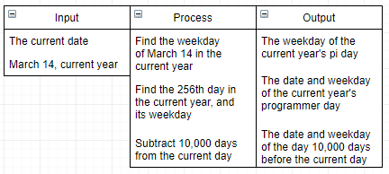

**Pseudocode**

input current_date;

input pi_day = March 14, current_year;

print(pi_day, day of pi_day)

print(256th day of current_year, day of year)

print(today-10,000 days, day of year, date)