**IPO Diagram**

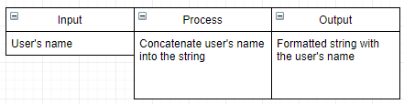

**Pseudocode**

Input name

Return “Hello, “ + name

Return “Goodbye, “ + name

Return “I’m sorry, “ + name + “, I can’t do that.”