**Working Title:** Four-year trajectories of subcanopy plant functional trait response to experimental disturbance and implications for ecosystem net primary production resilience

Authors: Lisa T. Haber, Jeff Atkins, Max Grigri, Kerstin Niedermaier, Ben P. Bond-Lamberty, Christopher M. Gough

Institutional Affiliations:

Target Journal: *Functional Ecology*

**1. Introduction:**

Key ideas:

[Why should we care?] We need better understanding of how forest C cycling responds to disturbance across realistic gradients of severity in order to more accurately forecast the future extent and functional trajectories of forests under global change. Our models are only as good as our assumptions, mechanistic understandings, and data. The subcanopy is critically important in supporting ecosystem production resilience following forest disturbance, yet we lack a full characterization of the disturbance-driven subcanopy plant functional trait shifts following disturbance needed to better parameterize ecosystem models.

We know that compensatory subcanopy growth can be an important stabilizer of carbon uptake in forest ecosystems following disturbance, wherein a large fraction of mature canopy-dominant trees senesce (REF: Fahey et al 2016, Stuart-Haentjens et al 2015). To date, however, few experimental studies have attempted to scale leaf functional response to ecosystem net primary production following disturbance (REF). In particular, the timing and magnitude of key plant functional responses to disturbance across gradients of severity – and the mechanisms responsible for triggering such shifts in leaf function – remain understudied.

Canopy structure is a putative driver of subcanopy functional response…

Canopy structure is an important determinant of subcanopy growth as it controls access to resources like light. Canopy complexity determines light distribution and attenuation through forest strata (REF: Matsuo et al. 2021)

Resource environment (light, nitrogen, water – reduced competition for these resources) is another…

Hypotheses & rationale:

Expected increase in leaf mass per area with rising disturbance severity (Prado Junior et al. 2015)

**2. Materials and Methods:**

*2.1 Experimental design and site description*

This study took place within the Forest Resilience Threshold Experiment (FoRTE; Gough et al. 2020, Grigri et al. 2020), an ecosystem-scale disturbance manipulation at the University of Michigan Biological Station in northern lower peninsula Michigan (UMBS, 45.56°N, 84.67°W). UMBS is dominated by secondary growth mixed deciduous and coniferous forest with mean annual precipitation of 817 mm and temperature of 5.5 °C (Gough et al. 2013). The roughly century-old regrown forest of UMBS and the Upper Great Lakes Region is broadly undergoing successional transition (Wolter & White REF), with dominant tree species shifting from early successional aspen (*Populus grandidentata* and *P. tremuloides*) and birch (*Betula papyrifera*) to later successional species including northern red oak (*Quercus rubra*), red maple (*Acer rubrum*), American beech (*Fagus grandifolia*), and white pine (*Pinus strobus*).

FoRTE is designed to disentangle the overlapping impacts of successional shifts and moderately severe disturbances – such as those imposed by defoliating insects, severe weather events, or novel fungal pathogens – on the temperate forest C cycle. Simulation of these coincident regional events is achieved through experimental implementation of disturbance across a controlled, replicated gradient of severity and two contrasting treatment types, each of which targets a different successional cohort of stems. Targeted gross defoliation levels of 0 (control), 45, 65, and 85 % LAI loss were chosen to span a gradient from moderate to severe disturbance, while “top-down” and “bottom-up” treatment types were implemented to sequentially eliminate the largest and smallest stems, respectively, until the desired defoliation level was reached. Because the largest stems at our site are generally the early successional aspen and birch trees and the smallest are mid- to late-successional species suppressed in the understory, contrasting treatments allowed for differentiation of disturbance impacts across distinct plant functional types.

Factorial combinations of disturbance severity and type were applied across four experimental replicates (Fig. 1 A), each consisting of four 0.5 ha circular plots divided into 0.25 ha halves where treatments were assigned (Fig. 1 B). Each experimental replicate is located on a distinct “landscape ecosystem” type according to a site-specific classification system developed at UMBS, characterized by distinct soil properties, vegetation communities, and microclimatic differences (Pearsall et al. 1995). Prior to disturbance, substantial differences in site productivity and forest canopy structure across UMBS were well documented (REF: Hardiman et al. 2011, Scheuermann et al. 2018), with the potential to inform post-disturbance trajectories of C cycling in FoRTE.

Baseline data collection, including tree inventory, assessment of forest structure, and above- and belowground carbon flux measurements, began in summer 2018 prior to experimental disturbance initiation within each of the 32, 0.1 ha. experimental subplots (Fig. 1 B). Tree inventory entailed tagging, species identification, stem diameter measurement, and mapping of all stems ≥ 8 cm diameter at breast height (DBH) using a laser-outfitted digital caliper and GPS transponder array (Haglöf Inc., Madison, Mississippi, USA). Before leaf out the following spring (May 2019), we stem girdled ~3700 trees across 8 ha. of forest. Stem girdling involves cutting and removal of a ring of bark and phloem tissue from the tree stem at approximately 1 m above the ground, achieved via chain saw and pry bar. Intended to simulate the effects of disturbance from wood-boring insects, stem girdling disrupts the transport of fixed carbon through the phloem, resulting in carbon starvation to the roots and tree death in 1 – 3 years following girdling (Gough et al., 2013).

*2.2 Community weighted mean leaf functional traits*

Physiological, morphological, and optical characteristics of subcanopy leaves were measured annually during the growing season in order to assess changes in leaf functional traits interannually across the disturbance severity gradient. To capture an extensive and representative sample of the FoRTE subcanopy, leaves were selected in a uniform way across all 32 experimental subplots. Three leaves without obvious signs of damage by pathogens or herbivores, each from unique woody stems ≥ 1 cm DBH, were chosen at 1 m height above ground within four established vegetation survey plots in each subplot (inset Fig. 1 B) for a total of 12 leaves per subplot. Where leaves at 1 m were not present, the nearest stem outside the survey plot with a leaf at the targeted height was selected. Stems were tagged and the terminal branch from which the leaf was sampled was flagged for repeat measurements in subsequent years. In a fraction of cases (39 of 433 unique stems sampled over four years, or 9 %), stems died and were replaced with new trees the following year. Because leaves were selected for sampling in a uniform way throughout the 32 FoRTE subplots, as a function of which trees were present in targeted areas and regardless of species, we refer to the mean values for leaf functional traits obtained in each subplot as “community-weighted means” (REF; probably Garnier et al 2004). To confirm that our samples were representative of community composition within each subplot, we compared species abundances from this sampling effort to an independent subcanopy stem survey conducted within FoRTE subplots and published in Grigri et al. 2020. Rankings of tree species by abundance within replicates were consistent in both surveys.

Leaf-level physiological variables, the light-saturated rate of photosynthesis (Asat) and stomatal conductance (gs), were measured using a LI-6400 XT portable photosynthesis system (LI-COR Biosciences Inc., Lincoln, Nebraska, USA) with internal chamber settings of 25 °C block temperature, 2000 µmol m-2 s-1 photosynthetically active radiation (PAR), 400 ppm CO2, and a targeted vapor pressure deficit below a maximum of 2 kPa. Leaves were sampled while still attached to the tree, then were removed and retained for further analysis.

Immediately following leaf removal from the tree, leaf reflectance was measured in the field for intact adaxial leaf surfaces of all broadleaf samples using a CI-710 miniature leaf spectrometer (CID Bio-Science Inc., Camas, Washington, USA). Conifer needles were too narrow to be measured with this instrument, resulting in the capture of reflectance spectra for a subset of physiologically sampled leaves. A suite of leaf reflectance indices, including the normalized difference vegetation index (NDVI) and its narrow-band counterpart, red edge NDVI (reNDVI), were computed from the reflectance data using the built-in SpectraSnap software.

Leaf morphology, summarized as leaf mass per area (LMA), was determined for every sampled leaf following collection in the field. While still fresh, leaves were scanned using an LI-3100C area meter (LI-COR Biosciences Inc., Lincoln, Nebraska, USA) on the appropriate resolution setting (1.0 mm2 for broadleaf and 0.1 mm2 for needleleaf samples). Subsequently, leaves were dried for 72 hours at 60 °C before being weighed, and then LMA was computed as the ratio of leaf area and dry mass.

*2.3 Vegetation canopy structure*

Canopy structure, or the quantity and arrangement of vegetation cover in the forest canopy, was assessed via annual measurements at full leaf-out across FoRTE subplots using portable canopy LiDAR (PCL). PCL entails the use of a user-mounted, upward facing near-infrared pulsed laser operating at 2000 Hz (Riegl USA, Inc., Orlando, Florida, USA) collecting returns as the user walks transects through experimental subplots (full methods described in Hardiman et al., 2011). Data are then analyzed using the *forestr* R package to compute a suite of canopy structural metrics (Atkins et al., 2018), including vegetation area index (VAI). VAI is a unitless measure of total canopy surface area (leaves plus the woody components of the canopy) per unit ground area and has been found to correlate with ecosystem functions of interest, including net primary production (REFS!!). VAI was computed from the means of two 40 m transects in each subplot in each year. Due to accidental omission, four subplots were excluded from measurement in 2018 and two in 2019.

*2.4 Aboveground wood net primary production*

Aboveground wood net primary production (ANPPw) was computed from repeated measurements of stem diameter for a subset of subcanopy trees (1-8 cm DBH). Two stems in this size class were chosen within the same vegetation survey plots where leaf functional trait sampling occurred or, if absent, at the nearest point in space to the plot. Using species- and region-specific allometric equations (Cooper et al. REF – see Max’s paper), biomass increment was inferred for each stem in each year, then multiplied by species-specific stem densities obtained through subplot stem surveys to obtain subplot-scale ANPPw.

*2.5 Statistical analysis*

All statistical analysis was performed in the R environment for statistical computing (REF: R Core Team 2021). To test relationships between subplot CWM leaf functional traits and disturbance severity, type, and time, we used split-split plot mixed effects ANOVA with experimental replicate as a blocking factor, similar in design to those used in first-year FoRTE analyses (Gough et al 2020, Grigri et al 2020). In these models, disturbance severity was the fully randomized whole-plot factor while treatment type (bottom-up or top-down) was the restrictively randomized split-plot factor. In addition to treatment, time (as year) could not be fully randomized within blocks and was treated as the split-split plot factor in the models. Pair-wise post-hoc comparisons using Fisher’s LSD in R package *agricolae* (REF) were tested at alpha = 0.05 where significant effects were found, with *a priori* expectations about the direction of change articulated in our hypotheses. While three of four leaf functional traits satisfied the assumptions of normality and homogeneous variance required for ANOVA, leaf mass per area (LMA) followed a right-skewed distribution typical for this variable in mixed hardwood-conifer forests (REF) and was transformed via 1/x transformation before running the analysis.

The remainder of our analysis entailed the use of linear mixed effects models to assess the relationships between canopy structure (as VAI), subcanopy ANPPw, disturbance severity, time, and leaf functional traits. Linear mixed effects models were selected for this analysis because of their applicability to hierarchically structured data, as well as their capabilities in handling missing outcome values and nonnormally distributed variables. All models and summary tables were generated using R packages *lme4* (REF: Bates et al) and *lmerTest* (REF: ) using restricted maximum likelihood (REML) criteria and the Satterthwaite method for t-tests (REF: ). The best candidate models were selected using the second-order Akaike information criterion suitable for small sample sizes (AICc; Burnham & Anderson 2002), computed with R package *MuMIn* (REF). In these models, VAI, year, and their interaction were treated as fixed effects with regression coefficients of interest, while replicate was included as a random effect. Because there is no assumption of a Gaussian distribution for outcome variables in linear mixed effects models, we did not transform LMA for this analysis. Post hoc comparisons of regression slopes were performed using R package *emmeans* (REF: ).

**3. Results**

*3.1 Vegetation area index and disturbance*

Vegetation area index (VAI) was found to decline at the upper end of our experimental disturbance severity gradient by the third year following disturbance (Fig. 2). Statistically significant interaction effects of disturbance severity and year were found in 2021 only at the 65 % (*t* = -2.47, *p* = 0.015) and 85 % (*t* = -2.89, *p* = 0.005) severity levels, indicating a temporally lagged effect of rising disturbance severity on canopy VAI. Additionally, we found that experimental replicate included as a random effect in the model contributed over half (53.5 %) of the total variance, suggesting a strong influence of landscape ecosystem type on VAI variation across FoRTE independent of disturbance severity.

*3.2 Community-weighted mean leaf functional traits and disturbance*

In a series of split-split plot ANOVAs to test the effects of disturbance severity, treatment type (top-down or bottom-up), time, and their interactions, we found evidence that some, but not all, CWM subcanopy leaf functional traits hypothesized to increase in response to disturbance did so in the first three years following disturbance initiation(Fig. 3). Models for community-weighted mean Asat and reNDVI had highly significant main effects of year (*F* = 46.5 and *F* = 35.2, respectively; *p* < 0.001) as well as highly significant interaction effects of year and disturbance severity (Asat: *F* = 2.06, *p* = 0.04, Fig. 3 a; reNDVI: *F* = 6.70, *p* < 0.001, Fig. 3 d). In particular, both traits exhibited the hypothesized upward trends in their CWMs in 2020 and 2021, with reNDVI increasing across all disturbance severity levels (45, 65, and 85 %) relative to control and Asat increasing at the upper end of the disturbance severity continuum (65 and 85 %).

The model for our second CWM leaf physiological trait, gs, was additionally found to have a highly significant main effect of year (*F* = 82.5*, p* < 0.001) and a moderately significant interaction effect of disturbance severity and year (*F* = 1.83, *p* = 0.08), rising as hypothesized with increasing disturbance severity and time since disturbance (Fig. 3 b). In contrast, our leaf morphological trait, LMA, yielded no significant disturbance effects in our model, but additional strong evidence for the effect of year on LMA community weighted means (*F* = 5.10, *p* = 0.003, Fig. 3 c).

*3.3 Subcanopy leaf functional response to declining canopy VAI*

To test whether community-weighted mean leaf functional traits of interest responded to the interactive effects of shifting canopy VAI and year, we generated a series of linear mixed effects models with replicate included as a random effect. In the model for CWM Asat, VAI (*t* = 2.31, *p* = 0.02), year (2019: *t* = 3.40, *p* < 0.001; 2020: *t* = 4.74, *p* < 0.001; 2021: *t* = 6.60, *p* < 0.001), and interaction terms for VAI with year (VAI*2019: *t* = -2.33, *p* = 0.02; VAI*2020: *t* = -3.49, *p* < 0.001; VAI*2021: *t* = -5.32, *p* < 0.001) were all statistically significant (AICc = 405.96, Table SX), providing strong support for the hypothesized negative relationship between canopy VAI and subcanopy Asat. Post hoc pairwise comparison indicated that regression slopes for all three years post-disturbance (2019-2021) were significantly different from the pre-disturbance slope (2018; *p* < 0.001), though not from each other (Fig. 4 a). In the Asat model, the random effect of replicate was found to contribute nearly a third of the total variance (29.8 %), suggesting ecologically meaningful differences in CWM Asat across landform types.

Our final model for CWM stomatal conductance (gs) found significant main effects for years 2019 (*t* = 2.20, *p* = 0.03), 2020 (*t* = 3.04, *p* = 0.003) and 2021 (*t* = 4.11, *p* < 0.001), as well as a moderately significant interaction for VAI*2020 (*t* = -1.81, *p* = 0.07) and a highly significant interaction for VAI*2021 (*t* = -2.31, *p* = 0.02; AICc = -538.23; Fig. 4 b). Our final model did not retain replicate as a random effect due to a variance component estimate of 0 for this term, and a resulting singular fit error when the random effect term was included; thus, we retained a linear model with fixed effects only.

Our model for reNDVI also found significant main effects of VAI (*t* = -2.50, *p* = 0.01), year (2019: *t* = -3.16, *p* = 0.002; 2020: *t* = -1.87, *p* = 0.06), and the interaction of VAI and year (VAI*2019: *t* = 2.61, *p* = 0.01; VAI*2020: *t* = 1.99, *p* < 0.05; AICc = -444.72; Fig. 4 d), with the random effect of replicate contributing only 0.43 % of the total variance. In contrast, we found no significant relationship between VAI, year, or their interaction for LMA (Fig. 4 c).

*3.4 Leaf functional trait relationships with subcanopy aboveground wood net primary production*

Finally, we tested hypothesized relationships between subcanopy ANPPw and rising disturbance severity, VAI, and subcanopy CWM leaf functional traits. Subcanopy ANPPw was strongly stimulated by rising disturbance severity in the second and third years following disturbance, with highly significant effects of year (*F* = 28.9, *p* < 0.001) and disturbance by year interaction (*F* = 5.81, *p* < 0.001, Fig. 4) in our split-split plot ANOVA model. However, subcanopy production was not directly related to disturbance-driven changes in canopy VAI (Table SX). Moreover, statistically significant loss of canopy VAI lagged significant increases in subcanopy ANPPw by a year, suggesting mechanisms other than canopy structural change underpinned subcanopy production stimulation.

In order to assess whether our four CWM leaf functional traits of interest could predict observed stimulation of subcanopy production, we used a stepwise AIC linear regression model selection process. Because of the difficulty in directly comparing AIC scores across models with and without random effects, we opted to include experimental replicate as a potential fixed effect along with each of the CWM leaf functional traits in our candidate models. Our final model retained only reNDVI and replicate (*p* < 0.001, R2adj = 0.25, AICc = 303.56, Table SX).

**4. Discussion**

[Big take-aways:] We found strong evidence supporting the hypothesized decline of canopy vegetation area index (VAI) with rising disturbance severity and increasing time since disturbance using our linear mixed effects model (Fig. 2). Disturbance leads to the disintegration of a closed canopy in our forest, but this effect lags disturbance initiation by two years, consistent with the time frame for stem mortality from girdling.

Three of four CWM leaf functional traits – Asat, gs, and reNDVI – were found to increase with rising disturbance severity and time since disturbance. Significant increases in the CWMs of Asat and reNDVI were measured prior to a substantial loss of canopy VAI, indicating that subcanopy physiological and biochemical enhancement by disturbance occurs alongside of, yet in some cases faster than, canopy structural change. All three leaf functional traits found to respond to rising disturbance severity also significantly related to canopy VAI loss in our linear mixed effects model analysis, suggesting that changing canopy VAI does help explain subcanopy leaf functional trait shifts.

Though disturbance was found to influence both canopy VAI and subcanopy ANPPw, VAI was not, in turn, found to relate to subcanopy ANPPw. These results suggest that rapid, sustained subcanopy ANPPw stimulation following disturbance is likely to be better explained by mechanisms within the subcanopy itself, rather than temporally lagged changes in canopy structure. Leaf functional traits are useful integrator variables of plant response to environmental change, and thus are important potential mechanistic linkages to study. Here, we found that the single best predictor of subcanopy net primary production following disturbance was reNDVIleaf, a reflectance index strongly tied to leaf chlorophyll content (REF). We found strong evidence that reNDVI increased rapidly and substantially following disturbance, and may be considered a proxy variable for rapid retranslocation of N within the disturbed forest understory (REF).

Spectral vegetation indices such as NDVI have been found to be useful predictors of disturbance transitions in forests including tree species decline (Khodaee et al 2021). To date, they have largely been employed for canopy process monitoring, including phenological status, (Huete 2012)

**Figures and Tables:**

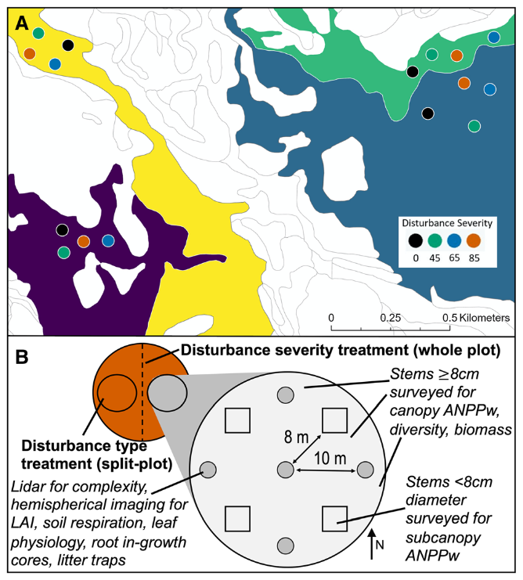

**Figure 1.** FoRTE site map including experimental replicate locations (A) and sampling design (B). Four replicates each containing four plots with designated whole-plot gross defoliation levels (0, 45, 65, or 85 % disturbance severity) are distributed across four distinct landscape ecosystem types at UMBS according to a local classification system (map colors in panel A). Each plot was halved to generate two subplots, each of which was issued a restrictively randomized assignment of “top-down” or “bottom-up” treatment type (panel B). All measurements of interest were located within the experimental unit of subplots.

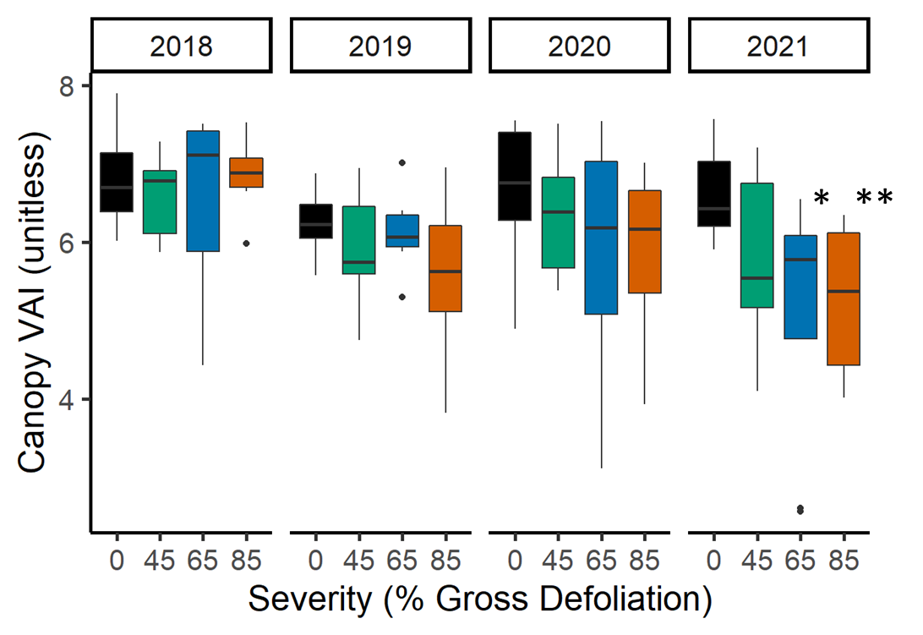

**Figure 2.** Subplot mean canopy vegetative area index (VAI, unitless) across experimental disturbance severities and years. 2018 was the year prior to disturbance, while 2021 was the third year following disturbance initiation. In 2021, two disturbance severities (65 %, \**p* < 0.05 and 85 %, \*\**p* < 0.01) had significantly different mean VAI from the control subplots in a linear mixed effects model. All statistical parameters are included in Table SX.

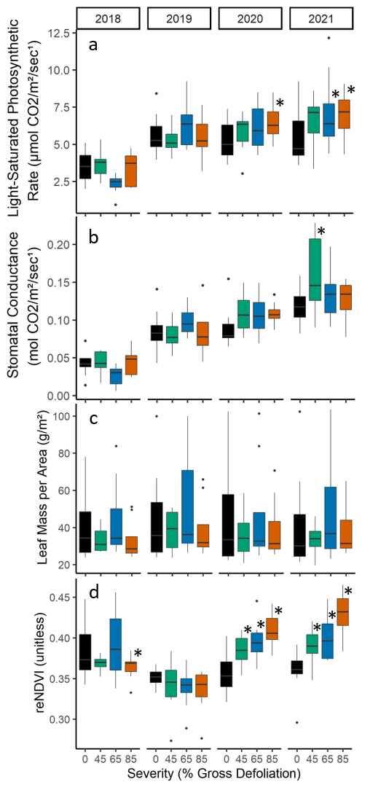

**Figure 3.** Boxplots illustrating the distribution of subplot CWM values of subcanopy leaf physiological (Asat, a; and gs, b), morphological (LMA, c) and optical (reNDVI; d) functional traits across the FoRTE manipulation, 2018-2021. Asterisks (*) denote significantly different (p < 0.05) mean values using Fisher’s LSD multiple comparisons test. All statistical parameters are included in Table SX.

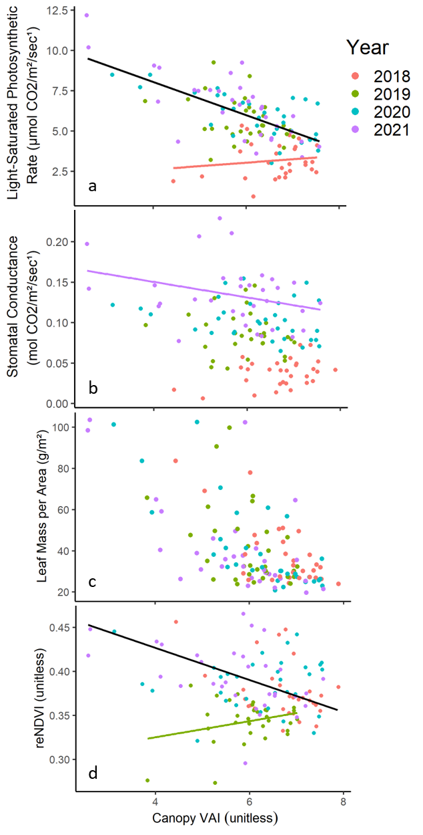

**Figure 4.** Bivariate plots illustrating leaf physiological (light-saturated rate of photosynthesis, a; and stomatal conductance, b), morphological (leaf mass per area, c), and optical (red edge NDVI, d) relationships with canopy vegetative area index (VAI) as assessed in linear mixed effect models (a, c, d) or multiple regression (b) with VAI, Year, and their interaction as predictors. Interactions (slopes of regression lines) with non-overlapping, non-zero 95 % confidence intervals found to have significant differences in a post hoc pairwise comparison (*p* < 0.001) are shown, with lines for specific year-by-VAI interactions illustrated in color and black lines illustrating

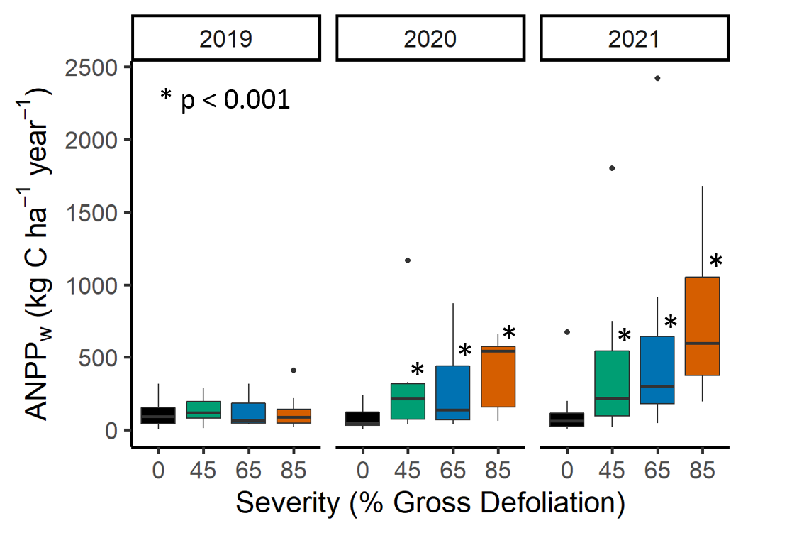

**Figure 5.** Subcanopy aboveground net primary production of wood (ANPPw) across the FoRTE disturbance manipulation. Asterisks denote distributions significantly different from the control in each year (*p* < 0.001, Fisher’s LSD).

**Table SX.** Summary of stepwise AIC model selection process for prediction of subcanopy ANPPw from CWM leaf functional traits. All candidate models were fit using *stepAIC()* function from package *MASS* in R. To generate AICc scores, we used function *AICc()* from package *MuMIn*.

|  |  |  |  |  |  |
| --- | --- | --- | --- | --- | --- |
| **Predictors** | **Adj. R2** | ***F*** | ***p*** | **AIC** | **AICc** |
| Asat  gs  LMA  reNDVI  replicate | 0.235 | 5.18 | < 0.001 | 33.06 | 309.85 |
| Asat  gs  reNDVI  replicate | 0.244 | 6.11 | < 0.001 | 31.33 | 307.42 |
| Asat  reNDVI  replicate | 0.250 | 7.34 | < 0.001 | 29.61 | 305.32 |
| reNDVI  replicate | 0.254 | 9.09 | < 0.001 | 28.18 | 303.56 |