Brenna Manning

4.06.2016

ENGR 2420

**Lab 07: MOS Differential Pair**

**POSTLAB**

I had done Experiment 1 using nMOS transistors. For the Postlab, I repeated these measurements in an LTspice simulation using pMOS transistors. My results are below.

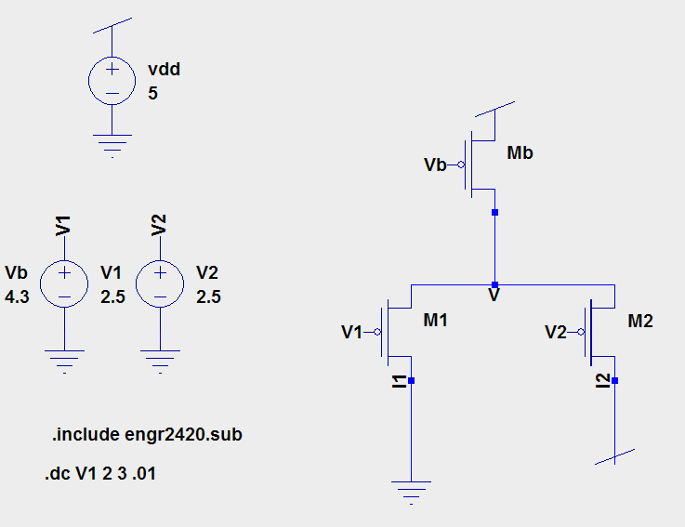**Vb at Threshold Measuring I1**Schematic:

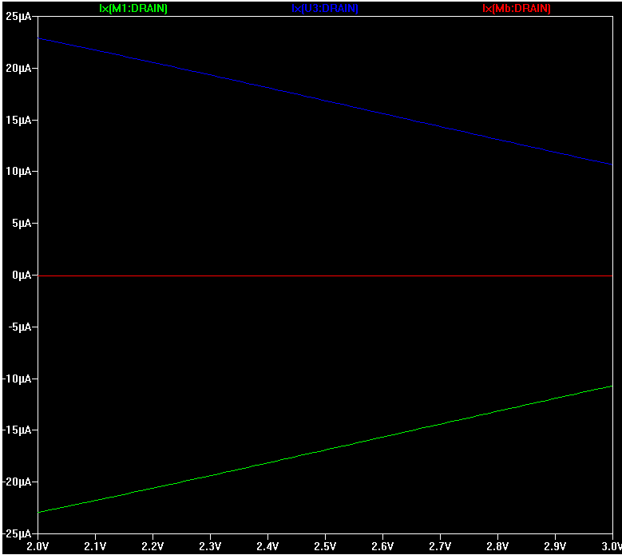Simulation Results

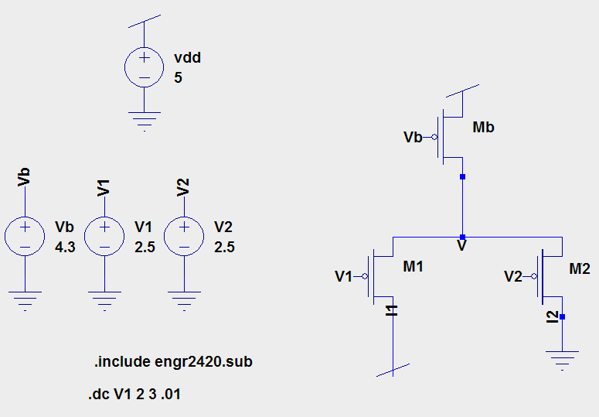**Vb at Threshold Measuring I2**Schematic:

Simulation Results

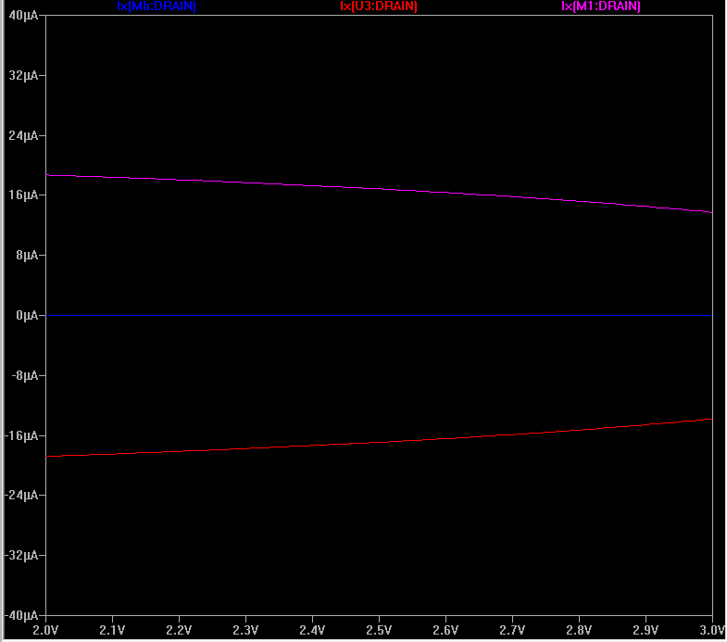

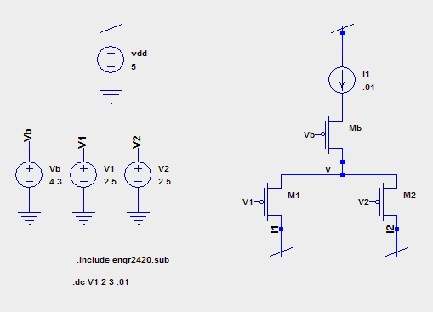**Vb at Threshold Measuring Node V**

Schematic:

Simulation Results:

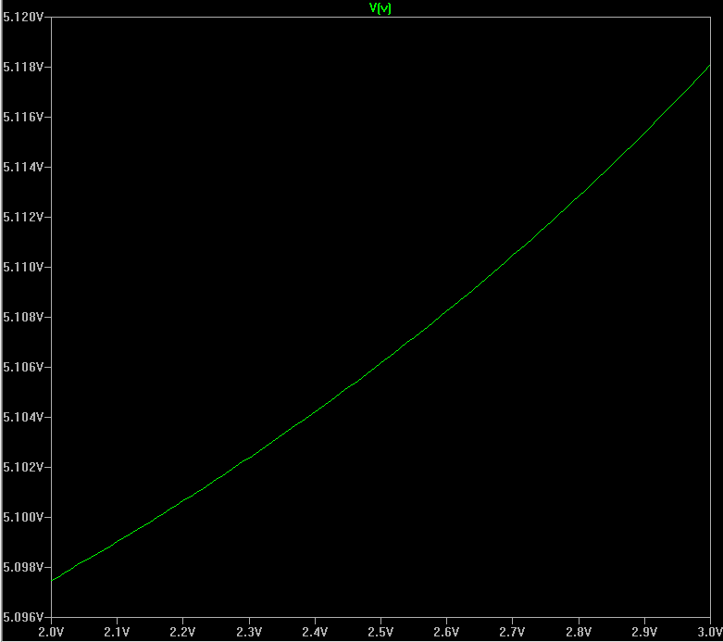

**Vb at Below Threshold Measuring I1**

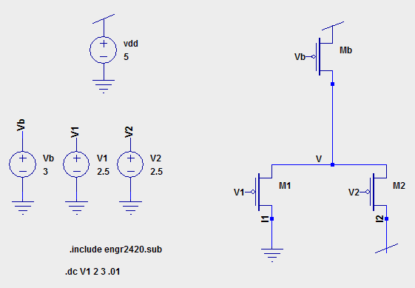Schematic:

Simulation Results:

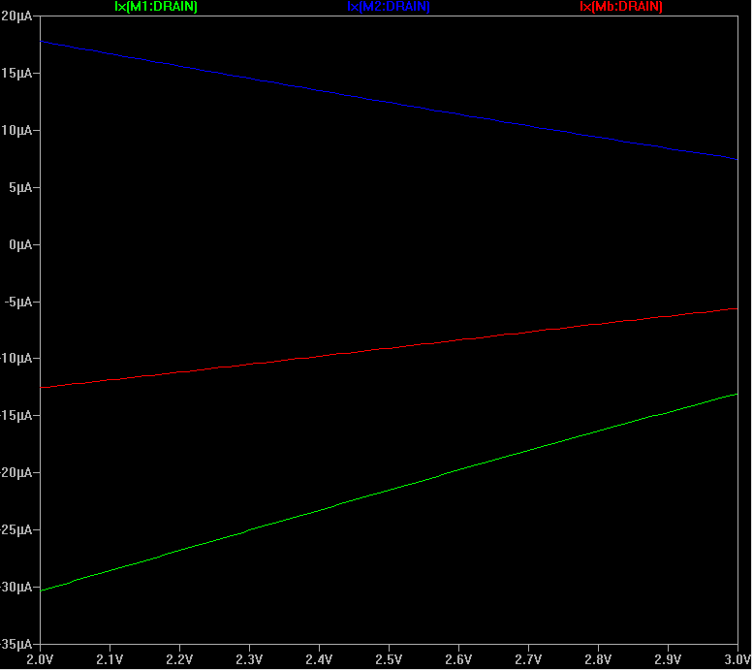

**Vb at Below Threshold Measuring I2**

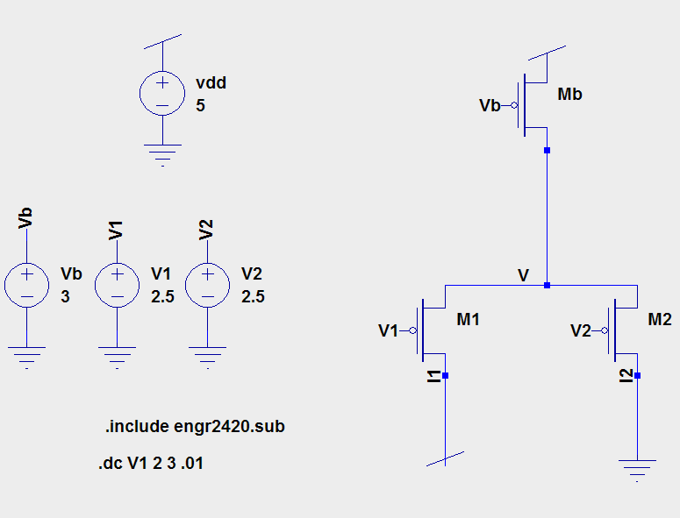Schematic:

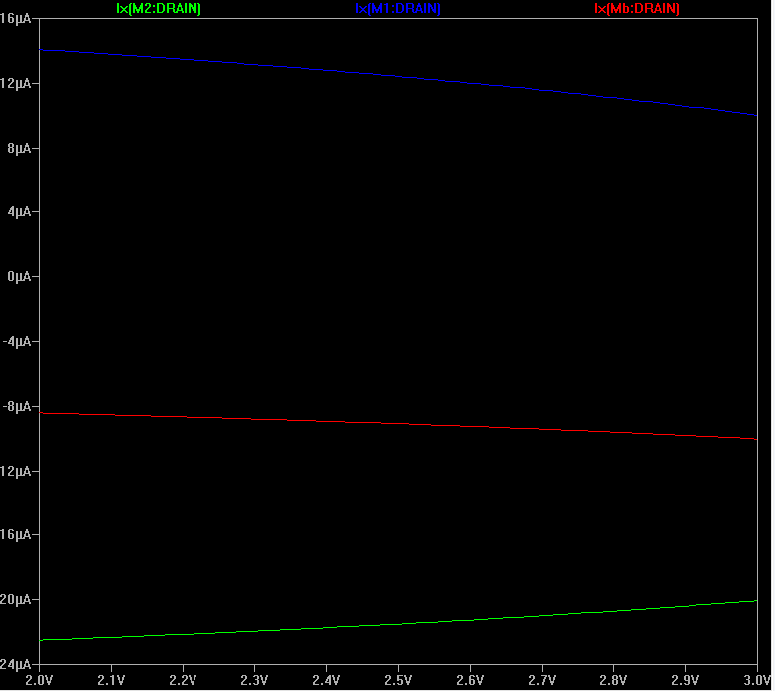Simulation Results:

**Vb at Below Threshold Measuring V**

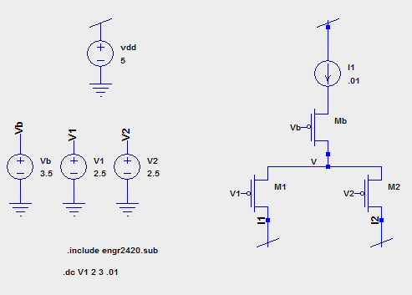Schematic:

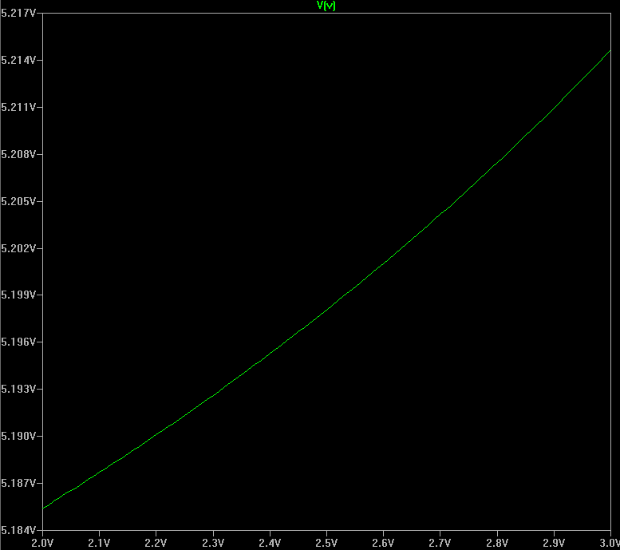Simulation Results:

The behavior of the pMOS differential pair corresponds to the behavior of the nMOS differential pair as expected. It follows similar behavior except voltages reference 5V instead of 0V, and currents behave the same way.