**TERM – WINTER 2023 **

| **Course & Section Code:** | **DBS501S1A** |
| --- | --- |
| **Course Name:** | **Procedure Using Oracles PL/SQL** |
| **Course Start & End Dates:** |  |
| **Q&A / Virtual Office Hour:** | **6:30 PM – 9:30 PM** |
| **Instructor Name & Email:** | **Ersan Cam: ersan.cam@senecacollege.ca** |

Lab#2 – Version 2

(Joins, Display data from multiple tables)

**Due Date : Feb 6th**

Instructions for delivery of this Labs file back to instructor.

**Step 1:** Download this word copy of Lab document.

**Step2:** Work on your question in SQL Developer.

**Step3:** Once you solve the problem copy paste the code under each question and Highlight with RED color

**Step4:** Also go to your Sql Developer and capture screen entire screen with command you execute and result at the bottom. Use Snipping tool in windows to capture screen shot. Below picture shows how to open free windows based snipping screen capture tool

Step5: Drop your finalized & saved word document to respective Lab dropbox assignment folder.

**Please note that Instructor has keep the right to call out any students randomly to ask demonstration their solution, and walk thru their work and justify their answers in one on one breakout room.**

**The tool to capture screen shot.**

**Demo Question.**

How to use SELECT with WHERE condition for table?

Demo Answer:

Copy paste of actual command: SELECT first_name, last_name FROM EMPLOYEES;

Demo Screen shot:

Copy paste screen shot of same command

**Subject: Joining multiple tables.**

**Lab Questions .**

**Total 4 questions ,each 25 points, total 100**

**Use Dream Home (DH_*) database for question 1 and 2**

**Question #1**

List the names of all clients who have viewed a property along with any comment supplied.

**Question #2**

For each branch office, list the numbers and names of staff

who manage properties, including the city in which the branch is located

and the properties that the staff manage.

**Use HumanResources (HR) for question 3 and 4**

**For these below questions you can switch back to your original connection where you build HR tables already.**

**Question#3**

Human resources management team needs to find the name and hire_date of all employees who were hired before their managers along with their manager’s names and hire dates.

Hint: Self Join

Sample output.

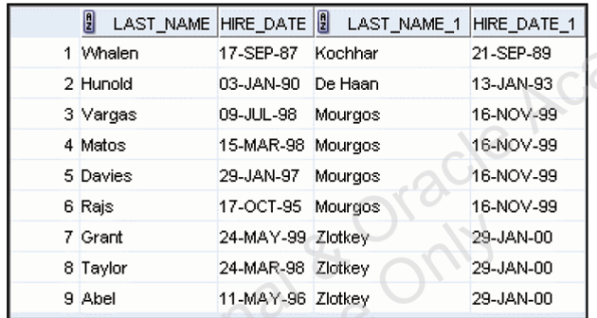

**Question 4**

Get all the employees (details are id, first_name,salary, job_id ,department number , city and state info) for those who has %REP% in their job_id

Hint: Join … also use WHERE LIKE

