**TERM – WINTER 2023 **

| **Course & Section Code:** | **DBS501S1A** |
| --- | --- |
| **Course Name:** | **Procedure Using Oracles PL/SQL** |
| **Course Start & End Dates:** |  |
| **Q&A / Virtual Office Hour:** | **6:30 PM – 9:30 PM** |
| **Instructor Name & Email:** | **Ersan Cam: ersan.cam@senecacollege.ca** |

Lab#5 (Variables, Loops , IF THEN ELSE)

**Due Feb 20th Midnight**

**Tasks (All the tasks marks are equal)**

**Below Exercise 1 and 2 are paper base exercise meaning you answer on the paper first without executing the code.. Then you can write and test the code**

|  |
| --- |
| 1. a) 2   b) Western Europe  c) 601  d) Product 11012 is in stock  e) global variable doesn’t exist |

|  |
| --- |
| 1. a) 201   b) Unisports  c) GOOD  d) Womansport  e) variable is not declared  f) GOOD |

**Preparation for Task 3**

Run this Create Table as SELECT command to create replica version of employees table

**CREATE TABLE emp**

**AS**

**SELECT * FROM employees;**

Then add one more column to this new table. New column name is stars (VARCHAR2 - 50 digit) . Run below command

**ALTER TABLE emp ADD stars VARCHAR2(50);**

SELECT emp table to see stars columns as empty.

**Task #3:**

Write PL/SQL anonyms block to fill newly added columns for each employee_id entered by end user from screen (use &emp_id to test one particular employee_id)

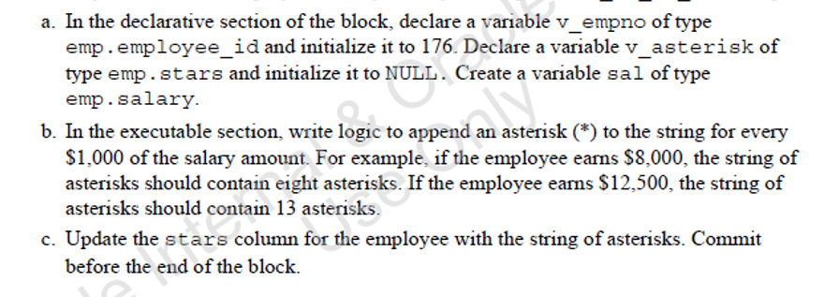

**Hint :** Use round(salary /1000) formula to find how many starts will be added to stars column.

For example, let’s say you will test 107

*SELECT round(salary/1000)*

*FROM EMPLOYEES*

*WHERE employee_id =* ***&empid*** *;*

107 employee id’s salary is 4830 so round will find 5 stars.

Now your job is to use one type of LOOPS and loop thru 5 times in this case and each loop iteration

UPDATE emp

SET stars = stars + ‘*’

WHERE employee_id= v__empid ; ( or WHERE employee_id=107)

Each time LOOP thru it will add one extra stars (*) eventually it will be 5 star

Once your PL/SQL complete executing, run SELECT statement to show the screen shot

***SELECT * FROM EMP WHERE employee_id=107;***

|  |
| --- |
| DECLARE  v_empno emp.employee_id%TYPE := 176;  v_asterisk emp.stars%TYPE := NULL;  sal emp.salary%TYPE;  BEGIN  SELECT  round(salary / 1000)  INTO sal  FROM  emp  WHERE  employee_id = v_empno;  FOR i IN 1..sal LOOP  v_asterisk := v_asterisk || '*';  UPDATE emp  SET  stars = v_asterisk  WHERE  employee_id = v_empno;  END LOOP;  END; |

**Task #4:**

Develop a PL/SQL block that would go through all the employees from EMPLOYEES table who work in department_id= 90 (there is suppose to be 3 employee who work in Department 90)

IN BEGIN END END SECTION;

Execute 3 separate of SELECT statement one after the other. Each SELECT will pull first_name , salary of each employee and store them in local variables.

SELECT LOAD INTO v_firstname1, v_salary1 WHERE employee_id=100

Then second

SELECT first_name, salary INTO v_firstname2, v_salary2 ….. WHERE employee_id=101

Then third

SELECT, SELECT first_name, salary INTO v_firstname3, v_salary3 ….. WHERE employee_id=102

You must now have 6 local variables. DECLARE all of them accordingly in DECLARE section and use them in BEGIN and END.

Then add another SELECT statement in BEGIN-END to find company average salary

SELECT avg(salary) INTO v_avgsal FROM EMPLOYEES;

!!! Do not forget to create v_avgsal local variable in DECLARE section.

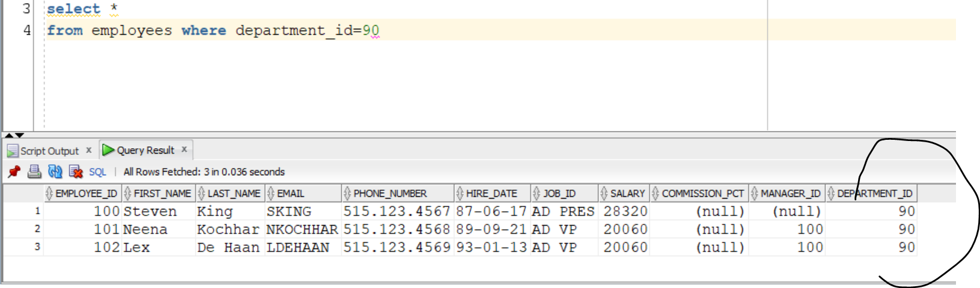

Now after loading all those info to local variables,

Use IF THEN ELSE to PRINT these messages on the screen based on compare results

**Hint: You can have one big IF ELSIF ELSIF END or you can have 3 separate IF THEN ELSE END IF statetement . Up to you**

**IF v_salary1 > v_avgsal THEN --( note** Employee_id = 100 salary 24000 )

‘Employee ‘ || v_firstname1 || ‘salary ‘ || v_salary1 || ‘ is more than average salary ‘

Or Else print (Display)

‘Employee ‘ || v_firstname1 || ‘salary ‘ || ‘is less average salary ‘

**IF v_salary2 > v_avgsal THEN --( note** Employee_id = 101 salary 17000 )

‘Employee ‘ || v_firstname2 || ‘salary ‘ || v_Salary2|| ‘is more than average salary ‘

Or Else print (Display)

‘Employee ‘ || v_firstname2 || ‘salary ‘ || ‘is less than average salary ‘

**IF v_salary3 > v_avgsal THEN --( note** Employee_id = 101 salary 17000 )

DBMS_OUTPUT ‘Employee ‘ || v_firstname3 || ‘salary ‘ || v_salary3 || ‘is more than average salary ‘

Or Else print (Display)

DBMS_OUTPUT ‘Employee ‘ || v_firstname3 || ‘salary ‘ || || v_salary3 || ‘is less than average salary ‘

|  |
| --- |
| DECLARE  v_firstname1 hr_employees.first_name%TYPE;  v_firstname2 hr_employees.first_name%TYPE;  v_firstname3 hr_employees.first_name%TYPE;  v_salary1 hr_employees.salary%TYPE;  v_salary2 hr_employees.salary%TYPE;  v_salary3 hr_employees.salary%TYPE;  v_avgsal hr_employees.salary%TYPE;  BEGIN  SELECT  first_name,  salary  INTO  v_firstname1,  v_salary1  FROM  hr_employees  WHERE  employee_id = 100;  SELECT  first_name,  salary  INTO  v_firstname2,  v_salary2  FROM  hr_employees  WHERE  employee_id = 101;  SELECT  first_name,  salary  INTO  v_firstname3,  v_salary3  FROM  hr_employees  WHERE  employee_id = 102;  SELECT  AVG(salary)  INTO v_avgsal  FROM  hr_employees;  IF v_salary1 > v_avgsal THEN  dbms_output.put_line('Employee '  || v_firstname1  || ' salary '  || v_salary1  || ' is more than average salary');  ELSE  dbms_output.put_line('Employee '  || v_firstname1  || ' salary '  || 'is less than average salary');  END IF;  IF v_salary2 > v_avgsal THEN  dbms_output.put_line('Employee '  || v_firstname2  || ' salary '  || v_salary2  || ' is more than average salary');  ELSE  dbms_output.put_line('Employee '  || v_firstname2  || ' salary '  || 'is less than average salary');  END IF;  IF v_salary3 > v_avgsal THEN  dbms_output.put_line('Employee '  || v_firstname3  || ' salary '  || v_salary3  || ' is more than average salary');  ELSE  dbms_output.put_line('Employee '  || v_firstname3  || ' salary '  || 'is less than average salary');  END IF;  END; |

5) Investigate below code and explain how CONTINUE would impact the DBMS OUTPUT printing options. Go with each i iterations from 1 to 10 and also go with internal child FOR LOOP j from 1 to 10

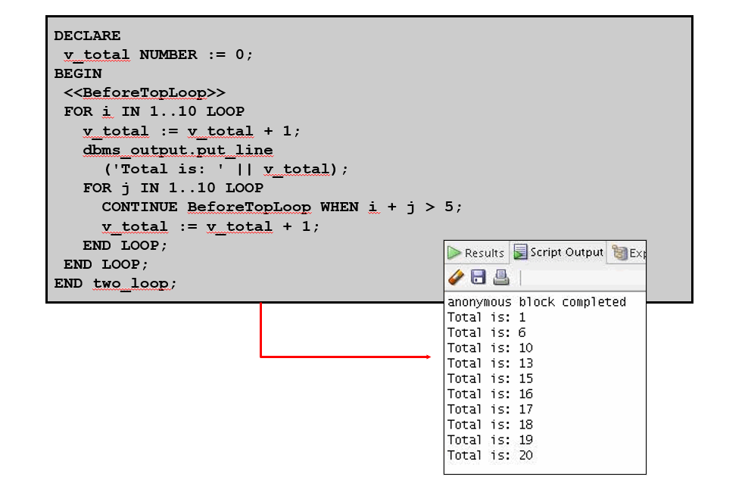

DECLARE

v_total NUMBER := 0;

BEGIN

<<BeforeTopLoop>>

FOR i IN 1..10 LOOP

v_total := v_total + 1;

dbms_output.put_line

('Total is: ' || v_total);

FOR j IN 1..10 LOOP

CONTINUE BeforeTopLoop WHEN i + j > 5;

v_total := v_total + 1;

END LOOP;

END LOOP;

END two_loop;

|  |
| --- |
| Based on the above code, the impact the CONTINUE statement would have on DBMS_OUTPUT printing would cause the inner loop to skip certain values of ‘i’ and ‘j’ but the outer loop will still execute DBMS_OUTPUT printing for each iteration. |