**TERM– WINTER 2023 **

| **Course & Section Code:** | **DBS501S1A** |
| --- | --- |
| **Course Name:** | **Procedure Using Oracles PL/SQL** |
| **Course Start & End Dates:** |  |
| **Q&A / Virtual Office Hour:** | **6:30 PM – 9:30 PM** |
| **Instructor Name & Email:** | **Ersan Cam: ersan.cam@senecacollege.ca** |

Lab#6 (Exception Handling)

1) Handling Predefined Exceptions

The Just Lee Book order application page was modified so that an employee can enter a order number. If person enters a order number which has more than one records or if invalid order number is entered there should be EXCEPTION to handle these two situations.

But If person enters valid order then it would display the info from JL_ORDERITEMS table.

Exception handler sections need to be added to the block that displays the message “Invalid Order Number” on screen.

Or More than one record belong to this order number

Use an initialized variable named lv_order_num to provide a Order ID.

This below code is given to you. Your job is to add exception handling (Proper predefined ones) and test three times with different order numbers…. First try with order# 1004 (for proper Order number which is returning 1 record), then try 1009 ( for multiple records case) , and then finally 1038 (for invalid order number)

Test and print screen with # 1004 and it should print (rec_order.order# || rec_order.isbn || rec_order.paideach);

Test and print screen with #1009 should go to EXCEPTION and print message “'More than one record “

Test and print screen with #1038 should go to EXCEPTION and print message “'Invalid Order Number “

*DECLARE*

*rec_order jl_orderitems%ROWTYPE;*

*lv_order_num jl_orderitems.order#%TYPE := 1004;*

*BEGIN*

*SELECT * INTO rec_order FROM jl_orderitems WHERE order# = lv_order_num;*

*DBMS_OUTPUT.PUT_LINE(rec_order.order# || rec_order.isbn || rec_order.paideach);*

*END;*

|  |
| --- |
| DECLARE  rec_order jl_orderitems%ROWTYPE;  lv_order_num jl_orderitems.order#%TYPE := &ordernum;  BEGIN  SELECT * INTO rec_order FROM jl_orderitems WHERE order# = lv_order_num;  DBMS_OUTPUT.PUT_LINE(rec_order.order# || rec_order.isbn || rec_order.paideach);  EXCEPTION  WHEN TOO_MANY_ROWS THEN  DBMS_OUTPUT.PUT_LINE('More than one record');  WHEN NO_DATA_FOUND THEN  DBMS_OUTPUT.PUT_LINE('Invalid Order Number');  END;  When looking up order number 1004:      When looking up order number 1009:    When looking up order number 1038: |

2)  **Handling Exceptions with Undefined Errors**

JL Book sell company wants to add a check constraint on the SHIPCOST column of the

ORDERS table. If a shopper’s shipcost is greater than 10 for an item,

JL BOOK wants to display the message “ShipCost can not be more than 10.Check amount” onscreen.

This below code is given to you to start.

DECLARE

BEGIN

insert into orders values (1032,1005,SYSDATE,SYSDATE+3, '121 Eagle Str', 'SEATTLE','WA',98114,**30**);

END;

As you can see this is simply inserting a new order to table. But notice shipcost is 30 and it accept entry because there is no rule yet.

Now

Run this ALTER TABLE, command to add check constraint to your table

ALTER TABLE orders

ADD CONSTRAINT cost_ship_ck CHECK (shipcost < 10);

With this constraint no one can create an order entry with shipcost more than $10.

Try entering one entry with below sample code

DECLARE

BEGIN

insert into orders values (1033,105,SYSDATE,SYSDATE+3, '121 Eagle Str', 'SEATTLE','WA',98114,**25**);

END;

You must get error message. Explain what error you get. What is the error number?

Is this something similar to below?  **ORA-02290**

|  |
| --- |
| I do get an error message. It is ORA-02290 and states the check constraint is violated as the values being inserted do not satisfy he named check for cost_ship_ck |

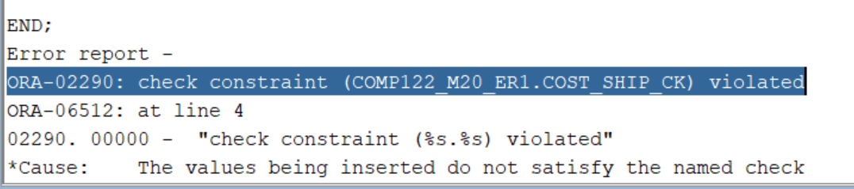

Now add additional code to this block to trap the check constraint violation and display the message.

In the Exception handling section code should print message **“ Ship cost is more than $10 , please reduce”**

Note: Use new INSERT in your code to get error and exception message. For example

insert into orders values (1033,1005,SYSDATE,SYSDATE+3, '121 Eagle Str', 'SEATTLE','WA',98114,**30**);

Hint:

In Declare section use these

anyname EXCEPTION;

PRAGMA EXCEPTION_INIT(anyname, -2290);

|  |
| --- |
| DECLARE  anyname EXCEPTION;  PRAGMA EXCEPTION_INIT(anyname, -2290);  BEGIN  insert into jl_orders values (1033,1005,SYSDATE,SYSDATE+3, '121 Eagle Str', 'SEATTLE','WA',98114,30);  EXCEPTION  WHEN OTHERS THEN  IF SQLCODE = -2290 THEN  DBMS_OUTPUT.PUT_LINE('Ship cost more than $10, please reduce');  RAISE anyname;  END IF;  END; |