**TERM – WINTER 2023 **

| **Course & Section Code:** | **DBS501** |
| --- | --- |
| **Course Name:** | **Procedure Using Oracles PL/SQL** |
| **Course Start & End Dates:** |  |
| **Q&A / Virtual Office Hour:** | **6:30 PM – 9:30 PM** |
| **Instructor Name & Email:** | **Ersan Cam: ersan.cam@senecacollege.ca** |

Lab#7 ( Composite DataTypes - Cursors)

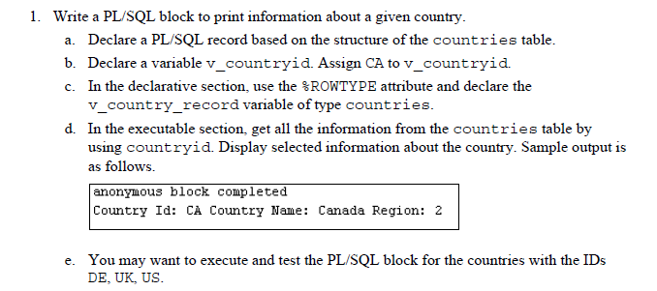

**2 )Cursor activity**

Let's create a new empty table called employee_promotion

CREATE TABLE employee_promotion

AS SELECT employee_id, first_name,last_name, sysdate as promition_date , hire_date,job_id, salary, department_id FROM employees

WHERE 1=2

2) check if there is any data in it.. ( It must be empty)

select * from employee_promotion

3) your job is to fill this new built table with employee info and their promotion date.. Promotion date is defined based on their department and

their current salary...

Create a PL/SQL Block program to process every employee

your cursor should include every columns (Fields ) from employees table and for all the employees record

add CURSOR FOR LOOP section to fetch and process each record one by one

Check each record and prepare INSERT statement accordingly

IF employee department is either 60 or 100 or 50 and at the same time employee salary is in between 1000 and 8000

then promotion date is set as today

employee_id, first_name,last_name, sysdate as promition_date , hire_date,job_id, salary, department_id

INSERT INTO employee_promotion VALUES (rec.employee_id ,rec.first_name,rec.last_name, promotion date , rec.hire_date,rec.job_id, rec.salary, rec.department_id)

IF employee department is either 60 or 100 or 50 and at the same time employee salary is grater than 8000

then promotion date is set 3 months later ( you can use ADD_MONTHS (sysdate, 3) function )

INSERT INTO employee_promotion VALUES (rec.employee_id ,rec.first_name,rec.last_name, promotion date , rec.hire_date,rec.job_id, rec.salary, rec.department_id)

IF employee department is either 40 or 80 or 20 and at the same time employee salary is in between 2000 and 6000

then promotion date is 2 months later

INSERT INTO employee_promotion VALUES (rec.employee_id ,rec.first_name,rec.last_name, promotion date , rec.hire_date,rec.job_id, rec.salary, rec.department_id)

IF employee department is either 40 or 80 or 20 and at the same time employee salary is grater than 6000

then promotion date is 3 months later

Everyone else's promotion date is 6 months later

Complete and execute your PL/SQL block ..

And select employee_promotion table to confirm all records are inserted.