Browser and Email/Communication
Forensic Artifacts

Practical Assignment Report

Lisa Kabue
September 12, 2026

1. Student Information
Table 1 Student Information
Field | Details
Student Name | Lisa Kabue
Student Email | lisa.kabue@student.moringaschool.com
Institution | Moringa School
Course | Digital Forensics
Date of Practical | September 12, 2026

2. Objective
The objective of this practical assignment is to understand how browser, email, and communication artifacts can provide forensic information about web activity, searches, downloads, messages, attachments, timestamps, routing information, and user activity. This is accomplished by creating controlled browser and email activity on an authorized computer, then examining the resulting forensic artifacts.
Specifically, this practical aims to:
- Identify common browser forensic artifacts.
- Examine history, searches, cookies, cache, and download activity.
- Examine email headers, metadata, and mailbox artifacts.
- Identify attachment, archived, and deleted communication artifacts.
- Build a basic web and communication timeline.
- Correlate browser and email evidence.
- Distinguish direct observations from forensic inferences.
- Present a defensible reconstruction of activity based on available evidence.

3. Browser Information
Table 1 Browser Installation Details
Field | Details
Browser Name | Google Chrome
Browser Version | 152.0.7977.83 (Official Build) (64-bit)
Installation Date | September 12, 2026
Operating System | Windows 11 Version 25H2 (Build 26200.9445)
Browser Profile | Forensics Test (Profile 4)
Profile Path | C:\Users\HomePC\AppData\Local\Google\Chrome\User Data\Profile 4
The following screenshots document the browser installation and configuration:
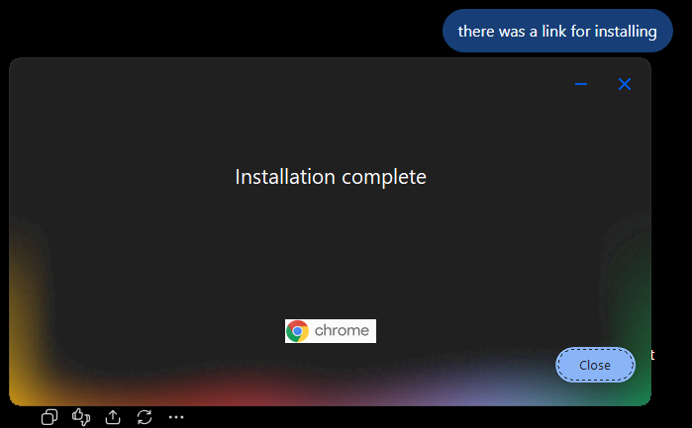
Figure 1 Chrome Installation Complete – Confirming Successful Browser Installation
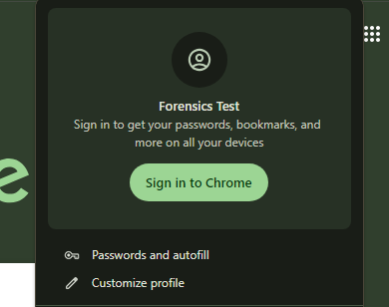
Figure 2 Forensics Test Profile – Dedicated Test Profile Created in Chrome
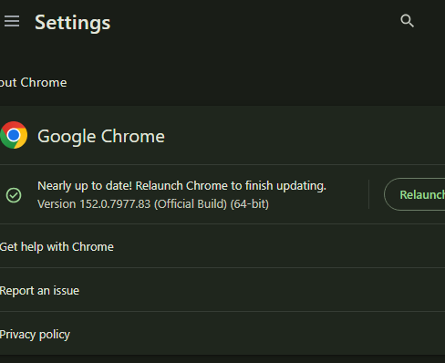
Figure 3 Chrome Version Information (chrome://version) – v152.0.7977.83 on Windows 11 Build 26200.9445

4. Email Application Information
Table 1 Email Application Installation Details
Field | Details
Email Application | Mozilla Thunderbird
Version | 155.0.1 (64-bit)
Installation Date | September 12, 2026
Test Account | lisa.kabue@student.moringaschool.com
Download Source | https://www.thunderbird.net/
Mailbox/Profile Location | Local Thunderbird Profile Directory
Thunderbird was downloaded via the Chrome browser (visible in Chrome download history as "Thunderbird Setup 155.0.1.exe" from https://www.thunderbird.net). The email account lisa.kabue@student.moringaschool.com was configured as the test account.
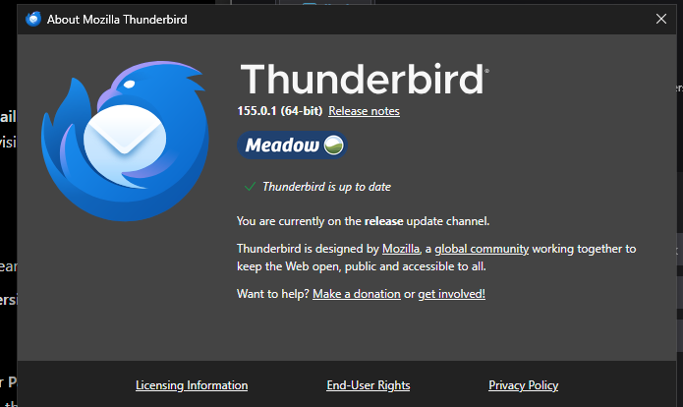
Figure 1 Thunderbird Version – About Dialog Showing v155.0.1 (64-bit), Codename Meadow
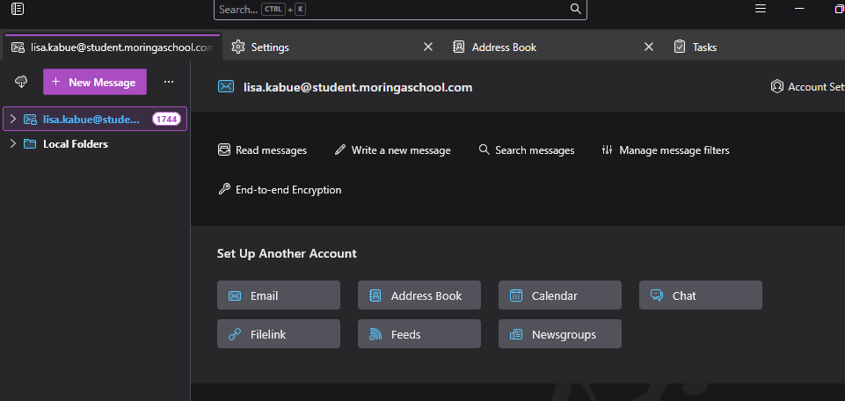
Figure 2 Thunderbird Account Overview – Confirming Test Email Account and Mailbox Structure

5. Tools and Versions Used
Table 1 Tools and Versions Used
Tool | Version | Purpose
Google Chrome | 152.0.7977.83 (64-bit) | Web browser for creating and examining browsing activity
Mozilla Thunderbird | 155.0.1 (64-bit) | Email client for creating and examining email communication artifacts
Windows 11 | 25H2 (Build 26200.9445) | Operating system platform
Chrome Built-in Tools | chrome://settings, chrome://history, chrome://downloads | Examining browser history, cookies, storage, and downloads
Chrome Site Settings | chrome://settings/content/all | Viewing site storage and cookie data

6. Browser Activity Created
The following controlled browsing activity was performed using the "Forensics Test" profile in Google Chrome on September 12, 2026. All activity was created for forensic examination purposes only.

6.1 Websites Visited
Table 1 Websites Visited
# | Website | URL | Time
1 | Google | https://www.google.com | 12:21 PM
2 | Wikipedia | https://www.wikipedia.org | 12:21 PM
3 | Mozilla | https://www.mozilla.org | 12:21 PM
4 | W3C | https://www.w3.org | 12:21 PM
5 | GitHub | https://www.github.com | 12:21 PM
6 | Google (revisited) | https://www.google.com | 12:24 PM
7 | W3C (PDF test document) | https://www.w3.org/WAI/ER/tests/pdf | 12:38 PM
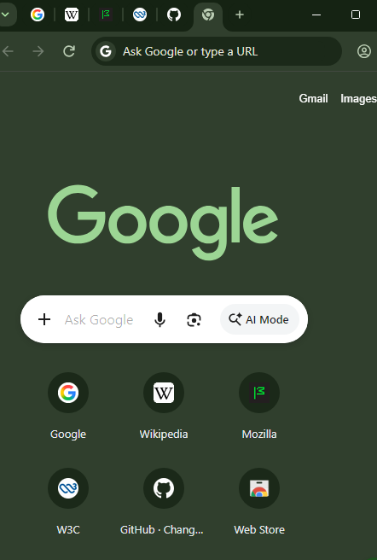
Figure 1 Browser Shortcuts – Frequently Visited Sites Displayed on Chrome New Tab Page

6.2 Searches Performed
Table 2 Searches Performed
# | Search Query | Time
1 | "digital forensics" | 12:27 PM
2 | "browser forensic artifacts" | 12:27 PM
3 | "email header analysis" | 12:29 PM
4 | "email" (Google search) | 12:31 PM
5 | "W3C PDF test document" | 12:37 PM
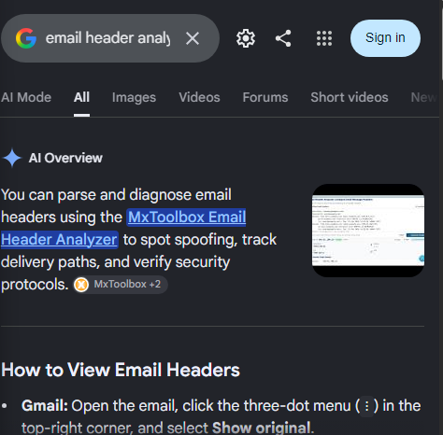
Figure 2 Search for 'Email Header Analysis' – Google Search Results Page

6.3 Files Downloaded
Table 3 Files Downloaded
# | File Name | Source URL | Time | Download Location
1 | table.pdf | https://www.w3.org | 12:42 PM | Default Chrome Downloads folder
2 | PDF_testfiles_20081027.zip | https://www.w3.org | ~12:42 PM | Default Chrome Downloads folder
3 | Thunderbird Setup 155.0.1.exe | https://www.thunderbird.net | Post 12:42 PM | Default Chrome Downloads folder
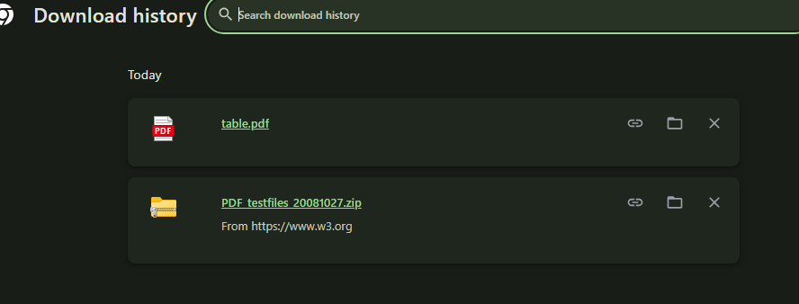
Figure 3 Chrome Download History – Downloaded Test Files from w3.org
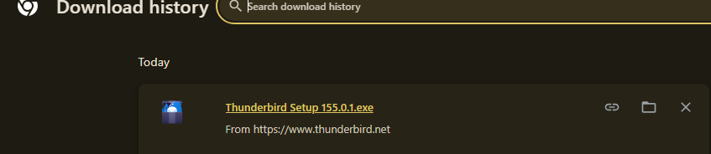
Figure 4 Thunderbird Installer Download – Chrome Downloads Showing Thunderbird Setup 155.0.1.exe

6.4 Bookmark Created
A bookmark titled "Forensics Test Bookmark" was created and saved under "Other bookmarks" in the Chrome bookmarks bar.
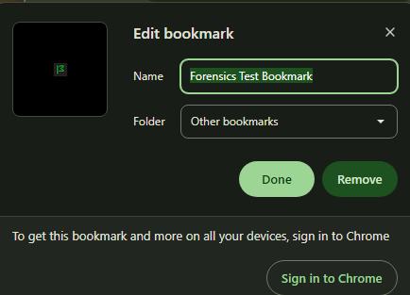
Figure 5 Forensics Test Bookmark – Chrome Bookmark Edit Dialog Showing Created Bookmark
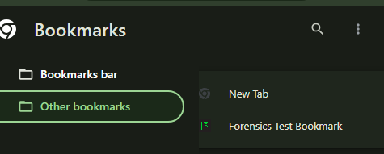
Figure 6 Bookmarks Menu - Forensics Test Bookmark Visible Under Other Bookmarks

6.5 Additional Activity
- Multiple tabs were opened during the browsing session (Google, Wikipedia, Mozilla, W3C, GitHub).
- The browser was closed and reopened to verify session restoration and recently closed tabs.
- The Google website was visited more than once (at 12:21 PM and 12:24 PM).
- Several pages related to the searches were opened (email header analysis results, W3C PDF test document page).
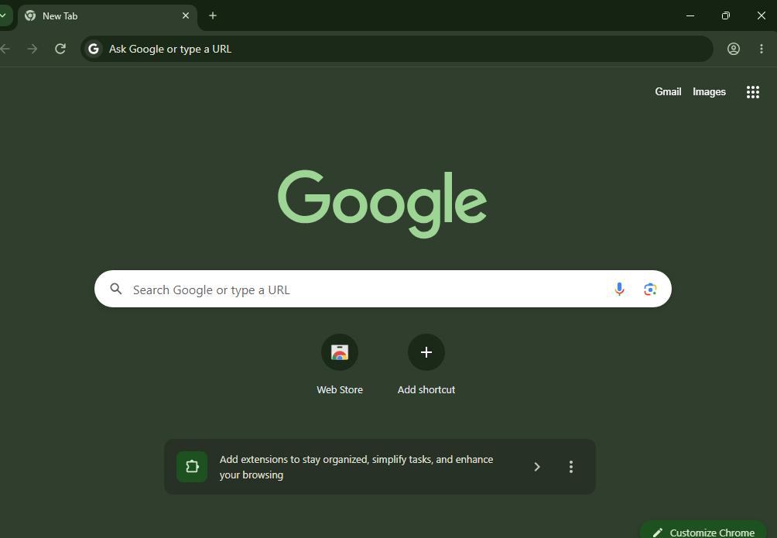
Figure 7 Chrome New Tab Page – Multiple Tabs Open During Browsing Session
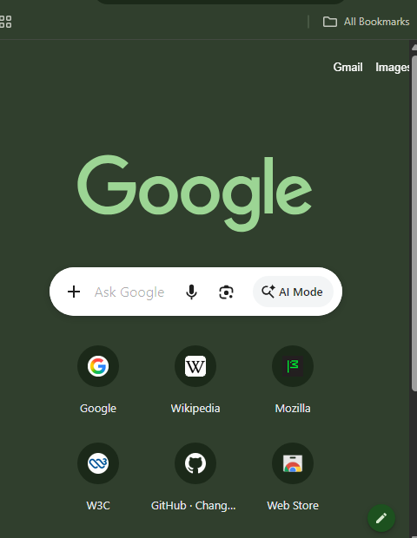
Figure 8 Chrome Bookmarks View – All Bookmarks Visible in Browser Interface

7. Browser Artifacts Examined
The following browser artifacts were examined using Chrome's built-in tools (chrome://history, chrome://downloads, chrome://settings/content/all, and chrome://version). Each artifact's location, type of information, relevant timestamps, observations, and forensic significance are documented below.

7.1 Artifact 1: Browsing History
Table 1 Artifact 1 – Browsing History
Field | Details
Artifact Name | Browsing History
Location/Path | C:\Users\HomePC\AppData\Local\Google\Chrome\User Data\Profile 4\History (SQLite database)
Type of Information | Chronological record of all URLs visited, page titles, visit counts, and timestamps
Relevant Timestamps | 12:21 PM – 12:42 PM, September 12, 2026
What Was Observed | History entries show visits to google.com, wikipedia.org, mozilla.org, w3.org, github.com, and search queries for 'digital forensics', 'browser forensic artifacts', 'email header analysis', and 'W3C PDF test document'. Google was visited twice. A clear progression from general site visits to specific forensic research is visible.
Forensic Relevance | Browsing history provides a timeline of user activity, revealing intent (e.g., searching for 'digital forensics' suggests research interest), sites visited, and the sequence of web navigation. Visit counts can indicate repeated interest. Timestamps enable correlation with other digital artifacts.
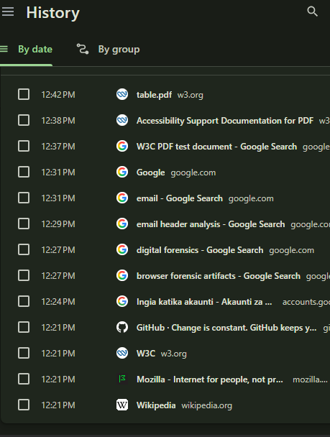
Figure 1 Browsing History – Chrome History Page Showing All Visited URLs with Timestamps
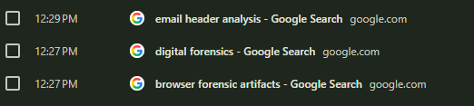
Figure 2 Search History Detail – Specific Search Queries Recorded in Chrome History

7.2 Artifact 2: Search History
Table 2 Artifact 2 – Search History
Field | Details
Artifact Name | Search History
Location/Path | C:\Users\HomePC\AppData\Local\Google\Chrome\User Data\Profile 4\History (SQLite database – keyword_search_terms table)
Type of Information | Search queries entered into search engines, including terms and timestamps
Relevant Timestamps | 12:27 PM, 12:29 PM, 12:31 PM, 12:37 PM, September 12, 2026
What Was Observed | Five distinct searches were recorded: 'digital forensics' (12:27 PM), 'browser forensic artifacts' (12:27 PM), 'email header analysis' (12:29 PM), 'email' (12:31 PM), and 'W3C PDF test document' (12:37 PM). The searches progress from general forensic concepts to specific email and PDF-related topics.
Forensic Relevance | Search history reveals user intent and areas of interest. In a forensic investigation, specific search terms can indicate knowledge, planning, or research related to an incident. The progression of searches can reconstruct a user's thought process and objectives.

7.3 Artifact 3: Download History
Table 3 Artifact 3 – Download History
Field | Details
Artifact Name | Download History
Location/Path | C:\Users\HomePC\AppData\Local\Google\Chrome\User Data\Profile 4\History (SQLite database – downloads table)
Type of Information | Records of files downloaded including file name, source URL, download start/end time, file size, and local save path
Relevant Timestamps | ~12:42 PM and post-12:42 PM, September 12, 2026
What Was Observed | Three files were downloaded: (1) table.pdf from w3.org, (2) PDF_testfiles_20081027.zip from w3.org, and (3) Thunderbird Setup 155.0.1.exe from thunderbird.net. The Chrome downloads page confirmed the source URLs and file names.
Forensic Relevance | Download history provides evidence of files obtained from the internet, including their source. This can link a user to specific content, software, or documents. The source URL and timestamps can be correlated with browsing history and email activity (e.g., the same table.pdf was later attached to an email).

7.4 Artifact 4: Cookies and Site Storage
Table 4 Artifact 4 – Cookies and Site Storage
Field | Details
Artifact Name | Cookies and Site Storage
Location/Path | C:\Users\HomePC\AppData\Local\Google\Chrome\User Data\Profile 4\Cookies (SQLite database); Local Storage
Type of Information | Cookie data, local/session storage, cached data per site, including site permissions and storage usage
Relevant Timestamps | Created during browsing session on September 12, 2026
What Was Observed | Site storage examination via chrome://settings/content/all showed total storage of 1,745 KB across 6 sites: google.com (1,737 KB, 8 cookies), mozilla.org (7.5 KB, 3 cookies), wikipedia.org (100 bytes, 4 cookies), github.com (0 B, 2 cookies), lensfrontend-pa.googleapis.com (0 B, 1 cookie), w3.org (0 B, 1 cookie). Google had the most cookies and storage, consistent with active searching and account interaction.
Forensic Relevance | Cookies confirm interaction with specific websites even if history is cleared. They may contain session identifiers, authentication tokens, and preferences that link a user to account activity. Storage sizes and cookie counts can indicate the depth and frequency of interaction with each site.
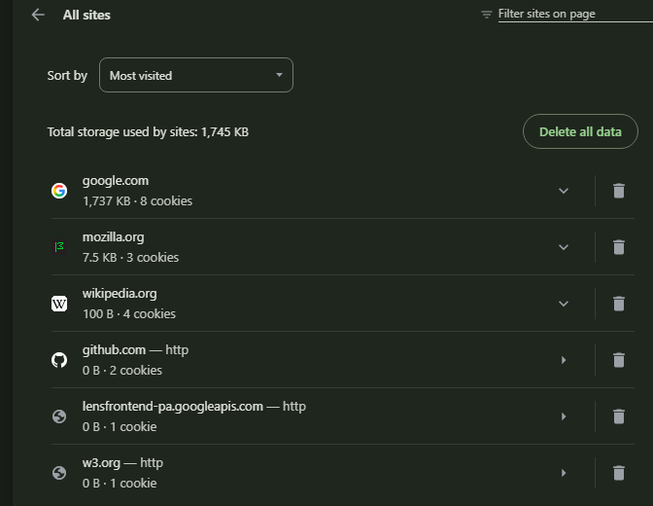
Figure 3 Site Storage and Cookies – Chrome Site Settings Showing Storage Usage and Cookie Counts Per Site

7.5 Artifact 5: Bookmarks
Table 5 Artifact 5 – Bookmarks
Field | Details
Artifact Name | Bookmarks
Location/Path | C:\Users\HomePC\AppData\Local\Google\Chrome\User Data\Profile 4\Bookmarks (JSON file)
Type of Information | User-saved URLs with names, folders, and timestamps for when bookmarks were added
Relevant Timestamps | Created during the browsing session, September 12, 2026
What Was Observed | A bookmark titled "Forensics Test Bookmark" was found under "Other bookmarks" in the bookmarks bar. The Chrome bookmarks menu showed "Bookmarks bar" and "Other bookmarks" categories with the test bookmark visible.
Forensic Relevance | Bookmarks indicate intentional saving of a URL, suggesting the user considered the page important or wanted to revisit it. Unlike history (which is passive), bookmarks represent a deliberate user action. In an investigation, bookmarks can reveal planned or recurring interests.

7.6 Artifact 6: Browser Cache
Table 6 Artifact 6 – Browser Cache
Field | Details
Artifact Name | Browser Cache
Location/Path | C:\Users\HomePC\AppData\Local\Google\Chrome\User Data\Profile 4\Cache
Type of Information | Cached web resources (images, scripts, HTML fragments) enabling faster page loading and offline access to previously viewed content
Relevant Timestamps | Cached during browsing session on September 12, 2026
What Was Observed | Cache data was present for visited sites. Specific cache entries were not individually examined via a separate tool in this practical, but cache presence was confirmed through the site storage data (1,745 KB total).
Forensic Relevance | Cached content can provide evidence of previously viewed pages even if browsing history has been deleted. Cached images, scripts, and HTML can be recovered to reconstruct the actual content a user viewed, not just the URLs.

7.7 Artifact 7: Web Storage / Saved Sessions
Table 7 Artifact 7 – Web Storage / Saved Sessions
Field | Details
Artifact Name | Web Storage / Saved Sessions
Location/Path | C:\Users\HomePC\AppData\Local\Google\Chrome\User Data\Profile 4\Local Storage; Session Storage
Type of Information | Key-value pairs stored by websites for session persistence, user preferences, and application state
Relevant Timestamps | Created during browsing session on September 12, 2026
What Was Observed | Site storage data was observed via Chrome settings showing local and session storage entries for visited sites. Specific key-value pairs were not individually extracted in this practical.
Forensic Relevance | Web storage can contain session tokens, user identifiers, application state data, and form input. This data persists across browser restarts and can link a browser session to specific user accounts or activities even after cookies expire.
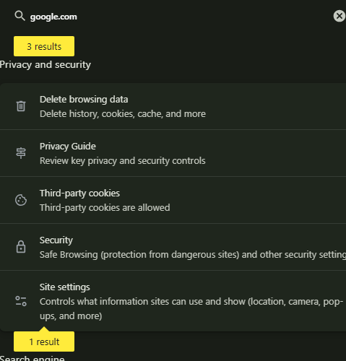
Figure 4 Chrome Privacy Settings – Browser Privacy and Security Configuration

8. Email/Communication Activity Created
The following controlled email activity was created using Mozilla Thunderbird with the test account lisa.kabue@student.moringaschool.com on September 12, 2026. All messages are authorized test communications for forensic examination purposes only.
Table 1 Email/Communication Activity Created
# | Sender | Recipient | Subject | Date/Time | Status | Attachment
1 | lisa.kabue@student.moringaschool.com | lisa.kabue@student.moringaschool.com | Forensics Test | 1:38 PM | Deleted (in Trash) | None
2 | lisa.kabue@student.moringaschool.com | lisa.kabue@student.moringaschool.com | Evidence Examination | 1:40 PM | In Evidence Examination folder | None
3 | lisa.kabue@student.moringaschool.com | lisa.kabue@student.moringaschool.com | Forensics Test - Attachment | 1:41 PM | In Inbox | table.pdf (65.3 KB)
4 | lisa.kabue@student.moringaschool.com | lisa.kabue@student.moringaschool.com | Reply to Evidence Examination | 1:43 PM | In Evidence Examination folder (Reply) | None
5 | lisa.kabue@student.moringaschool.com | lisa.kabue@student.moringaschool.com | Archived Test Message | ~1:45 PM | Archived (in All Mail / Archive) | None
Note: The same email address was used as both sender and recipient because this was a self-addressed test environment. In a real investigation, sender and recipient addresses would typically differ and provide additional forensic leads.

8.1 Mailbox Folder Structure
- Inbox: 849 messages (includes the Forensics Test - Attachment email)
- Drafts: No test messages
- Sent: 1 message (test emails sent from this account)
- All Mail: 856 messages (includes archived messages)
- Spam: No test messages
- Trash: 1 message (Forensics Test – deleted message at 1:38 PM)
- Important: 36 messages
- Starred: No test messages
- Local Folders: Available for local storage
- Evidence Examination: Custom folder with 2 messages (original + reply)
Figure 1 Thunderbird Account Overview – Full Mailbox Folder Structure and Test Account Configuration

9. Email Artifacts Examined
The following email artifacts were examined using Mozilla Thunderbird's built-in tools, including folder views, message source/header view, and attachment inspection. Each artifact's location, metadata, observations, and forensic significance are documented below.

9.1 Artifact 1: Email Message Headers
Table 1 Email Artifact 1 – Message Headers
Field | Details
Artifact Name | Email Message Headers
Location/Source | Thunderbird message source view (Ctrl+U); stored in the mailbox mbox files within the Thunderbird profile directory
Metadata Available | From, To, Subject, Date, Message-ID, Received (routing), MIME-Version, Content-Type, Return-Path, Reply-To, X-Mailer/custom headers
What Was Observed | Headers for each test email confirmed sender (lisa.kabue@student.moringaschool.com), recipient (same), subject lines, timestamps (1:38 PM to ~1:45 PM), and message structure. The 'Received' header fields show the mail server routing path. Message-ID provides a unique identifier for each message.
Forensic Relevance | Email headers are critical forensic artifacts. The 'Received' fields trace the path of an email through mail servers, potentially revealing the true origin. The 'Date' field records when the sender claims to have sent the message (can be spoofed). The 'Message-ID' is unique and can link copies across different mailboxes. However, headers alone do not prove the identity of a person — they record what the mail system logged, which may be manipulated.

9.2 Artifact 2: Email Attachments
Table 2 Email Artifact 2 – Attachments
Field | Details
Artifact Name | Email Attachment
Location/Source | Email message body in Thunderbird; stored as MIME part within the mailbox mbox file
Metadata Available | Attachment filename, content type, file size, encoding method (Base64), disposition (attachment/inline)
What Was Observed | The email with subject 'Forensics Test - Attachment' (1:41 PM) contained an attachment named 'table.pdf' (65.3 KB). Thunderbird displayed a 'Save' button for the attachment. The attachment filename matches the file downloaded from w3.org via Chrome (table.pdf, downloaded at 12:42 PM).
Forensic Relevance | Attachments provide evidence of files shared or transmitted. The filename, size, and content can link an email to file-system artifacts or browser downloads (e.g., the same table.pdf was downloaded and then emailed). Hash comparison (MD5/SHA) would confirm if the files are identical. Attachments may also contain malware or contraband.
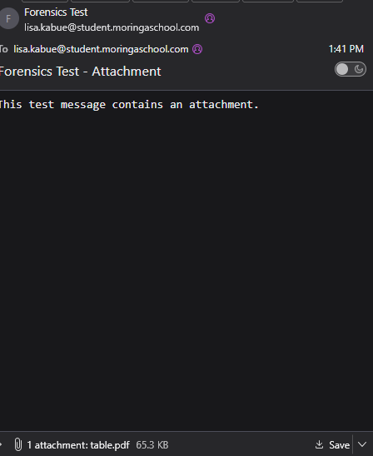
Figure 1 Email with Attachment – 'Forensics Test - Attachment' Email Showing table.pdf (65.3 KB)

9.3 Artifact 3: Deleted Messages (Trash)
Table 3 Email Artifact 3 – Deleted Messages
Field | Details
Artifact Name | Deleted Messages / Trash Folder
Location/Source | Thunderbird Trash folder; physically stored in the Trash mbox file within the Thunderbird profile directory
Metadata Available | Subject, sender, date, message body, headers (retained until compacted/purged)
What Was Observed | The Trash folder contained 1 message: 'Forensics Test' sent at 1:38 PM. The message was moved to Trash by the user. The message subject, sender, and timestamp were still visible in the Trash folder view.
Forensic Relevance | Deleted email is a significant forensic artifact. Many users believe deleting an email removes it, but it typically remains recoverable in the Trash folder until the folder is compacted or emptied. Even after emptying, fragments may persist in unallocated disk space. The presence of a deleted message can indicate an attempt to conceal communication.
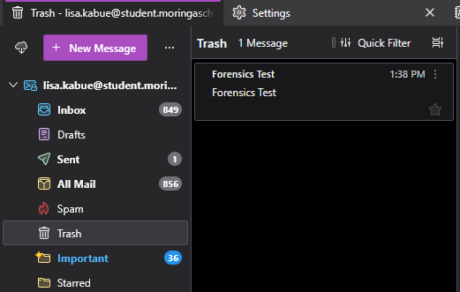
Figure 2 Thunderbird Trash Folder – Deleted 'Forensics Test' Email Recovered at 1:38 PM

9.4 Artifact 4: Archived Messages
Table 4 Email Artifact 4 – Archived Messages
Field | Details
Artifact Name | Archived Messages
Location/Source | Thunderbird 'All Mail' folder / Archive folder; stored in the corresponding mbox file within the Thunderbird profile directory
Metadata Available | Subject, sender, recipient, date, message body, headers, labels/tags
What Was Observed | The 'All Mail' folder contained 856 messages, including the archived test message. Archiving removed the message from the Inbox while preserving it in All Mail. The archived message retained all original metadata.
Forensic Relevance | Archived messages are often overlooked by users attempting to hide evidence, as they are removed from the Inbox but not deleted. They retain full headers and content. An investigator should examine all mailbox folders, including archive and All Mail, to find messages a user may have moved out of immediate view.

9.5 Artifact 5: Reply/Thread Structure
Table 5 Email Artifact 5 – Reply/Thread Structure
Field | Details
Artifact Name | Reply/Thread Structure
Location/Source | Thunderbird 'Evidence Examination' folder; stored in the mbox file with thread references linking messages
Metadata Available | References header, In-Reply-To header, thread index, subject (RE: prefix), timestamps
What Was Observed | The 'Evidence Examination' folder contained 2 messages: (1) Original at 1:40 PM – 'This is another authorized test communication for forensic examination.', and (2) Reply at 1:43 PM – 'This is the reply for the controlled communication test.' The reply is linked to the original via the In-Reply-To and References headers.
Forensic Relevance | Thread structure establishes relationships between messages, proving that a reply was in response to a specific original message. The In-Reply-To and References headers contain Message-IDs of parent messages, creating a verifiable chain. This can demonstrate communication flow, response timing, and which messages were seen or replied to.
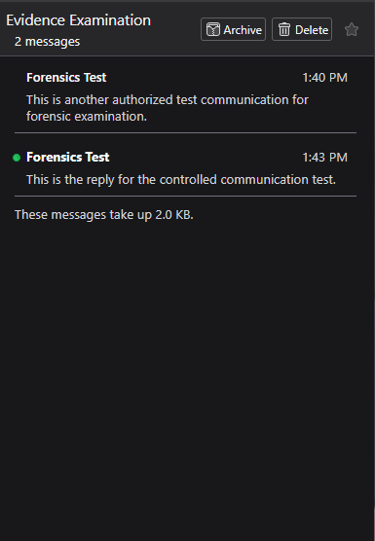
Figure 3 Message Thread in Evidence Examination Folder – Original (1:40 PM) and Reply (1:43 PM)

9.6 Artifact 6: Mailbox Folder Structure
Table 6 Email Artifact 6 – Mailbox Folder Structure
Field | Details
Artifact Name | Mailbox Folder Structure
Location/Source | Thunderbird profile directory; visible in the folder pane sidebar
Metadata Available | Folder names, message counts, unread counts, folder hierarchy
What Was Observed | The mailbox contained the following folders with message counts: Inbox (849), Drafts, Sent (1), All Mail (856), Spam, Trash (1 deleted test message), Important (36), Starred, Local Folders, and a custom folder 'Evidence Examination' (2 messages). The total account unread count was 1,744.
Forensic Relevance | The folder structure reveals how a user organizes their email. Custom folders (e.g., 'Evidence Examination') can indicate specific topics or projects. Message counts in Trash and Spam can reveal cleanup behavior. Folder names and hierarchy may reflect the user's workflow, priorities, or attempts to organize/hide specific communications.
Figure 4 Thunderbird Main Interface – Home Screen with Test Account and Folder Pane

10. Screenshots
The following screenshots document the browser and email activity and artifacts examined during this practical. Each screenshot includes a caption explaining what it demonstrates.

10.1 Browser Setup and Configuration
Figure 1 Chrome Installation Complete – Confirming Successful Browser Installation on Windows 11
Figure 2 Forensics Test Profile – Dedicated Test Profile Created and Selected in Chrome
Figure 3 Chrome Version Information – Version 152.0.7977.83, Windows 11, Profile Path
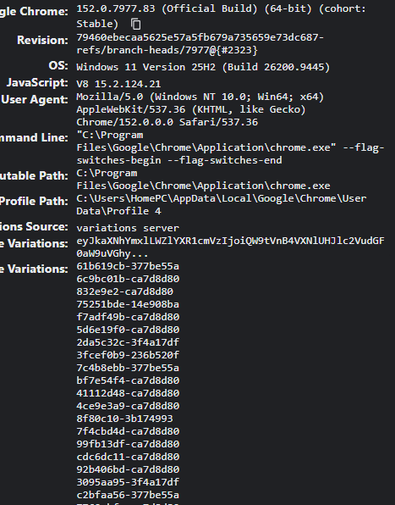
Figure 4 Chrome Technical Details (chrome://version) – OS Build, User-Agent, Executable and Profile Paths

10.2 Browser Activity
Figure 5 Chrome New Tab Page – Browser Interface with Shortcuts to Frequently Visited Sites
Figure 6 Browser Shortcuts – Google, Wikipedia, Mozilla, W3C, GitHub Displayed on New Tab
Figure 7 Search for 'Email Header Analysis' – Google Search Results Demonstrating Search Activity
Figure 8 Chrome Download History – table.pdf and PDF_testfiles_20081027.zip Downloaded from w3.org
Figure 9 Forensics Test Bookmark – Bookmark Edit Dialog Showing Created Bookmark

10.3 Browser Artifacts
Figure 10 Browsing History – Chrome History Page with All Visited URLs and Timestamps
Figure 11 Search History – Recorded Search Queries with Timestamps in Chrome
Figure 12 Site Storage and Cookies – 1,745 KB Total Across 6 Sites with Cookie Counts
Figure 13 Bookmarks Menu - Forensics Test Bookmark Under Other Bookmarks
Figure 14 Bookmarks Bar View – All Bookmarks and Folders Visible in Browser
Figure 15 Thunderbird Download via Chrome – Chrome Downloads Showing Thunderbird Installer
Figure 16 Chrome Privacy and Security Settings – Browser Configuration Options

10.4 Email/Thunderbird Setup and Activity
Figure 17 Thunderbird Version – About Dialog Showing v155.0.1 (64-bit), Codename Meadow
Figure 18 Thunderbird Account Overview – Test Email Account with Full Mailbox Structure
Figure 19 Thunderbird Home Screen – Account Actions and Configuration Options
Figure 20 Email with Attachment – 'Forensics Test - Attachment' with table.pdf (65.3 KB)
Figure 21 Message Thread – Original and Reply in Evidence Examination Folder
Figure 22 Trash Folder – Deleted 'Forensics Test' Email Recoverable at 1:38 PM

11. Timeline
The following chronological timeline reconstructs the browser and email activity observed during this practical. Each entry distinguishes between direct evidence (observed in artifacts) and inference (interpreted from available data).
Table 1 Chronological Timeline of Browser and Email Activity
# | Time | Event | Source | Type
1 | 12:21 PM | Visited google.com, wikipedia.org, mozilla.org, w3.org, github.com | Chrome Browsing History | Direct Observation
2 | 12:24 PM | Visited google.com (second visit) and Google accounts page | Chrome Browsing History | Direct Observation
3 | 12:27 PM | Searched 'digital forensics' and 'browser forensic artifacts' on Google | Chrome Search/History | Direct Observation
4 | 12:29 PM | Searched 'email header analysis' on Google | Chrome Search/History | Direct Observation
5 | 12:31 PM | Searched 'email' on Google | Chrome Search/History | Direct Observation
6 | 12:37 PM | Searched 'W3C PDF test document' on Google | Chrome Search/History | Direct Observation
7 | 12:38 PM | Visited W3C Accessibility Support Documentation for PDF | Chrome Browsing History | Direct Observation
8 | 12:42 PM | Downloaded table.pdf and PDF_testfiles_20081027.zip from w3.org | Chrome Download History | Direct Observation
9 | Post 12:42 PM | Downloaded Thunderbird Setup 155.0.1.exe from thunderbird.net | Chrome Download History | Direct Observation
10 | ~12:42–1:30 PM | Installed and configured Thunderbird with test email account | Inference (Thunderbird installed after download) | Inference
11 | 1:38 PM | Sent test email 'Forensics Test' and subsequently deleted it | Thunderbird Trash Folder | Direct Observation
12 | 1:40 PM | Sent email 'Evidence Examination' to self | Thunderbird Evidence Examination Folder | Direct Observation
13 | 1:41 PM | Sent email 'Forensics Test - Attachment' with table.pdf attached | Thunderbird Inbox | Direct Observation
14 | 1:43 PM | Replied to 'Evidence Examination' email | Thunderbird Evidence Examination Folder | Direct Observation
15 | ~1:45 PM | Archived one test message to All Mail | Thunderbird All Mail Folder | Direct Observation

12. Browser and Email Correlation
The following relationships were identified between browser artifacts and email artifacts. These correlations demonstrate how cross-referencing different artifact types can strengthen forensic reconstructions.

12.1 Correlation 1: Downloaded File Attached to Email
Table 1 Correlation 1 – Downloaded File Attached to Email
Field | Details
Browser Artifact | Chrome download history shows table.pdf was downloaded from w3.org at 12:42 PM
Email Artifact | Thunderbird email 'Forensics Test - Attachment' (1:41 PM) contains an attachment named table.pdf (65.3 KB)
Date/Time | Download: 12:42 PM; Email with attachment: 1:41 PM
Observed Relationship | The file table.pdf appears in both the browser download history and as an email attachment. The email was sent after the file was downloaded from the browser. The filename and size match.
Interpretation | The user downloaded table.pdf from w3.org via Chrome and subsequently attached the same file to a test email in Thunderbird. This is a direct observation of matching filenames; confirming the files are identical would require hash comparison (MD5/SHA-256), which is an inference beyond the currently available data.

12.2 Correlation 2: Browser Download of Thunderbird Preceding Email Activity
Table 2 Correlation 2 – Thunderbird Download Preceding Email Activity
Field | Details
Browser Artifact | Chrome download history shows 'Thunderbird Setup 155.0.1.exe' was downloaded from thunderbird.net after 12:42 PM
Email Artifact | Thunderbird email activity begins at 1:38 PM with the first test message
Date/Time | Thunderbird download: after 12:42 PM; First email: 1:38 PM
Observed Relationship | The Thunderbird installer was downloaded via Chrome before any email activity occurred in Thunderbird. The email activity starts approximately 56 minutes after the browser activity begins, with the Thunderbird download occurring in between.
Interpretation | The user downloaded and installed Thunderbird using Chrome, then configured the email account and began creating test messages. This sequence is directly observed in the download history and confirmed by the email timestamps. The installation and configuration period between download and first email use is inferred.

12.3 Correlation 3: Search for Email Header Analysis Preceding Email Communication
Table 3 Correlation 3 – Search Topic Related to Subsequent Email Activity
Field | Details
Browser Artifact | Chrome search history shows a search for 'email header analysis' at 12:29 PM
Email Artifact | Thunderbird email activity with forensic test messages begins at 1:38 PM; email headers are a key part of the examination
Date/Time | Search: 12:29 PM; Email activity: from 1:38 PM
Observed Relationship | The user searched for 'email header analysis' approximately 1 hour and 9 minutes before creating the first test email. The search topic directly relates to the email forensic examination performed later.
Interpretation | The user researched email header analysis before conducting the email portion of the forensic practical. This suggests the search informed the user's understanding of email forensics. However, it cannot be confirmed as the sole motivation for the search — the user may have had other reasons. This is an inference based on the chronological sequence and topic relevance.

13. Direct Observations vs. Inferences
A critical principle in forensic analysis is distinguishing between what was directly observed in the evidence and what is inferred or interpreted. The following table summarizes the key distinctions made in this report.
Table 1 Direct Observations vs. Inferences
Item | Direct Observation | Inference/Interpretation
Browsing History | URLs, timestamps, and page titles recorded in Chrome History database | The user's intent or motivation for visiting specific sites cannot be confirmed from history alone
Search Queries | Specific search terms and timestamps recorded in Chrome | The purpose or motivation behind each search is inferred from context; the user may have had reasons other than forensic research
Downloaded Files | File names, source URLs, and timestamps in Chrome Downloads | That a user intentionally downloaded a specific file is directly observed; why they downloaded it is inferred
Email Headers | From, To, Subject, Date, Message-ID fields as recorded by the mail system | Header fields record what the mail system logged, which may be spoofed or manipulated; they do not prove the identity of a person
Email Attachment | Attachment filename (table.pdf) and size (65.3 KB) visible in Thunderbird | That the attached file is identical to the downloaded file requires hash comparison to confirm; filename match alone is not proof of identity
Deleted Email | Message found in Trash folder with subject and timestamp | The reason for deletion cannot be determined from the artifact alone; it may be routine cleanup or an attempt to conceal
Archived Email | Message found in All Mail / Archive folder | Archiving may indicate the user wanted to preserve but organize, or it may be routine; intent is inferred
Reply Thread | In-Reply-To and References headers link the reply to the original message | That the user read the original before replying is likely but not directly proven by the headers alone
Thunderbird Installation | Thunderbird Setup 155.0.1.exe downloaded via Chrome | Installation and configuration between download and first email is inferred from the time gap
Correlation of table.pdf | table.pdf appears in both Chrome downloads and Thunderbird attachment | Files are likely identical, but hash comparison is needed for confirmation

14. Conclusion
This practical demonstrated that browser and email applications create a wide range of forensic artifacts that can be examined to reconstruct user activity. Through controlled browsing and email communication, the following key findings were established:
- Browser artifacts are rich and persistent. Chrome's History SQLite database records browsing history, search queries, download records, and visit counts with timestamps. Cookies and site storage confirm interaction with specific websites. Bookmarks represent deliberate user actions. Even after a browser is closed and reopened, session data and recently closed tabs persist.
- Email artifacts provide verifiable communication records. Thunderbird stores messages in structured mailbox folders (Inbox, Sent, Trash, Archive, custom folders). Each email contains headers with routing information, timestamps, and unique identifiers. Attachments link to file-system and browser artifacts. Deleted messages remain recoverable in the Trash folder until compacted.
- Cross-artifact correlation strengthens forensic reconstructions. Three correlations were identified: (1) table.pdf was downloaded via Chrome and subsequently attached to an email in Thunderbird; (2) the Thunderbird installer was downloaded through Chrome before email activity began; (3) a browser search for 'email header analysis' preceded the email forensic examination by approximately one hour. These correlations provide a more complete picture than any single artifact type alone.
- Distinguishing observation from inference is essential. Throughout this report, care was taken to label direct observations (e.g., URL in history, filename in downloads) separately from inferences (e.g., user intent, file identity based on filename alone). A forensic conclusion must be based on available evidence and not overstate what the data proves. For example, matching filenames between a download and an attachment suggest the same file, but only hash comparison can confirm this.
- Deleted does not mean destroyed. The deleted 'Forensics Test' email was fully recoverable from the Trash folder, with subject, sender, timestamp, and body content intact. In a real investigation, examining all mailbox folders — including Trash, Spam, Archive, and custom folders — is critical to avoid missing evidence a user may have attempted to hide.
In conclusion, browser and email forensic artifacts together provide a powerful basis for reconstructing user activity, establishing timelines, and identifying relationships between different types of digital evidence. Forensic analysts must examine all available artifact types, correlate findings across applications, and clearly distinguish between what is directly observed and what is inferred to present defensible conclusions.

