DIGITAL FORENSICS
PRACTICAL ASSIGNMENT REPORT
File Signatures, Deleted Files & Data Carving

Student Name | Lisa Wanja Kabue
Course / Subject | Digital Forensics
Evidence Examined | USB_Forensic_Image.E01
Primary Tools | Exterro FTK Imager 8.3.0.27; PhotoRec 7.3-WIP
Date | 9 September 2026

1. Objective
The objective of this practical was to examine file signatures and headers, assess the presence of deleted or residual data, perform a basic data-carving exercise, and explain the forensic significance of unallocated space. The examination was performed on the forensic disk image USB_Forensic_Image.E01 without intentionally modifying the evidence.

2. Tools and Evidence
Item | Details
Forensic image | USB_Forensic_Image.E01
File-system observed | FAT32
FTK Imager | Exterro FTK Imager 8.3.0.27
Carving tool | PhotoRec 7.3-WIP
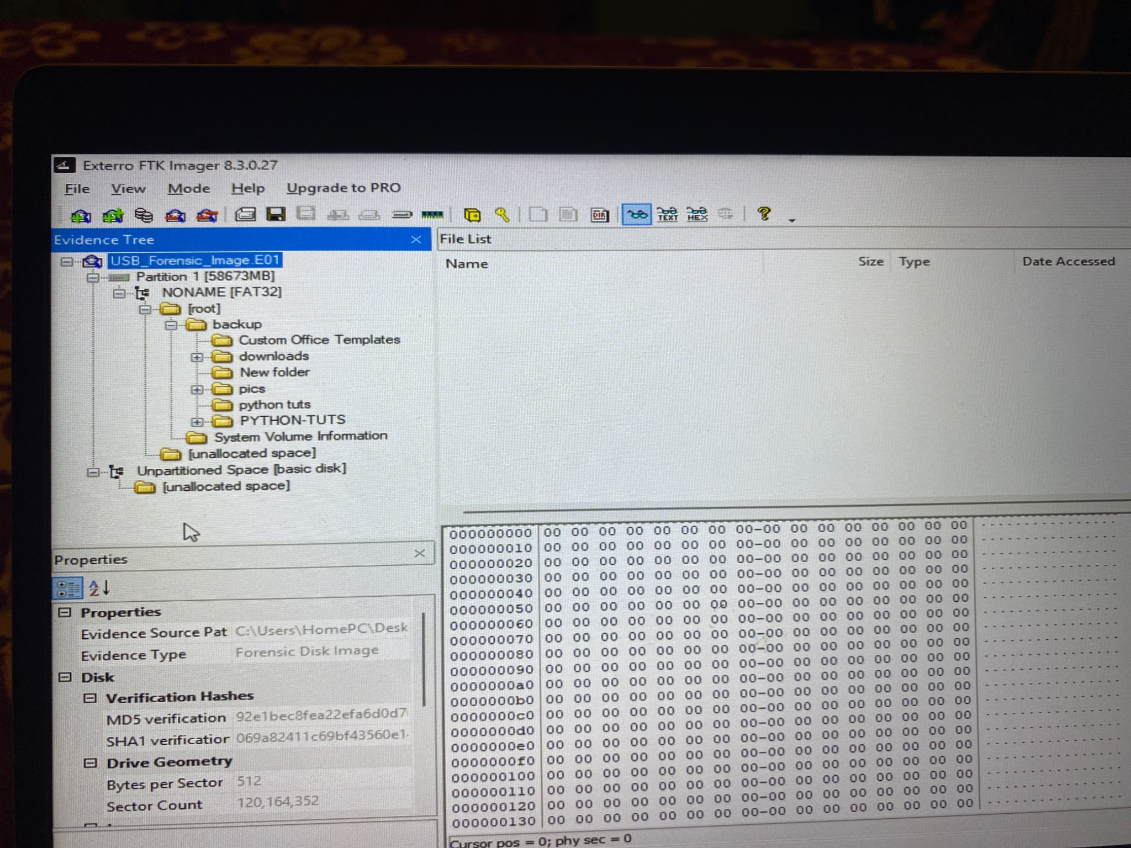
Figure 1. FTK Imager evidence tree showing USB_Forensic_Image.E01 and the FAT32 partition.

3. Part 1 – File Signatures
Five files from the forensic image were selected for examination. The apparent file extensions were compared with the identified file types. Hexadecimal header examination was performed directly for the PNG and JPEG files.
File | Extension | Identified type | Known/expected signature | Header directly observed? | Observation
2024-09-13_NetworkDiagram4Lab.png | .png | PNG image | 89 50 4E 47 0D 0A 1A 0A | Yes | Extension matches identified type; PNG header observed.
6d07ce0a92e860cef5dc8a6a4fc40194.jpg | .jpg | JPEG image | FF D8 FF E0 | Yes | Extension matches identified type; JPEG/JFIF header observed.
2025-06-13-traffic-analysis-exercise-forensic-analysis.zip | .zip | ZIP archive | 50 4B 03 04 | No | Extension is consistent with the identified ZIP archive; signature not directly examined in hex.
2025-06-13-traffic-analysis-exercise.pcap | .pcap | PCAP network capture | PCAP signature varies by capture format | No | Extension is consistent with the identified PCAP file; header not directly examined in hex.
about-the-practice-exam (1).htm | .htm | HTML document | No single universal magic number | No | Extension is consistent with an HTML document.
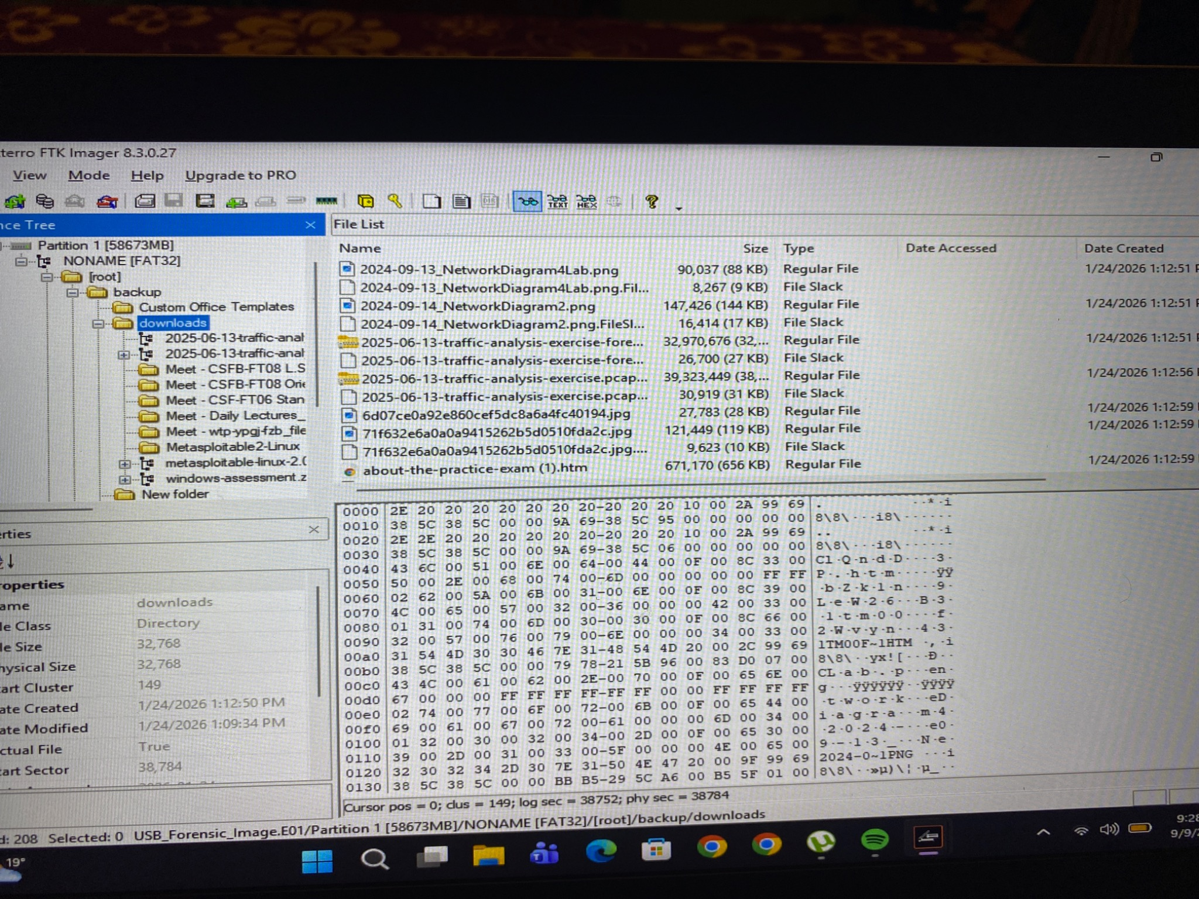
Figure 2. FTK Imager file list showing the selected files in the downloads directory.
Observation: The examination showed that the apparent extensions of the five selected files were consistent with their identified types. The PNG and JPEG files were additionally examined at the hexadecimal level and recognizable file signatures were observed. A file extension alone should not be treated as definitive proof of a file's actual type because extensions can be changed without changing the underlying data. File signatures provide a stronger indication of file format because they are contained within the file data, although forensic interpretation should still consider the full file structure and context.

4. Part 2 – Examination of File Headers
Two file types were examined at the hexadecimal level using FTK Imager's hex view. The purpose was to compare the observed header bytes with the known signatures for the file formats.
File type | Extension | Magic number / signature | Observed header
PNG image | .png | 89 50 4E 47 0D 0A 1A 0A | 89 50 4E 47 0D 0A 1A 0A; ASCII includes PNG and IHDR
JPEG image | .jpg | FF D8 FF | FF D8 FF E0; ASCII includes JFIF
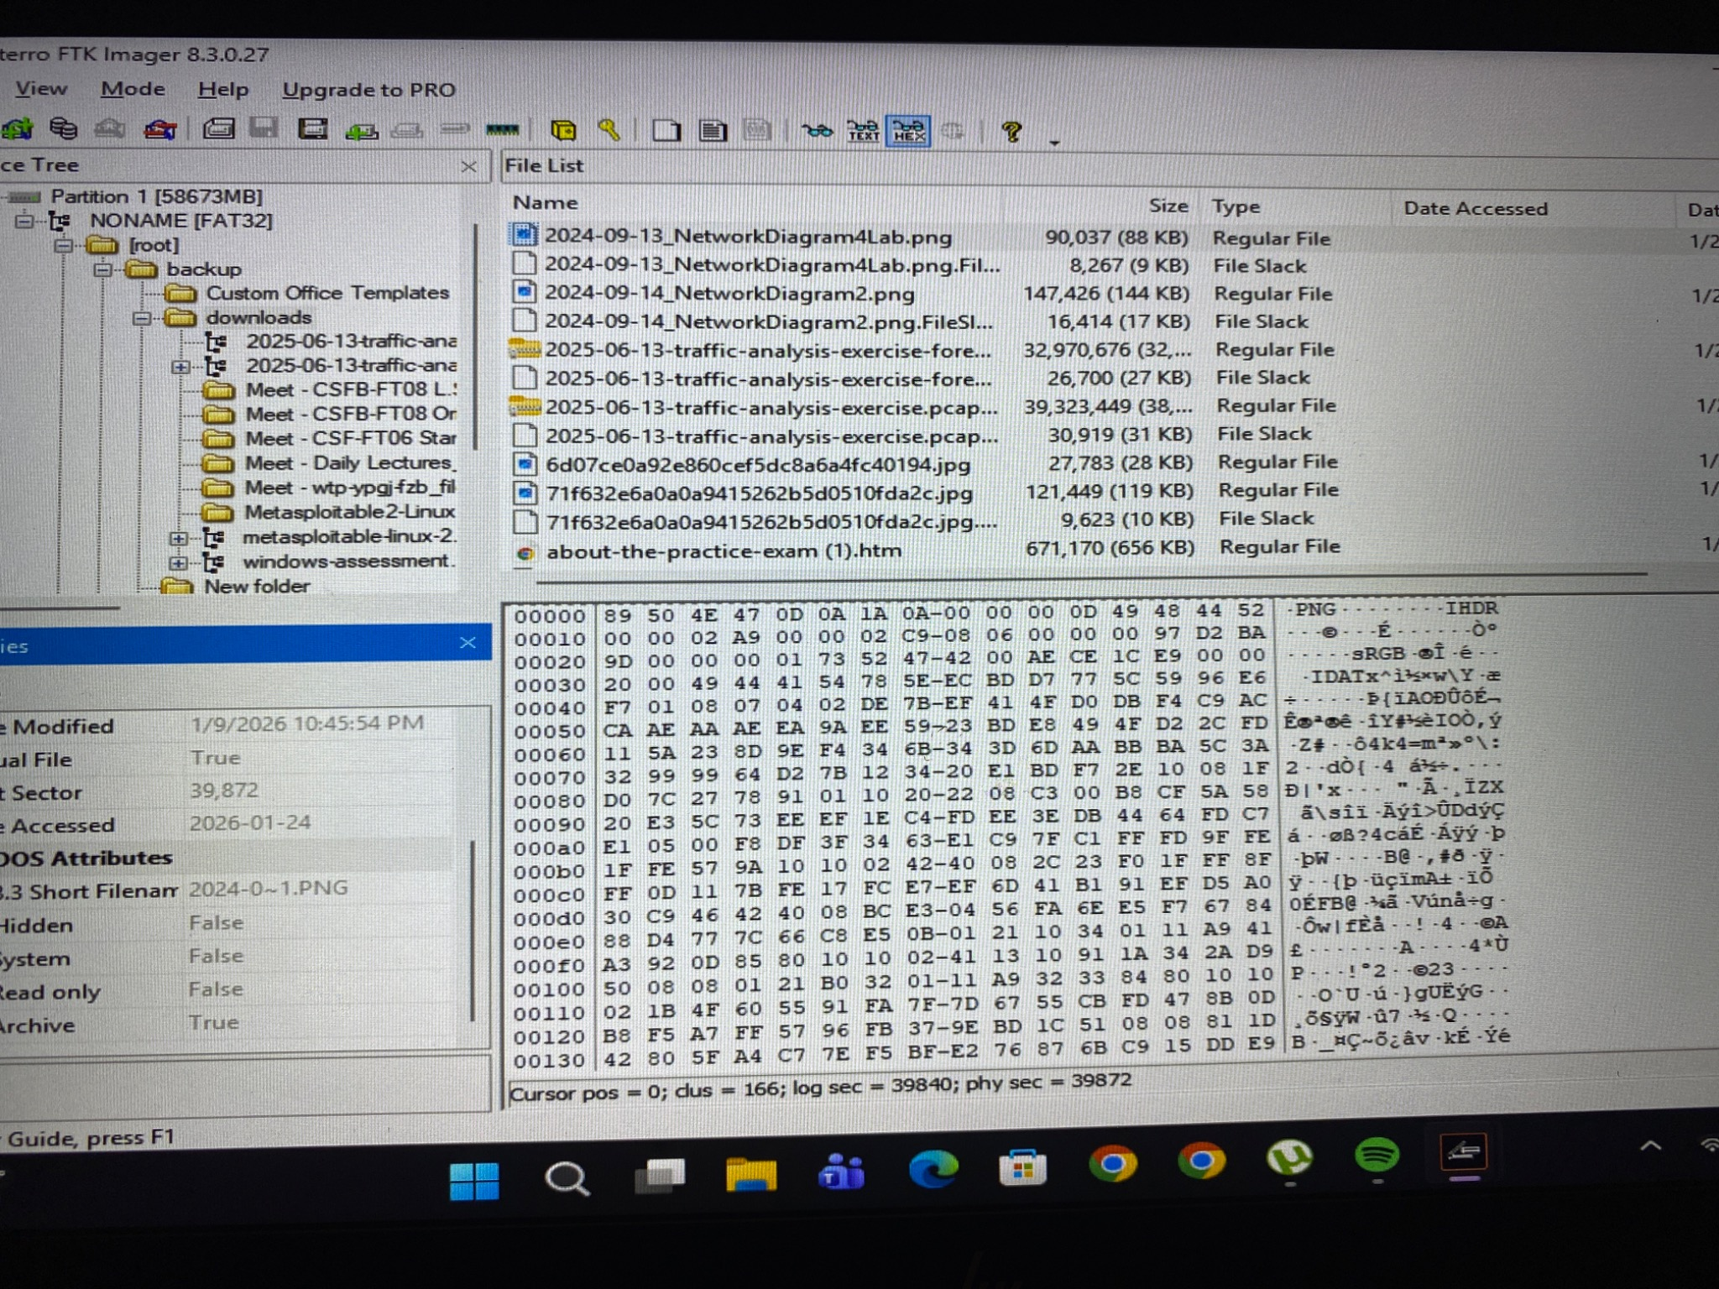
Figure 3. Hexadecimal header of the PNG file showing 89 50 4E 47 0D 0A 1A 0A and PNG/IHDR text.
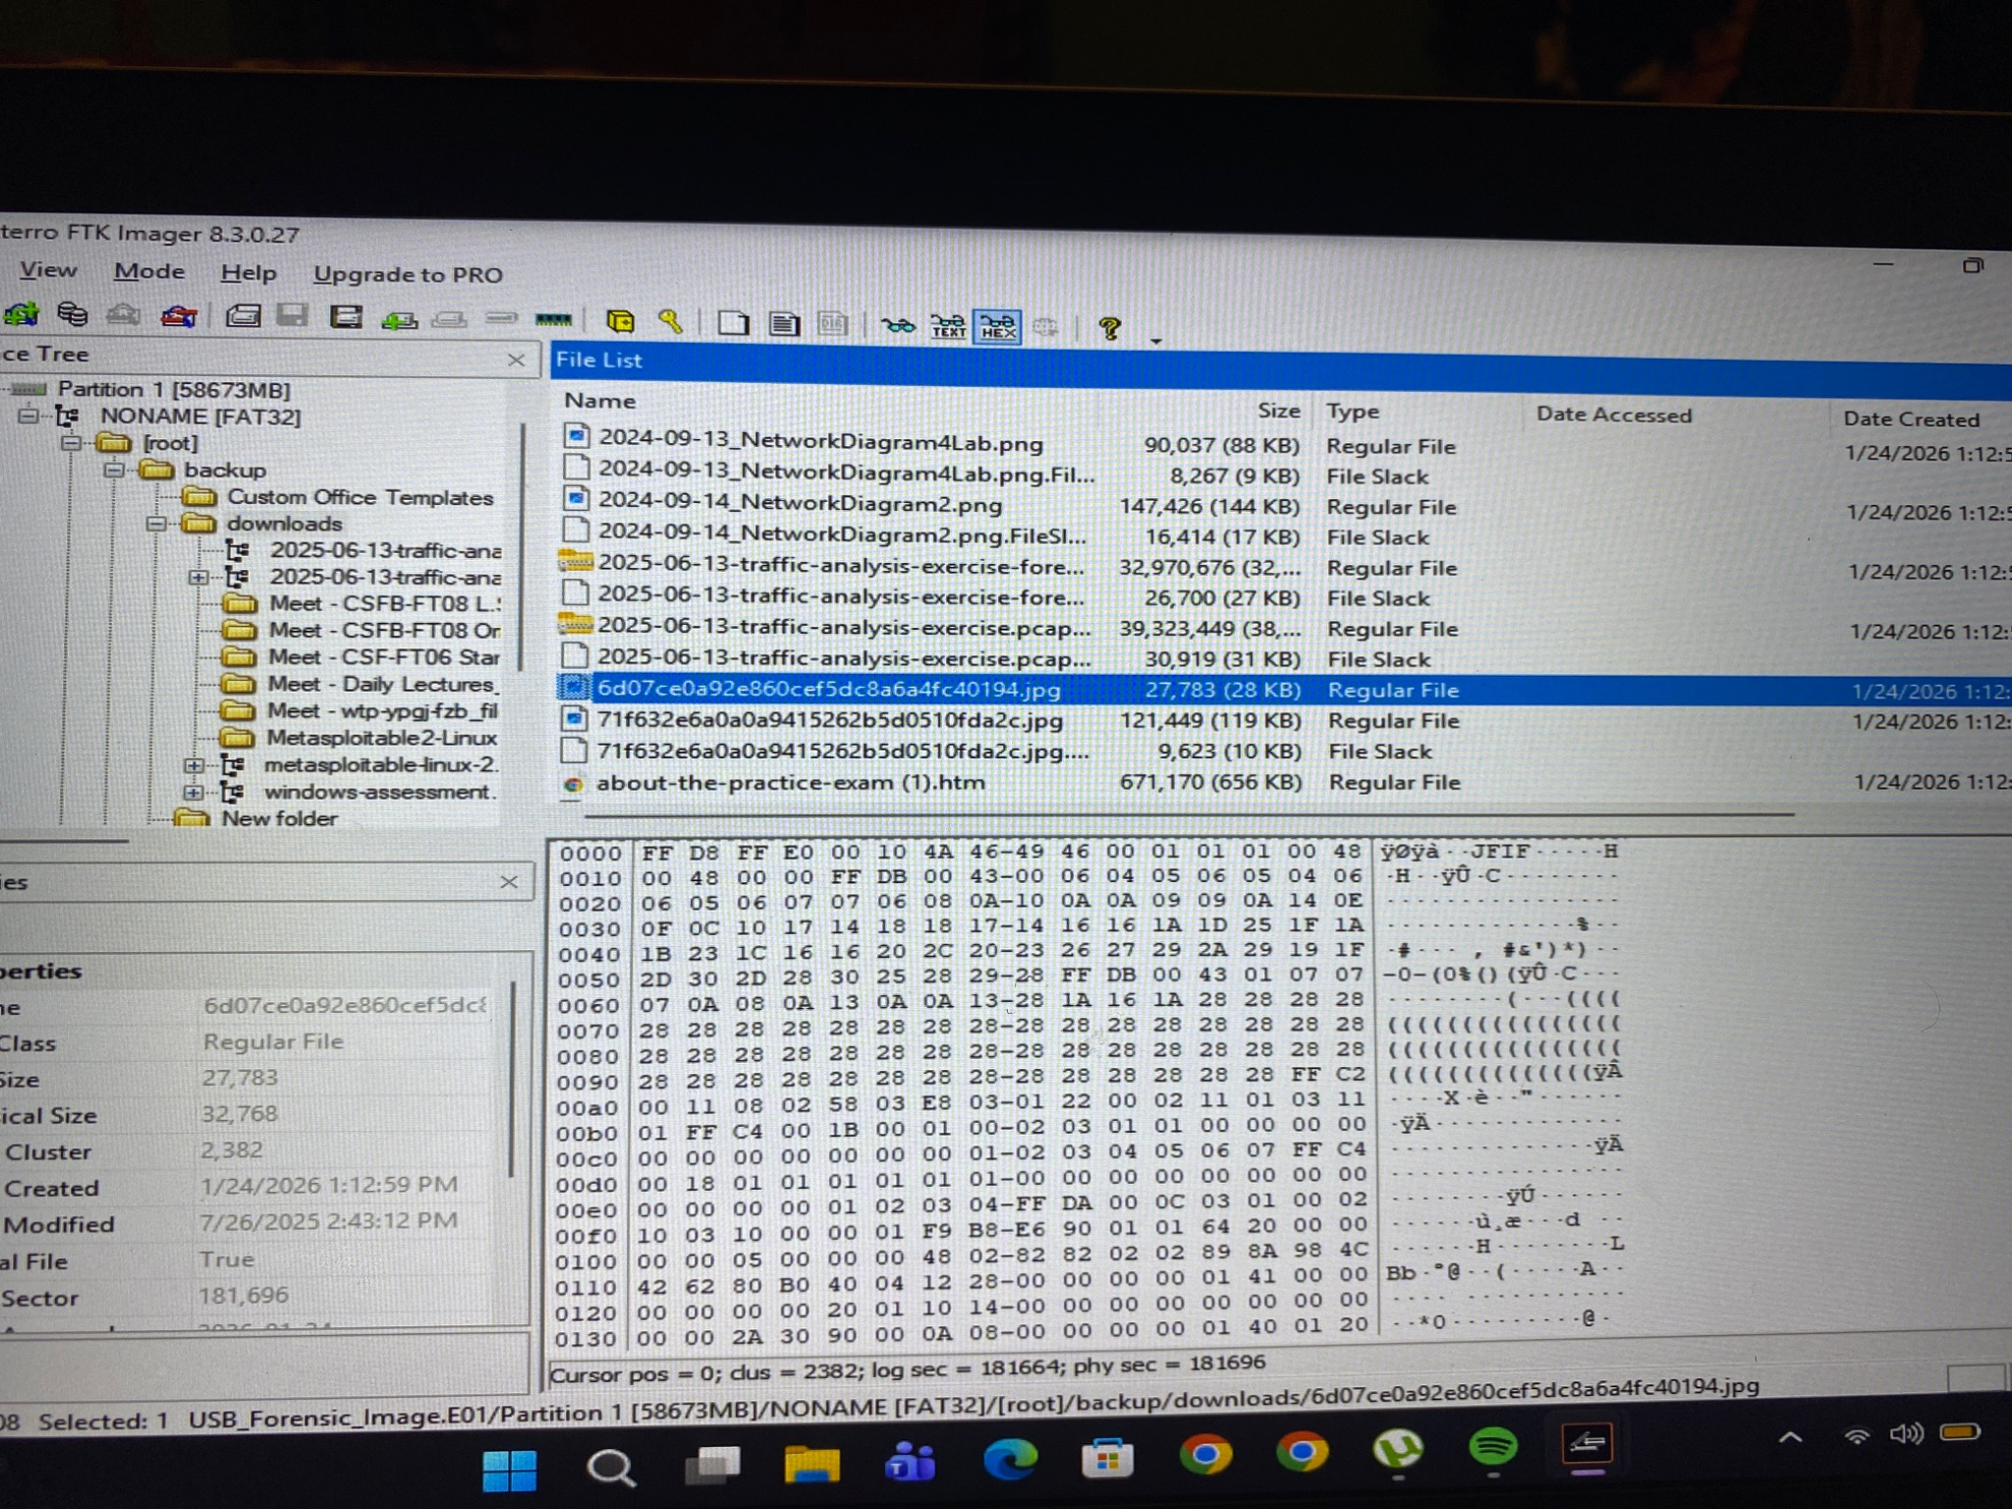
Figure 4. Hexadecimal header of the JPEG file showing FF D8 FF E0 and JFIF text.
The observed headers were consistent with the identified PNG and JPEG formats. These observations demonstrate why examining file headers can provide stronger evidence of file type than relying only on the filename extension.

5. Part 3 – Deleted File Examination
No file entries explicitly marked as deleted were visibly identified in the examined directory structure. The FAT32 partition did, however, contain unallocated space, which was examined as part of the investigation. The unallocated-space entries observed in FTK Imager were storage areas not currently assigned to active files and were not individually treated as confirmed deleted files.
Figure 5. FTK Imager view of unallocated space within the FAT32 partition.
Finding: No specific deleted file was directly observed or recovered during this examination. The presence of unallocated space indicates that storage areas were available for reuse and that residual data could potentially exist there.

6. Part 4 – Data Carving
Requirement | Result
Source image | USB_Forensic_Image.E01
File system | FAT32
Area examined | Free space / unallocated space
Tool | PhotoRec 7.3-WIP
File type focus | JPEG/JPG was the intended target for the basic carving exercise
Carving process | The E01 image was opened in PhotoRec, the FAT32 partition was selected, 'Other' was chosen for the filesystem family, and 'Free' was selected to examine free/unallocated space.
Recovery location | C:\Users\HomePC\Desktop\recup_dir
Recovered files | 0 files
Result | Recovery completed successfully, but no files were saved/recovered.
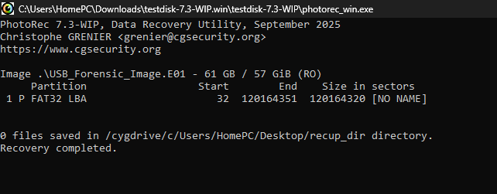
Figure 6. PhotoRec completed the carving process and reported 0 files saved to the recovery directory.
Limitation: A zero-result carving exercise does not prove that the unallocated space contains no residual information. Data may be fragmented, overwritten, damaged, or may not match the file signatures recognized by the selected carving process.

7. Part 5 – Unallocated & Residual Data

7.1 What is unallocated space?
Unallocated space refers to areas of a storage device that are not currently assigned to active files by the file system. Although the space is marked as available for new data, it may still contain remnants of previously stored files.

7.2 Why can deleted information remain?
When a file is deleted, the file system generally removes or changes the reference that identifies the file as active and marks the space as available for reuse. The actual data may remain until it is overwritten by new information. Deleted information can therefore remain as residual data in unallocated space.

7.3 How does data carving work without directory structures?
Data carving is a forensic technique that searches raw storage data for recognizable file signatures and structural patterns. It can recover files even when normal directory or file-system information is unavailable or damaged. For example, a JPEG file can be identified using its characteristic header signature.

7.4 Why does recovered data require careful examination?
Recovered or carved data must be examined carefully because it may be incomplete, fragmented, corrupted, or partially overwritten. A successful recovery does not automatically mean that the entire original file has been recovered. Investigators should verify the recovered data and consider its context before drawing conclusions.

8. Overall Observations
- The forensic image was examined as a read-only source during the PhotoRec carving exercise.
- The examined partition was identified as FAT32.
- Five selected files had extensions consistent with their identified file types.
- PNG and JPEG headers were directly observed in hexadecimal view.
- No specific deleted-file entry was visibly identified in the directory structure.
- Unallocated space was present in the FAT32 partition.
- PhotoRec completed the free-space carving process but recovered 0 files.
- Observed findings and general forensic interpretations have been distinguished in the report.

9. Conclusion
This practical demonstrated key techniques used in digital forensic examination of file types, file headers, deleted or residual data, and unallocated space. FTK Imager was used to inspect the forensic image and verify file-system and file-level information, while PhotoRec was used to perform a basic free-space data-carving exercise. The PNG and JPEG headers provided direct hexadecimal evidence of their respective formats, demonstrating the forensic value of file signatures over filename extensions alone. Although unallocated space was present, no specific deleted file was directly identified and the PhotoRec carving process recovered no files. The results therefore support careful interpretation of both positive and negative forensic findings.

10. Evidence Handling Note
The original forensic image was not intentionally modified during the examination. Recovered-file output was directed to a separate Desktop recovery directory rather than the evidence-image folder. The report distinguishes directly observed results from general forensic explanations and inferences.

