Mobile Device Forensics Report

Logical Acquisition and Artifact Examination of an Authorized Android Virtual Device using Android Studio, ADB and ALEAPP

[Student Name]
18 September 2026
Practical Assignment — Mobile Device Forensics
Toolchain: Android Studio · AVD · ADB · Python 3 · ALEAPP

Table of Contents
Table of Contents 2
1. Student Information 3
2. Objective 3
3. Android Studio and AVD Information 3
4. ADB Information 6
5. Device State and Preservation 7
5.1 Principles of mobile evidence preservation 8
6. Controlled Test Activity 11
6.1 Contacts and browser search terms 12
7. Evidence Acquisition 13
7.1 Files collected 13
8. Evidence Hash 14
9. Messages, Calls and Contacts 15
10. Browser Artifacts 16
11. Application Artifacts and ALEAPP Examination 17
11.1 Protected application data (access test) 17
11.2 ALEAPP setup 17
12. Photos/Videos and Metadata 19
13. Location / GPS Artifacts 21
14. Backup / Recovered Data 21
15. Acquisition Method and Limitations 21
15.1 Acquisition method 21
15.2 Limitations 22
16. Screenshots (Figure Index) 22
17. Timeline 23
18. Cross-Source Correlation 24
19. Direct Observations vs. Inferences 25
20. Conclusion 25

1. Student Information
The details below identify the examiner and the assignment. Replace the bracketed placeholders before submission.
Table 1 Student and submission details
Field | Value
Student name | Lisa kabue
Student ID | [Student ID]
Course / Module | Digital forensics
Instructor | [Instructor]
Submission date | 18 September 2026
Examination workstation OS | Windows 10 (build 10.0.26200)

2. Objective
The objective of this practical is to examine mobile-device evidence produced on an authorized Android Virtual Device (AVD) and to demonstrate the full logical-forensics workflow: identifying mobile evidence sources, preserving and documenting device state, performing a logical acquisition of accessible data with the Android Debug Bridge (ADB), verifying integrity with cryptographic hashing, parsing supported artifacts with ALEAPP, and interpreting the findings into a defensible reconstruction.
All data used in this exercise is fictional test data created solely for this practical on an examiner-owned emulator. No real person's device or personal data was examined, and no security controls were bypassed. Where an artifact could not be obtained, it is explicitly marked “Not Available” together with the reason.
Throughout the report, statements are separated into direct observations (what the evidence literally shows) and inferences (interpretations drawn from one or more artifacts). Metadata and network state are treated as indicative, not as proof of a person's physical presence or intent.

3. Android Studio and AVD Information
An Android Virtual Device was created in Android Studio Device Manager using a standard Google device profile and an x86_64 system image. The environment is summarised below and evidenced in Figures 1–4.
Table 1 Android Studio and AVD environment
Item | Recorded value
Android Studio | Android Studio (current release, 2026 channel)
Device / emulator model | Pixel 6 (AVD); reported model sdk_gphone16k_x86_64
Manufacturer | Google
Android version (release) | Android 17.0 (“CinnamonBun”)
API level | 37 (image label API 37.2 / 37.0 installed)
ABI | x86_64 (translated ABI arm64-v8a)
System image | Google APIs Intel x86_64 Atom System Image
AVD name | Pixel 6
Resolution / density | 1080 x 2400, 420 dpi, 6.4″
SDK location | C:\Users\HomePC\AppData\Local\Android\Sdk
Date / time | 18 September 2026
Workstation OS | Windows 10 (build 10.0.26200)
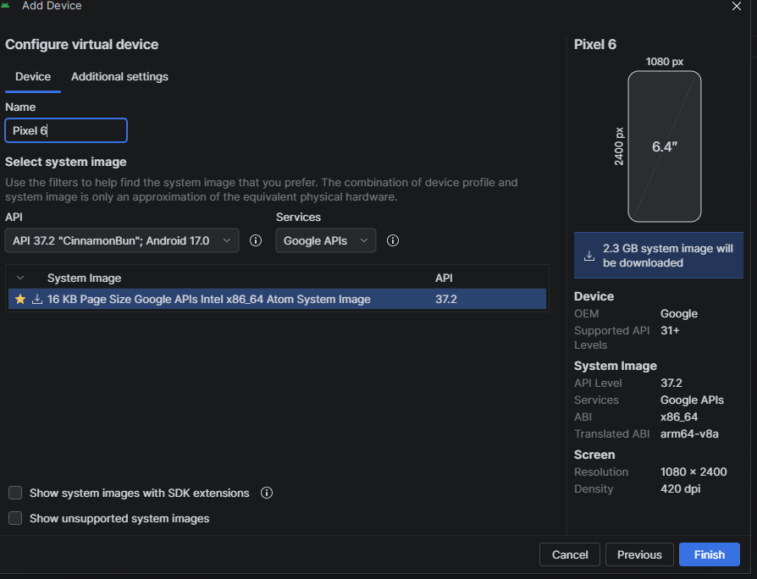
Figure 1 AVD configuration in Android Studio Device Manager — Pixel 6, Android 17.0, API 37.2, Google APIs, x86_64 system image.
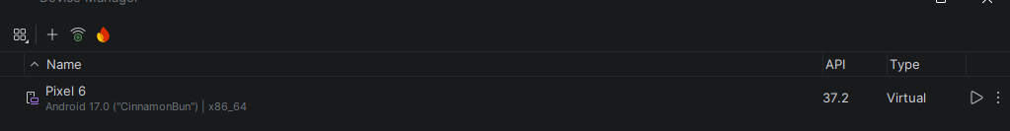
Figure 2 Device Manager listing the created virtual device: Pixel 6, Android 17.0 (“CinnamonBun”), x86_64, API 37.2, type Virtual.
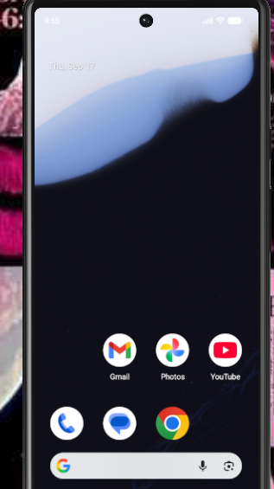
Figure 3 Running emulator home screen showing the Android version environment (status bar clock 9:55, date Thu 17 Sep).
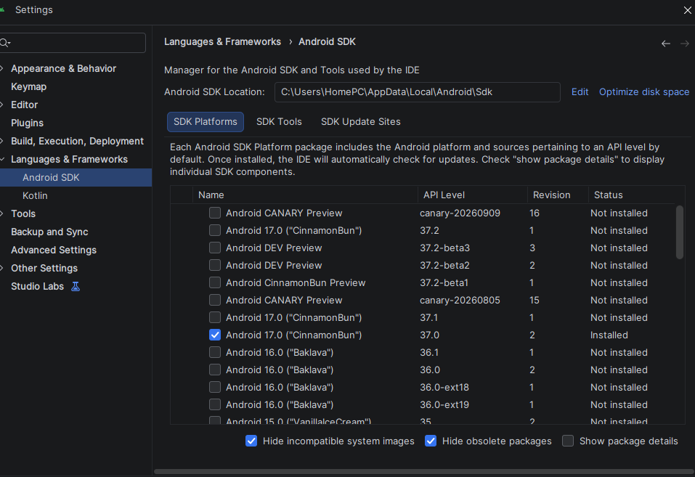
Figure 4 Android SDK Platforms pane confirming Android 17.0 (API 37.0) installed at the recorded SDK location.

4. ADB Information
ADB (Android Debug Bridge) was used to communicate with the running emulator and to collect accessible evidence. The ADB binary shipped with the platform-tools package was verified with adb version and the connection confirmed with adb devices (Figure 5).
Table 1 ADB environment and connection status
Item | Recorded value
ADB version | Android Debug Bridge 1.0.41
Platform-tools version | 37.0.1-15733141
ADB path | C:\Users\HomePC\AppData\Local\Android\Sdk\platform-tools\adb.exe
Running on | Windows 10.0.26200
Emulator / device ID | emulator-5554
Connection status | device (connected / authorised)
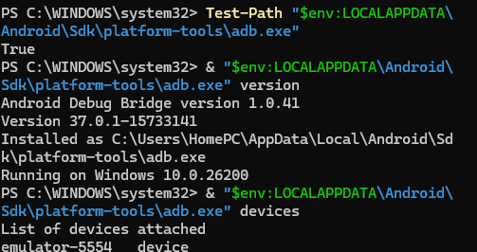
Figure 1 adb version and adb devices output confirming ADB 1.0.41 and the connected emulator-5554.

5. Device State and Preservation
Before any test activity was interpreted, the device state was documented using ADB getprop, dumpsys and shell utilities so that the acquisition context is fixed and reproducible (Figures 6–8).
Table 1 Documented device state prior to interpretation
State item | Observed value
Power / charging state | AC/USB/Wireless powered: false; battery level 100%; not charging
Battery health | health 2 (good), present true, technology Li-ion, temperature 25.0°C
Lock / unlock state | mDreamingLockscreen=false (lock screen not being shown)
Network connectivity | Connected and validated; Mobile LTE and Wi-Fi networks present
Wi-Fi | Connected / validated (SSID AndroidWifi, interface wlan0)
Link address (validated net) | 10.0.2.15/24, DNS 10.0.2.3, gateway 10.0.2.2
Device date / time | Fri Sep 18 12:52:49 +03 2026
Model | sdk_gphone16k_x86_64
Android release / SDK | 17 / 37
Manufacturer | Google
Storage (/data) | ~10 GB total, ~1.2 GB used, ~8.3 GB available
Storage (df -h, system) | / 1.3G (97% used); /vendor 114M; /product 2.5G; tmpfs 1.9G

5.1 Principles of mobile evidence preservation
- Isolate and stabilise the state. The examination was performed on an authorised emulator whose power, network and lock state were recorded first, so that later changes can be distinguished from the baseline.
- Acquire in order of volatility. Volatile context (battery, network, running state) was captured with dumpsys before pulling comparatively stable files from storage.
- Do not alter the original. Evidence was copied out with adb pull (read/copy only). No files were deleted, edited or re-saved on the device, and analysis was performed on the pulled copies.
- Verify integrity. A cryptographic hash (SHA-256) was computed on a collected file so any later change can be detected (Section 8).
- Document everything. Commands, outputs, paths, timestamps and limitations were recorded contemporaneously with screenshots to support reproducibility and chain of custody.
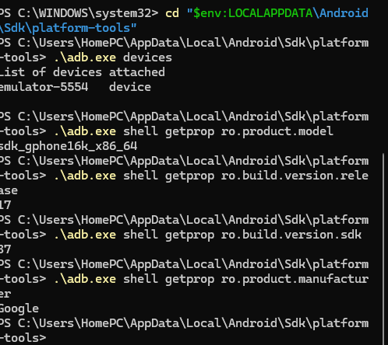
Figure 1 Device properties (model, release 17, SDK 37, manufacturer Google), date, and df -h storage output.
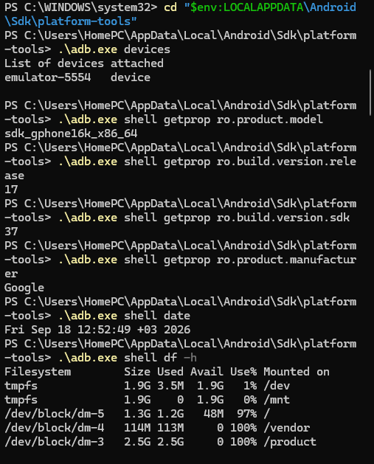
Figure 2 dumpsys battery (level 100, not powered) and dumpsys window showing mDreamingLockscreen=false.
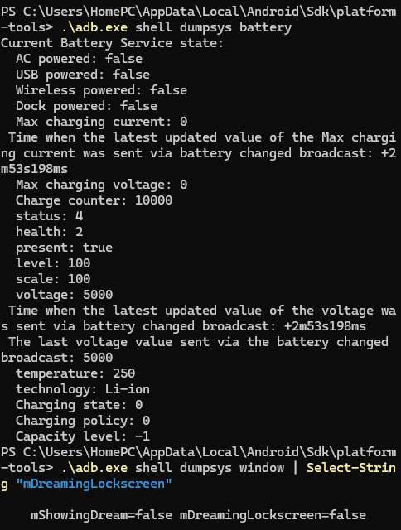
Figure 3 dumpsys connectivity showing validated Mobile LTE and Wi-Fi networks with link address 10.0.2.15/24.

6. Controlled Test Activity
Fictional test activity was created on the authorised emulator to generate examinable artifacts. Only invented names, numbers and content were used. Activities not supported or not produced on this emulator are recorded as “Not Available.”
Table 1 Controlled test activity performed (fictional data only)
Activity | Application | Detail | Date/time | Expected evidence
3 test contacts | Contacts | Amina Test / Brian Demo / Carol Sample | 18 Sep 2026 | Contacts database entries
5 test messages | Messages | Fictional SMS exchange | 18 Sep 2026 | SMS/MMS store records
3 test calls | Phone | Calls to the 3 test contacts | 18 Sep 2026 | Call-log entries
3 browser searches | Chrome | see 6.1 | 18 Sep 2026 | Browser history / search terms
3 browser visits | Chrome | Pages opened from searches | 18 Sep 2026 | Browser history URLs
2 downloads | Chrome | see Section 7 | 18 Sep 2026 ~13:44 | Files in /sdcard/Download
5 photographs | Camera | IMG_20260918_*.jpg | 18 Sep 2026 13:33–13:36 | JPEGs in /sdcard/Pictures
1 test video | Camera | Not Available | — | Not Available
Application activity | — | Not Available | — | Not Available
Location activity | — | Not Available | — | Not Available

6.1 Contacts and browser search terms
Table 2 Fictional test contacts
Test contact | Fictional number
Amina Test | 0711000001
Brian Demo | 0711000002
Carol Sample | 0711000003
- Search: “Android digital forensics”
- Search: “mobile evidence preservation”
- Search: “Android ADB documentation”
Note: contacts, messages, calls and browser history were created live on the device. As explained in Sections 8 and 15, these stores live in protected application databases under /data/data, which were not accessible over ADB without root; they are therefore documented as created activity and, where the parsed store was not obtained, marked “Not Available” at the artifact level.

7. Evidence Acquisition
A working directory C:\Mobile_Forensics was created on the workstation. Accessible shared-storage paths were listed with adb shell ls -la and relevant test files were copied out with adb pull (a read/copy operation that does not modify the source). The acquisition log is summarised below and evidenced in Figure 9.
Table 1 ADB logical acquisition log (18 Sep 2026)
Source path | Destination | Result | ADB command
/sdcard/DCIM | C:\Mobile_Forensics\DCIM | 0 files pulled, 0 skipped | adb pull /sdcard/DCIM ...
/sdcard/Download | C:\Mobile_Forensics\Download | 2 files (2,968,206 bytes) | adb pull /sdcard/Download ...
/sdcard/Pictures | C:\Mobile_Forensics\Pictures | 7 files (566,845 bytes) | adb pull /sdcard/Pictures ...

7.1 Files collected
Table 2 Test files collected via adb pull
Category | File
Download | datasets_sample.txt at master · selva86_datasets · GitHub.mht
Download | sample-local-pdf.pdf
Pictures | IMG_20260918_133323.jpg
Pictures | IMG_20260918_133535.jpg
Pictures | IMG_20260918_133536.jpg
Pictures | IMG_20260918_133537.jpg
Pictures | IMG_20260918_133537_1.jpg
Pictures (other) | .thumbnails/.database_uuid, .thumbnails/.nomedia
Limitations. /sdcard/DCIM was empty (0 files); camera images were stored under /sdcard/Pictures. Only user-accessible shared storage was reachable via ADB — protected app data under /data/data was not (Section 11).
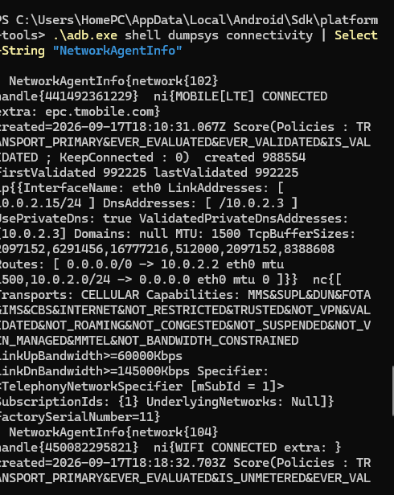
Figure 1 ls -la /sdcard/Pictures/ listing and adb pull of DCIM (0), Download (2) and Pictures (7) into C:\Mobile_Forensics.

8. Evidence Hash
To support integrity verification, SHA-256 was computed on a collected file in the Ubuntu WSL environment. The hash allows any later modification of the file to be detected (Figure 10).
Table 1 SHA-256 integrity record
Field | Value
File name | sample-local-pdf.pdf
Path | /mnt/c/Mobile_Forensics/Download/sample-local-pdf.pdf
Hash algorithm | SHA-256
Hash value | 40c5b733d0e21c53a9e40fa6eb9df01bb6898b842f5f13bd42db5524c2a97dd0
Command | sha256sum /mnt/c/Mobile_Forensics/Download/sample-local-pdf.pdf
Date / time | 18 Sep 2026 (~13:44, host file time)
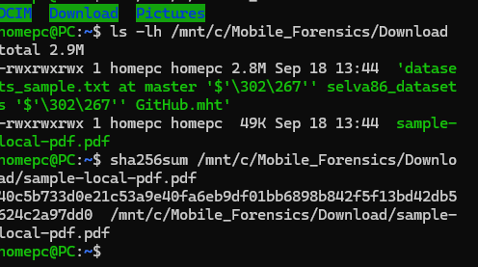
Figure 1 sha256sum output for sample-local-pdf.pdf and the directory listing of the two collected downloads.

9. Messages, Calls and Contacts
The three artifact classes were created as live test activity (Section 6). On this emulator their backing stores reside in protected application databases under /data/data, which were not accessible over ADB without root (Figure of the permission-denied result is described in Section 11). No parsed message/call/contact records were extracted, so at the artifact level these are recorded as follows.
Table 1 Messages, calls and contacts — created activity vs. extracted artifacts
Artifact | Source / application | Path | Result | Tool
Contacts | Contacts provider | /data/data/...contacts (protected) | Created (3); store Not Available over ADB | ADB / ALEAPP
Messages | SMS/MMS provider | /data/data/...telephony (protected) | Created (5); store Not Available over ADB | ADB / ALEAPP
Calls | Call-log provider | /data/data/...contacts calllog (protected) | Created (3); store Not Available over ADB | ADB / ALEAPP
Direct observation: three contacts, five messages and three calls were created on the device. Not Available: the underlying provider databases could not be pulled over ADB on a non-rooted emulator, so their parsed records are not presented. This is a genuine logical-acquisition limitation, not an absence of activity.

10. Browser Artifacts
Three search terms were entered in Chrome and three pages visited, producing two downloaded files that were recovered from shared storage. Chrome's history database resides under /data/data and was not accessible over ADB; the browser history itself is therefore “Not Available” at the database level, but the download products are direct evidence of browser activity.
Table 1 Browser activity and recovered download products
Artifact | Detail | Source | Result
Search terms | Android digital forensics; mobile evidence preservation; Android ADB documentation | Chrome | Created; history DB Not Available over ADB
Page visits | Pages opened from the three searches | Chrome | Created; history DB Not Available over ADB
Download 1 | datasets_sample.txt ... selva86_datasets ... GitHub.mht | /sdcard/Download | Collected (part of 2.83 MB)
Download 2 | sample-local-pdf.pdf (49 KB) | /sdcard/Download | Collected; SHA-256 verified (Section 8)
Direct observation: two files consistent with web downloads were present in /sdcard/Download — a saved GitHub page (.mht) and a sample PDF. Inference: the .mht filename referencing a datasets repository and the recorded search terms about digital forensics are consistent with the described forensic-research browsing session; this is an interpretation, not proof of specific URLs, because the history database was not extracted.

11. Application Artifacts and ALEAPP Examination

11.1 Protected application data (access test)
An explicit attempt was made to reach protected application storage:
.\adb.exe shell ls -la /data/data/
ls: /data/data/: Permission denied
Direct observation: ADB returned “Permission denied” for /data/data. This confirms that application databases (contacts, SMS, call log, Chrome history) are sandboxed and inaccessible on a non-rooted emulator via logical ADB acquisition. Those artifacts are therefore “Not Available” in this examination — a documented limitation supported by direct evidence, not a fabricated finding.

11.2 ALEAPP setup
Table 1 ALEAPP installation and launch
Item | Value
Environment | Ubuntu WSL on Windows 10
Python | Python 3 (virtual environment aleapp_env)
Install method | git clone + pip install requirements in a venv
Dependency note | lz4 build issue resolved before dependencies installed successfully
Install path | ~/mobile_forensics/ALEAPP
Launch verified | python aleapp.py --help (usage/options displayed)
ALEAPP HTML report | Not Available (no parsed report generated)
ALEAPP was installed and launched successfully; its help output confirms the tool runs and accepts input types fs/tar/zip/gz/raw (Figures 11–12). No parsed ALEAPP HTML report was produced in this session, so ALEAPP-derived artifact tables are “Not Available.” ALEAPP also principally targets protected paths (e.g. /data), which were not obtainable here, so limited parseable input existed even had a run been performed.
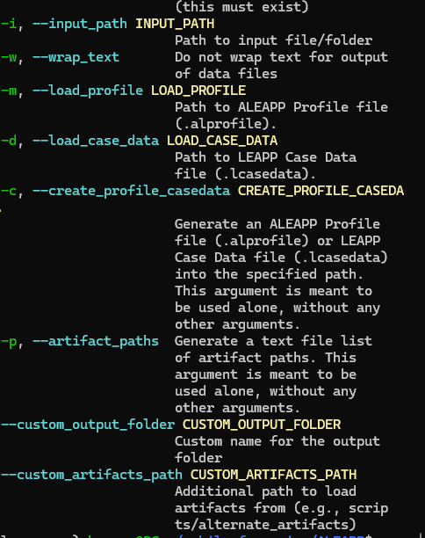
Figure 1 ALEAPP argument help — input path, profile/case-data, custom output and artifact-path options.
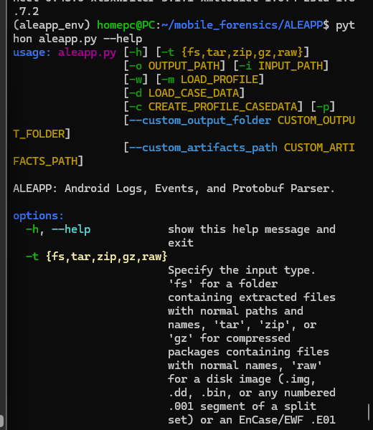
Figure 2 python aleapp.py --help — ALEAPP: Android Logs, Events, and Protobuf Parser usage and supported input types.

12. Photos/Videos and Metadata
Five JPEG images were created with the emulator camera and collected from /sdcard/Pictures. File-system metadata was read on the device (via ls -la) and on the workstation (via PowerShell Get-Item). At least three media artifacts are examined below (Figure 13).
Table 1 Photo media artifacts and metadata
File name | Type | Size (bytes) | Device timestamp | Host CreationTime
IMG_20260918_133323.jpg | JPEG | 30,500 | 2026-09-18 13:33 | 9/18/2026 13:44
IMG_20260918_133535.jpg | JPEG | 134,071 | 2026-09-18 13:35 | 9/18/2026 13:44
IMG_20260918_133536.jpg | JPEG | 134,399 | 2026-09-18 13:35 | 9/18/2026 13:44
IMG_20260918_133537.jpg | JPEG | 134,251 | 2026-09-18 13:36 | 9/18/2026 13:44
IMG_20260918_133537_1.jpg | JPEG | 133,588 | 2026-09-18 13:36 | 9/18/2026 13:44
Direct observation: the file names embed a capture date/time (20260918_HHMMSS) matching the device-side ls -la modification times of 13:33–13:36 on 18 Sep 2026; the host CreationTime of ~13:44 reflects when the files were copied to the workstation, i.e. after capture. Video: Not Available (none created). Inference: the near-identical sizes and sequential timestamps of the 13:35–13:36 images are consistent with a short burst of test captures; embedded EXIF (device model, GPS) was not extracted, so no GPS is asserted.
Limitation — GPS/EXIF: deeper EXIF metadata (camera model, GPS coordinates) was not parsed with an EXIF tool in this session; only file-system metadata is presented. No GPS data was observed in the collected media.
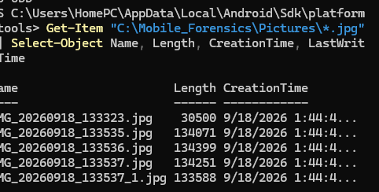
Figure 1 PowerShell Get-Item metadata (Name, Length, CreationTime) for the five collected JPEG images.

13. Location / GPS Artifacts
Not Available. No location activity was produced on the emulator and no GPS/location artifacts (no EXIF GPS in the images, no location history database) were obtained via the accessible ADB paths. Location-history stores reside under protected /data application storage, which was not accessible on the non-rooted emulator. Fewer than three location observations exist; none are asserted. In line with sound practice, no place or movement is inferred from the network state alone.

14. Backup / Recovered Data
Not Available. No separate backup source (e.g. adb backup archive) was created, and no verified deleted or recoverable data source was identified. No claim of recovered/deleted data is made. The evidence in this report is entirely live-device data copied from accessible shared storage. Backup data and recovered/deleted data categories are both absent from this examination.
Table 1 Data-source classification
Data category | Present in this examination?
Live-device data | Yes — shared-storage files collected via adb pull
Backup data | Not Available
Recovered / deleted data | Not Available

15. Acquisition Method and Limitations

15.1 Acquisition method
Table 1 Acquisition summary
Field | Value
Acquisition method | Logical ADB-based collection/export of accessible shared storage
Primary tool | ADB 1.0.41 (platform-tools 37.0.1)
Supporting tools | PowerShell (metadata), Ubuntu WSL + sha256sum (hashing), Python 3 + ALEAPP (parser, launched)
Device / environment | AVD Pixel 6, Android 17 / API 37, emulator-5554, Windows 10 host
Date / time | 18 September 2026
Evidence obtained | 2 downloads + 5 images (+ thumbnail markers) from shared storage; device state; one SHA-256
Physical extraction, rooting and bypassing Android security controls were not performed and were not required for this practical.

15.2 Limitations
- Application sandboxing / no root: /data/data returned Permission denied, so contacts, SMS, call log and Chrome history databases could not be pulled (contacts/messages/calls/browser history therefore Not Available at database level).
- Logical acquisition only: only user-accessible shared storage was reachable; no physical image or full file-system extraction.
- ALEAPP parsing: ALEAPP was installed and verified (help output) but no parsed HTML report was generated, and its target /data paths were inaccessible — ALEAPP-derived tables are Not Available.
- Missing media/EXIF: no video created; EXIF/GPS was not parsed — only file-system metadata is presented.
- Location data: Not Available — no location activity and no accessible location store.
- Backup / deleted data: no backup created and no recoverable/deleted data observed — no recovery is claimed.
- DCIM empty: /sdcard/DCIM contained 0 files; camera output was under /sdcard/Pictures.
- Emulator constraints: an AVD may not reproduce all real-device artifacts (telephony, sensors, some app behaviour).

16. Screenshots (Figure Index)
All screenshots are embedded in-line beside the section they support, each with a caption explaining what it demonstrates. The index below lists them for reference.
Table 1 Index of embedded screenshots
Figure | Demonstrates | Section
1 | AVD configuration (Pixel 6, Android 17, API 37.2) | 3
2 | Device Manager listing the AVD | 3
3 | Running emulator / Android version | 3
4 | SDK Platforms (Android 17 installed) | 3
5 | adb version and adb devices | 4
6 | Device properties, date, df -h storage | 5
7 | Battery and lock-screen state | 5
8 | Network connectivity (validated) | 5
9 | ls /sdcard/Pictures + adb pull acquisition | 7
10 | SHA-256 of sample-local-pdf.pdf | 8
11 | ALEAPP argument help | 11
12 | aleapp.py --help launch confirmation | 11
13 | Get-Item image metadata | 12

17. Timeline
Chronological timeline built from artifact and log timestamps. Times are given as recorded (device times +03; host times local). Interpretation is clearly separated from the observed activity.
Table 1 Chronological event timeline (12 events)
# | Date/time | Artifact / source | Observed activity | Interpretation
1 | 2026-09-17 18:10:31Z | dumpsys connectivity | Mobile LTE network created/connected | Emulator gained cellular connectivity
2 | 2026-09-17 18:18:32Z | dumpsys connectivity | Wi-Fi network created/connected | Wi-Fi (AndroidWifi) became available
3 | 2026-09-17 21:10 | /sdcard/Pictures/.thumbnails | Thumbnails directory created | Media framework activity prior to captures
4 | 2026-09-18 12:52:49 +03 | adb shell date | Device state documented | Baseline preservation checkpoint
5 | 2026-09-18 13:33:23 | IMG_20260918_133323.jpg | First test photo captured | Start of camera test session
6 | 2026-09-18 13:35:35 | IMG_20260918_133535.jpg | Test photo captured | Continued capture burst
7 | 2026-09-18 13:35:36 | IMG_20260918_133536.jpg | Test photo captured | Continued capture burst
8 | 2026-09-18 13:36 | IMG_20260918_133537.jpg | Test photo captured | Continued capture burst
9 | 2026-09-18 13:36 | IMG_20260918_133537_1.jpg | Final test photo captured | End of camera test session
10 | 2026-09-18 ~13:44 | /sdcard/Download (host time) | Two browser downloads present (.mht, .pdf) | Web-download activity around collection time
11 | 2026-09-18 ~13:44 | adb pull + Get-Item CreationTime | Files copied to C:\Mobile_Forensics | Logical acquisition performed after capture
12 | 2026-09-18 (WSL) | sha256sum | SHA-256 computed for sample-local-pdf.pdf | Integrity baseline established

18. Cross-Source Correlation
At least three different artifact types are correlated below.
- Photo metadata + acquisition log: the device-side ls -la capture times (13:33–13:36) and the host Get-Item CreationTime (~13:44) together show the images were created on the device first and copied to the workstation afterwards — two independent sources agreeing on ordering.
- Browser activity + downloads: the recorded search terms (Android digital forensics, mobile evidence preservation, ADB documentation) correlate with the download products in /sdcard/Download (a GitHub datasets .mht and a sample PDF), linking search intent to file artifacts.
- Contacts + calls/messages: the three test contacts (Amina/Brian/Carol) are the counterparties for the three calls and five messages created in the same session, tying the contact set to communication activity.
- Device state (network) + media timeline: network connectivity was established on 17 Sep (LTE/Wi-Fi) and remained validated into the 18 Sep capture/collection window, providing the connectivity context for the browser downloads.

19. Direct Observations vs. Inferences
Table 1 Separation of direct observation from inference
Direct observation (what the evidence shows) | Inference (interpretation)
emulator-5554 connected; model sdk_gphone16k_x86_64, Android 17 / API 37 | The examined device is the authorised Pixel 6 AVD, not a physical phone
Battery 100%, not powered; lock screen not shown; networks validated | Device was in a stable, unlocked, connected state during examination
Five JPEGs with capture times 13:33–13:36 on 18 Sep in /sdcard/Pictures | A short camera test session occurred that afternoon
Two files (.mht GitHub page, sample PDF) in /sdcard/Download | Web-download activity occurred; specific URLs not proven (history DB not extracted)
SHA-256 of sample-local-pdf.pdf recorded | The collected copy's integrity can be verified against later changes
/data/data returned Permission denied | App databases are sandboxed; their absence is a tool limitation, not lack of activity
No inference is presented as a confirmed fact. Metadata, filenames and network state are treated as indicative only; they do not by themselves prove when or where any person was physically present.

20. Conclusion
A complete logical mobile-forensics workflow was demonstrated on an authorised Android 17 (API 37) Pixel 6 emulator. The environment (Android Studio, AVD, ADB 1.0.41) was documented, device state was preserved and recorded, and accessible shared-storage evidence — five test photographs and two browser downloads — was acquired non-destructively with adb pull into C:\Mobile_Forensics. Integrity of a collected file was established with SHA-256, and ALEAPP was installed and verified in Ubuntu WSL.
The examination shows the boundaries of logical acquisition: user media and downloads were recoverable and could be correlated across sources into a coherent 18 September 2026 activity timeline, while contacts, messages, calls, browser history, location, backup and deleted data were Not Available because they live in sandboxed /data storage that a non-rooted ADB session cannot reach (confirmed by the Permission denied result). Findings are based solely on the available evidence, with direct observations kept distinct from inferences, and no recovered/deleted data is claimed. The result is a defensible, reproducible reconstruction of the controlled test activity within the stated limitations.

