DIGITAL FORENSICS
PRACTICAL ASSIGNMENT REPORT
Operating System Forensics & Activity Reconstruction

Field | Details
Student Name | Lisa Wanja Kabue
Course | Digital Forensics
Operating System Examined | Microsoft Windows 11 Pro
Date | 11 September 2026

1. Student Information
Field | Details
Student Name | Lisa Wanja Kabue
Course | Digital Forensics
Assignment | Operating System Forensics & Activity Reconstruction
Date | 11 September 2026

2. Objective
The objective of this practical exercise was to examine operating-system artifacts and use available evidence to reconstruct basic user and system activity. The examination focused on Windows operating-system identification, Registry artifacts, event logs, application execution artifacts, USB storage information, and user activity records.

3. Operating System Information
The operating system examined was identified as Microsoft Windows 11 Pro. The examination was performed on the student's local Windows computer as the evidence source. No separate forensic disk image was used for this practical.
Item | Observed value
Operating system | Microsoft Windows 11 Pro
Version | 25H2
OS Build | 26200.9168 (About Windows)
System Information version | 10.0.26200 Build 26200
System name | PC
Manufacturer | HP
System model | HP mt45 Mobile Thin Client
System type | x64-based PC
BIOS mode | UEFI
Registered owner | Windows User
Windows directory | C:\WINDOWS
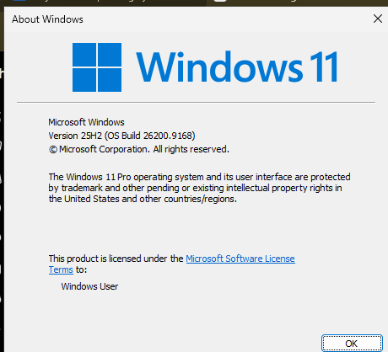
Screenshot 1: About Windows window showing Windows 11 Pro, version 25H2 and OS build 26200.9168.
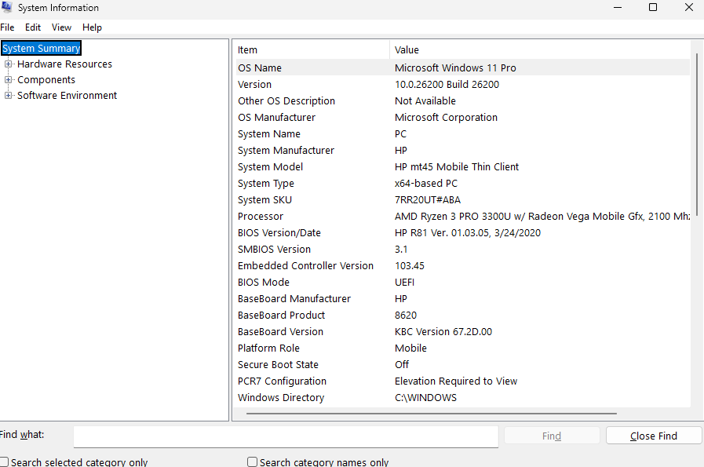
Screenshot 2: System Information showing OS, system name, manufacturer, model, architecture and other system details.

4. Artifacts Examined
Artifact | Location/Path | Information Provided
Windows System Event Log | Event Viewer → Windows Logs → System | System, service and update activity.
Windows Application Event Log | Event Viewer → Windows Logs → Application | Application and service events.
Windows Security Event Log | Event Viewer → Windows Logs → Security | Security auditing and account-related activity.
Windows Registry – CurrentVersion | HKLM\SOFTWARE\Microsoft\Windows NT\CurrentVersion | OS version, build and installation information.
UserAssist Registry | HKCU\Software\Microsoft\Windows\CurrentVersion\Explorer\UserAssist\{GUID}\Count | User/application activity-related registry data.
Prefetch | C:\Windows\Prefetch | Artifacts associated with application execution.
USBSTOR Registry | HKLM\SYSTEM\CurrentControlSet\Enum\USBSTOR | USB storage device recognition information.

5. Relevant Artifacts

5.1 Windows System Event Log
Location: Event Viewer → Windows Logs → System. Event ID 43 from WindowsUpdateClient was observed at 9/11/2026 11:11:09 AM. The event states that Windows started installing an update, including the Windows Malicious Software Removal Tool x64 – v5.145 (KB890830).
Relevance: This provides a timestamped record of system update activity and can help establish system-maintenance activity during reconstruction.
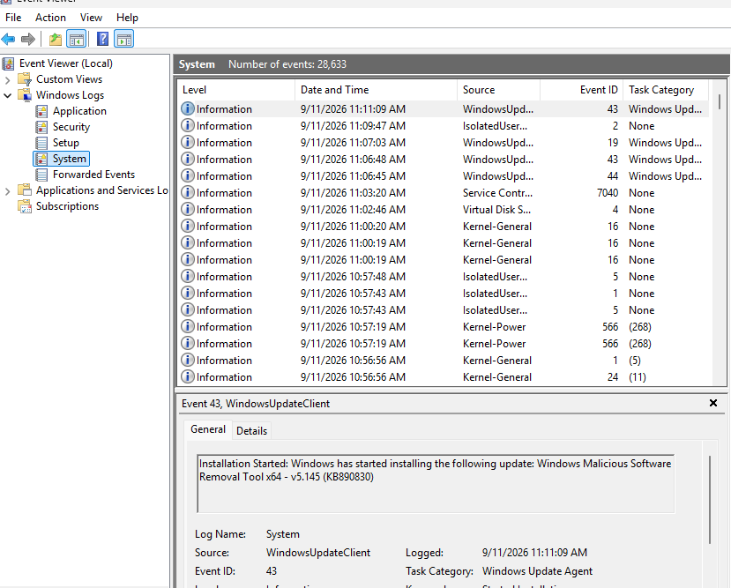
Screenshot 3: Windows System log showing WindowsUpdateClient Event ID 43 and the update-installation message.

5.2 Windows Application Event Log
Location: Event Viewer → Windows Logs → Application. VSS Event ID 8224 was observed at approximately 9/11/2026 11:09 AM. The event states that the Volume Shadow Copy Service was shutting down due to an idle timeout.
Relevance: This provides timestamped evidence of Windows service activity and can be correlated with other system events.
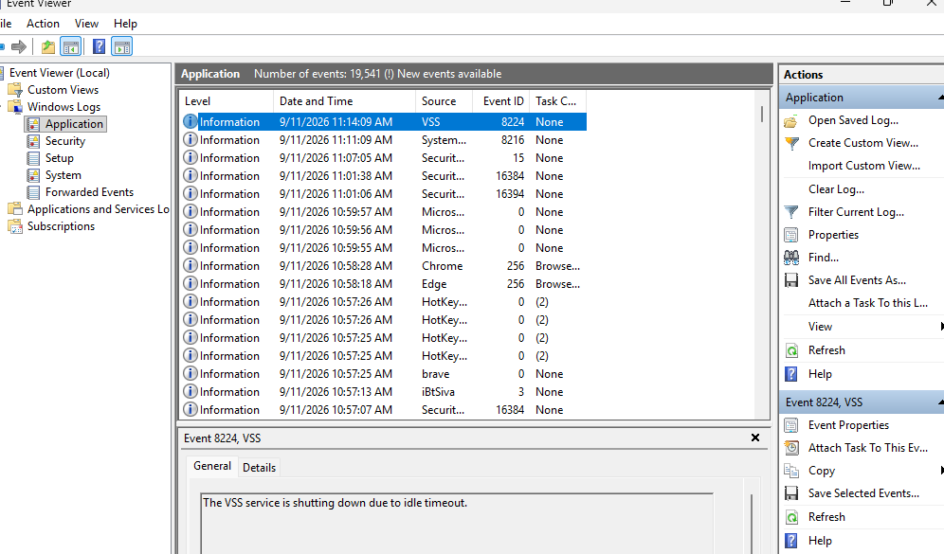
Screenshot 4: Windows Application log showing VSS Event ID 8224 and the idle-timeout message.

5.3 Windows Security Event Log
Location: Event Viewer → Windows Logs → Security. Event ID 5379 was recorded at 9/11/2026 11:42:28 AM. The event states that Credential Manager credentials were read, with the read operation shown as 'Enumerate Credentials'. The account shown is HomePC and the computer is PC.
Relevance: Security audit events can provide evidence of security-sensitive activity and are useful when reconstructing activity on a Windows host.
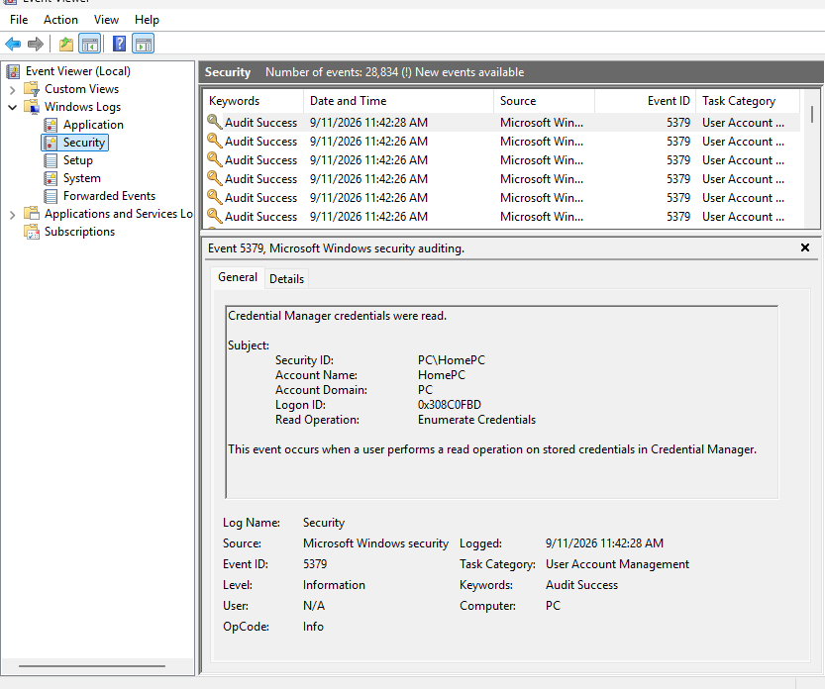
Screenshot 5: Windows Security log showing Event ID 5379 and a Credential Manager credential-read operation.

5.4 Windows Registry – CurrentVersion
Location: HKEY_LOCAL_MACHINE\SOFTWARE\Microsoft\Windows NT\CurrentVersion. The displayed values include CurrentBuild 26200, CurrentBuildNumber 26200, DisplayVersion 25H2, EditionID Professional, ProductName Windows 10 Pro, RegisteredOwner Windows User, and Windows path C:\WINDOWS.
Relevance: Registry information establishes the operating-system environment and configuration. The discrepancy between the registry's ProductName value ('Windows 10 Pro') and the live System Information/About Windows identification ('Windows 11 Pro') is recorded rather than silently resolved. This illustrates why multiple artifacts should be correlated.
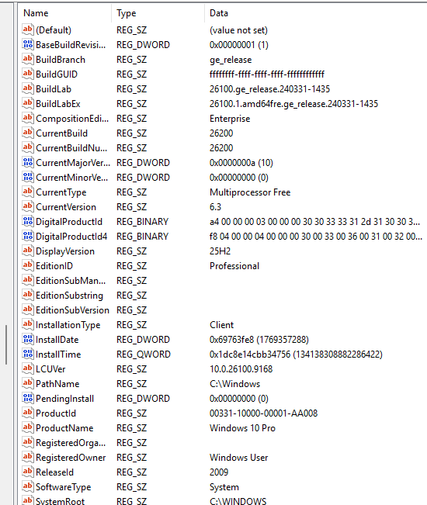
Screenshot 9: CurrentVersion Registry values showing build, display version, edition, ProductName and installation path.

5.5 USBSTOR Registry
Location: HKEY_LOCAL_MACHINE\SYSTEM\CurrentControlSet\Enum\USBSTOR. USB storage device entries are visible beneath the USBSTOR key.
Relevance: USBSTOR can support identification of removable storage devices recognized by Windows. The screenshot alone does not establish the exact connection time of a particular device.
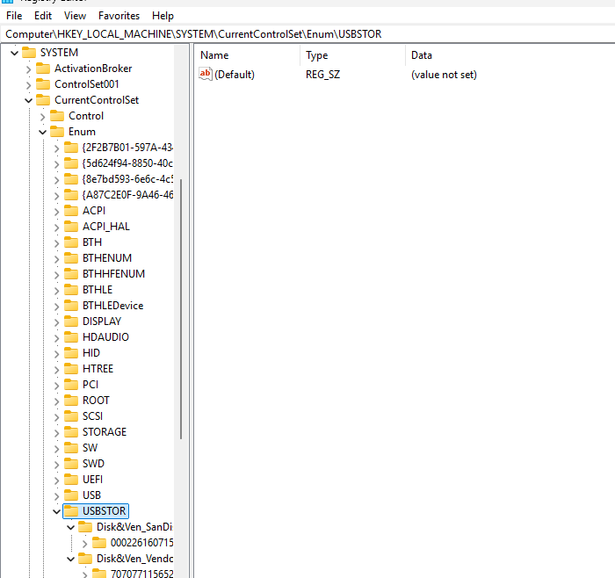
Screenshot 8: USBSTOR Registry key showing USB storage device entries.

5.6 Prefetch
Location: C:\Windows\Prefetch. The directory contains .pf files, including BACKGROUNDTASKHOST.EXE entries with displayed timestamps of 9/11/2026 10:56 AM and 11:00 AM, as well as BRAVE.EXE-related entries.
Relevance: Prefetch artifacts can support application-execution reconstruction. The displayed file timestamp is not treated as proof of the exact moment an application was executed.
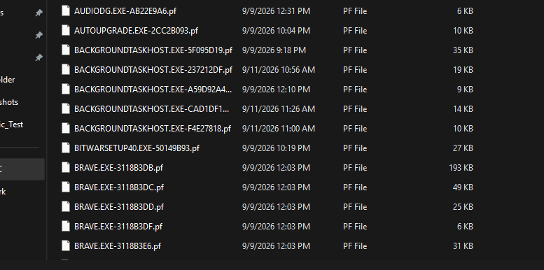
Screenshot 7: Prefetch directory showing .pf artifacts for BackgroundTaskHost, Brave and other applications.

5.7 UserAssist Registry
Location: HKEY_CURRENT_USER\Software\Microsoft\Windows\CurrentVersion\Explorer\UserAssist\{GUID}\Count. A Count key containing a REG_BINARY value is present. The raw value was not decoded during this exercise.
Relevance: UserAssist can provide application/user-activity information after appropriate decoding. Because the value was not decoded, no specific application-use conclusion is drawn from it.
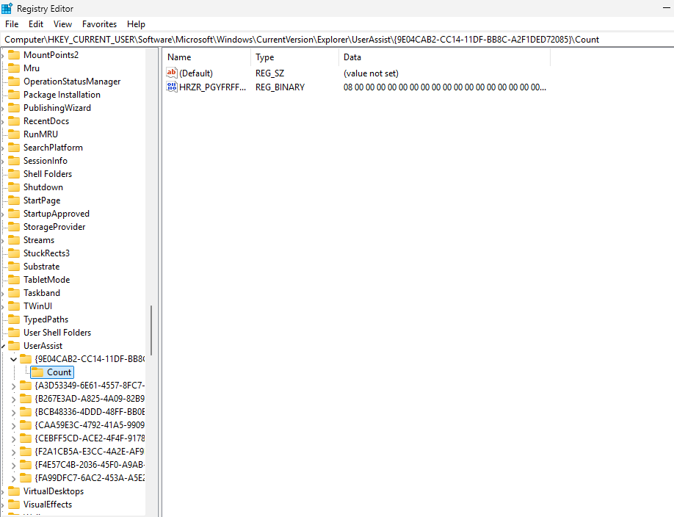
Screenshot 6: UserAssist Count Registry key containing a binary value.

6. Timeline & Activity Reconstruction
The timeline below uses timestamps visible in the examined artifacts. Direct observations are distinguished from interpretations. Prefetch timestamps are treated as artifact timestamps, not as definitive execution times.
Date/Time | Artifact/Source | Observed Activity | Interpretation
11 Sep 2026, 10:56 AM | Prefetch | BACKGROUNDTASKHOST.EXE .pf artifact displays a 10:56 AM timestamp. | Direct observation. The timestamp may relate to Prefetch artifact activity; exact execution time is not established.
11 Sep 2026, 11:00 AM | Prefetch | Another BACKGROUNDTASKHOST.EXE .pf artifact displays an 11:00 AM timestamp. | Direct observation. It may indicate another Prefetch artifact update; exact execution time is not established.
11 Sep 2026, ~11:09 AM | Application Event Log | VSS Event ID 8224 records the Volume Shadow Copy Service shutting down due to an idle timeout. | Direct observation. Indicates Windows service activity around this time.
11 Sep 2026, 11:11:09 AM | System Event Log | WindowsUpdateClient Event ID 43 records that Windows started installing an update. | Direct observation. Indicates update-related system activity.
11 Sep 2026, 11:42:28 AM | Security Event Log | Security Event ID 5379 records a Credential Manager credential-read operation ('Enumerate Credentials') for HomePC. | Direct observation. Indicates a credential-read operation; the event alone does not establish its purpose or the human operator.

7. Cross-Source Correlation
The System Event Log and Application Event Log provide two different sources of operating-system activity. The VSS event at approximately 11:09 AM and the WindowsUpdateClient event at 11:11:09 AM show system/service activity occurring within a short period on the same date. Their timing is consistent with active Windows background or maintenance operations, but the evidence does not prove that the VSS event was directly caused by the update event.
The Security Event Log adds a separate security-audit source at 11:42:28 AM, documenting a Credential Manager credential-read operation. This demonstrates why a single artifact should not be treated as a complete explanation of an event.
The Registry provides an important cross-check. The CurrentVersion Registry screenshot shows CurrentBuild 26200 and DisplayVersion 25H2, which agree with the Windows 11 build information shown by System Information. However, its ProductName value displays 'Windows 10 Pro'. This discrepancy should be recorded and investigated further rather than ignored; other current OS-identification evidence identifies the running system as Windows 11 Pro.

8. Direct Observations vs. Inferences
Classification | Statement
Direct observation | About Windows identifies the system as Windows 11 Pro, version 25H2, build 26200.9168.
Direct observation | System Information identifies Microsoft Windows 11 Pro, build 26200, on an HP mt45 Mobile Thin Client.
Direct observation | System Event Log contains WindowsUpdateClient Event ID 43 at 11:11:09 AM recording update installation start.
Direct observation | Application Event Log contains VSS Event ID 8224 at approximately 11:09 AM recording an idle-timeout shutdown.
Direct observation | Security Event Log contains Event ID 5379 at 11:42:28 AM recording a Credential Manager credential-read operation.
Direct observation | USBSTOR contains USB storage device entries.
Direct observation | Prefetch contains .pf artifacts including BackgroundTaskHost and Brave-related files.
Inference | The VSS and Windows Update events may be related to broader Windows maintenance activity, but direct causation is not established.
Inference | Prefetch entries may support application-execution reconstruction, but their displayed timestamps are not treated as exact execution times.
Inference | The Security Event ID 5379 indicates a credential-read operation, but does not by itself identify the human operator or purpose.

9. Conclusion
The examination demonstrated how Windows operating-system artifacts can be used to identify a system and reconstruct portions of user and system activity. The available evidence included Windows Registry information, System/Application/Security event logs, Prefetch artifacts, UserAssist data, and USBSTOR information. Timestamped events provided a basic chronological sequence, while cross-source comparison showed the importance of correlating artifacts before drawing conclusions. The findings are limited to the artifacts visible on the local Windows system and should not be interpreted as a complete forensic reconstruction of all activity on the computer.

