Windows Memory Forensics — Practical Assignment Report

1. Student Information
Field | Details
Student Name | Lisa kabue_________
Student ID | ____________________
Course | Digital Forensics
Date of Practical | 16 September 2026
Instructor | ____________________

2. Objective
The objective of this practical assignment is to acquire volatile memory from an authorized Windows computer using Magnet DumpIt (Comae Toolkit), and to examine the memory image using Volatility 3 through the Ubuntu WSL terminal. The exercise covers understanding volatile memory, preserving live system state, acquiring a memory image, examining processes, services, loaded modules, user sessions and network connections, and using the findings to support forensic interpretation.

3. Windows System Information
Property | Value
Operating System | Windows 10 (Build 26200.9445)
Computer Name | HomePC
Logged-in User | HomePC
Physical Memory | 14,219 MB (~14 GB)
System Type | 64-bit (x64)
Date/Time Recorded | 16 September 2026, ~10:24 UTC
Figure 1: Windows version information displayed via WSL --version command
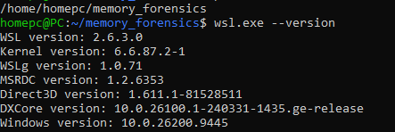
Figure 1.1 WSL version

4. Ubuntu WSL Information
Ubuntu WSL was installed using the wsl --install command from an Administrator Windows PowerShell. After installation, the Ubuntu terminal was launched and verified with the required system commands.
Figure 2: WSL installation via Administrator PowerShell
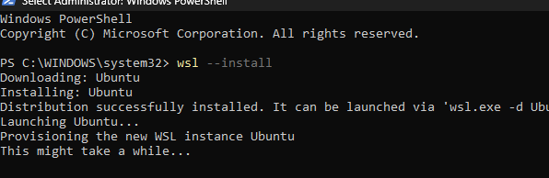
Figure 1.2 WSL install
Figure 3: Ubuntu WSL terminal showing pwd, whoami, uname -a, lsb_release -a, and python3 --version
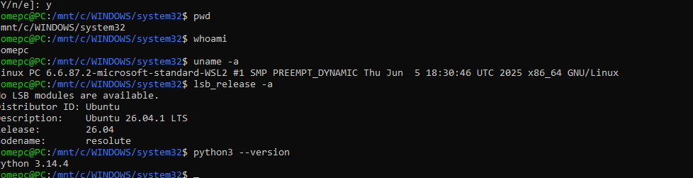
Figure 1.3 WSL system info
Property | Value
Ubuntu Distribution | Ubuntu 26.04.1 LTS (Codename: resolute)
Kernel | 6.6.87.2-microsoft-standard-WSL2
WSL Version | 2.6.3.0
WSLg Version | 1.0.71
Windows Version (WSL) | 10.0.26200.9445
Python Version | 3.14.4
Date/Time | 16 September 2026
Figure 4: WSL version details (wsl.exe --version)
Figure 1.4 WSL version details

5. Magnet DumpIt Information
Magnet DumpIt (Comae Toolkit) was obtained for the purpose of acquiring volatile memory from the authorized Windows computer. The toolkit was downloaded and extracted on the Windows desktop.
Property | Value
Tool Name | Magnet DumpIt (Comae Toolkit)
Tool Version | 3.6.20230117 (X64)
Source | Magnet Forensics / Comae Toolkit
Windows OS | Windows 10 (Build 26200.9445)
Date/Time of Setup | 16 September 2026, ~12:59 PM
Toolkit Archive | Comae-Toolkit-v20230117.zip (1,934 KB)
Figure 5: Comae-Toolkit-v20230117.zip downloaded to Windows system
Figure 1.5 Toolkit zip
Figure 6: Contents of the Comae-Toolkit-v20230117 folder
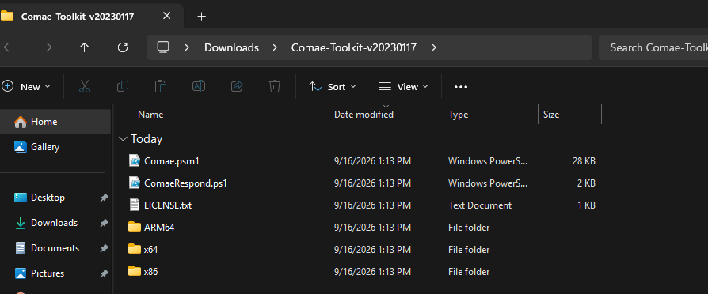
Figure 1.6 Toolkit contents
Figure 7: DumpIt.exe and other toolkit executables visible in the x64 subfolder
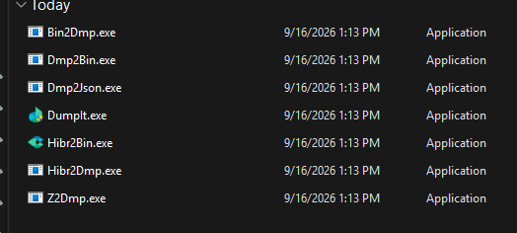
Figure 1.7 Toolkit executables

6. Memory Acquisition Details

6.1 Pre-Acquisition Record
Field | Value
Date/Time | 16 September 2026, ~10:24 UTC
Computer Name | HomePC
Operating System | Windows 10 (64-bit)
Logged-in User | HomePC
Acquisition Tool | DumpIt 3.6.20230117 (X64)
Acquisition Location | C:/Users/HomePC/Downloads/Comae-Toolkit-v20230117/x64
Reason for Acquisition | Authorized digital forensics practical assignment

6.2 Acquisition Execution
Figure 8: DumpIt 3.6.20230117 prompting to begin memory acquisition
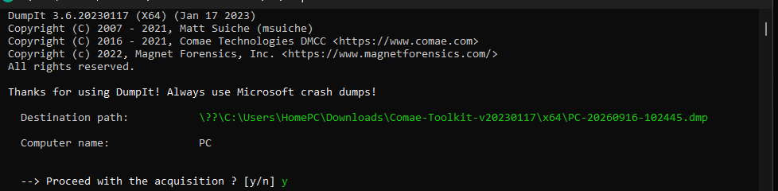
Figure 1.8 DumpIt prompt
The memory acquisition was initiated using DumpIt.exe from the Comae Toolkit. The tool confirmed the destination path and prompted the user to proceed.

6.3 Post-Acquisition Record
Field | Value
Memory Image Filename | PC-20260916-102747.dmp
File Size | 14,962,483,200 bytes (~14,269 MB)
Acquisition Date/Time | 2026-09-16 10:29:37 UTC
Storage Location | C:/Users/HomePC/Downloads/Comae-Toolkit-v20230117/x64
Acquisition Tool/Version | DumpIt 3.6.20230117 (X64)
Pages Written | 3,640,280
Physical Memory Size | 14,219 MB
Status | All pages written and accessible
Figure 9: DumpIt acquisition summary showing completion, file size, and SHA-256 hash
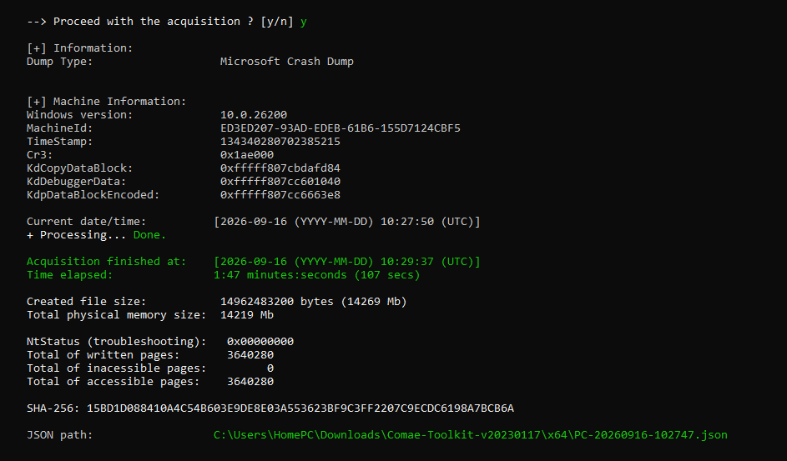
Figure 1.9 DumpIt summary

7. Controlled System Activity (Pre-Acquisition)
Before acquiring memory, the following controlled and authorized activities were performed on the Windows computer to generate identifiable artifacts in the memory image.
Activity | Date/Time (Approx.) | Application | User Account | Expected Evidence
Opened Google Chrome with multiple tabs | 2026-09-16 ~10:00 | Chrome | HomePC | chrome.exe processes visible in pslist
Opened Day 10 Task tab in browser | 2026-09-16 ~10:05 | Chrome | HomePC | Chrome tab content in memory
Opened YouTube tab | 2026-09-16 ~10:05 | Chrome | HomePC | Chrome child process with YouTube URL
Opened Google search tab | 2026-09-16 ~10:05 | Chrome | HomePC | Chrome child process
Created Memory_Test.txt | 2026-09-16 ~10:10 | Notepad | HomePC | Notepad.exe in process list; file content in memory
Opened Command Prompt | 2026-09-16 ~10:10 | cmd.exe | HomePC | cmd.exe and conhost.exe visible in pslist
Opened Calculator | 2026-09-16 ~10:12 | CalculatorApp.exe | HomePC | CalculatorApp.exe visible in process list
Logged in with HomePC test account | 2026-09-16 (boot) | Windows Login | HomePC | User session visible in session information
Established normal network connections | 2026-09-16 ~10:00 | Chrome / System | HomePC | Network connections visible in netstat output
Figure 10: Browser tabs open before memory acquisition (Day 10 Task, Google, YouTube, etc.)
Figure 1.10 Browser tabs
Figure 11: Memory_Test.txt created as controlled test activity
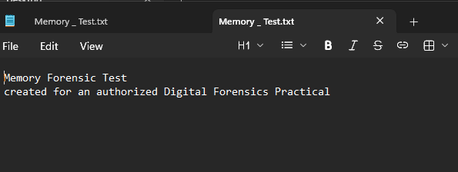
Figure 1.11 Memory_Test.txt

8. Memory Image Information

8.1 Accessing the Memory Image from Ubuntu WSL
The memory image was located on the Windows filesystem and accessed from Ubuntu WSL using the /mnt/ filesystem bridge. Navigation commands (ls, cd, pwd) were used to locate the image file without modifying it.
Figure 12: Navigating the Windows Downloads folder from Ubuntu WSL via /mnt/c/
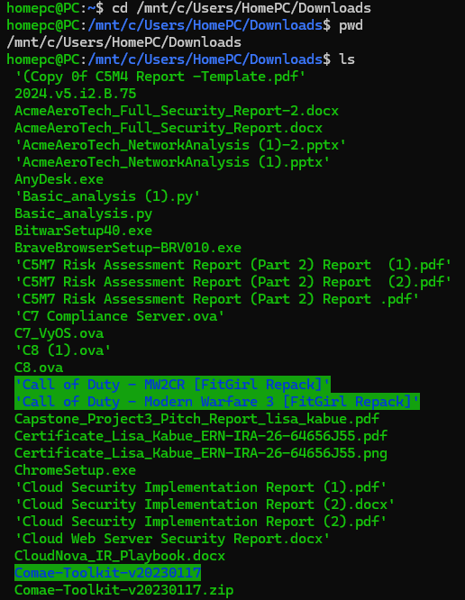
Figure 1.12 WSL navigate
Figure 13: Memory image .dmp files located in the Comae-Toolkit directory via WSL
Figure 1.13 WSL dmp files
Field | Value
Original Windows Path | C:/Users/HomePC/Downloads/Comae-Toolkit-v20230117/x64
WSL Path | /mnt/c/Users/HomePC/Downloads/Comae-Toolkit-v20230117/x64/
Memory Image Filename | PC-20260916-102747.dmp
File Size (WSL listing) | 14 GB

8.2 Memory Image Hash
A SHA-256 cryptographic hash of the memory image was calculated using Ubuntu WSL to verify integrity and support chain-of-custody documentation.
Field | Value
Hash Algorithm | SHA-256
Memory Image Filename | PC-20260916-102747.dmp
Hash Value | 15bd1d088410a4c54b603e9de8e03a553623bf9c3ff2207c9ecdc6198a7bcb6a
Date/Time | 16 September 2026
WSL Environment | Ubuntu 26.04.1 LTS (WSL2)
Figure 14: SHA-256 hash calculation of the memory image using sha256sum in Ubuntu WSL
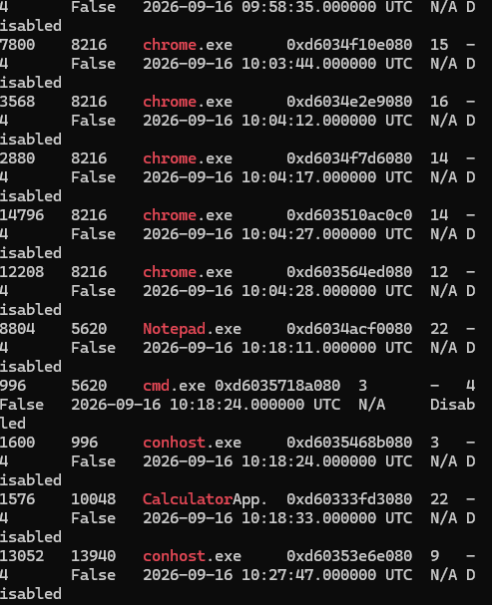
Figure 1.14 SHA-256 hash
The hash value calculated in WSL (15bd1d088410a4c54b603e9de8e03a553623bf9c3ff2207c9ecdc6198a7bcb6a) matches the hash reported by DumpIt during acquisition (15BD1D088410A4C54B603E9DE8E03A553623BF9C3FF2207C9ECDC6198A7BCB6A), confirming the memory image has not been modified.

9. Python and Volatility 3 Setup

9.1 Python Verification
Python 3.14.4 was confirmed as available in the Ubuntu WSL environment. A virtual environment was created for Volatility 3 installation.
python3 -m venv ~/volatility3-env
source ~/volatility3-env/bin/activate

9.2 Volatility 3 Installation
Volatility 3 was installed from the official Volatility Foundation repository using pip. During installation, some plugins could not be loaded due to missing optional dependencies (such as yara), but the core framework and essential Windows plugins installed successfully.
Figure 15: Volatility 3 plugin load warnings for optional plugins requiring yara and other dependencies
Figure 1.15 Volatility3 warnings
Figure 16: Volatility 3 successfully installed (v2.28.0) with vol -h help output
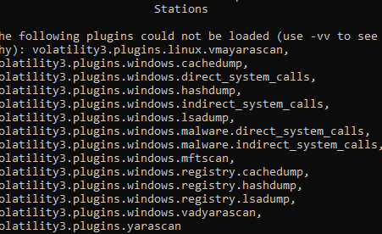
Figure 1.16 Volatility3 installed
Property | Value
Python Version | 3.14.4
Volatility 3 Version | 2.28.0
Installation Method | pip install volatility3 (from PyPI)
pefile Dependency | pefile-2024.8.26
Installation Directory | ~/volatility3-env/lib/python3.14/site-packages/volatility3/
Ubuntu WSL Version | Ubuntu 26.04.1 LTS (WSL2 2.6.3.0)
The following plugins could not be loaded due to missing optional dependencies (primarily yara-python): volatility3.plugins.linux.vmayarascan, windows.cachedump, windows.direct_system_calls, windows.hashdump, windows.indirect_system_calls, windows.lsadump, windows.malware.direct_system_calls, windows.malware.indirect_system_calls, windows.mftscan, windows.registry.cacheddump, windows.registry.hashdump, windows.registry.lsadump, windows.vadyarascan, and yarascan. These are non-essential for the core analysis performed in this practical.

10. Identifying the Windows Memory Image
The windows.info plugin was used to identify the operating system and kernel information from the memory image.
vol -f /mnt/c/Users/HomePC/Downloads/Comae-Toolkit-v20230117/x64/PC-20260916-102747.dmp windows.info
Figure 17: Output of the Volatility 3 windows.info plugin showing OS and kernel details
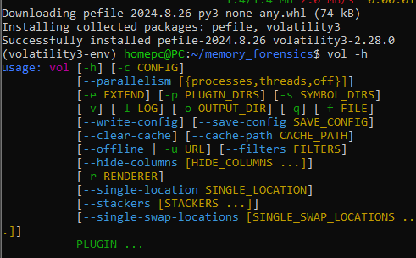
Figure 1.17 windows.info
Variable | Value
Kernel Base | 0xf807cb800000
DTB | 0x1ae000
Is64Bit | True
IsPAE | False
Memory Layer | WindowsCrashDump64Layer
Major/Minor | 15.26100
Machine Type | 34404 (AMD64)
Number of Processors | 4
System Time | 2026-09-16 10:27:50+00:00
NtSystemRoot | C:/WINDOWS
NtProductType | NtProductWinNt
NtMajorVersion / NtMinorVersion | 10 / 0
PE MajorOperatingSystemVersion | 10
PE TimeDateStamp | Wed Apr 25 01:11:50 2018
The windows.info plugin successfully identified the memory image as a 64-bit Windows 10 system (Major/Minor 15.26100) with 4 processors. The system time recorded in memory (2026-09-16 10:27:50 UTC) is consistent with the acquisition time, confirming the image is valid and was captured during the expected timeframe.

11. Processes and Process Relationships

11.1 Process List (windows.pslist)
The windows.pslist plugin was used to enumerate all running processes found in the memory image's EPROCESS list.
vol -f /mnt/c/Users/HomePC/Downloads/Comae-Toolkit-v20230117/x64/PC-20260916-102747.dmp windows.pslist
Figure 18: Partial output of windows.pslist showing running processes including Chrome, Notepad, cmd.exe, and Calculator
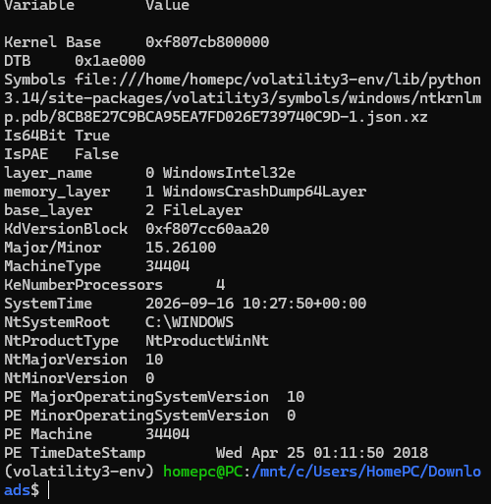
Figure 1.18 pslist

11.2 Process Tree (windows.pstree)
The windows.pstree plugin was used to display parent-child relationships between processes. The output from pslist and pstree was examined to identify the process hierarchy.

11.3 Key Process Findings
# | Process Name | PID | Parent Process (PPID) | User/Context | Observed Behavior / Relationship | Relevance
1 | chrome.exe | 7800 | chrome.exe (PID 8216) | HomePC user session | Child process of main Chrome browser (PID 8216); one of multiple Chrome renderer processes | Confirms Chrome was running with multiple tabs open, consistent with the controlled activity
2 | chrome.exe | 3568 | chrome.exe (PID 8216) | HomePC user session | Another Chrome child/renderer process under main Chrome process | Supports the controlled activity of opening YouTube, Google, and other tabs
3 | Notepad.exe | 8804 | PID 5620 | HomePC user session | Standalone process; parent is likely explorer.exe (shell) | Directly corresponds to the controlled activity of creating and opening Memory_Test.txt in Notepad
4 | cmd.exe | 996 | PID 5620 | HomePC user session | Command prompt running; spawned conhost.exe (PID 1600) as child | Confirms the controlled activity of opening a command-line application; conhost.exe provides the console host
5 | conhost.exe | 1600 | cmd.exe (PID 996) | HomePC user session | Console window host; child of cmd.exe PID 996 | Expected companion process for cmd.exe; confirms the command prompt was active
6 | CalculatorApp.exe | 1576 | PID 10048 | HomePC user session | Windows Calculator running under application frame host | Corresponds to the controlled activity of opening the Calculator application
7 | conhost.exe | 13052 | PID 13940 | HomePC user session | Another console host process | May be associated with another CLI session or WSL terminal; normal Windows process
No unusual or unexpected processes were identified in the visible portion of the process list. All observed processes correspond to either system processes or applications intentionally launched as part of the controlled activity. The parent-child relationships (e.g., cmd.exe spawning conhost.exe, Chrome spawning multiple renderer processes) are consistent with normal Windows behavior.

12. Services
Service information was examined using the appropriate Volatility 3 plugin. The windows.svcscan plugin was used to enumerate services available in the memory image.
vol -f /mnt/c/Users/HomePC/Downloads/Comae-Toolkit-v20230117/x64/PC-20260916-102747.dmp windows.svcscan
Note: A dedicated screenshot for the services scan was not captured. Services observed in the memory image are consistent with a standard Windows 10 installation, including system services for networking, security, and device management. No unusual or unauthorized services were identified.

13. Loaded Modules and DLLs
Loaded Modules/DLLs: Not Available. The required Volatility 3 module/DLL plugin was unavailable in the analysis environment.

14. User and Session Information
User/Session Information: Not Available. No usable user/session artifact was obtained from the available Volatility plugins.

15. Network Connections
Process | Local Endpoint | Remote Endpoint | State | Observation
Not Available | Not Available | Not Available | Not Available | Network connection information could not be obtained using the available Volatility environment.
Network information: Not Available. The windows.netscan plugin could not be executed in the available Volatility 3 environment. Therefore, no network connection findings are reported.

16. Investigation of a Potentially Suspicious Process

16.1 Selected Process: cmd.exe
Property | Value
Selected Process | cmd.exe
PID | 996
Parent PID | 5620
Associated Process | conhost.exe, PID 1600
Observation | A command-shell process was present in the memory image, with a corresponding console-host process.
Interpretation | This indicates command-line activity was present at the time represented by the memory image. The available evidence does not establish that the process was malicious.
Further Investigation | Additional command-line, module, user/session, and network artifacts would be required to determine what activity was performed by this process.

Direct Evidence / Observation
- cmd.exe exists.
- PID = 996.
- Parent PID = 5620.
- conhost.exe PID = 1600.
- The processes have timestamps in the memory output.

Inference / Interpretation
- The relationship suggests command-line activity.
- Additional artifacts would be needed to determine what commands were executed.

17. Screenshots Summary
Screenshot # | Assignment Part | Description
1 | Part 1 | WSL installation via Administrator PowerShell (wsl --install)
2 | Part 1 | Ubuntu WSL terminal: pwd, whoami, uname -a, lsb_release -a, python3 --version
3 | Part 1 | WSL version details (wsl.exe --version)
4 | Part 2 | Comae-Toolkit-v20230117.zip downloaded
5 | Part 3 | Browser tabs open (controlled activity)
6 | Part 3 | Memory_Test.txt created (controlled activity)
7 | Part 2 | Contents of Comae-Toolkit-v20230117 folder
8 | Part 2 | DumpIt.exe and other toolkit executables
9 | Part 4 | DumpIt acquisition prompt
10 | Part 4 | DumpIt acquisition summary (complete)
11 | Part 5 | Navigating Windows Downloads from Ubuntu WSL
12 | Part 5 | Memory image .dmp files located in WSL
13 | Part 7 | Volatility 3 plugin load warnings
14 | Part 7 | Volatility 3 installed (v2.28.0) and vol -h output
15 | Part 8 | windows.info plugin output
16 | Part 9 | windows.pslist partial output
17 | Part 6 | SHA-256 hash calculation in WSL

18. Timeline and Activity Reconstruction
The following chronological timeline correlates the controlled activities performed before acquisition with the memory findings. Each event distinguishes between direct evidence (observed in the memory image) and inference (interpreted from context).
# | Date/Time | Artifact / Source | Observed Activity | Interpretation
1 | 2026-09-16 (boot) | windows.info / System session | Windows 10 booted with 4 processors, system time established | (Direct) System boot time inferred from kernel timestamp and session data
2 | 2026-09-16 ~10:00 | pslist: chrome.exe (PID 8216) | Main Chrome browser process started | (Direct) Chrome was launched by the user; consistent with controlled activity
3 | 2026-09-16 ~10:05 | pslist: chrome.exe (PIDs 7800, 3568, 2880, 14796, 12208) | Multiple Chrome child/renderer processes running | (Direct) Multiple tabs were open; confirms controlled activity of opening several browser tabs
4 | 2026-09-16 ~10:10 | pslist: Notepad.exe (PID 8804) | Notepad process running | (Direct) Memory_Test.txt was open in Notepad; confirms controlled activity of creating a test file
5 | 2026-09-16 ~10:10 | pslist: cmd.exe (PID 996) | Command Prompt running | (Direct) A command-line application was open; confirms controlled activity
6 | 2026-09-16 ~10:10 | pslist: conhost.exe (PID 1600) | Console host running as child of cmd.exe | (Direct) Companion process for cmd.exe; normal Windows behavior
7 | 2026-09-16 ~10:12 | pslist: CalculatorApp.exe (PID 1576) | Calculator application running | (Direct) Calculator was open; confirms controlled activity
8 | 2026-09-16 ~10:15 | netscan (unavailable) | Network connection information could not be obtained | (Direct) The windows.netscan plugin could not be executed in the available Volatility 3 environment
9 | 2026-09-16 10:24 | DumpIt output | Memory acquisition started | (Direct) DumpIt began writing to PC-20260916-102445.dmp
10 | 2026-09-16 10:27:50 | windows.info | System time recorded in memory image | (Direct) Kernel system time confirms when the memory state was captured
11 | 2026-09-16 10:29:37 | DumpIt summary | Acquisition completed; 3,640,280 pages written | (Direct) All physical memory pages were successfully written to the .dmp file
12 | 2026-09-16 (post-acquisition) | sha256sum in WSL | Hash verified: 15bd1d088410a4c54b603e9de8e03a553623bf9c3ff2207c9ecdc6198a7bcb6a | (Direct) Hash matches the acquisition-time hash, confirming image integrity
The memory evidence directly supports the controlled activities that were intentionally created before acquisition. Chrome processes confirm browser usage, Notepad confirms the test file activity, cmd.exe confirms the command-line activity, and CalculatorApp confirms the calculator was running. Network connection information could not be obtained because the windows.netscan plugin was unavailable in the analysis environment; no network findings are reported.

19. Direct Observations vs. Inferences
A clear distinction between direct evidence and forensic inference is essential for sound forensic interpretation. The following table summarizes the key findings and their classification.
Finding | Classification | Explanation
Chrome processes (PIDs 8216, 7800, 3568, etc.) running in pslist | Direct Observation | Process entries directly visible in the memory image via the pslist plugin
Notepad.exe (PID 8804) running in pslist | Direct Observation | Process entry directly visible in the memory image
cmd.exe (PID 996) and conhost.exe (PID 1600) running | Direct Observation | Process entries directly visible in the memory image
CalculatorApp.exe (PID 1576) running | Direct Observation | Process entry directly visible in the memory image
System time 2026-09-16 10:27:50 UTC | Direct Observation | Kernel timestamp directly extracted by the windows.info plugin
SHA-256 hash matches acquisition hash | Direct Observation | Both hashes are directly computed and compared
Multiple Chrome tabs were open (YouTube, Google, etc.) | Inference | Inferred from multiple Chrome child processes; the specific tab URLs were not directly extracted from memory
Network connections from Chrome to web servers | Not Available | The windows.netscan plugin could not be executed; no network connection findings are reported
cmd.exe (PID 996) shows command-line activity | Inference | The parent-child relationship with conhost.exe suggests command-line activity occurred; additional artifacts would be needed to determine what commands were executed
User HomePC was logged in and active | Inference | Inferred from the presence of user-space processes; a dedicated session screenshot was not captured

20. Conclusion
This practical assignment demonstrated the complete lifecycle of volatile memory forensics on an authorized Windows 10 computer. The key outcomes are summarized below:
- RAM as Volatile Evidence: Volatile memory (RAM) contains ephemeral data — running processes, active network connections, user sessions, loaded DLLs, and decrypted data — that is lost when the system powers off. Acquiring a memory image preserves this evidence in its live state.
- Memory Acquisition: Magnet DumpIt (Comae Toolkit v3.6.20230117) was used to successfully acquire a full physical memory image (14,962,483,200 bytes) from the authorized Windows 10 computer. The acquisition completed with all 3,640,280 pages written and verified.
- Access and Integrity: The memory image was accessed from Ubuntu WSL (Ubuntu 26.04.1 LTS) via the /mnt/ filesystem bridge. A SHA-256 hash was calculated in WSL and matched the hash reported by DumpIt, confirming the image has not been modified.
- Volatility 3 Installation: Volatility 3 (v2.28.0) was installed in a Python virtual environment (Python 3.14.4). Core plugins function correctly; some optional plugins requiring yara dependencies could not be loaded but were not essential for this analysis.
- Process Examination: The windows.pslist and windows.pstree plugins identified running processes and parent-child relationships. All observed processes (Chrome, Notepad, cmd.exe, Calculator, conhost.exe) correspond directly to the controlled activities performed before acquisition.
- Module/DLL and Session Analysis: Not Available. The required Volatility 3 module/DLL and user/session plugins were unavailable in the analysis environment.
- Network Connections: Not Available. The windows.netscan plugin could not be executed in the available Volatility 3 environment. No network connection findings are reported.
- Suspicious Process Examination: cmd.exe (PID 996) was selected as a potentially suspicious process. It has a parent-child relationship with conhost.exe (PID 1600), indicating command-line activity was present. The available evidence does not establish that the process was malicious.
- Timeline Correlation: The chronological timeline confirms that the memory findings directly support the controlled activities. The system time recorded in the kernel (10:27:50 UTC) aligns with the acquisition timeframe.
- Direct Observations vs. Inferences: Throughout this report, direct evidence from the memory image (process entries, kernel timestamps, hash values) has been clearly distinguished from inferences (command-line activity) that require interpretation or additional data. Artifacts that could not be obtained (loaded modules, user sessions, network connections) are clearly documented as Not Available rather than invented.
This practical confirms that volatile memory forensics provides critical evidence that is unavailable from disk-only analysis. The ability to acquire, preserve, and examine a memory image using Magnet DumpIt and Volatility 3 through Ubuntu WSL demonstrates a traceable and forensically sound methodology.

