TO ASSIGN SOMEONE TO A PROJECT/TASKS
For assistance, contact: TRAX Support (866) 233-5463, M-F, 8am-11pm EST or support@beeline.com
- Go to Manager Portal > TRAX Manager.
- Select “Quick Links” > “Time System”.
- Select “Project > Project Mgmt > Project Teams”
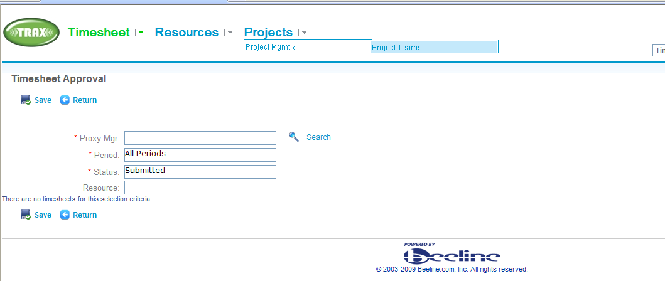
- Select “Select Project”
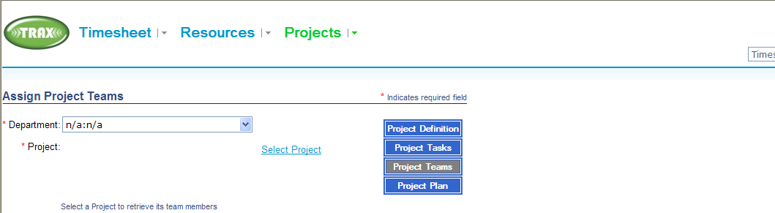
- Search for desired project. Double click on desired project to select it.
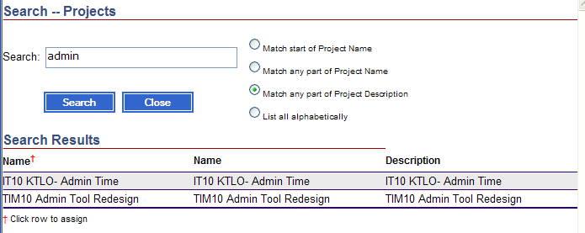
- Select resource (use “Search”). Highlight Resource. Highlight all tasks a person should be able to post time to. Select “Assign”.
- Repeat as necessary to assign all resources to project/tasks.
