

Salesperson’s Step by Step Guide

- Walk in Customer Process – Greeting to desk a deal.

- Phone up Customer Process – Call to appointment.

- Be Back Process – Return visit to desk a deal.

- Follow up Process – How Motosnap helps me sell cars.

Walk in Customer Process – Greeting to desk a deal. Page 1

- Login

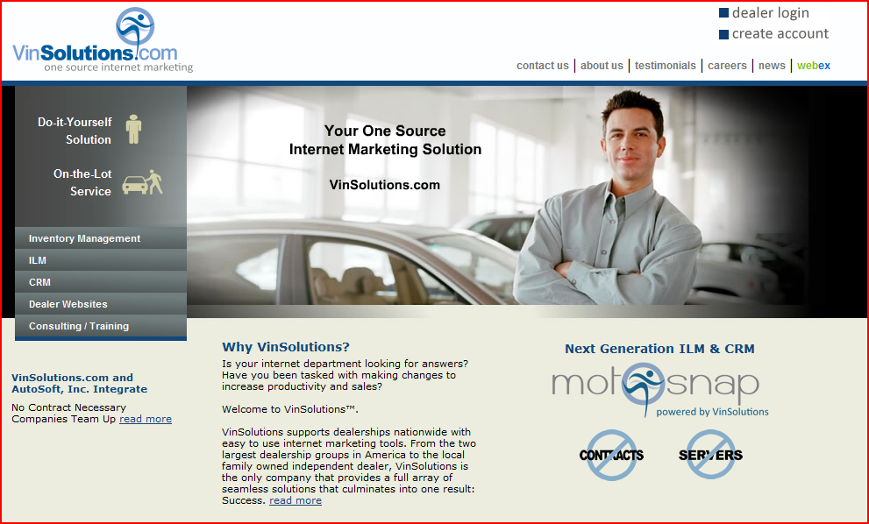
________________________________________________________________________________________________________________________________________________________________________________________________________________________________________________________________________

- Select Add

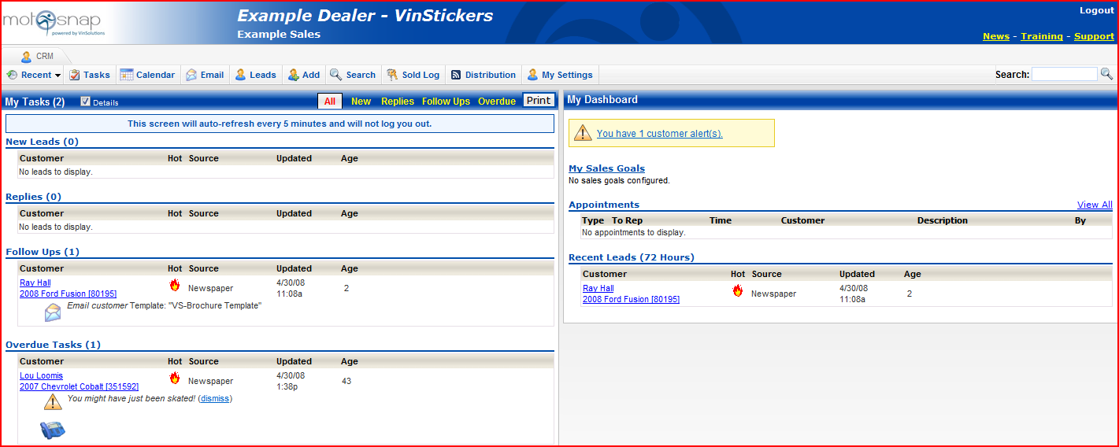
________________________________________________________________________________________________________________________________________________________________________________________________________________________________________________________________________

Walk in Customer Process – Greeting to desk a deal. Page 2

- Enter Customer Info

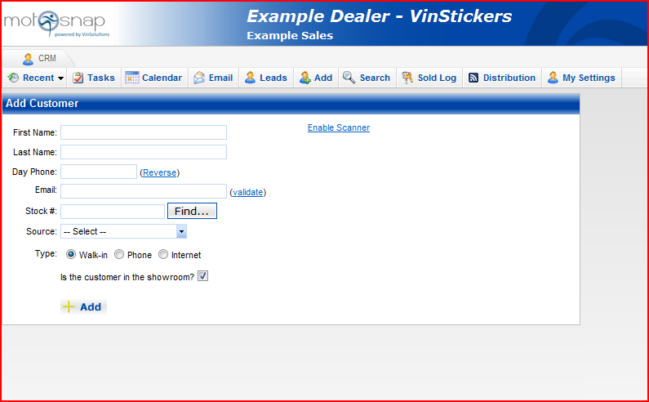
________________________________________________________________________________________________________________________________________________________________________________________________________________________________________________________________________

- Select Vehicle

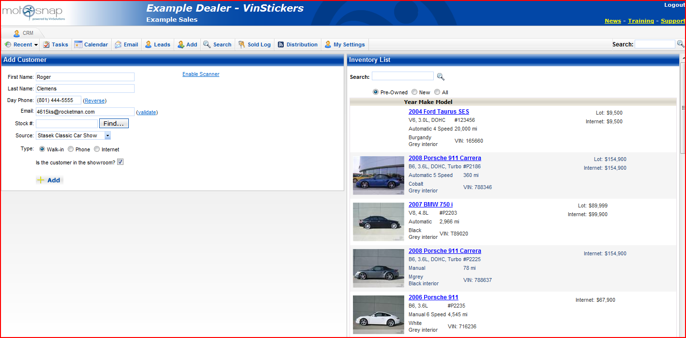
________________________________________________________________________________________________________________________________________________________________________________________________________________________________________________________________________

Walk in Customer Process – Greeting to desk a deal. Page 3

- Update / Complete Customer Info.

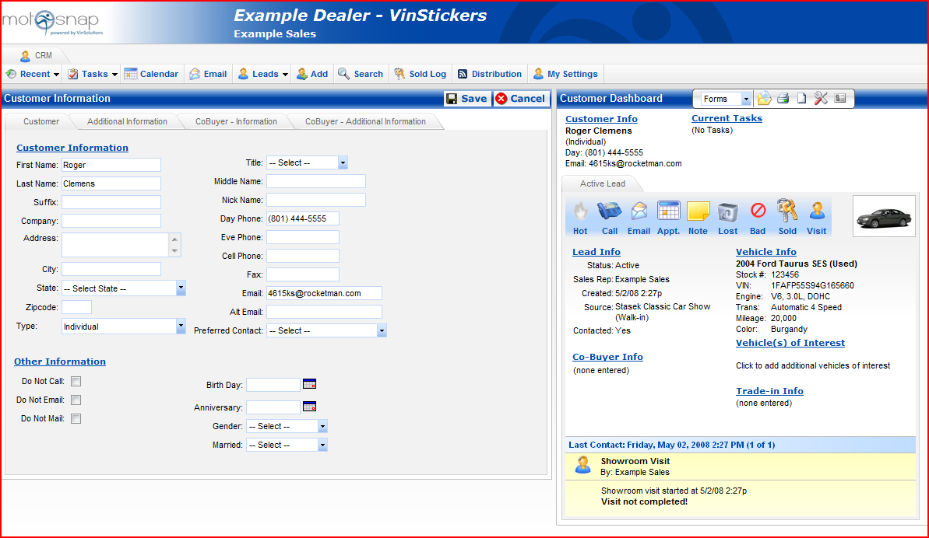
________________________________________________________________________________________________________________________________________________________________________________________________________________________________________________________________________________________________________________________________________________________________________________________________________________________________________________________________________________________________________________________________________________
________________________________________________________________________________________________________________________________________________________________________________________________________________________________________________________________________
________________________________________________________________________________________________________________________________________________________________________________________________________________________________________________________________________
________________________________________________________________________________________________________________________________________________________________________________________________________________________________________________________________________
________________________________________________________________________________________________________________________________________________________________________________________________________________________________________________________________________
________________________________________________________________________________________________________________________________________________________________________________________________________________________________________________________________________

Phone up Customer Process – Call to appointment. Page 1

- Login, then select add.

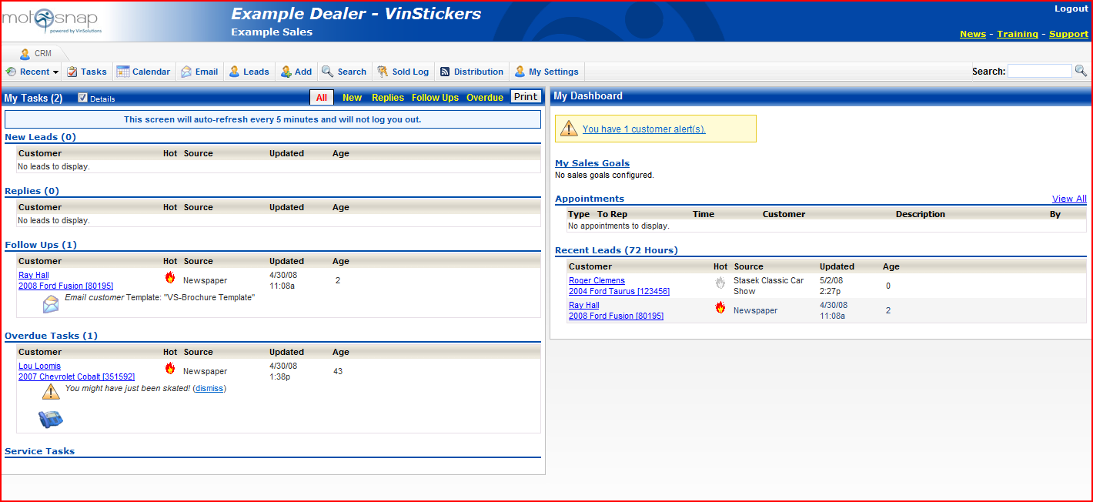
_________________________________________________________________________________________________________________________________________________________________________________________________________________________________________________________________________________

- Enter Customer info, choose source.

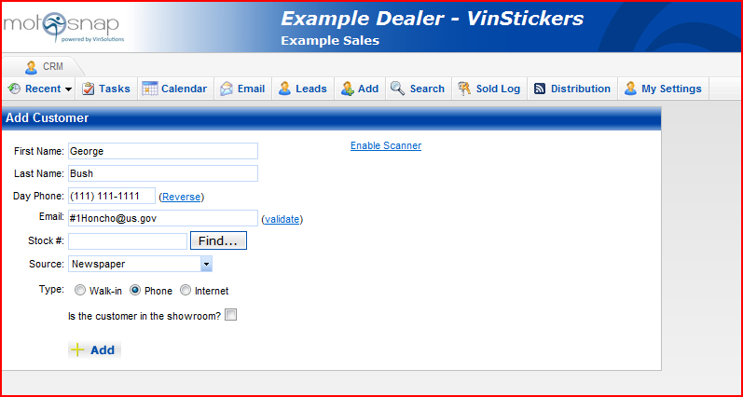
_________________________________________________________________________________________________________________________________________________________________________________________________________________________________________________________________________________

Phone up Customer Process – Call to appointment. Page 2

- Select Vehicle

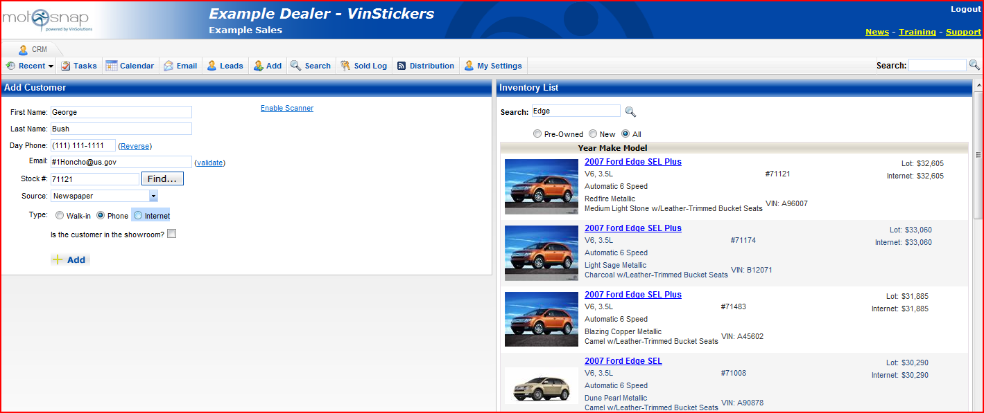
_________________________________________________________________________________________________________________________________________________________________________________________________________________________________________________________________________________

- Create Appointment in customer record.

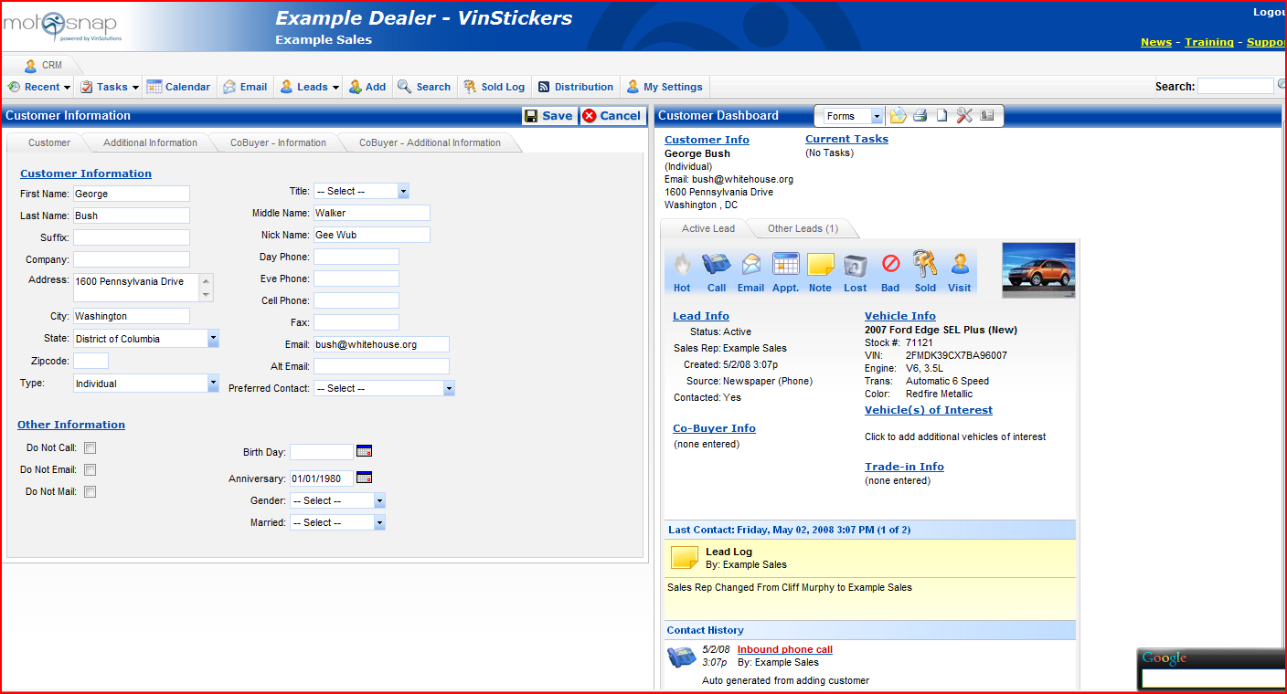
_________________________________________________________________________________________________________________________________________________________________________________________________________________________________________________________________________________

Phone up Customer Process – Call to appointment. Page 3

- Enter Appointment Info

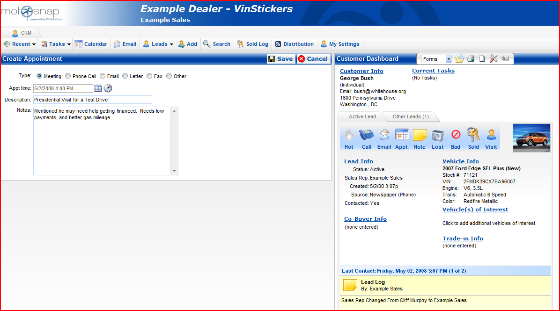
_________________________________________________________________________________________________________________________________________________________________________________________________________________________________________________________________________________

- Appointment Appears on Salesperson Dashboard

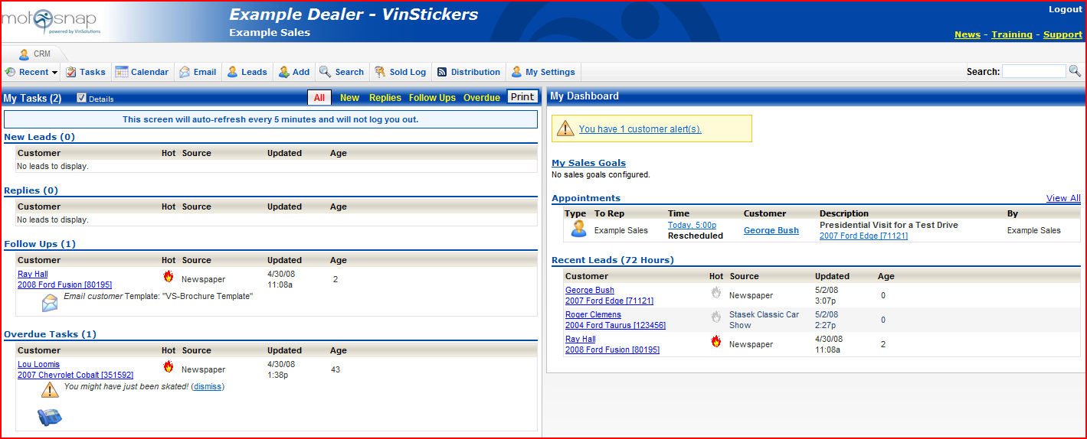
_________________________________________________________________________________________________________________________________________________________________________________________________________________________________________________________________________________

Be-Back process – Return visit to desk a deal. Page 1

- Login, then choose Select.

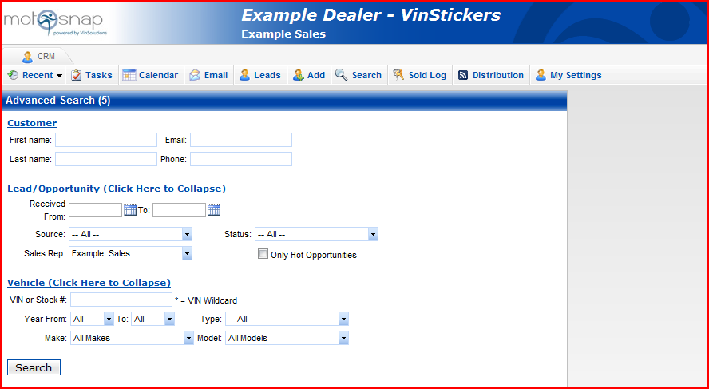
_________________________________________________________________________________________________________________________________________________________________________________________________________________________________________________________________________________

- Click on matching response.

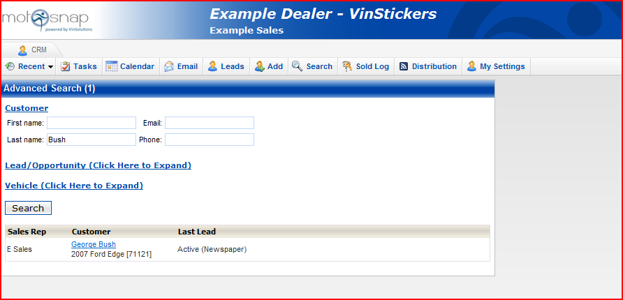
_________________________________________________________________________________________________________________________________________________________________________________________________________________________________________________________________________________

Be-Back process – Return visit to desk a deal. Page 2

- Click the Visit/Be-Back Button

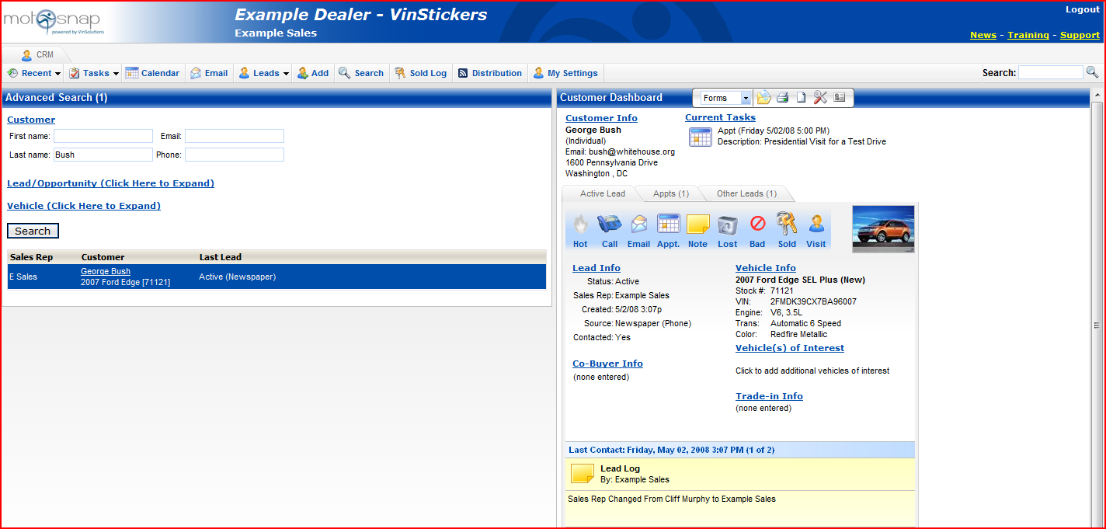
_________________________________________________________________________________________________________________________________________________________________________________________________________________________________________________________________________________

- Confirm active visit at bottom.

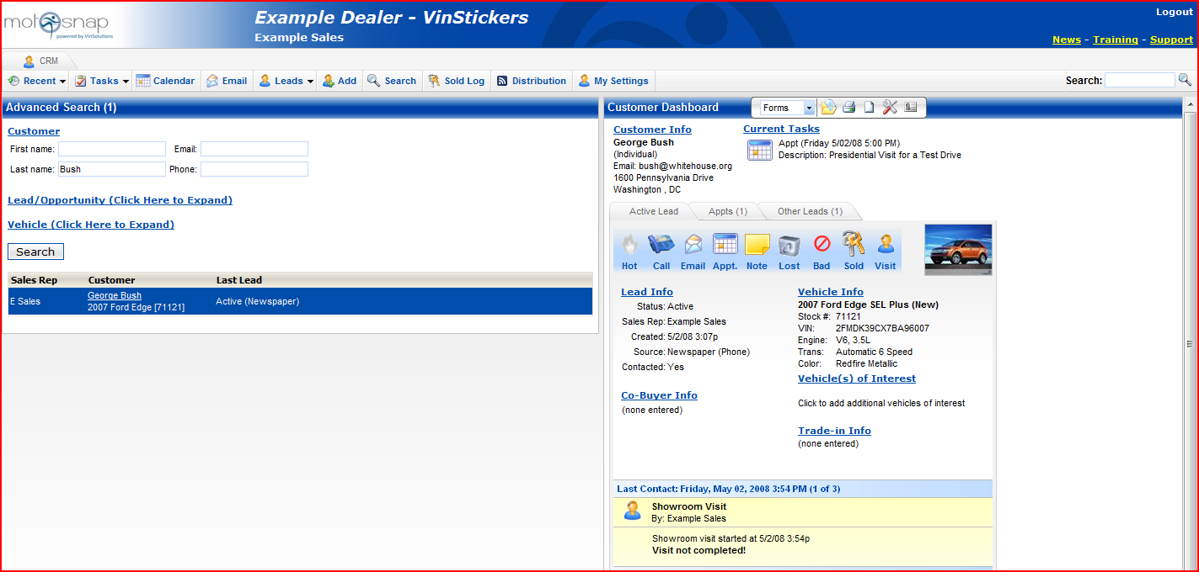
_________________________________________________________________________________________________________________________________________________________________________________________________________________________________________________________________________________

Follow up Process – How MotoSnap helps me sell cars. Page 1

- Login – Default screen.

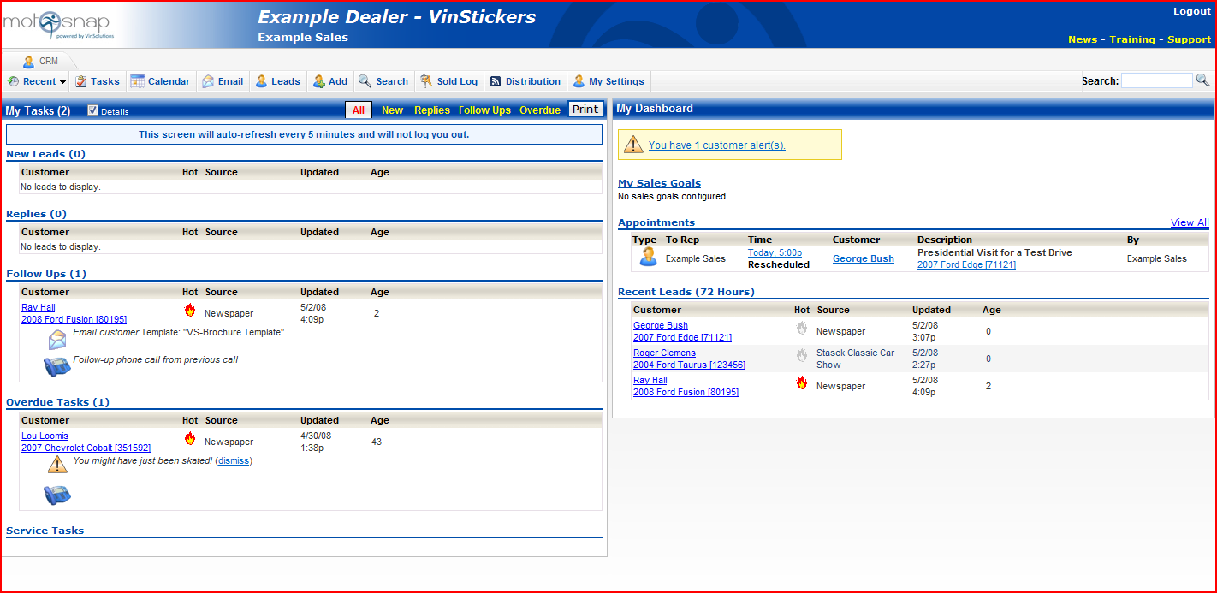
_________________________________________________________________________________________________________________________________________________________________________________________________________________________________________________________________________________

- Click phone icon.

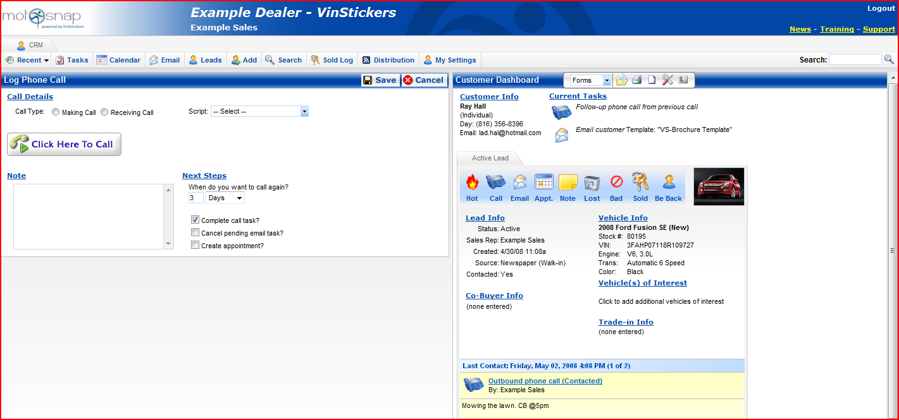
_________________________________________________________________________________________________________________________________________________________________________________________________________________________________________________________________________________

Follow up Process – How MotoSnap helps me sell cars. Page 2

- Enter Call info.
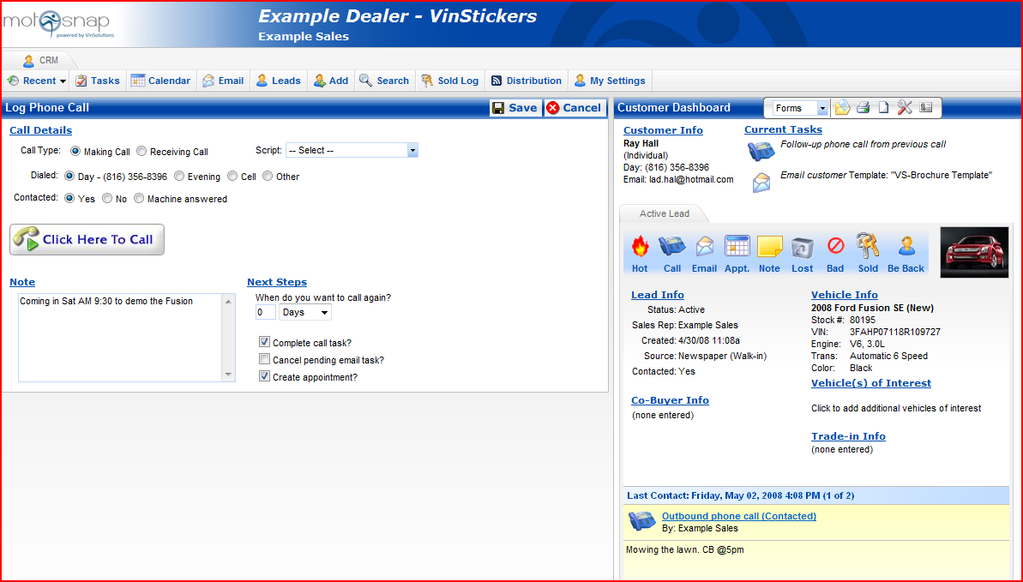
_________________________________________________________________________________________________________________________________________________________________________________________________________________________________________________________________________________
- Enter Appointment Info
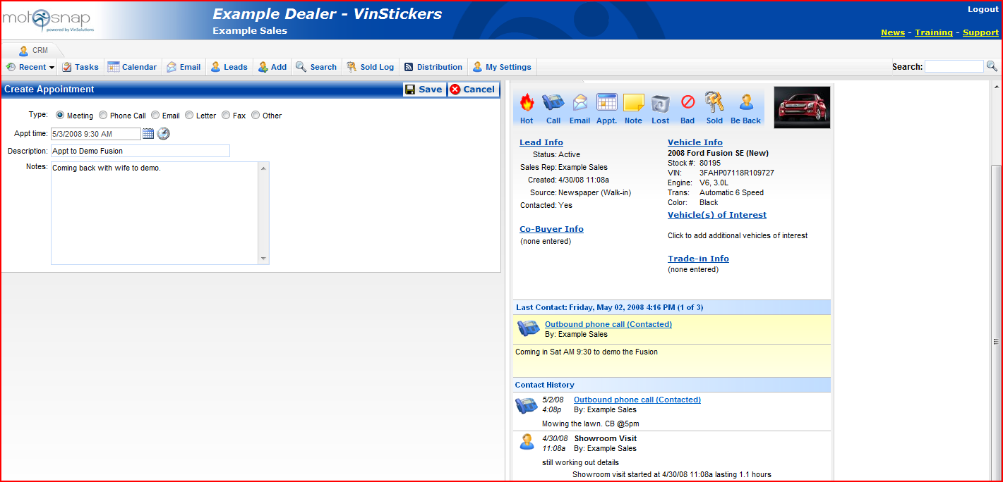
_________________________________________________________________________________________________________________________________________________________________________________________________________________________________________________________________________________

Follow up Process – How MotoSnap helps me sell cars. Page 2

- Confirm addition on the Dashboard.
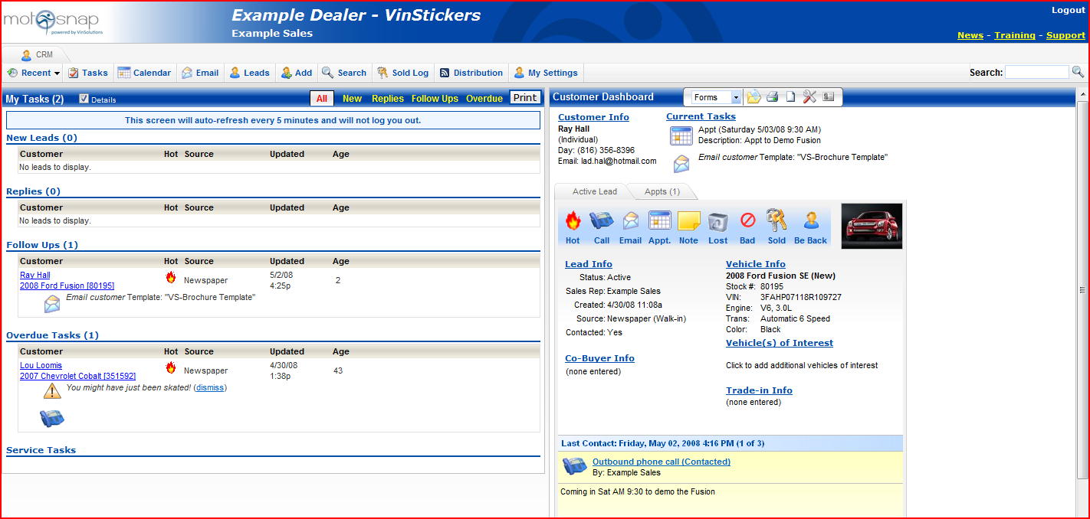
______________________________________________________________________________________________________________________________________________________________________________________________________________________________________________________________________________________________________________________________________________________________________________________________________________________________________________________________________________________________________________________________________________________________________________________________________________________________________________________________________________________________________________________________________________________________________________________________________________________________________________________________________________________________________________________________________________________________________________________________________________________________________________________________________________________________________________________________________________________________________________________________________________________________________________________________________________________________________________________________________________________________________________________________________________________________________________________________________________________________________________________________________________________________________________________________________________________________________________________________________________________________________________________________________________________________________________________________________________________________________________________________________________________________________________________________________________________________________________________________________________________________________________________________________________________________________________________________________________________________________________________________________________________________________________________________________________________________________________________________________________________________________________________________________________________________________________________________

Salesperson Acknowledgement

I, _______________________________, have attended the VinSolutions Training course, completed the following modules, and certify my proficiency with this program.

- Walk in Customer Process – Greeting to desk a deal.

- Phone up Customer Process – Call to appointment.

- Be Back Process – Return visit to desk a deal.

- Follow up Process – How Motosnap helps me sell cars.

Signed this ___day of ____________________, 2008.

_________________________

Trainer: _______________________________________

