**Accessing Salesforce Online Training**



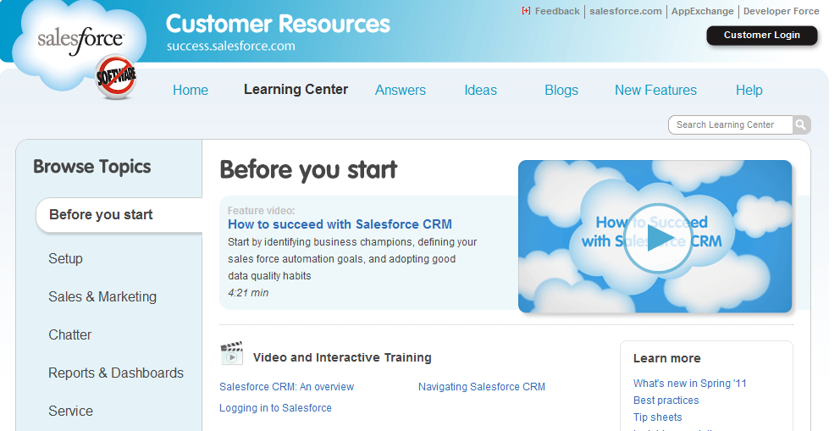

1. Click on the “Help & Training” link in the upper right corner of the Salesforce application window
2. Under the “Learning Center” take the 3 video training sessions: Salesforce CRM an overview, Logging into Salesforce, and Navigating Salesforce CRM.