**Approving Expense Reports**

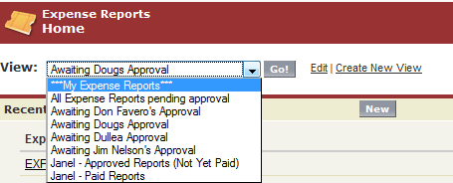

Click on the Expense Reports Tab and click on the drop down view arrow to find your view, select “GO!”

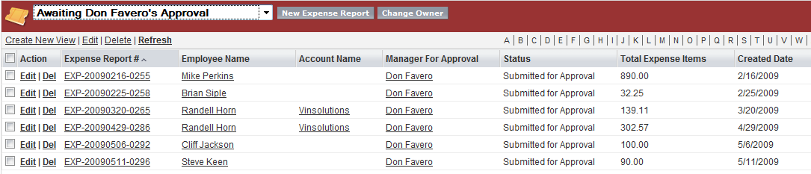

Click on the Expense Report to View

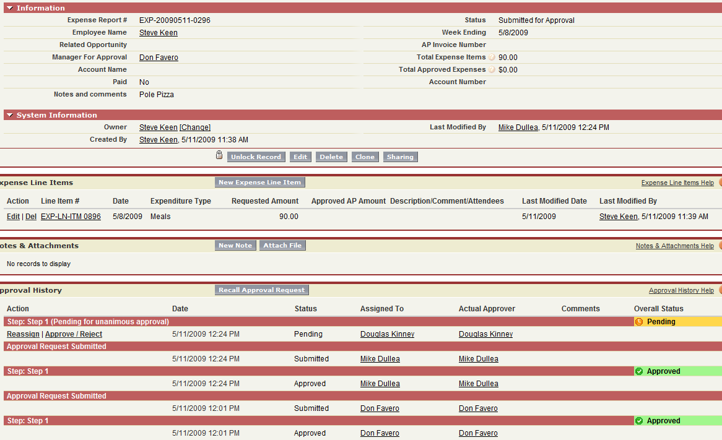

Review the Expense Report – to change an expense item “Requested Amount”, click on “Edit” to the left of the individual expense item.

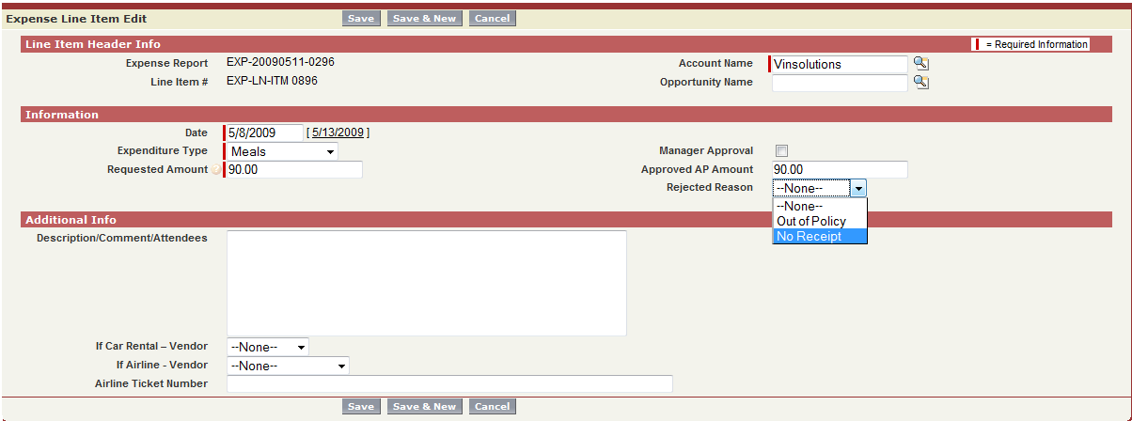

Edit the requested amount in the “Approved AP Amount” field and select the reason for the change. Add Comments if applicable and Save.

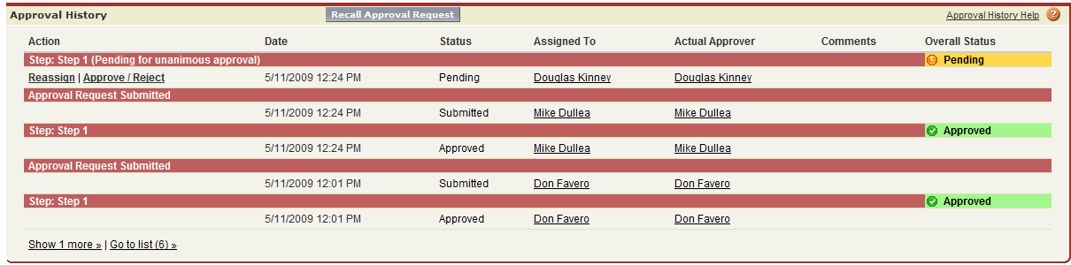

Select “Reassign” to assign Expense Report to new Approver

Select “Approve” to Approve Expense Report

Select “Reject” to reject the Expense Report