**How to Handle a Cancellation Task**

When a customer has requested to cancel all or part of services with VinSolutions, the Accounting department will be creating a case for the cancellation process. The Regional will receive an email task linked to that case with the details of the cancellation. Additionally, an email alert will be sent to the Don Favero, Steve Keen, the account Regional , Regional Assistant, Territory Manager and DDM.

The task will appear on the home page of the Regional and will give the Regional a link to the related case.

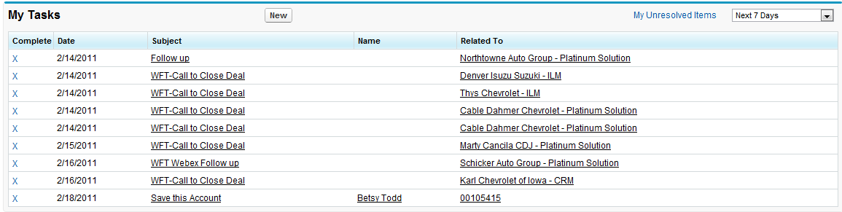

Link to Case

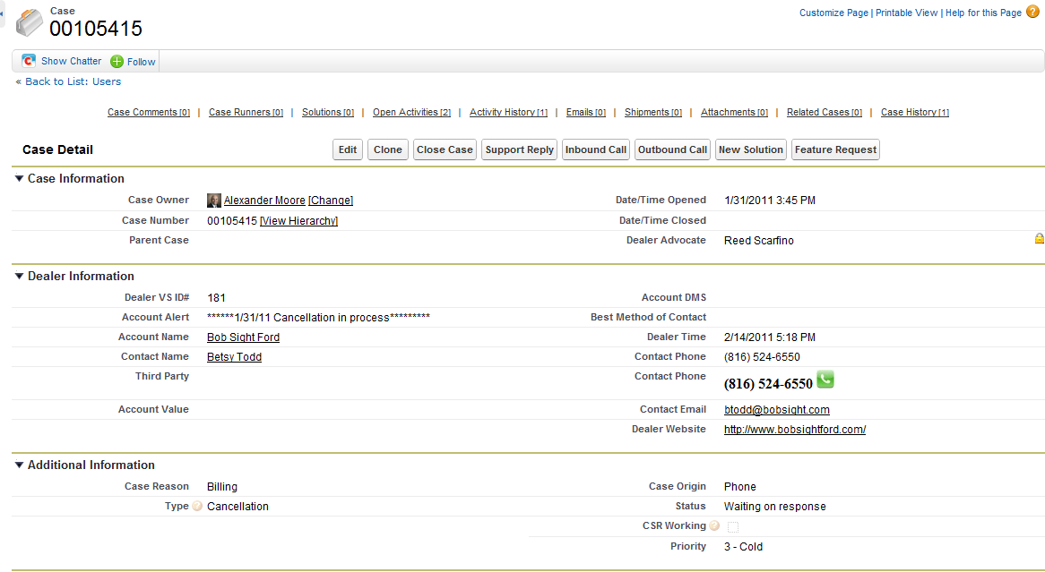

Case

Create a case comment to share internal information about this account with internal users.

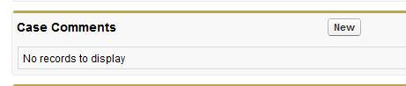

There are buttons at the top of the page for logging calls: Outbound versus Inbound. If you call the customer to discuss the cancellation, click on the Outbound Call button and log your notes when you finish the call and click on Save. Click on the Inbound Call button if you receive a call from the customer to discuss the cancellation, log your notes and click on Save.



**All calls/emails must be logged into this case for legal purposes.**