**Opportunity Installments**

Every Opportunity generated will have at least 1 Installment

Upon Payment of the 1st Installment the Project and Project Pieces will be generated

Paid revenue will be recognized by the Installment paid date

Requests for multiple installments have to be submitted for approval to Keith, Randell, Don and the Opportunity cannot be “Closed or Won” until approved.

Installment amounts and due dates are auto-generated but editable and must be updated prior to “Closed or Won”. (Only Don, Randell & Keith can edit the Payment Amounts and Due Dates).

Deal Sheet will have the list of Installment Amounts and Due Dates

Email notification to Deal Contact 5 days before next installment due date

If subsequent Installments not paid on time, email alert Keith, Don, Randell, Regional and Operations to freeze project

When past due installment paid, email notification to Operations to unfreeze project

**How to get Approval for Installments on an Opportunity**

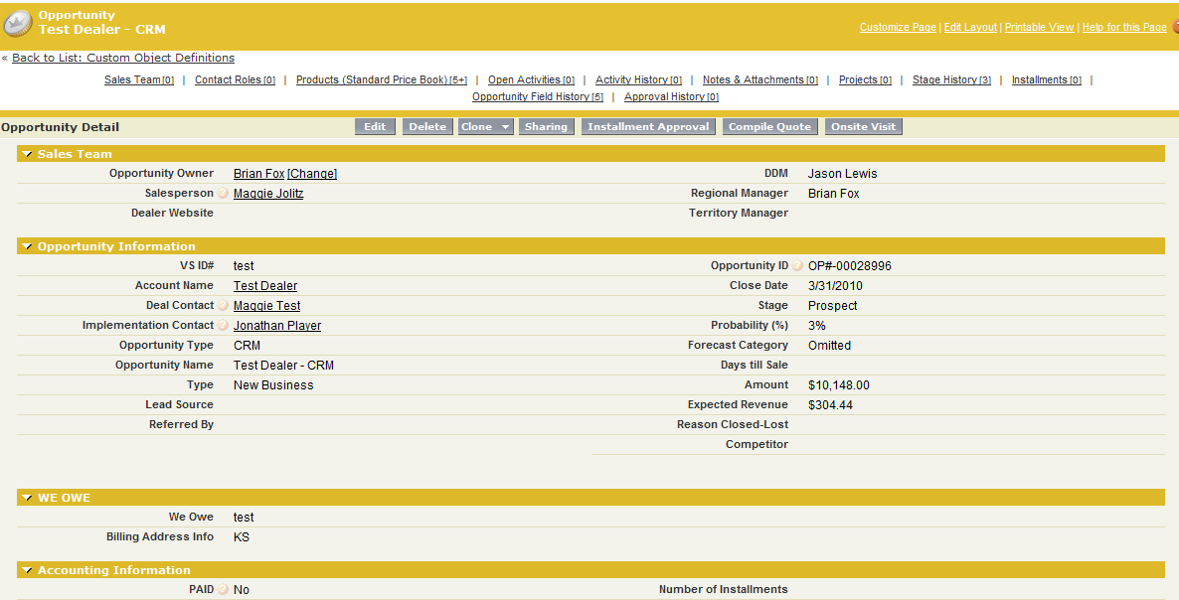

1. Enter # of Installments Requested
2. Submit for Approval

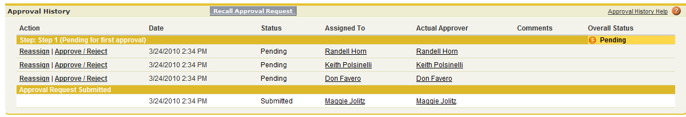

Related List – Approval History

Pending Approval

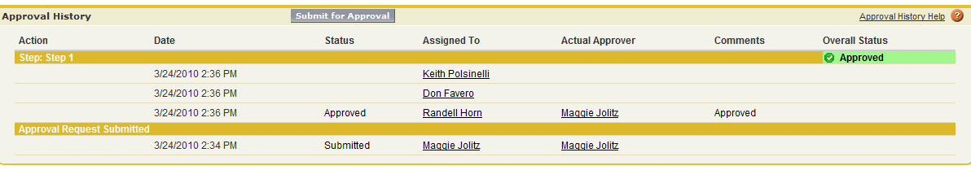

Related List – Approval History

Approved

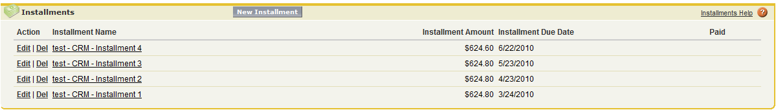

Related List – Installments