**Onsite Visits**

**Introduction**

Whenever there is an onsite visit for a client the Regional will click on the “Onsite Visit” button from within the Opportunity. This will create a special Onsite Visit Project for the Regional to work from to complete the checklist of information prior to the visit.

**Process**

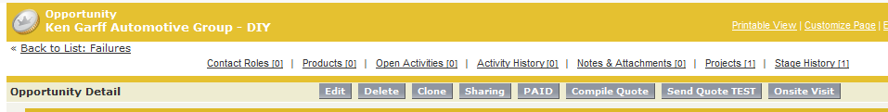

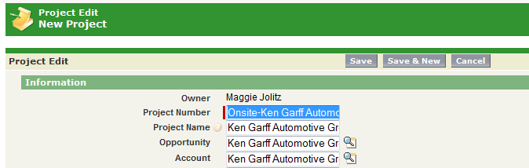

Click the “Save” button when the Project opens

Click the “Onsite Visit” button

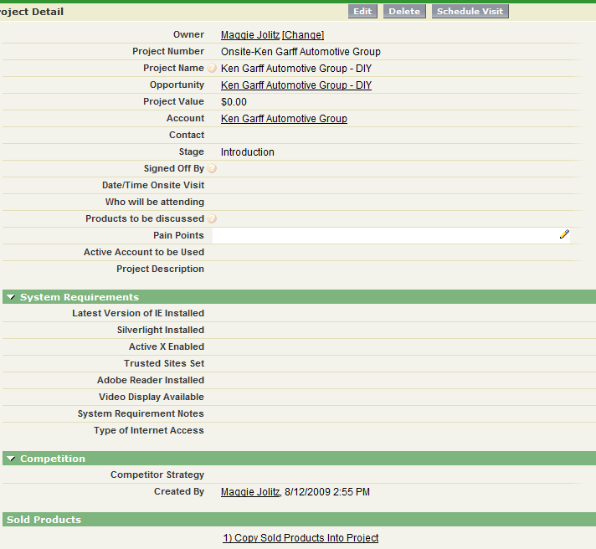

Project Shell- update the information as it is gathered

**Information to be Collected/Updated**

|  |  |
| --- | --- |
| **Salesforce Field** | **Description** |
| Signed Off By | Don or Randell will assign themselves to this project when the information has been completed |
| Stage | Introduction – default stage  Completed – update to completed when all information gathered |
| Date/Time Onsite Visit | Date and Time that onsite visit is scheduled |
| Products to be discussed | Free form text box |
| Who will be attending | Free form text box |
| Pain Points | Free form text box-enter issues that customer is currently having that our software can resolve |
| Active Account to be Demoed | The name of the dealership they will use as an example during the onsite visit |
| Project Description | Free form text box to put information about the onsite visit |
| Latest Version of IE Installed | Check the box when verified |
| Silverlight Installed | Check the box when verified |
| Active X Enabled | Check the box when verified |
| Trusted Sites Set | Check the box when verified |
| Adobe Reader Installed | Check the box when verified |
| Video Display Available | Pick list: Big Screen, PC, Projector |
| Type of Internet Access | Pick list: Dial-up, DSL, T1, WiFi |
| System Requirement Notes | Any notes about the system requirements |
| Competitor Strategy | Free form text box to put in notes about who we are up against. |
| Sold Products | Link that the user can click on to bring over the Products from the Opportunity into the Project |

Related Lists

|  |  |
| --- | --- |
| **Salesforce Related List** | **Description** |
| Project Comments | Users can add comments related to the project |
| Products Sold | If the user clicks the link 1) Copy Sold Products into Project the Products from the Opportunity will be displayed here |
| Teams | Assigns internal Salesforce users to the Project- what VinSolutions people will be meeting with Dealer |
| Dealer Project Teams | Assigns customer contacts to the project – who will you be meeting with at the Dealership |
| Notes & Attachments |  |
| Open Activities | Any tasks or events that have not been completed – Click on “New Event” to actually schedule the onsite visit, this will ensure the event is posted to the group calendar that records all the onsite visits scheduled. |
| Activity History | Completed Activities and Events |

**Views**

From the Projects tab find the view “Onsite Visits” and click Go, this will present all the onsite visits scheduled for the future.

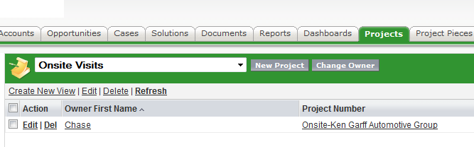

**To Print the Information**



Click the link “Printable View” in the upper right hand corner of the Project

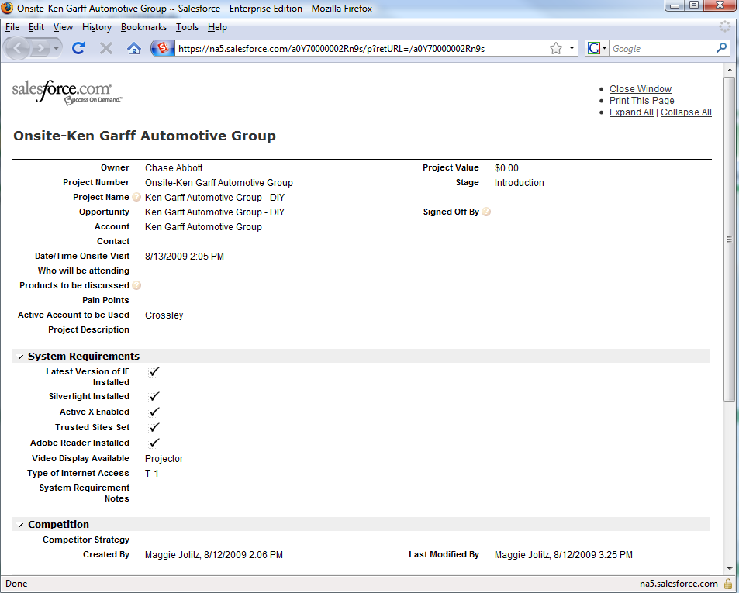

Printout