**VinSolutions.com**

**Craig’s List Posting Configuration Guide**

**Internal Manual**

Created: 06/10/2009

**CRAIG’S LIST POSTING SOFTWARE INSTALLATION**

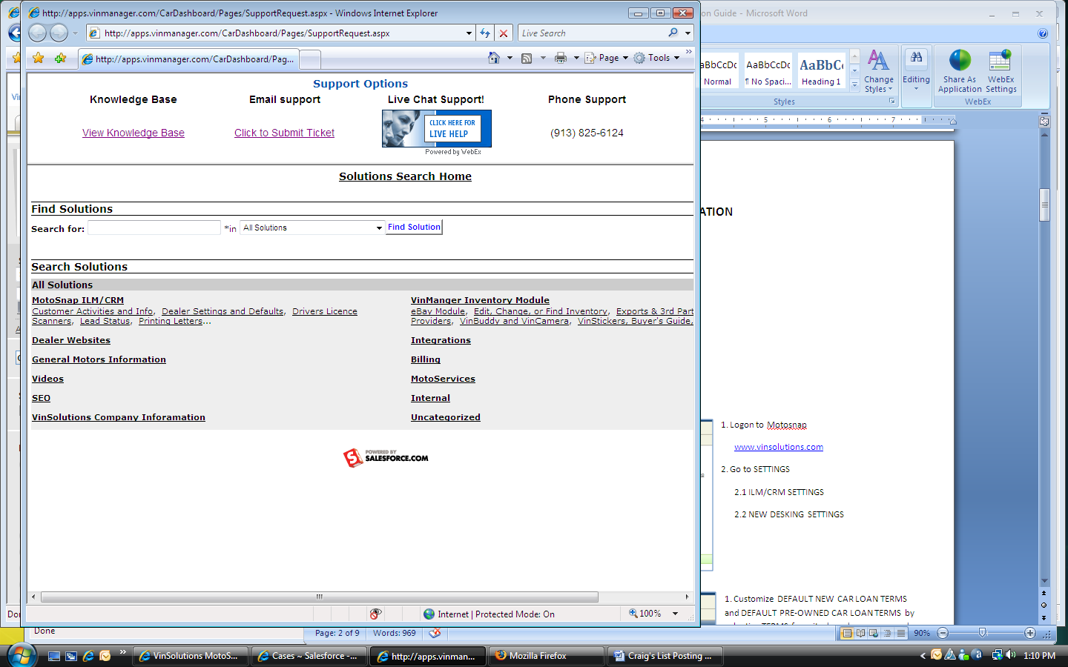1. Log on to Motosnap at [www.vinsolutions.com](http://www.vinsolutions.com)

2. Click on SUPPORT link on top right corner to open up a new SUPPORT OPTIONS window

3. Search for Craig’s List in ALL SOLUTIONS by typing in a keyword “craigslist” in the search box

4. The search engine returns a list of solutions. Click on a solution titled WHERE CAN I GET THE CRAIGSLIST POSTER, last modified on 1/21/2009

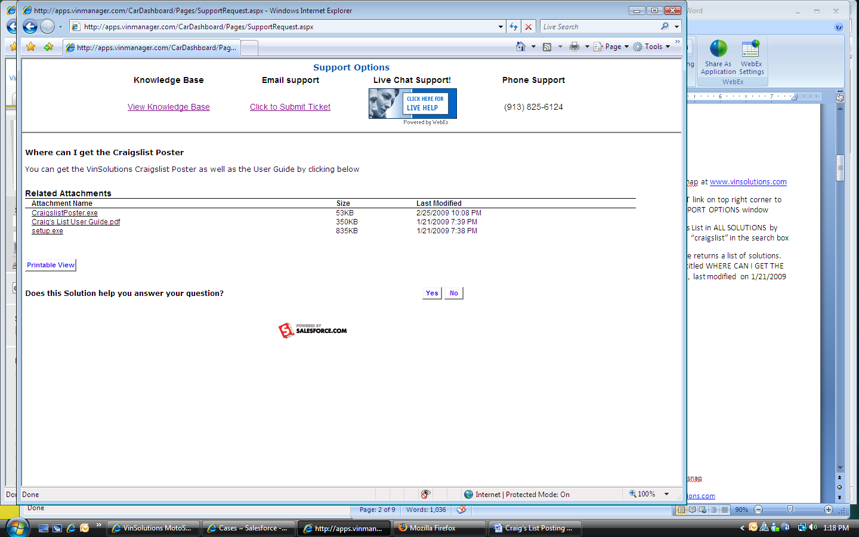1. Click on SETUP.EXE from RELATED ATTACHMENTS

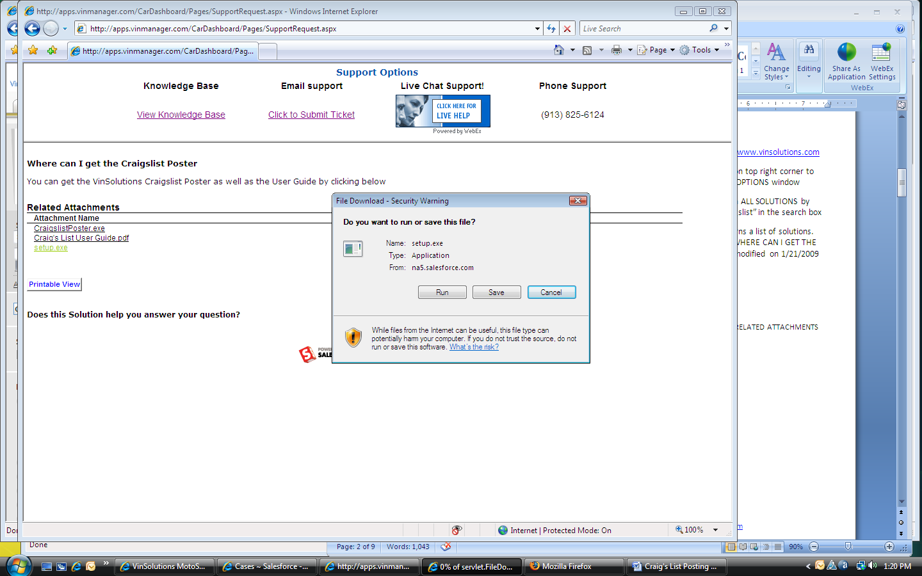

1. FILE DOWNLOAD window pops up on the screen

2. Click on SAVE. Change the location to the desktop. Save the file

NOTE: Clear the CLOSE THIS DIALOG BOX WHEN DOWNLOAD COMPLETES checkbox when download starts

**2**

3. When download completes, Click on RUN button to execute the installation

4. When INTERNET EXPLORER – SECURITY WARNING window pops up for UNKNOWN PUBLISHER, click on RUN to continue with the installation