**VinSolutions.com**

**MotoBlast Installation and Troubleshooting Guide**

**For Dealership Installation**

Created: 06/10/2009

**STEP1 DEALERSHIP:** **Register for SmartPromote**

The dealership will receive an email from VinSolutions support team. The email contains a single page PDF file (SmartPromoteInstallDirections.pdf) and a hyperlink within its body that leads to the SmartPromote Registration site.

NOTE: Make sure that you have Administrative Rights on your computer

Click on the link provided in the email from VinSolutions support team:

<http://smartpost.smartpillars.com/vinsolutions/register.html>

**SMARTPROMOTE REGISTRATION**

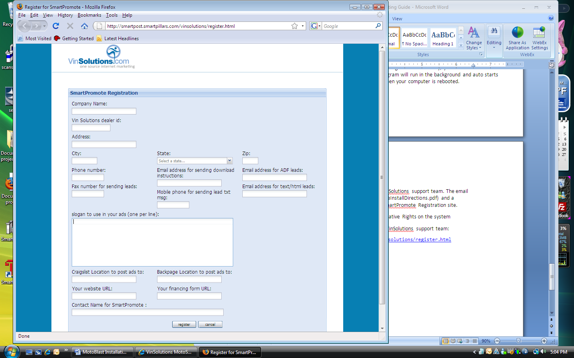1. Fill out all data fields

2. Use four-digit VinSolutions Dealer ID. This ID number can be found on top of your Motosnap home page.

**2**

**3**

**4**

**1**

3. For CRAIGSLIST TO POST ADS TO field and BACKPAGE LOCATION TO POST ADS TO field, enter a name of the nearest metropolitan area and the second nearest city to be listed on the Craig’s List. This setting will determine the location of your posting.

4. Click on REGISTER button to complete the registration

**STEP2 DEALERSHIP:** **Install SmartPromote Software**

You will receive an email from VinSolutions support team. The email contains a single page PDF file (SmartPromoteInstallDirections.pdf) and a hyperlink within its body that leads to the SmartPromote Registration site.

NOTE: Make sure that you have Administrative Rights on your computer

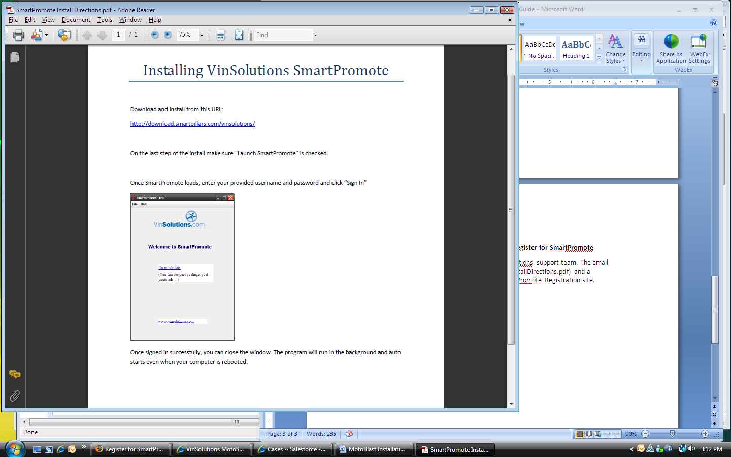**SmartPromoteInstallDirections.pdf**

1. Click on the URL:

<http://download.smartpillars.com/vinsolutions/>

2. A Security Warning windows pops up. Click on ALLOW button to continue with the installation

**1**

**2**

**3**

**4**

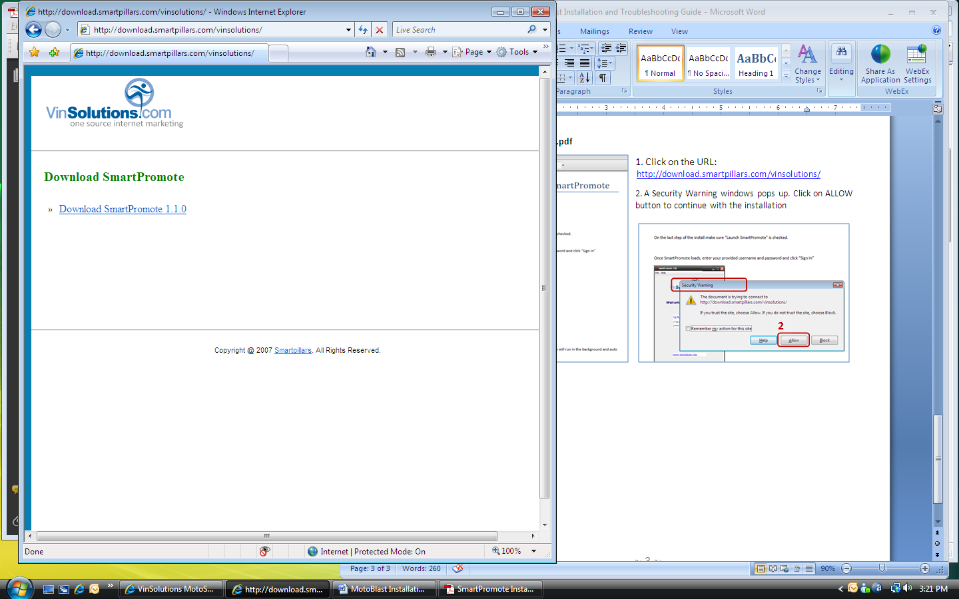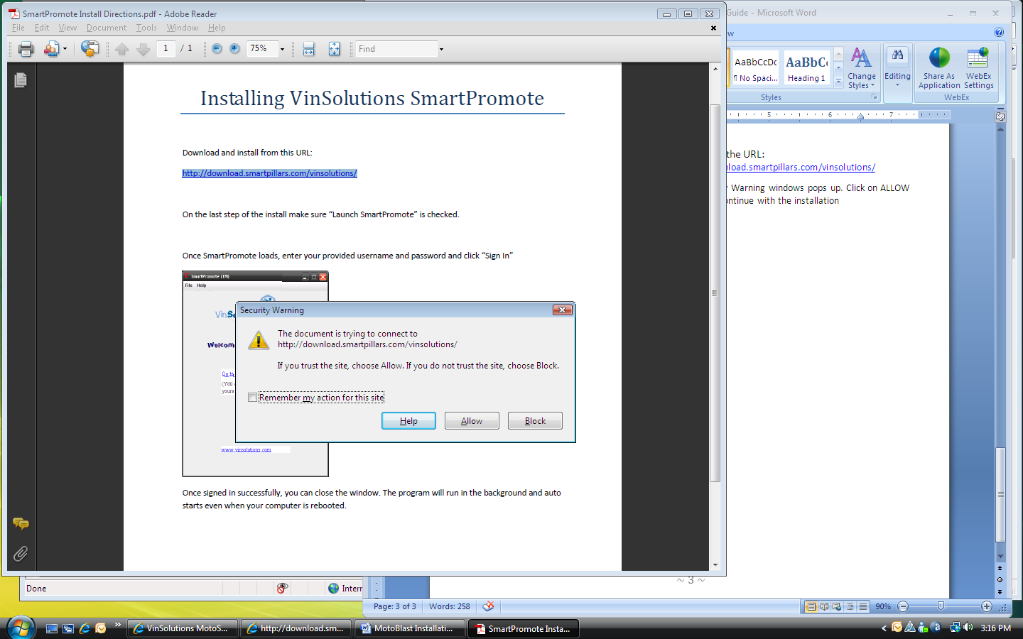

3. A new window pops up with a link for SmartPromote Download. Click on Download SmartPromote 1.1.0

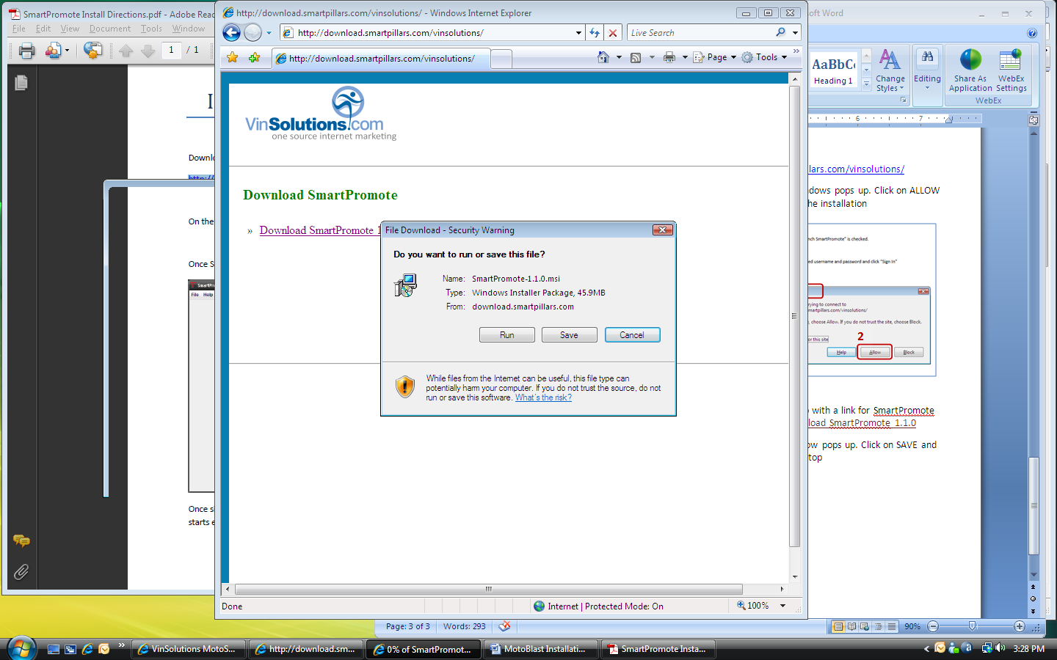4. FILE DOWNLOAD window pops up. Click on SAVE and save the file on your desktop

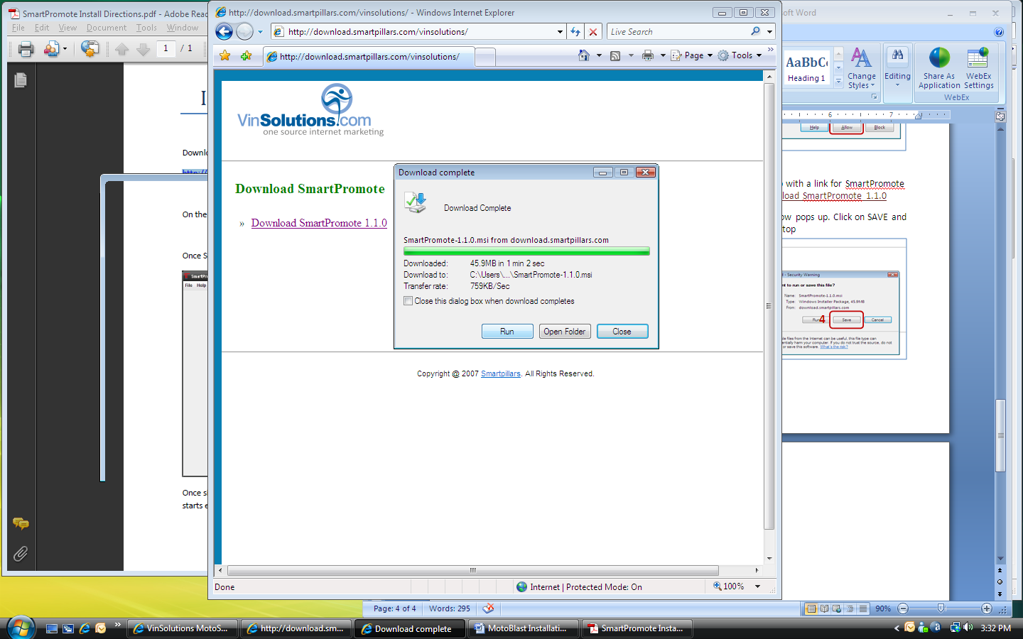5. Uncheck the CLOSE THIS DIALOG BOX WHEN DOWNLOAD COMPLETES checkbox when file download starts

6. When download is complete, click on RUN button to continue

7. An INTERNET EXPLORER – SECURITY WARNING window pops up for UNKNOWN PUBLISHER warning. Click on RUN button to continue

**5**

**6**

**8**

**9**

**10**

**11**

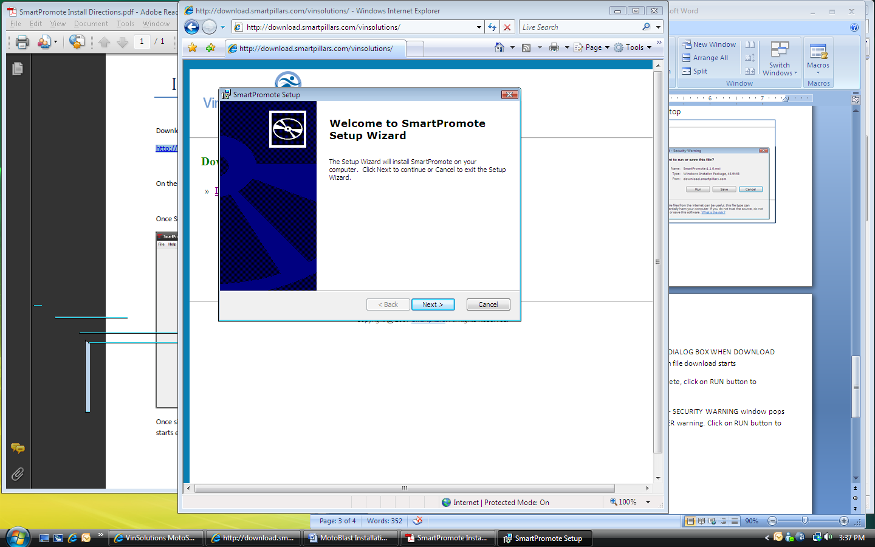

8. A SETUP WIZARD pops up. Click NEXT to start the wizard

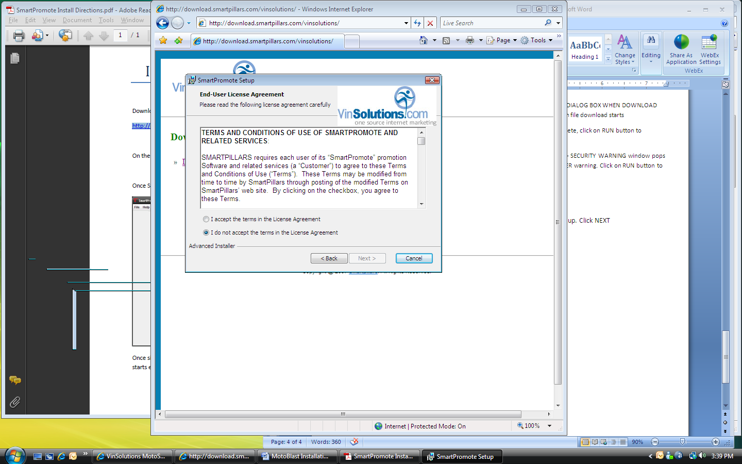

9. Click on I ACCEPT THE TERMS radio button

10. Click NEXT to continue

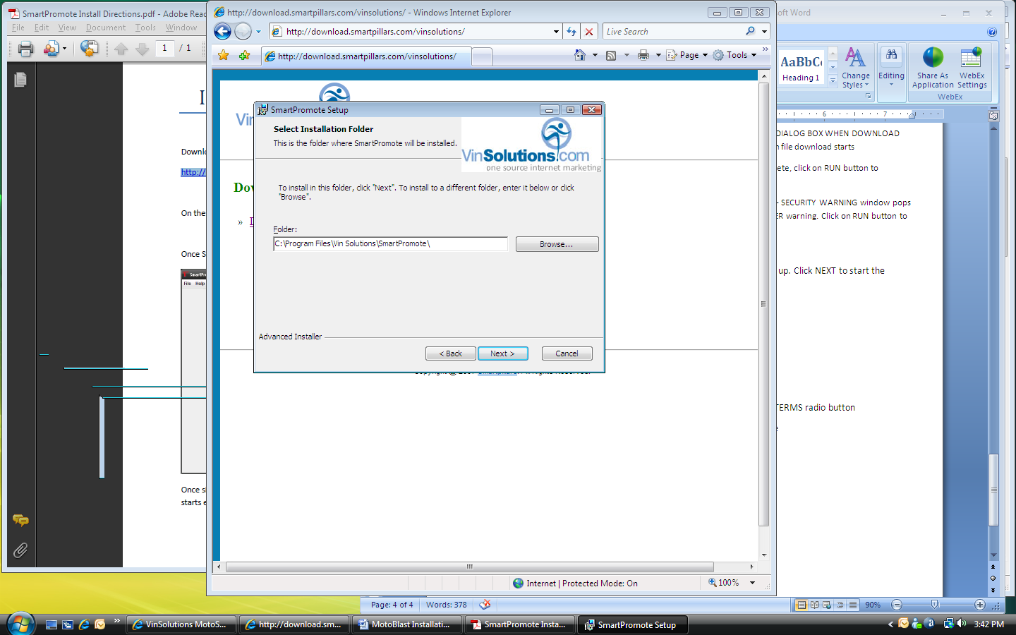11. Keep the default setting for INSTALLATION FOLDER path and click NEXT

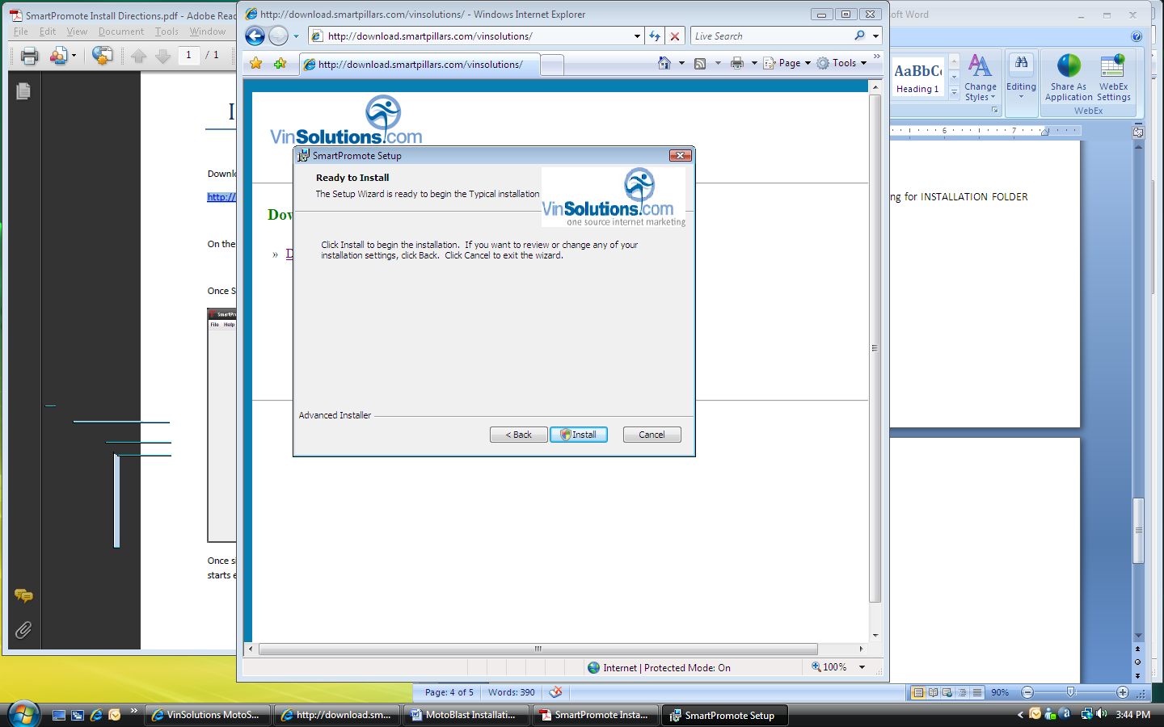12. Click INSTALL to begin the installation

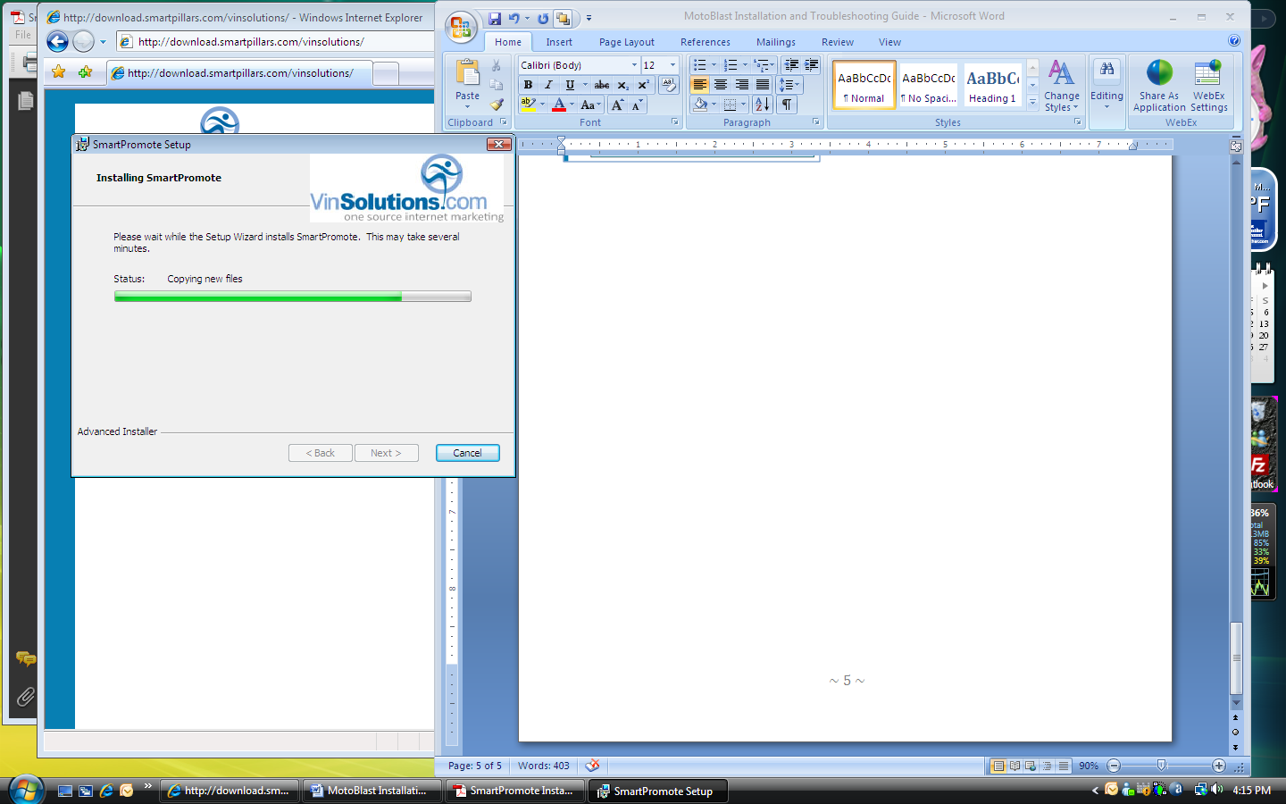

**12**

**12**

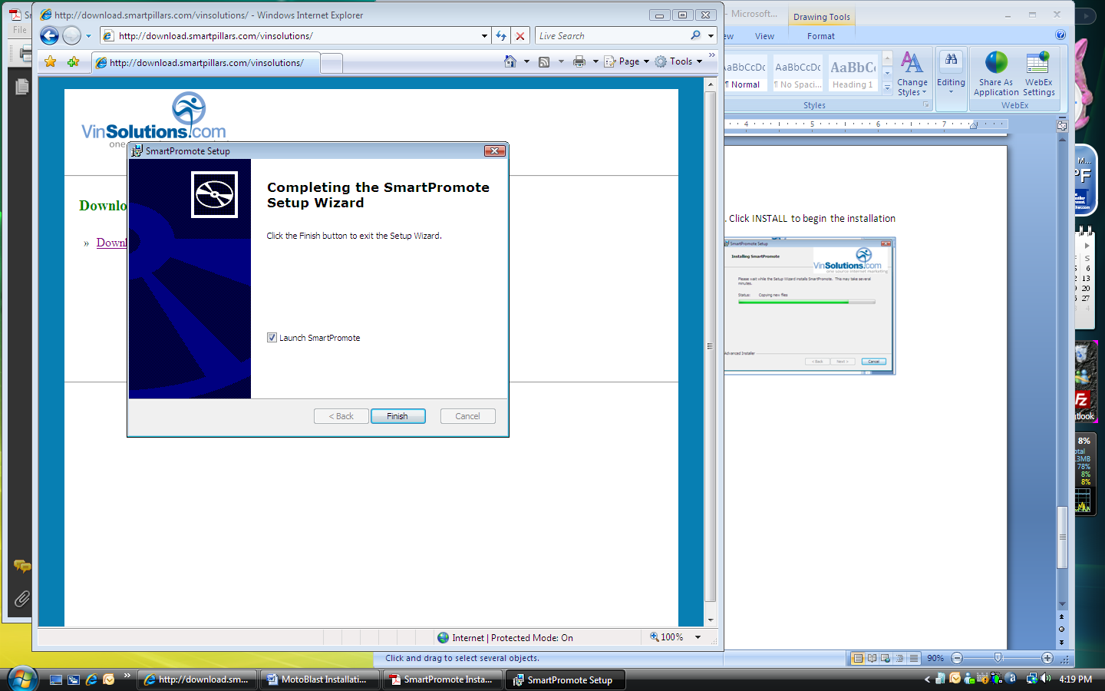13. Click FINISH to complete the installation

14. Make sure that LAUNCH SMARTPROMOTE checkbox is checked

**13**

**14**

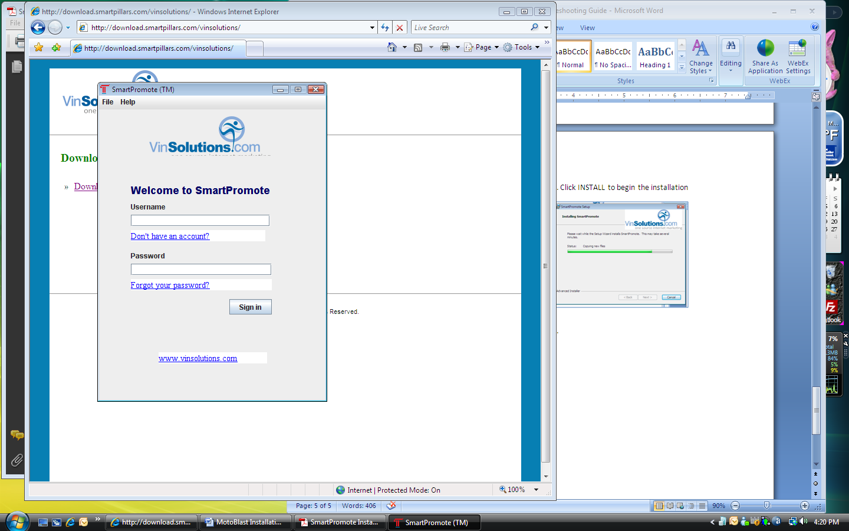

15. SmartPromote window is launched

NOTE: You should have received your Username and Password from SmartPillar after the registration from page 2

16. Username:

**16**

**17**

**18**

17. Password:

18. Click SIGN IN

19. Once signed in successfully, you can close the window. The program will run in the background and auto starts even when your computer is rebooted.