**VinSolutions.com**

**MotoBlast Installation and Troubleshooting Guide**

**For Internal Use Only**

Created: 06/10/2009

**MotoBlast Installation Guide**

**STEP1. VinSolutions:** **Create and send out an invitation email to the dealership**

Use the following format to create the email:

My name is YOUR NAME HERE and I am the YOUR POSITION HERE here at VinSolutions. Congratulations on your upgrade to MotoBlast. I am attaching a form that you need in order to setup your MotoBlast. Your VS id is DEALER VS ID HERE. Prior to the software installation, you will need to complete a registration with Smart Pillar by clicking on the link provided below. Once registered, please open attached PDF file. Open up the document and follow the instructions provided to complete the installation of VinSolutions SmartPromote.

Registration Link:

<http://smartpost.smartpillars.com/vinsolutions/register.html>

NOTE: The PDF file is stored in VinSolutions Network drive V:\Support\Support Document folder

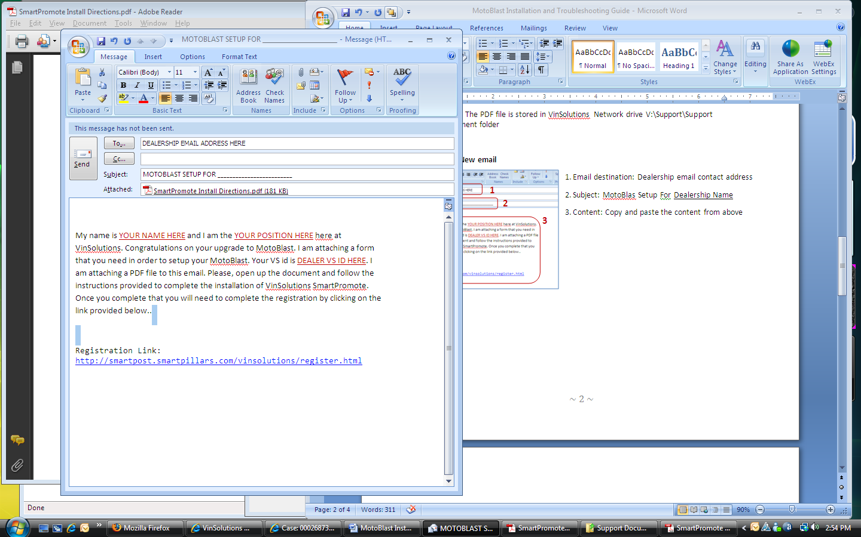**Microsoft Outlook: New email**

1. Email destination: Dealership email contact address

**1**

**2**

**3**

**4**

**3**

**5**

2. Subject: “MotoBlas Setup For Dealership Name”

3. Attachment: Click on the attachment icon.

Locate the file: SmartPromoteInstallDirections.pdf from V:\Support\Support

Click INSERT to attach the file

4. Content: Copy and paste the content from above

5. Click SEND to complete the task

**STEP2 DEALERSHIP:** **Register for SmartPromote**

The dealership will receive an email from VinSolutions support team. The email contains a single page PDF file (SmartPromoteInstallDirections.pdf) and a hyperlink within its body that leads to the SmartPromote Registration site.

NOTE: Make sure that the user has Administrative Rights on the system

Click on the link provided in the email from VinSolutions support team:

<http://smartpost.smartpillars.com/vinsolutions/register.html>

**SMARTPROMOTE REGISTRATION**

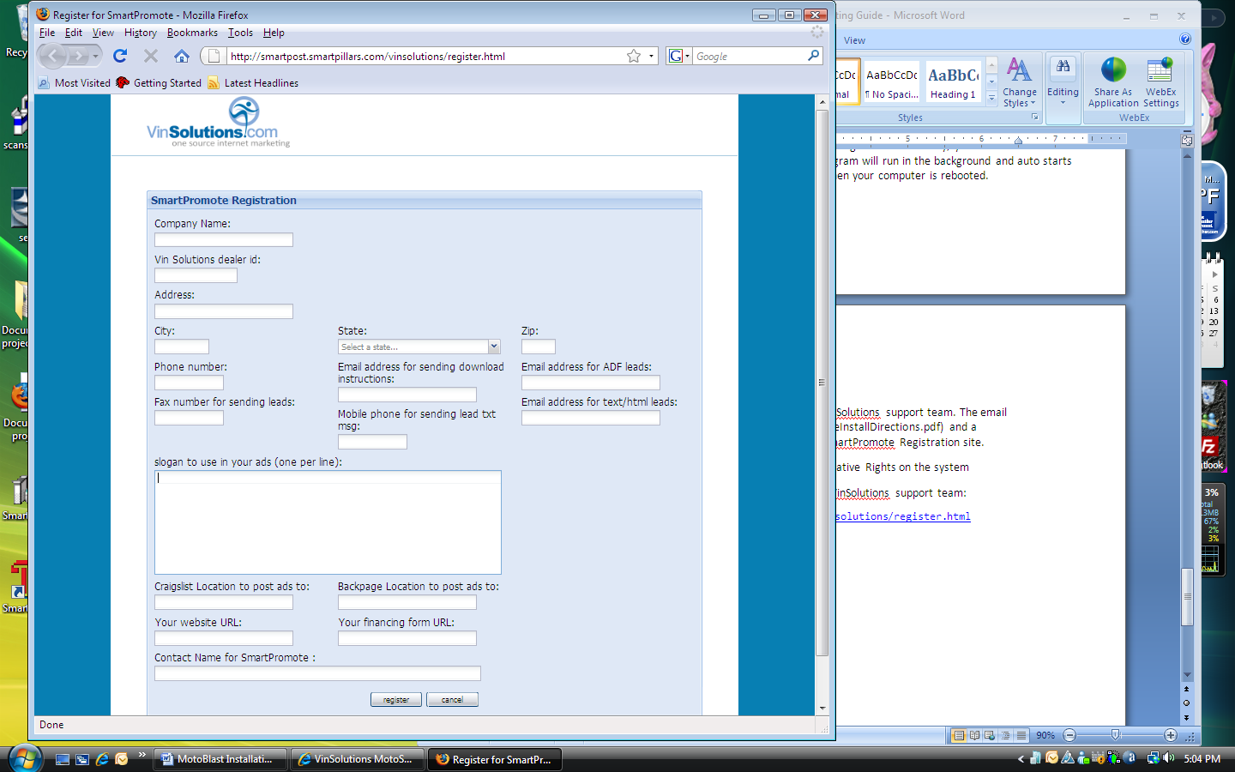1. Fill out all data fields

2. Use four-digit VinSolutions Dealer ID. This ID number can be found on top of your Motosnap home page.

**2**

**3**

**4**

**1**

3. For CRAIGSLIST TO POST ADS TO field and BACKPAGE LOCATION TO POST ADS TO field, enter a name of the nearest metropolitan area and the second nearest city to be listed on the Craig’s List. This setting will determine the location of your posting.

4. Click on REGISTER button to complete the registration

**STEP3 DEALERSHIP:** **Install SmartPromote Software**

The dealership will receive an email from VinSolutions support team. The email contains a single page PDF file (SmartPromoteInstallDirections.pdf) and a hyperlink within its body that leads to the SmartPromote Registration site.

NOTE: Make sure that the user has Administrative Rights on the system

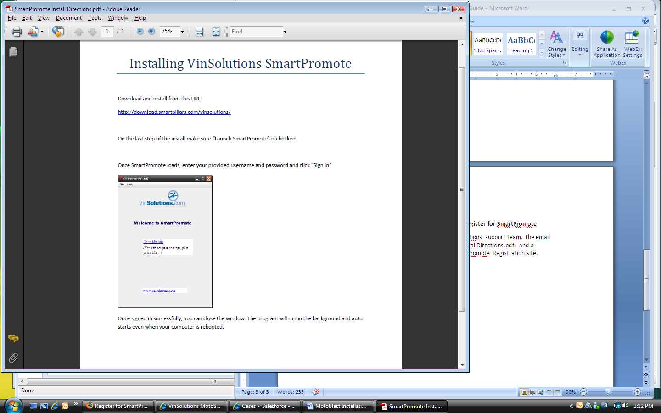**SmartPromoteInstallDirections.pdf**

1. Click on the URL:

<http://download.smartpillars.com/vinsolutions/>

2. A Security Warning windows pops up. Click on ALLOW button to continue with the installation

**1**

**2**

**3**

**4**

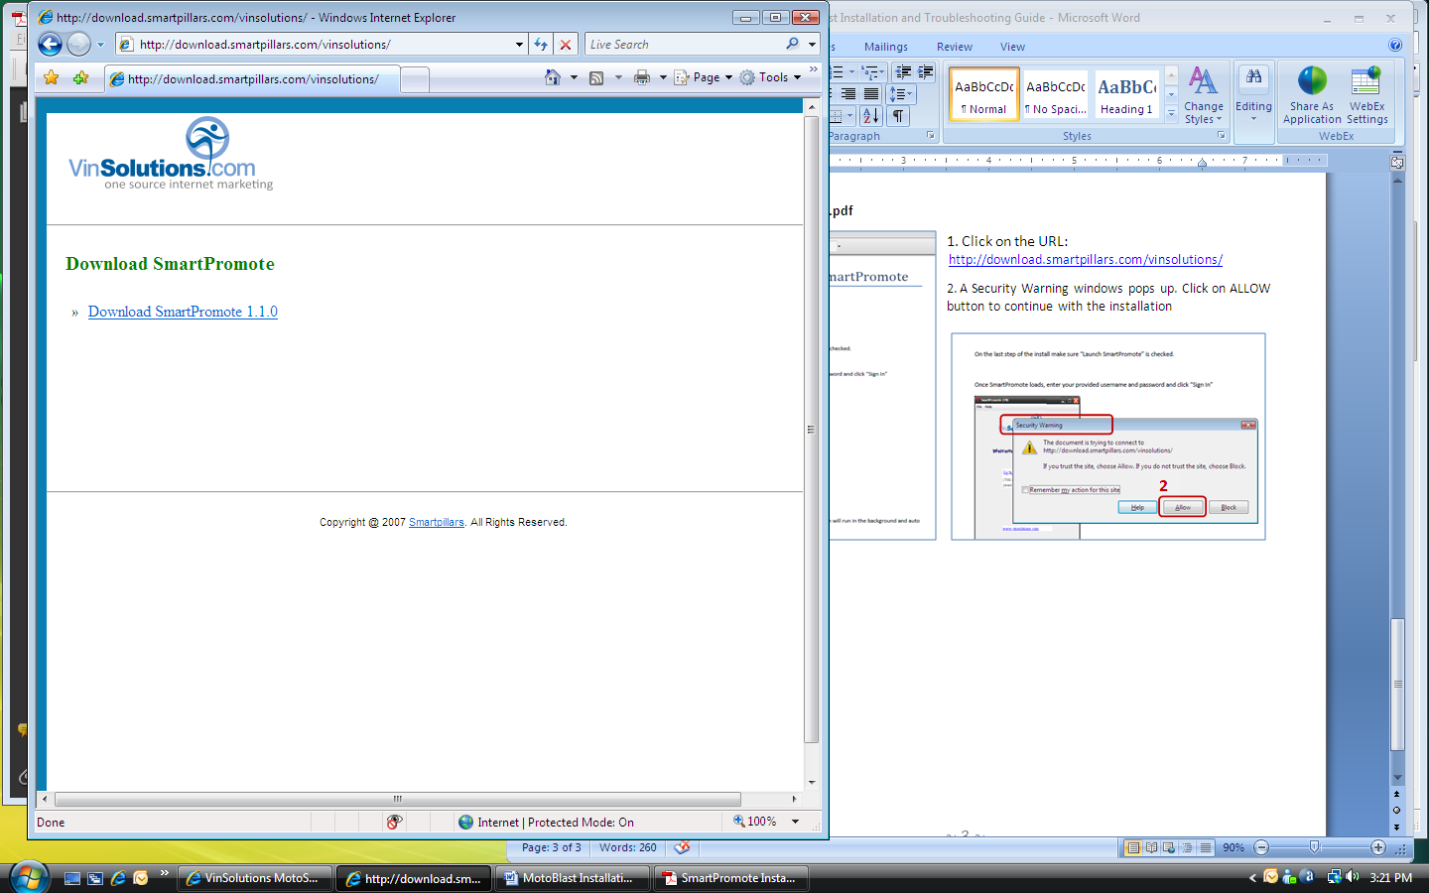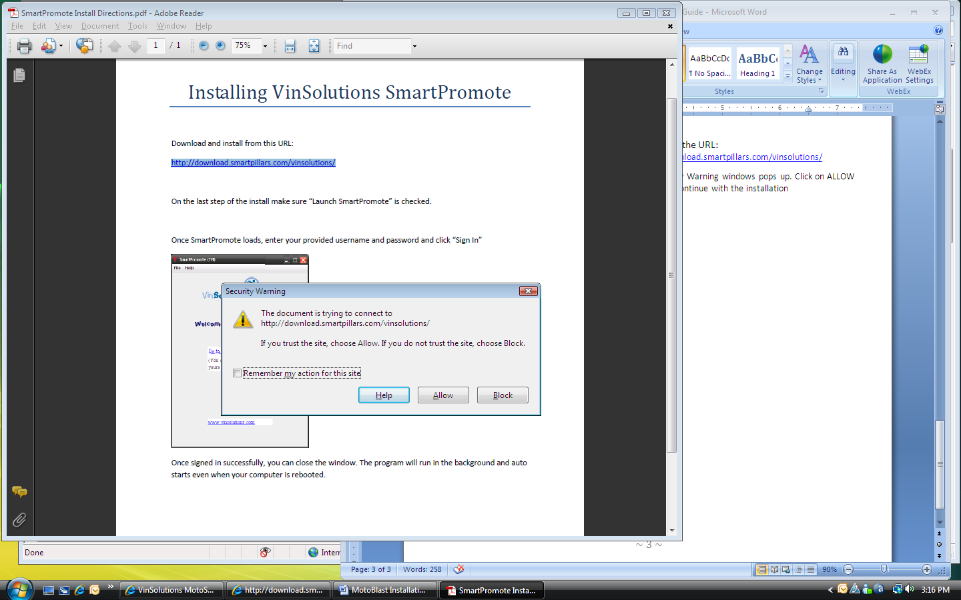

3. A new window pops up with a link for SmartPromote Download. Click on Download SmartPromote 1.1.0

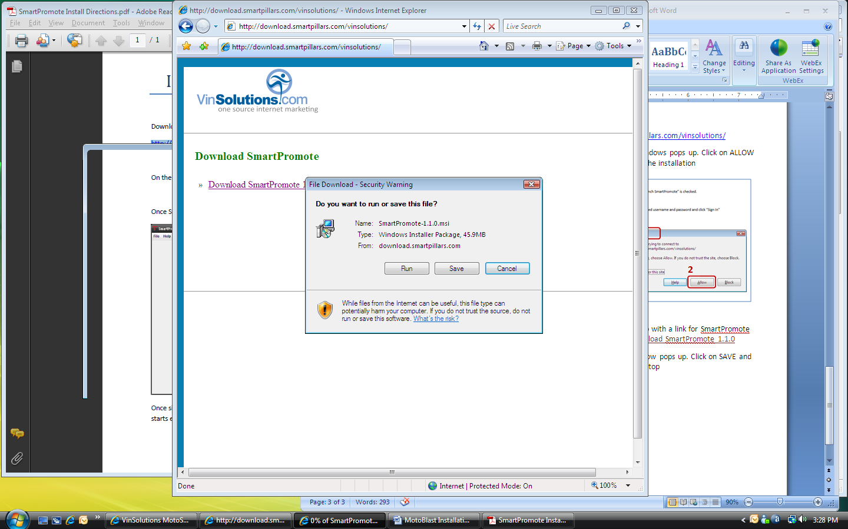4. FILE DOWNLOAD window pops up. Click on SAVE and save the file on your desktop

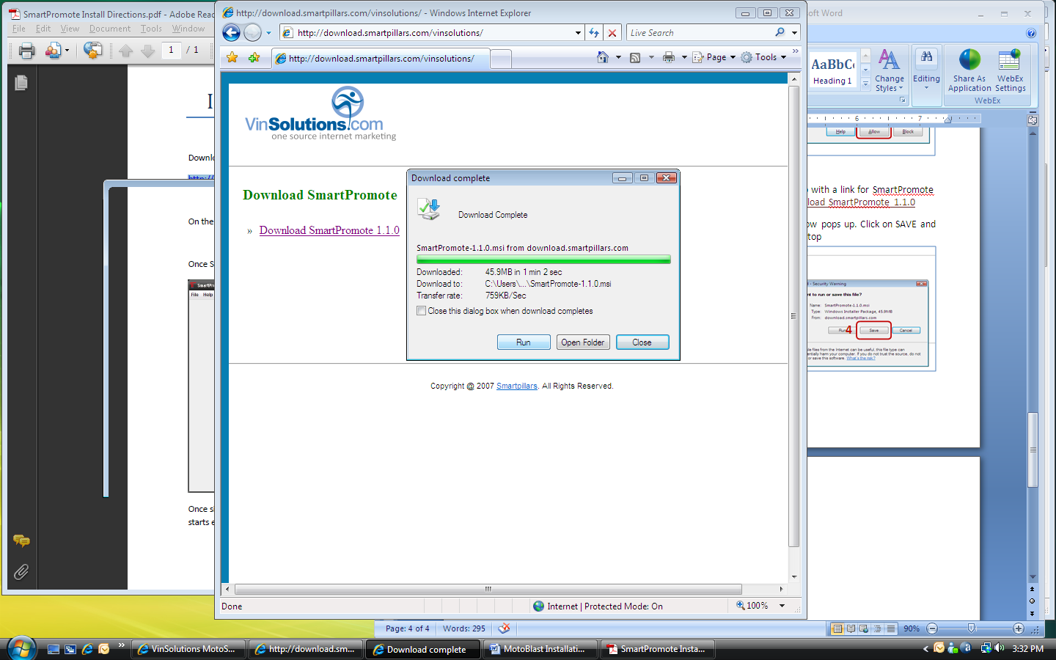5. Uncheck the CLOSE THIS DIALOG BOX WHEN DOWNLOAD COMPLETES checkbox when file download starts

6. When download is complete, click on RUN button to continue

7. An INTERNET EXPLORER – SECURITY WARNING window pops up for UNKNOWN PUBLISHER warning. Click on RUN button to continue

**5**

**6**

**8**

**9**

**10**

**11**

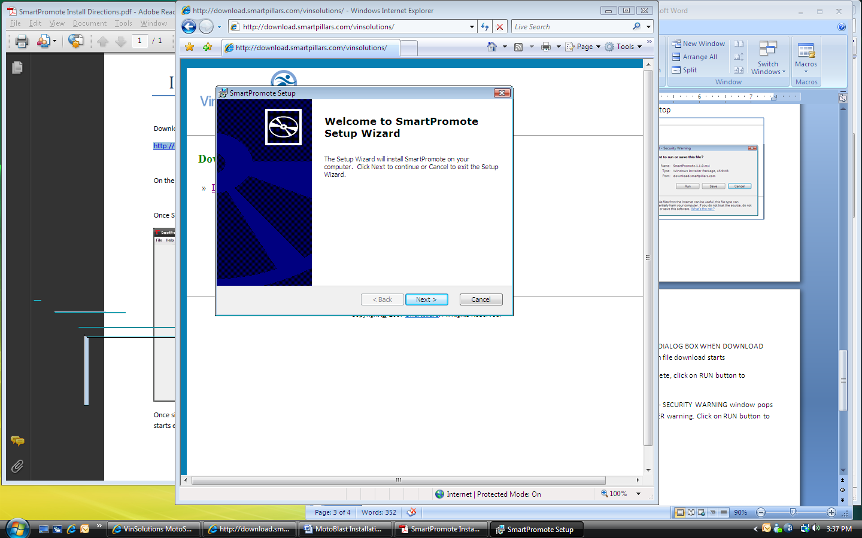

8. A SETUP WIZARD pops up. Click NEXT to start the wizard

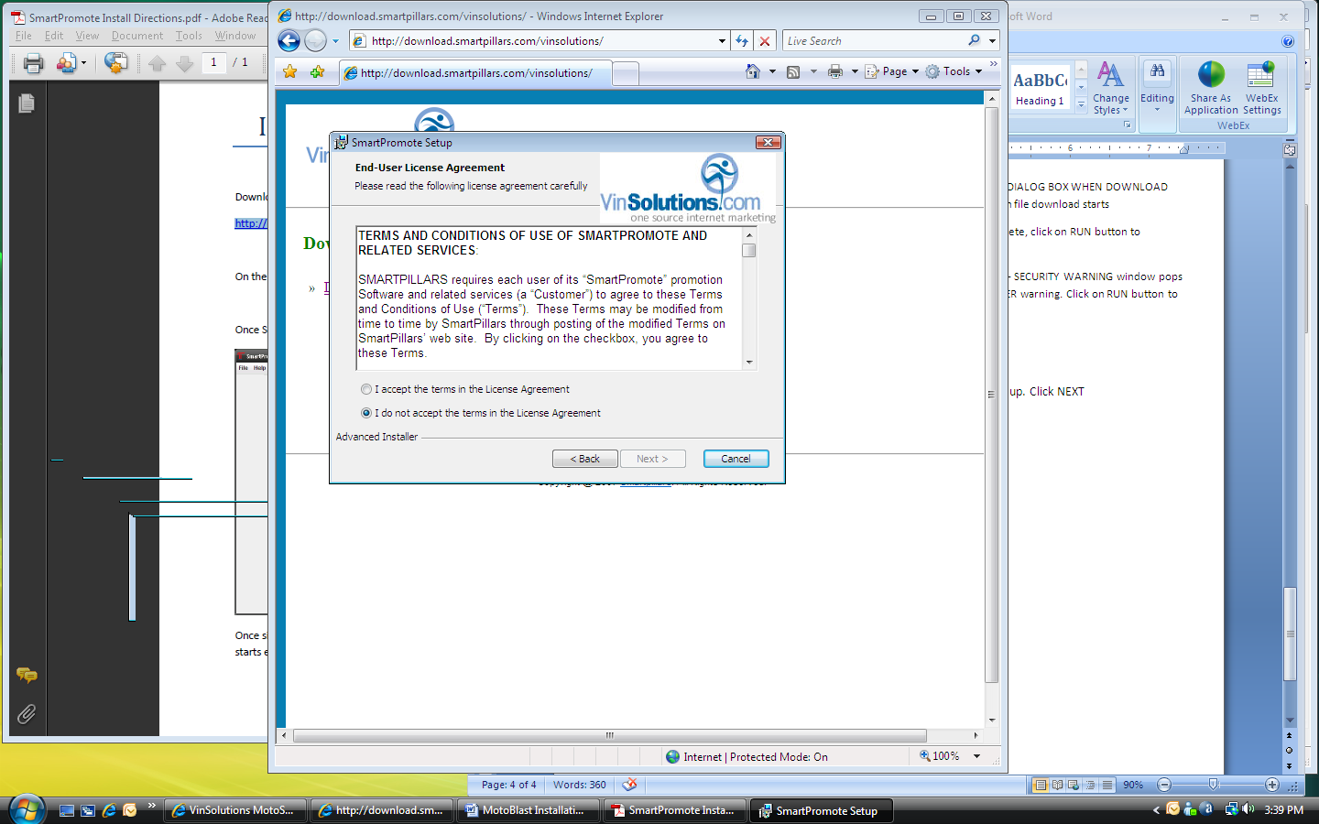

9. Click on I ACCEPT THE TERMS radio button

10. Click NEXT to continue

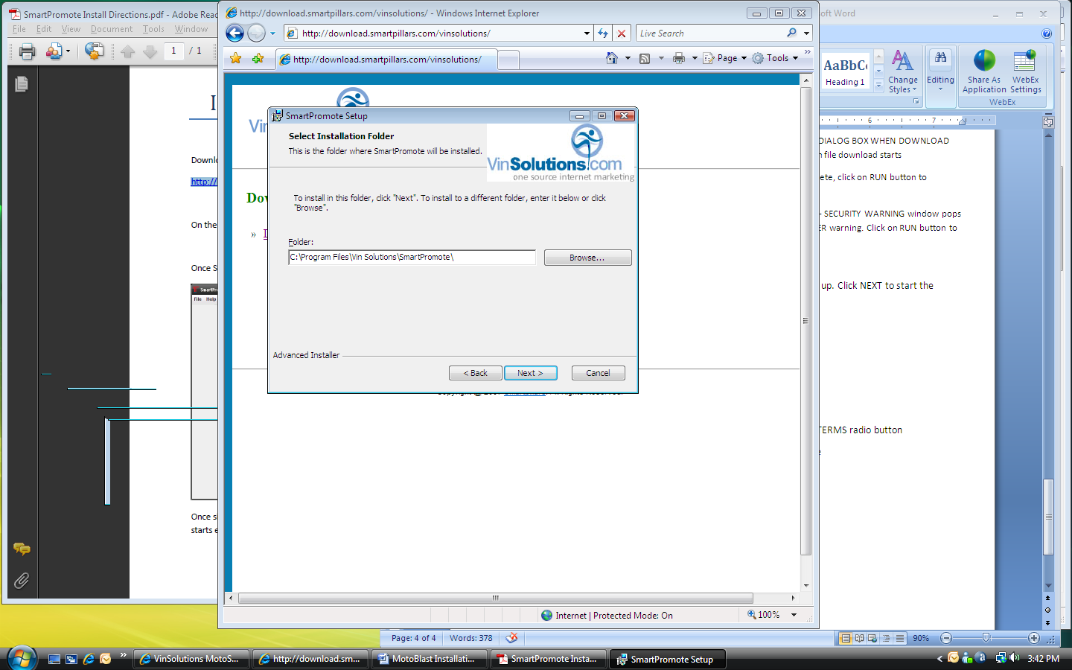11. Keep the default setting for INSTALLATION FOLDER path and click NEXT

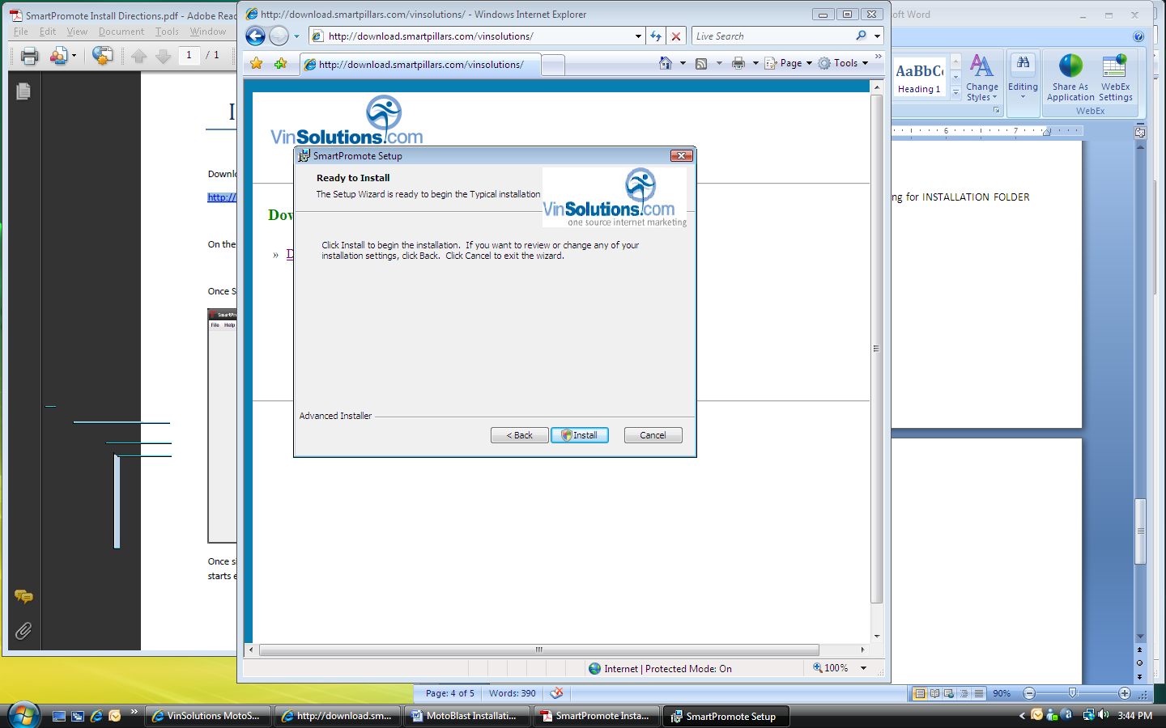12. Click INSTALL to begin the installation

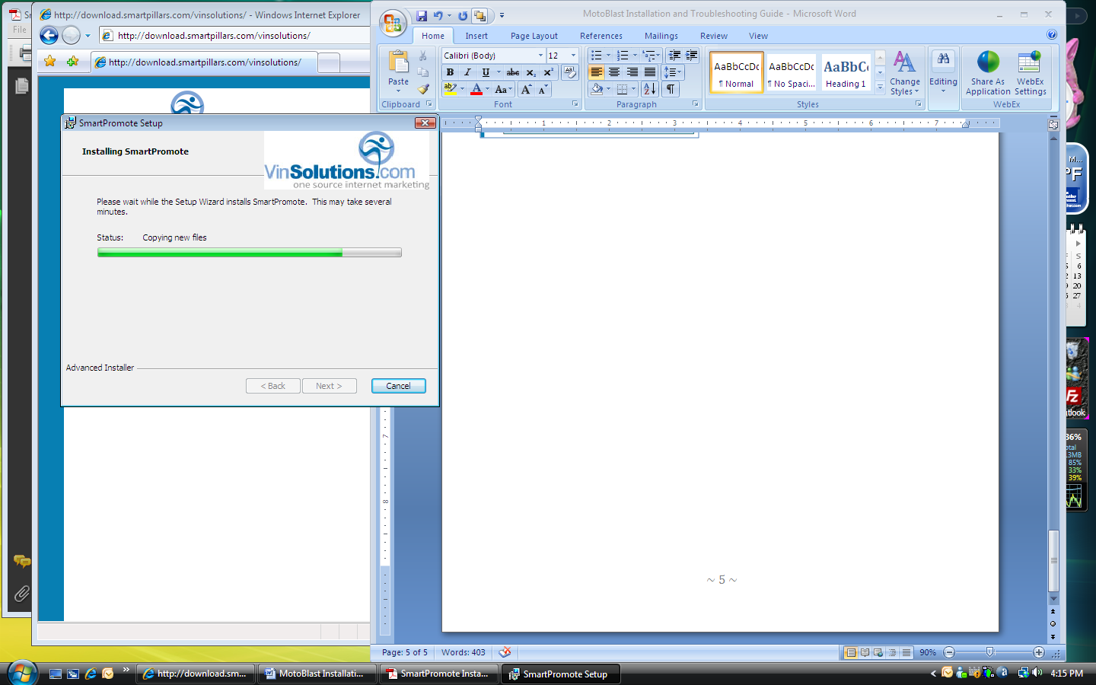

**12**

**12**

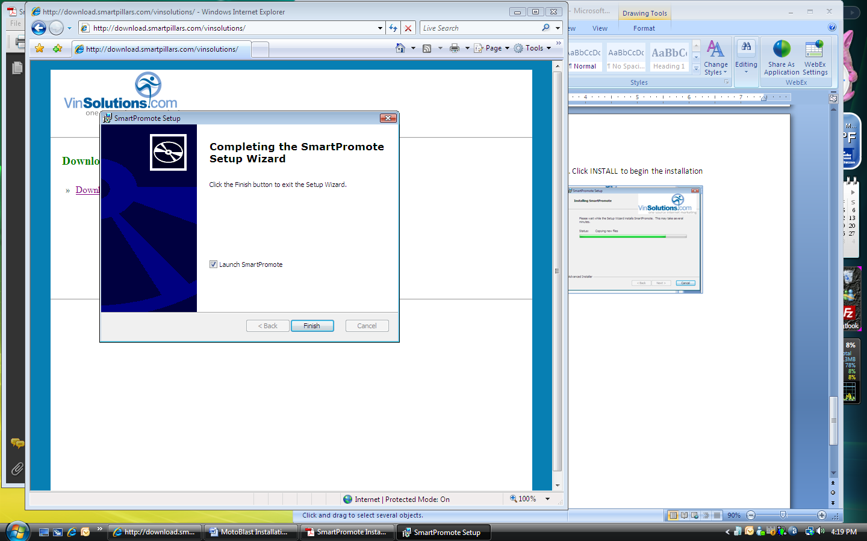13. Click FINISH to complete the installation

14. Make sure that LAUNCH SMARTPROMOTE checkbox is checked

**13**

**14**

NOTE: Smart Pillars will provide the Dealership its username and password. We do not directly provide this information. The information below is for support team’s troubleshooting use only

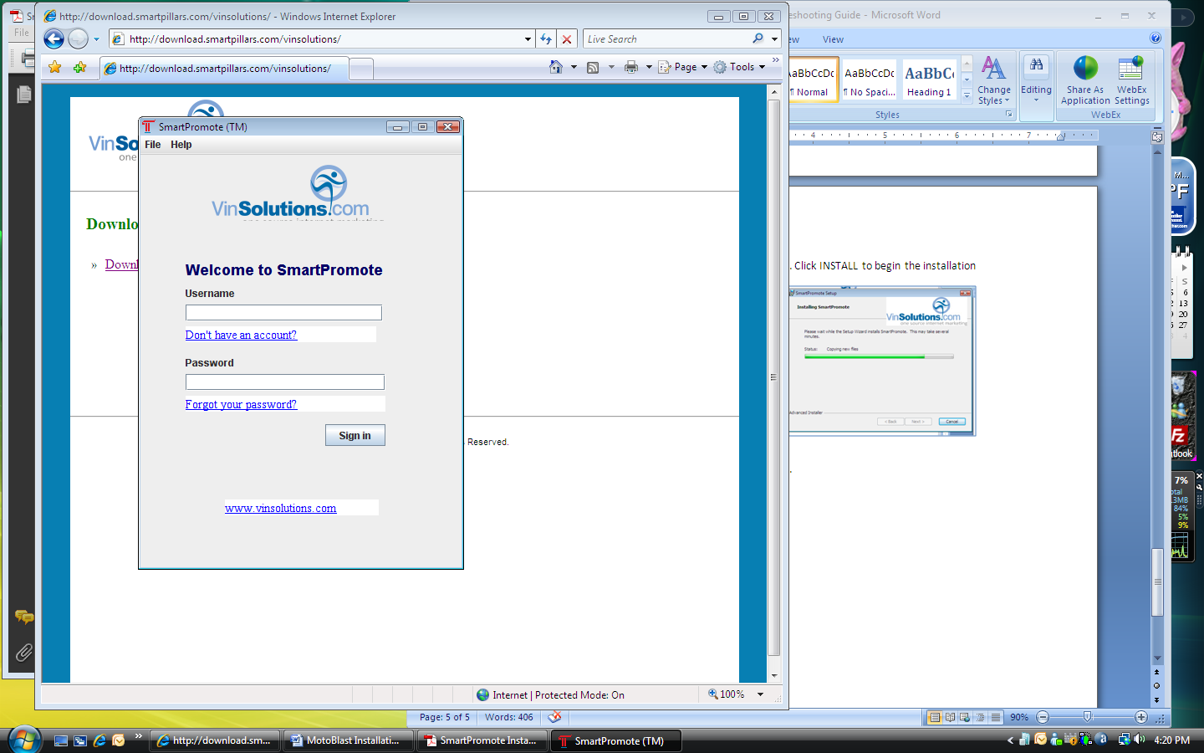

15. SmartPromote window is launched

16. Username: vs_####

NOTE: Username is vs_ (lower case and an underscore) and four digit VinSolutions dealer ID number

**16**

**17**

**18**

17. Password: pass

18. Click SIGN IN

19. Once signed in successfully, you can close the window. The program will run in the background and auto starts even when your computer is rebooted.

**STEP 4 VinSolutions:** **Dealership Inventory Export Account Setup**

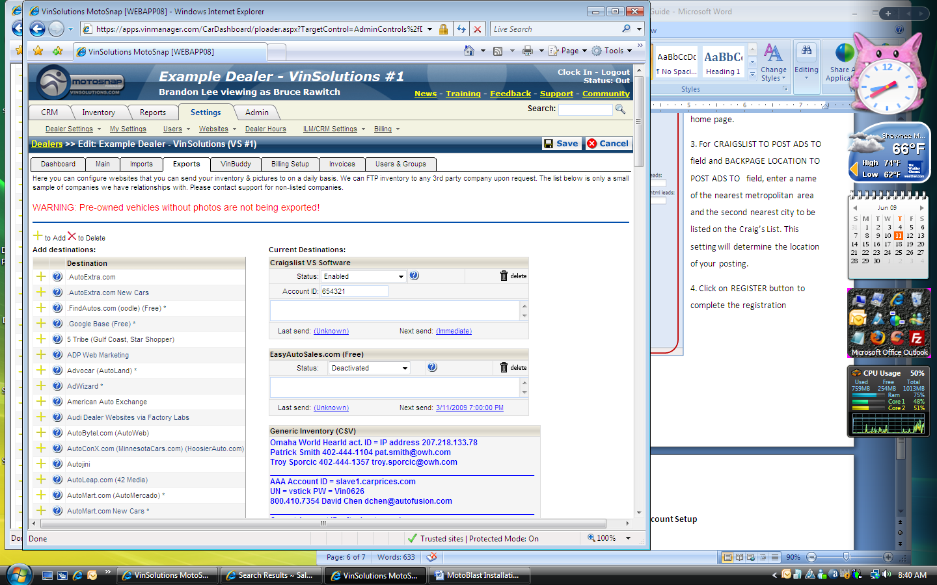

**2**

**3**

**4**

**5**

**6**

1. Log on to Motosnap

2. Select the dealership name

3. Go to SETTINGS tab

4. Click on DEALER SETTINGS

5. Click on EXPORTS

6. Select CRAIGSLIST/BACKPAGE MOTOBLAST/SMARTPROMOTE from the DESTINATION list and click on ADD (+) button

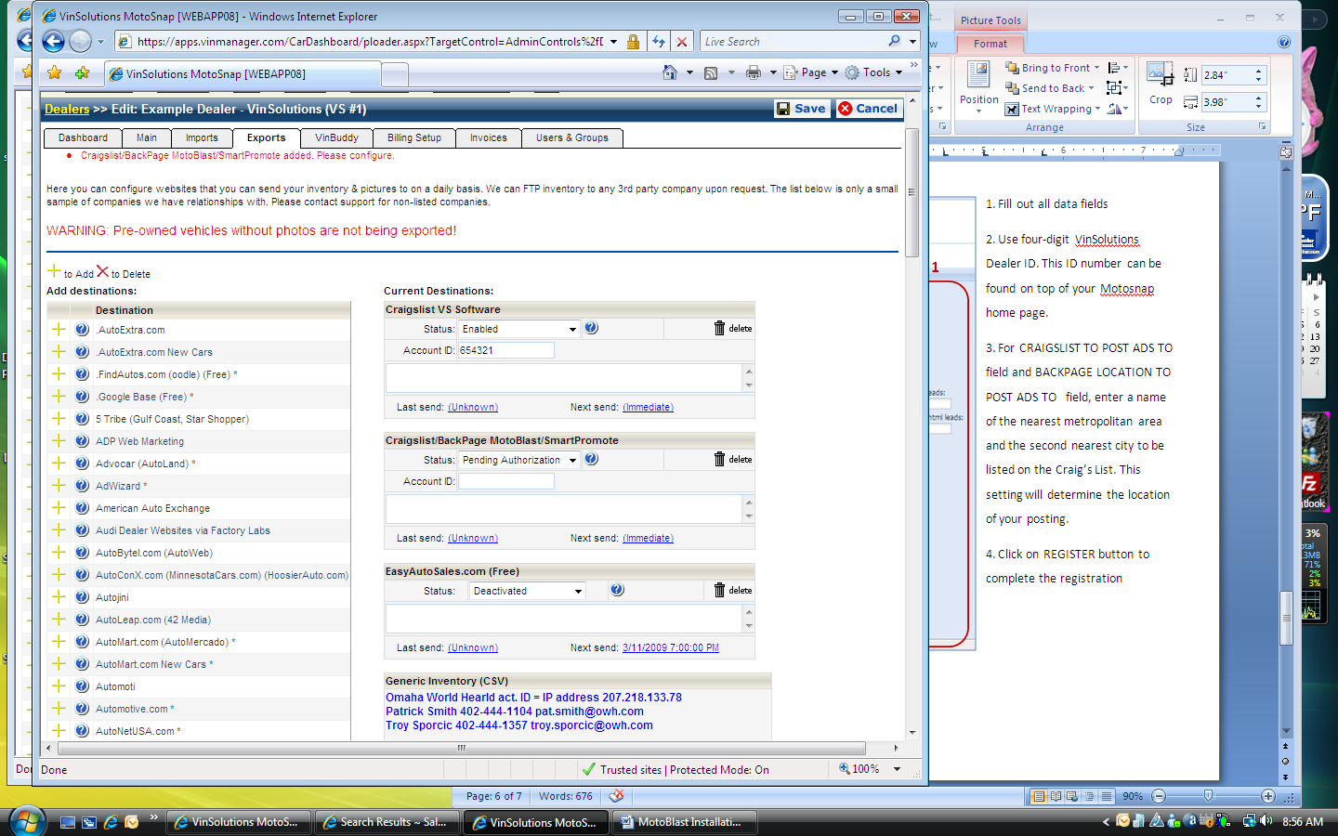

7. EXPORT page refreshes

**7**

**8**

**9**

**10**

**11**

8. From CURRENT DESTINATIONS, locate CRAIGSLIST/BACKPAGE MOTOBLAST/SMARTPROMOTE

9. Change STATUS to ENABLED

10. Enter the VS Dealership ID for ACCOUNT ID

11. Enter note on the case

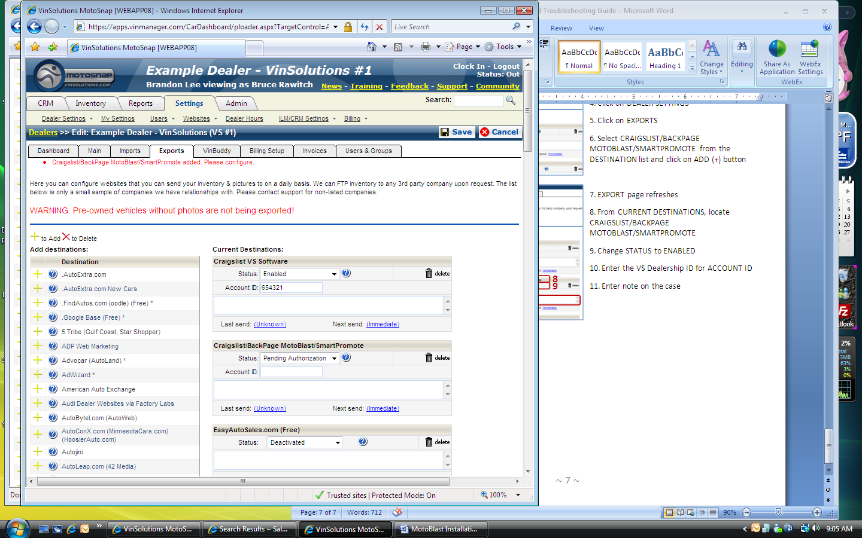

**12**

**13**

**14**

12. Click on UNKNOWN from LAST SEND. The page refreshes

13. Click on UNKNOWN from NEXT SEND to push for an immediate feed. The page refreshes

14. Click on SAVE button to complete the export settings

**STEP 5 VinSolutions: Troubleshooting**

* When the whole setup process is complete, it usually takes 48 to 62 hours for the inventory to be posted on Craig’s List
* SmartPillars posts 14-20% of the dealerships inventory per day. The entire posting will run on 5 to 7 day cycle
* Craig’s List allows a viewer, any viewer to raise a flag on any posting. A posting may be pulled down because it was flagged or because there exists another posting with a duplicate VIN number