**VinSolutions.com**

**VinSolutions New Desking Configuration Guide**

CONTENTS

1. NEW DESKING SETTINGS --------------------------------------------- Page 2

2. MAIN --------------------------------------------------------------------- Page 3

3. PRINTING ---------------------------------------------------------------- Page 4

4. PROC/DOC FEEs -------------------------------------------------------- Page 5

5. GOV’T LICENSE --------------------------------------------------------- Page 6

6. PURCHASE TAX --------------------------------------------------------- Page 7

Created: 06/10/2009

**NEW DESKING SETTINGS**

WHAT IT IS:

The DESKING settings control all the defaults for the DESKING tool used by managers to calculate the payments for customers.

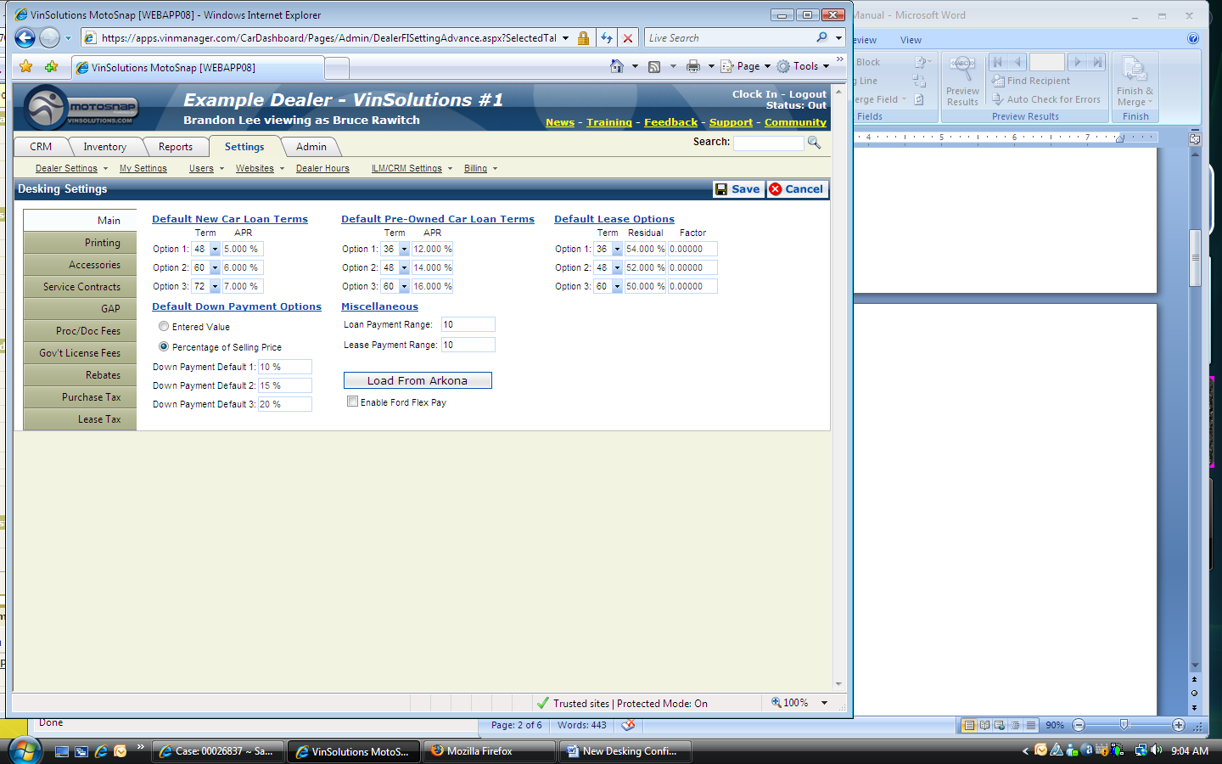

HOW IT WORKS:

User can set the loan terms, lease options, and default down payment options from the MAIN tab, configure PRINTING settings, choose ACCESSORIES for purchase, customize SERVICE CONTRACTS, GAP, PROC/DOC FEES, GOV’T LICENSE FEES, REBATES, PURCHASE TAX, and LEASE TAX settings from NEW DESKING SETTINGS page. More detailed instructions on each tab menu are provided on following pages.

WHERE IT IS:

The NEW DESKING SETTINGS page can be found by clicking on the SETTINGS main-tab, hover over ILM/CRM SETTINGS sub-tab, and clicking on NEW DESKING SETTINGS

1. 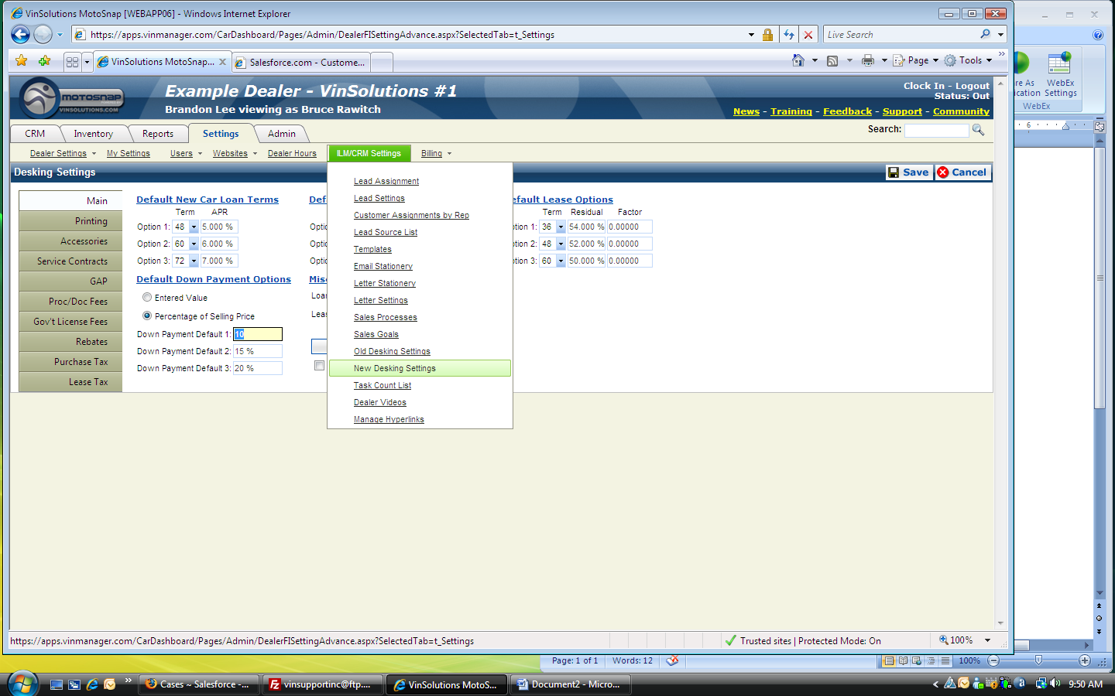1. Logon to Motosnap

**2**

**2.1**

**2.2**

[www.vinsolutions.com](http://www.vinsolutions.com)

2. Go to SETTINGS

2.1 ILM/CRM SETTINGS

2.2 NEW DESKING SETTINGS

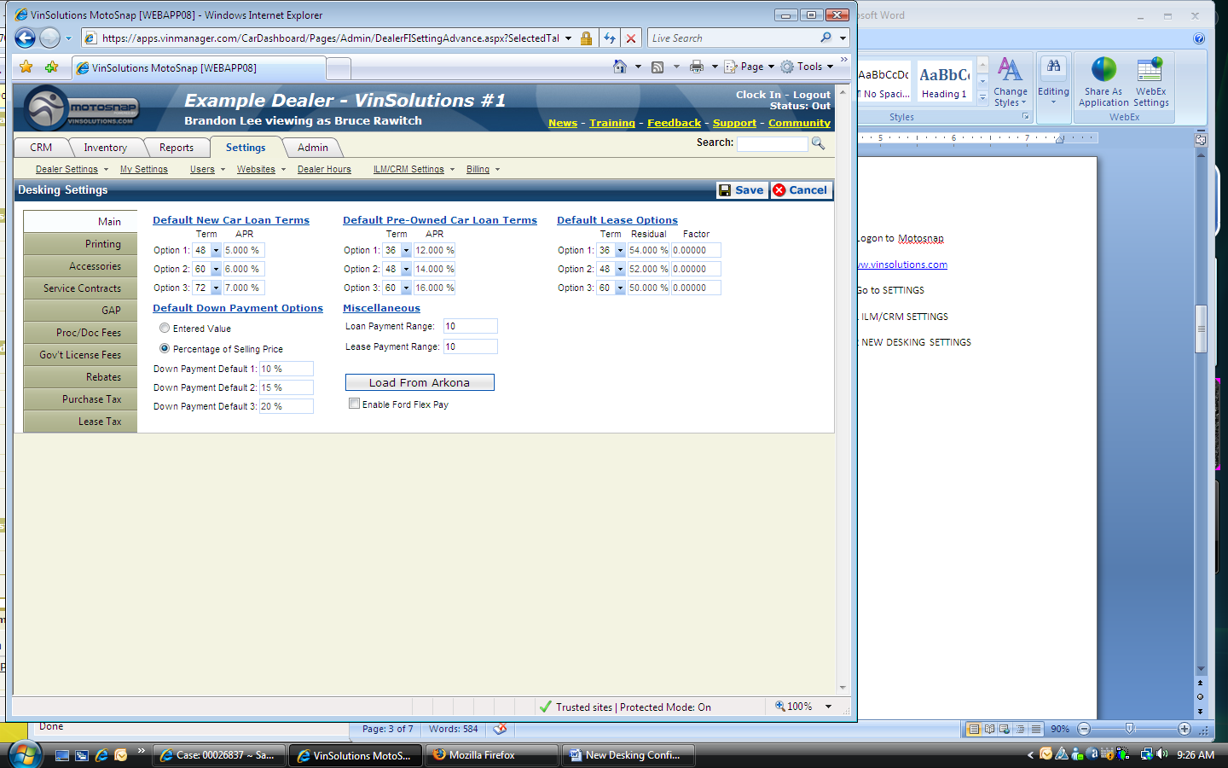

1. Customize DEFAULT NEW CAR LOAN TERMS and DEFAULT PRE-OWNED CAR LOAN TERMS by selecting TERMS from its drop down menu and enter in a numeric value for the APR

**1**

**2**

2. You can select ENTERED VALUE and enter a dollar amount or select PERCENTAGE OF SELLING PRICE and enter a percentage value

NOTE: When switching back and forth from each radio button, it takes some time to refresh the input field

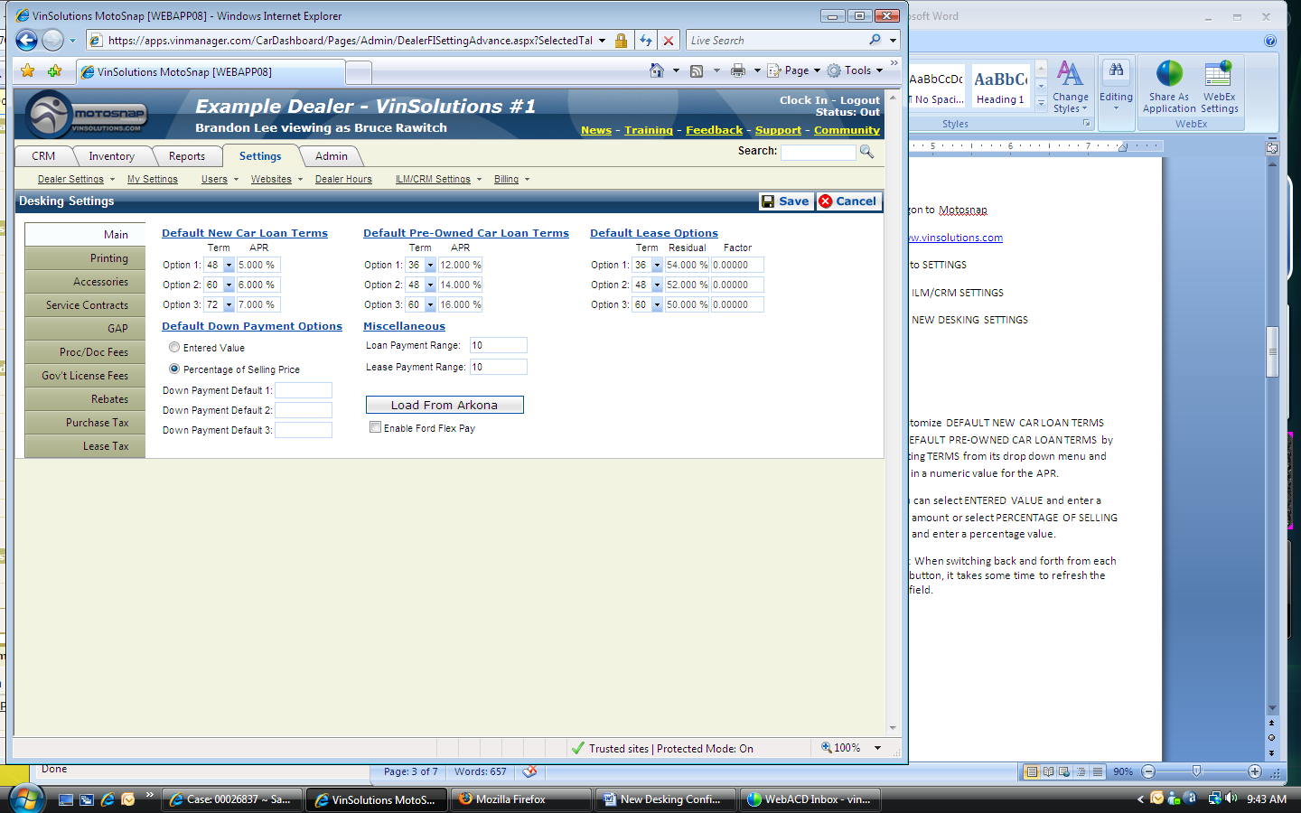

1. Enter a numeric value for LOAN PAYMENT RANGE and LEASE PAYMENT RANGE

**1**

**2**

**3**

**4**

**5**

2. Select TERMS from dropdown menu, enter a percentage value for RESIDUAL and FACTOR

3. ARKONA DMS users can click on LOAD FROM ARKONA button and pull up its pre-defined data

4. Mark the ENABLE FORD FLEX PAY checkbox to enable the option (Applicable dealership only)

5. Click on SAVE button to save all your changes before exiting this page

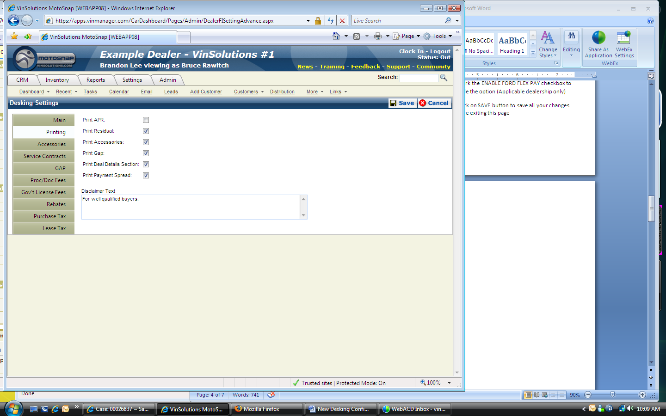1. Click on PRINTING tab

2. Select desired options by marking the checkbox

**1**

**2**

**3**

3. You can customize the disclaimer by entering inits contents in the DISCLAIMER TEXT box

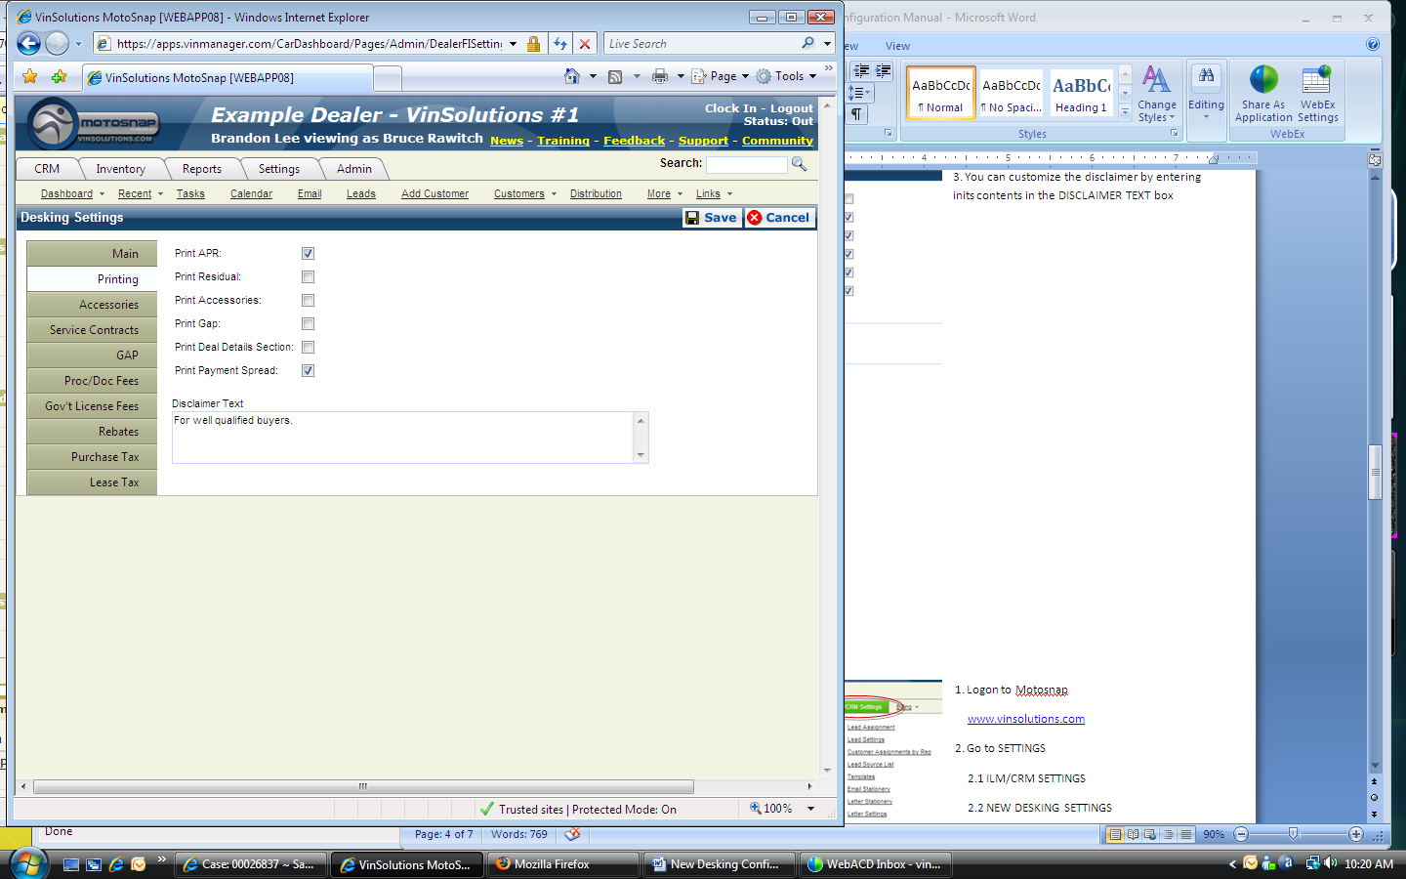

1. Make sure to click on SAVE button to save all settings

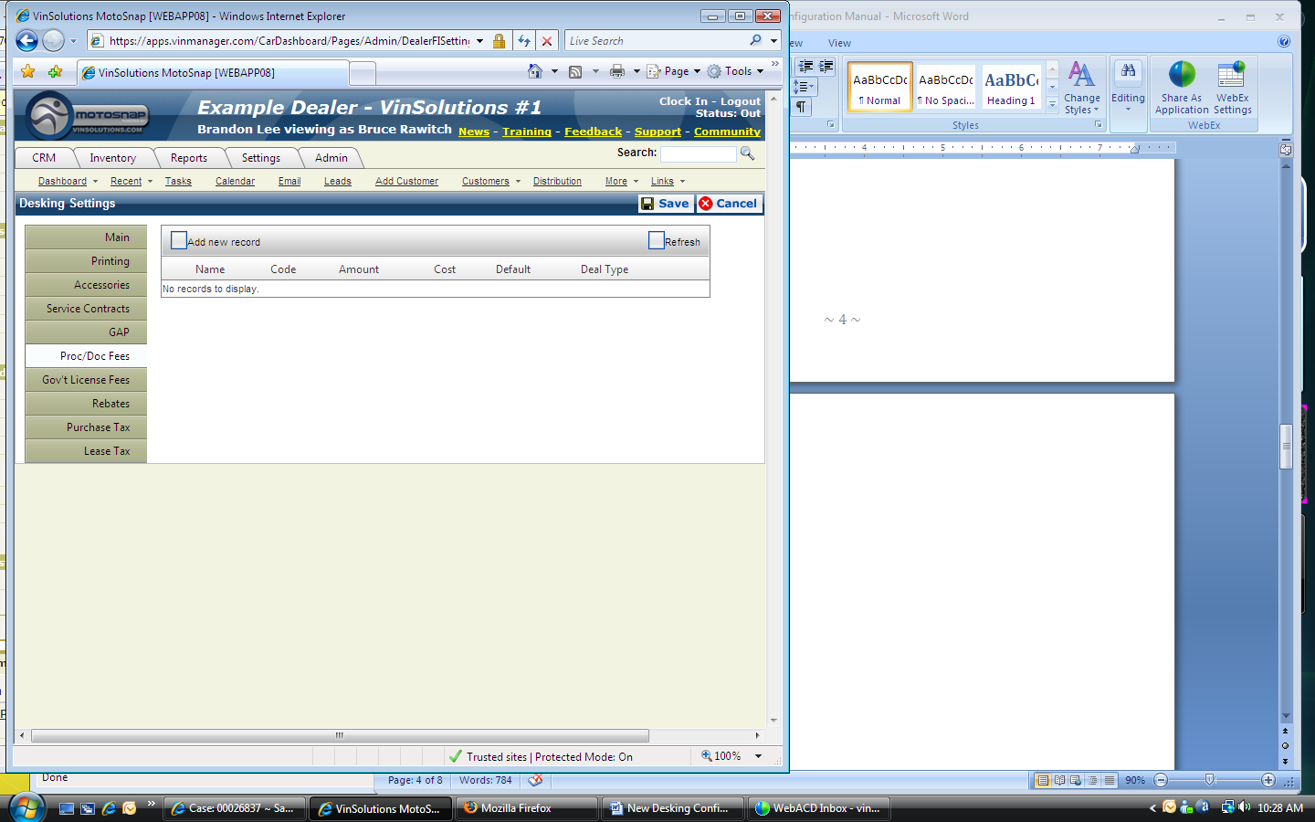1. Click on PROC/DOC FEES tab

2. Click on ADD NEW RECORD

**1**

**2**

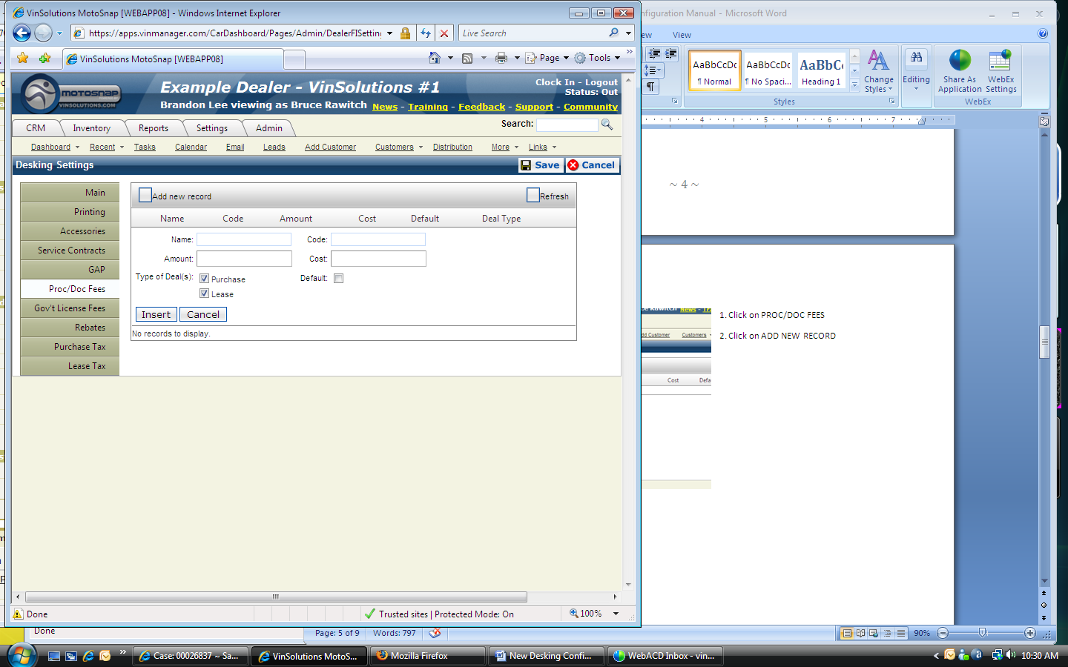

1. Enter NAME, CODE, AMOUNT, and COST information

NOTE: All data fields must be filled out in order to create a new record. The AMOUNT and Cost field only take numeric value. You do not need to enter a $ symbol. The system will automatically generate it for you

**1**

**2**

**3**

2. Select desired TYPE OF DEAL(S) by marking each checkbox

3. Click on INSERT button to complete the record

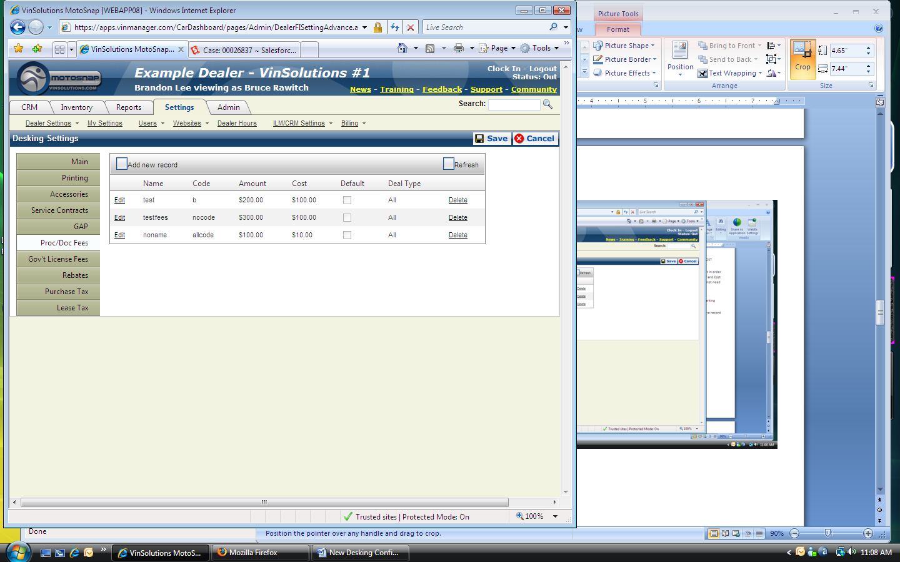1. Existing records can be modified or can be removed by clicking on EDIT or DELETE link

**1**

**2**

**3**

NOTE: There is no UNDO function for a deleted record. Please, double check before clicking on the DELETE link

2. Additional record can be created from the same page by clicking on the ADD NEW RECORD button

3. Make sure to click on SAVE button to save all settings. If you exit the page without clicking on the button, all new records will be lost

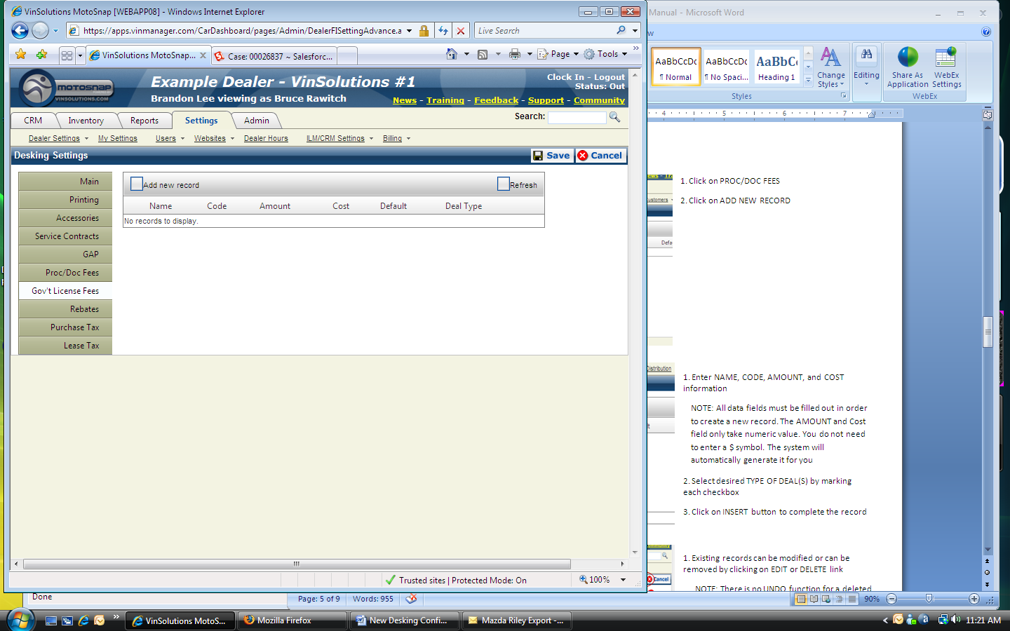1. Click on GOV’T LICENSE FEES tab

2. Click on ADD NEW RECORD

**2**

**1**



1. Enter NAME, CODE, AMOUNT, and COST information

NOTE: All data fields must be filled out in order to create a new record. The AMOUNT and Cost field only take numeric value. You do not need to enter a $ symbol. The system will automatically generate it for you

**1**

**2**

**3**

2. Select desired TYPE OF DEAL(S) by marking each checkbox

3. Click on INSERT button to complete the record

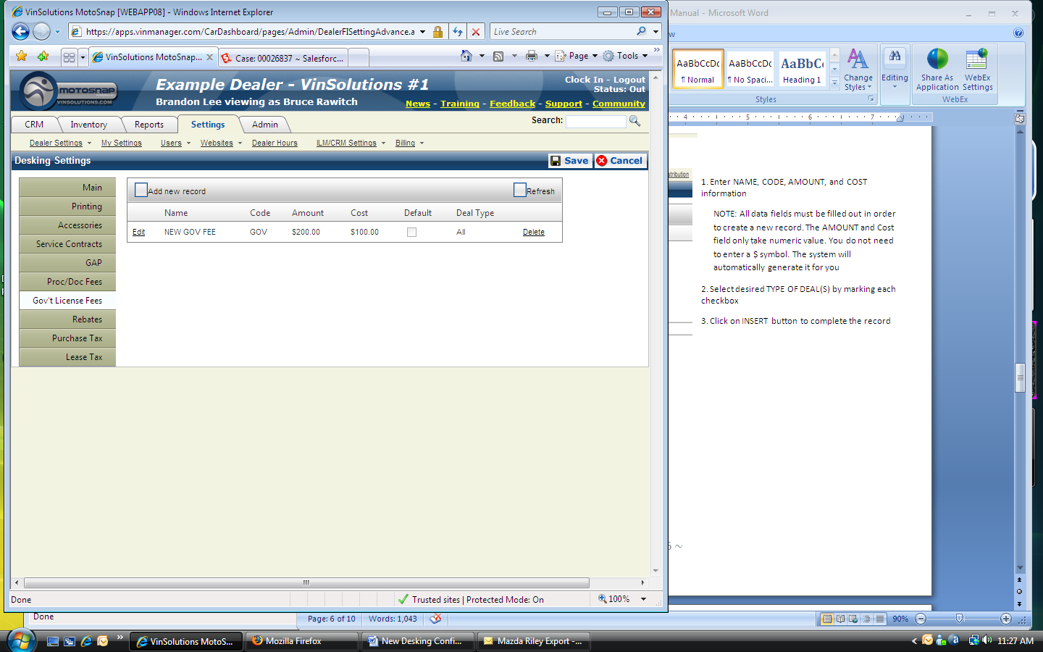

1. Existing records can be modified or can be removed by clicking on EDIT or DELETE link

NOTE: There is no UNDO function for a deleted record. Please, double check before clicking on the DELETE link

**3**

**2**

**1**

2. Additional record can be created from the same page by clicking on the ADD NEW RECORD button

3. Make sure to click on SAVE button to save all settings. If you exit the page without clicking on the button, all new records will be lost

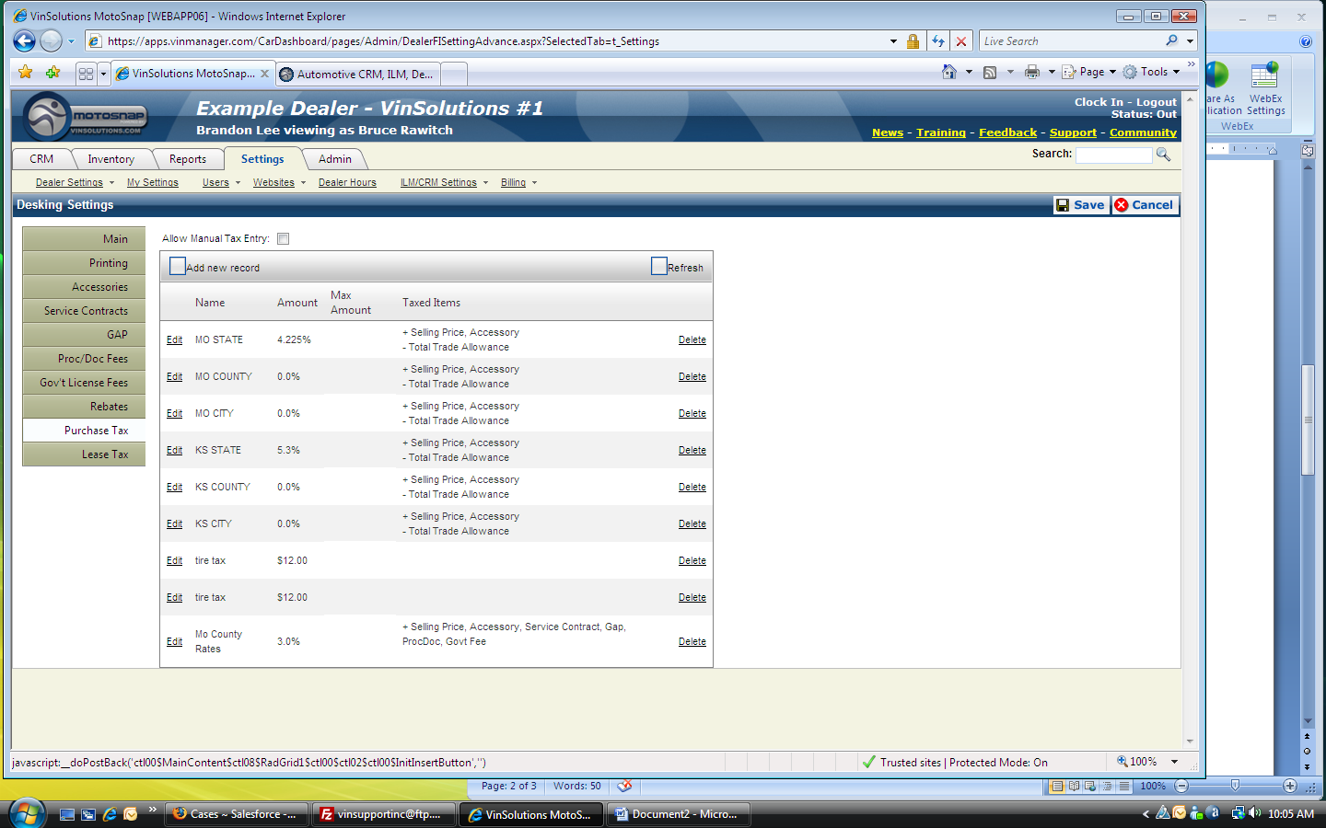

**1**

**2**

1. Click on PURCHASE TAX tab

2. Click on ADD NEWW RECORD

This will refresh and bring up a new page to configure a new tax entry.

**2**

**1**

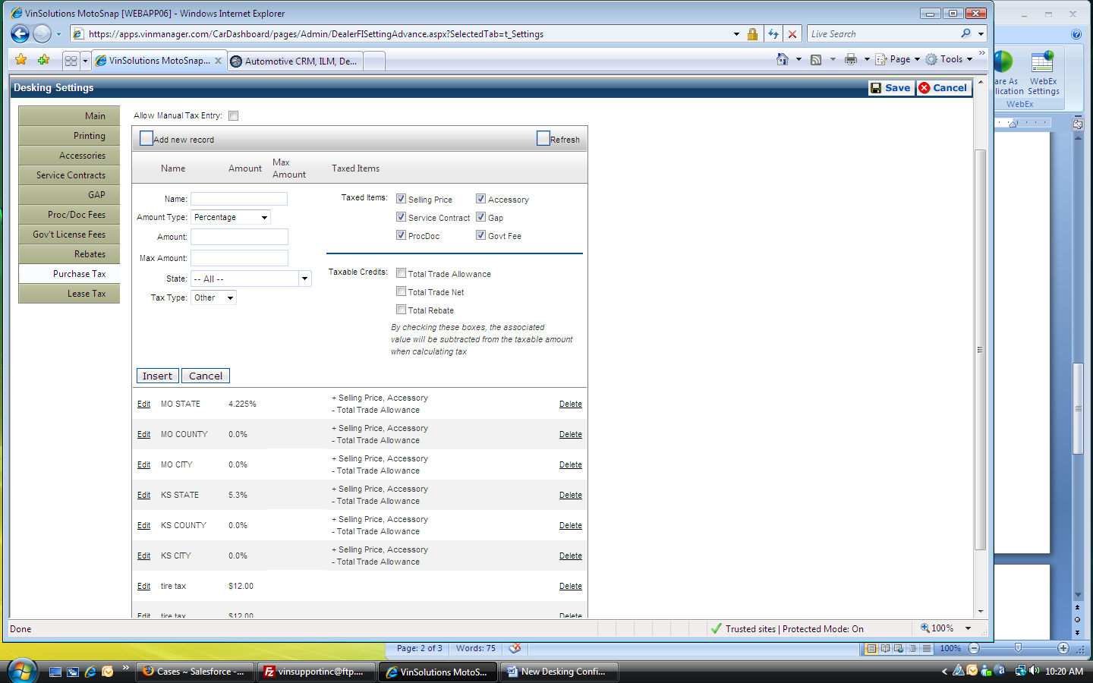1. Enter a name for the new record

2. You can choose SPECIFIC AMOUNT or PERCENTAGE from AMOUNT TYPE dropdown menu

**1**

**2**

**3**

3. Enter a percentage value or specific amount in the AMOUNT Field

NOTE: You do not need to enter a currency ($) or a percentage (%) symbol with the numeric value. The system will place the symbol automatically

1. MAX AMOUNT is an optional field

2. Select a State from STATE dropdown menu

**1**

**2**

**3**

**4**

**5**

3. You can choose the type of current tax record from TAX TYPE dropdown menu. You can either create it as a STATE tax, COUNTY tax, CITY tax, or OTHER type of tax record.

4. You can add/remove TAXED ITEMS by checking or clearing the group of checkbox

5. Configure TAXABLE CREDITS accordingly.

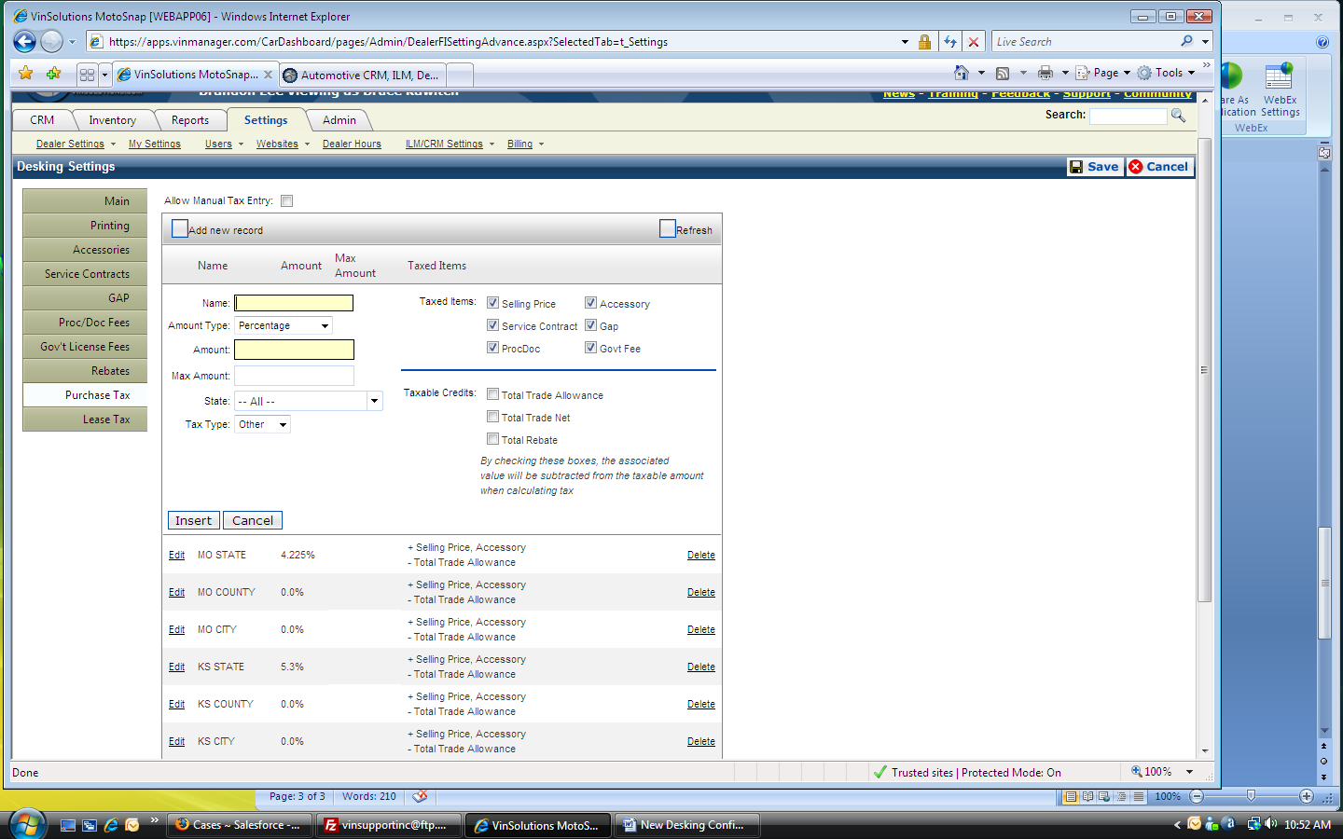

1. You can edit an existing record by clicking on EDIT link

NOTE: It will expand the record slot on current page and bring up its current information. Make sure you click on UPDATE to save your change.

**1**

**2**

2. You can also delete a record by clicking on DELETE link

NOTE: There is no undo function. Make sure you have the right record before deleting

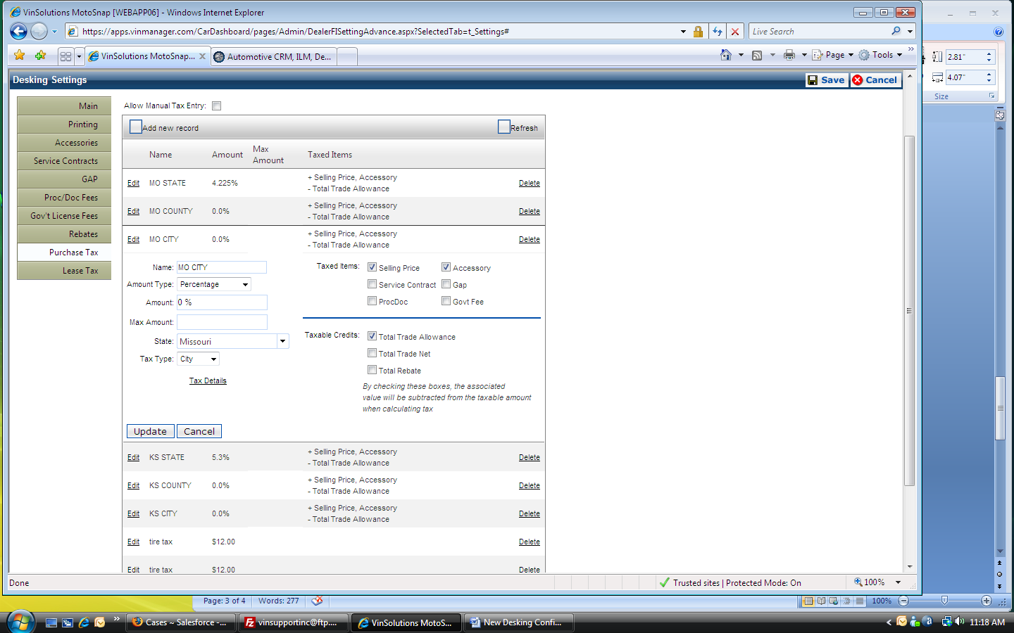

1. The TAX DETAILS link appears on the record when its TAX TYPE is set as CITY, COUNTY, or OTHER.

You can create and set tax rates for each county and city so the VinSolutions system can apply the right tax rates according to the customer information entered by the dealer

NOTE: You must make sure that all customer information is entered correctly into the system before utilizing this tool. Also, there may exist a case that one county may have two different cities under its name.

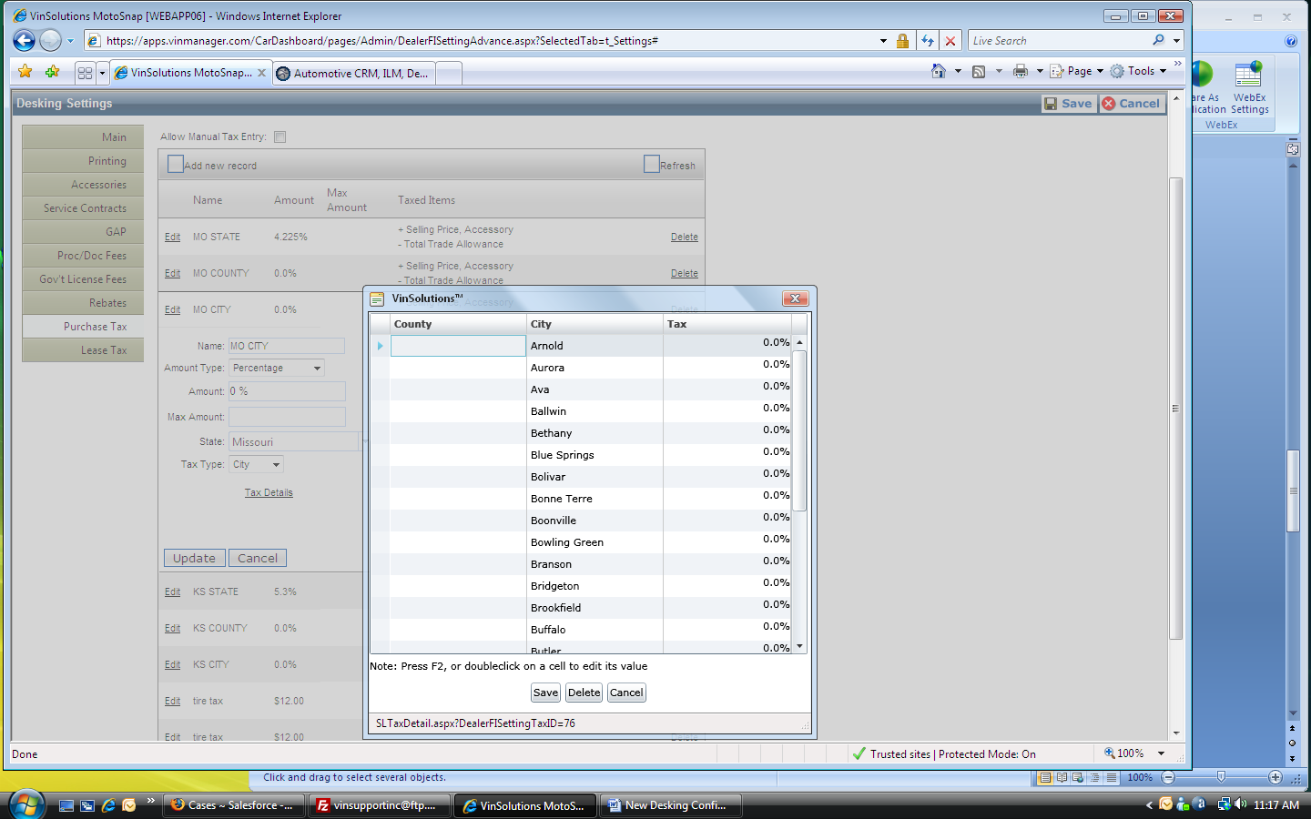

You can change the name of the city or its tax rates by pressing F2 key from the keyboard or double clicking on the cell

NOTE: Make sure to save all changes by clicking on SAVE button. There is no undo function for deleting a record. Please, make sure that you have right record before you click on DELETE button

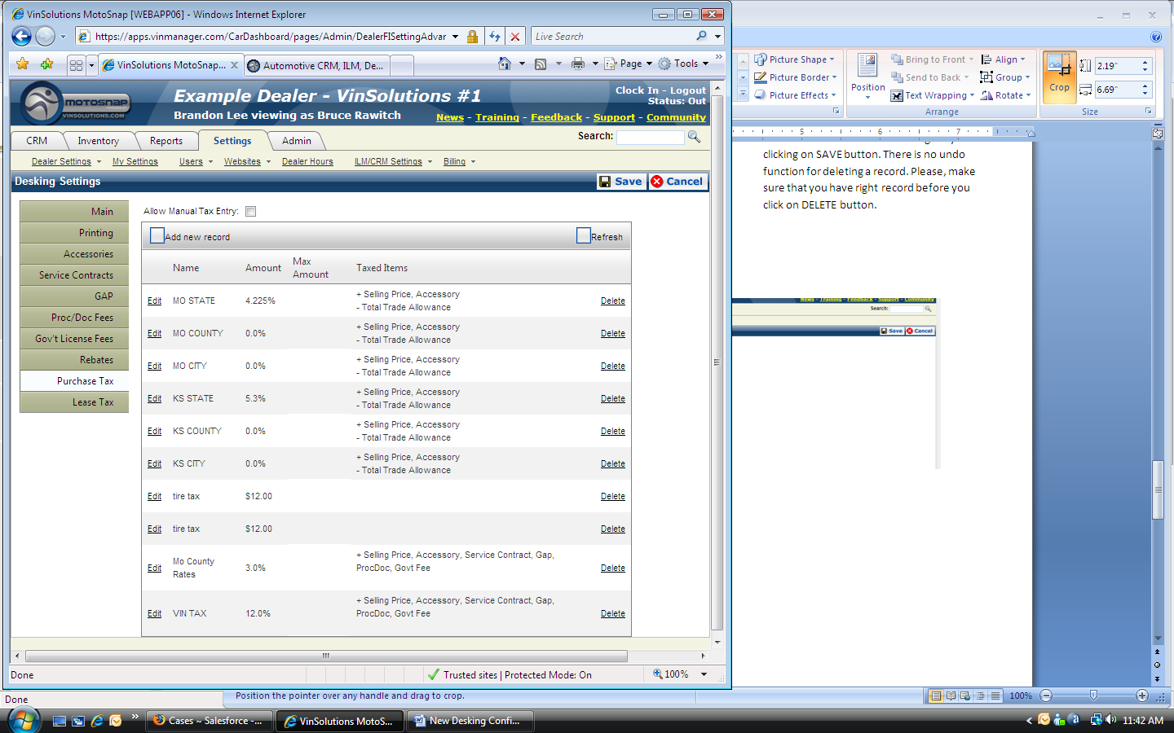

Make sure to click on SAVE button in order to save all changes before you exit the settings page