**VinSolutions.com**

**VinSolutions Inventory Export Manual**

Created: 06/04/2009

Last Modified:

**PART 1 ACCOUNT SETUP**

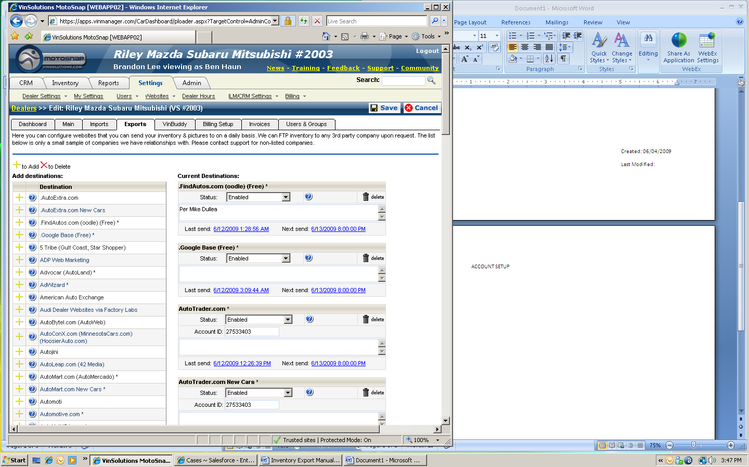**1. Creating an Export Account**

**1**

**2**

**3**

**2**

**4**

**5**

1. Select Dealership

2. Click on SETTINGS tab, Click on DEALER SETTINGS

3. Click on EXPORTS tab

4. Make sure that the name of dealership on top matches with the name on the sub window

5. Select the export destination from the list

NOTE: Make sure that SETUP STATUS of the dealership is COMPLETE (SETTINGS 🡪 DEALER SETTINGS 🡪 DASHBOARD) Otherwise, do not enable the export until implementation team finishes the account setup.

**6**

**7**

**8**

**9**

**10**

**11**

**12**

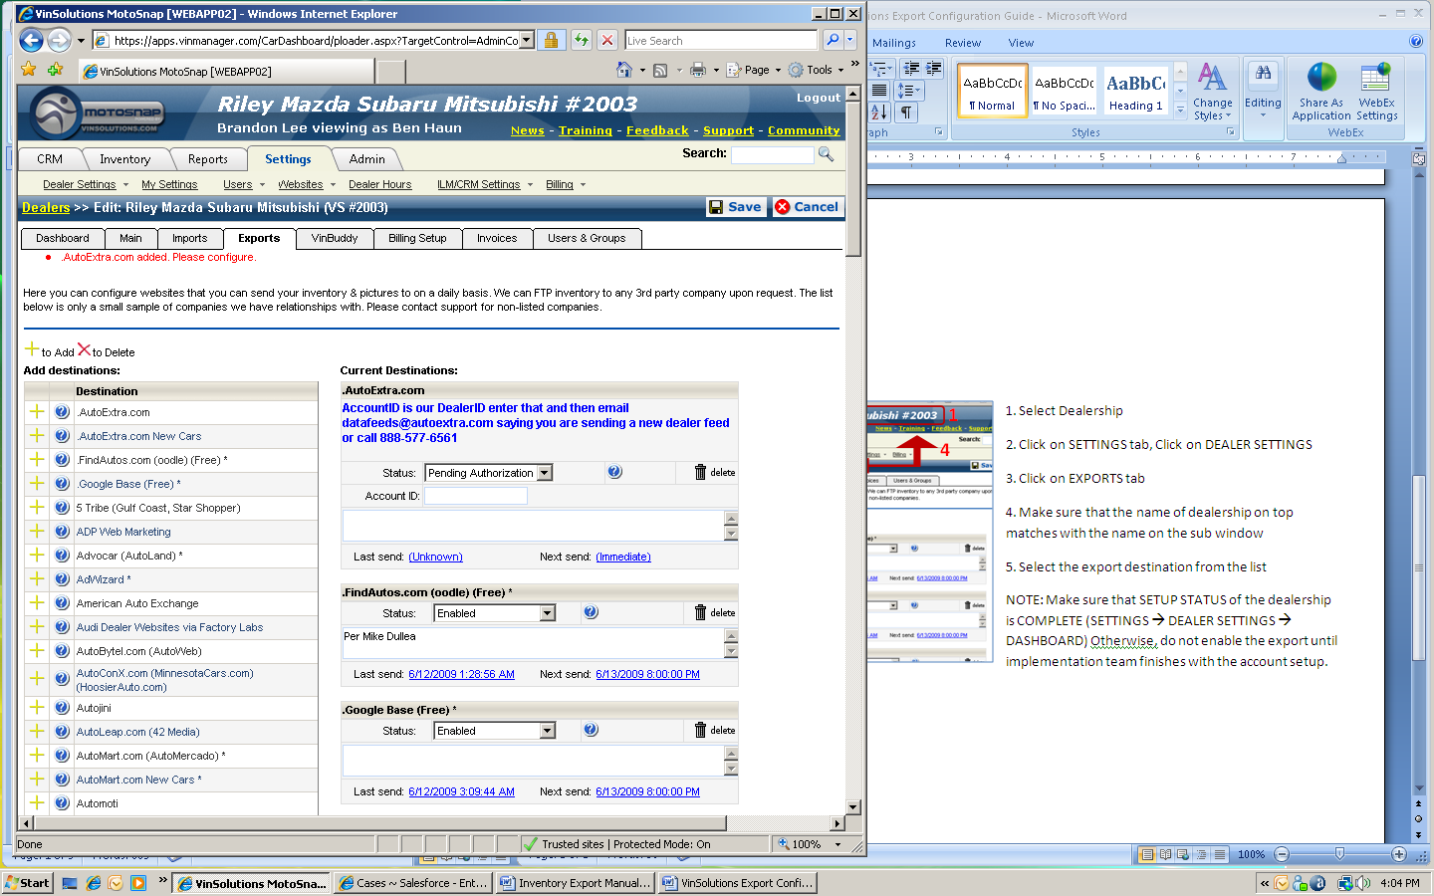6. New configuration warning appears

7. For most export account settings, basic instructions will appear within the configuration box in blue. Read the instruction carefully

8. Change status to ENABLE and Enter ACCOUNT ID

9. Leave a note on the case Ex. Case number

10. Click on UNKNOWN next to LAST SEND

11. Click on UNKNOWN next to NEXT SEND

12. Click on SAVE to complete the configuration

NOTE: There are five different categories to choose from for account STATUS.

* Select PENDING AUTHORIZATION if the dealer’s account with VinSolutions is currently being setup
* Select ENABLED or DEACTIVATED to initiate or terminate the data transfer
* Select WAITING ON 3rd PARTY or WAITING ON DEALER to indicate that we are waiting for a response to enable the export.

**2. Creating a Generic Inventory (CSV) Export Account**

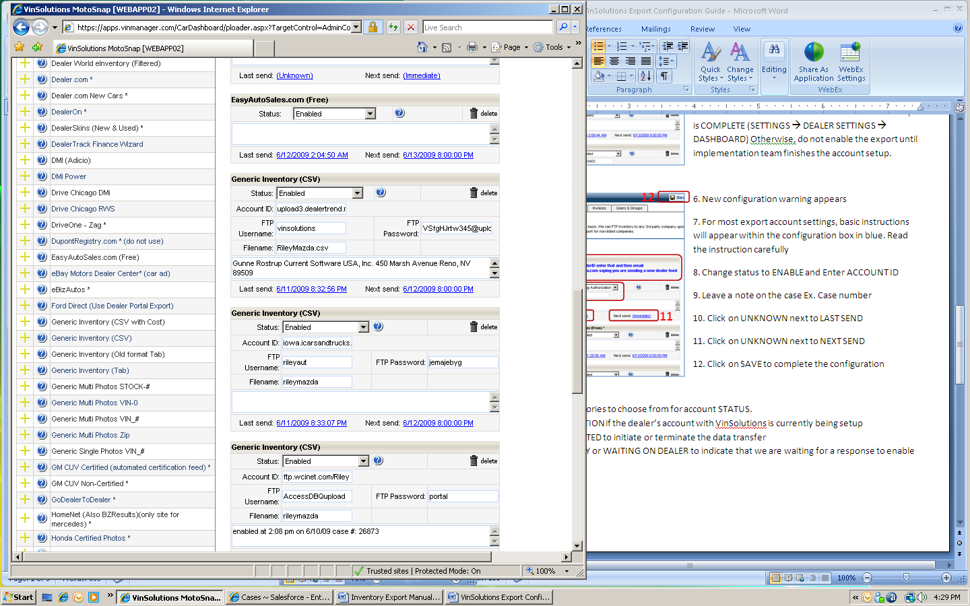1. Change status to ENABLED

2. The third party requesting this export will provide following information: ACCOUNT ID, USERNAME, PASSWORD. Most of the time, a FTP site address is used as an ACCOUNT ID, and dealership name in lower case with no space will be used as a FILENAME.

**2**

3. Leave a note on the case Ex. Case number

4. Click on UNKNOWN next to LAST SEND

5. Click on UNKNOWN next to NEXT SEND

6. Click on SAVE to complete the configuration

NOTE: **CSV FILE:** Generic Inventory (CSV with cost) is rarely (mostly likely never) used. The Generic Inventory (CSV) file will include most data required for the export.

NOTE: **FILE CUSTOMIZATION:** If the vendor requests to customize the .csv file, we can do so if the vendor has more than 15 dealership accounts associated with it.

**3. Customizing Generic Inventory Export File**

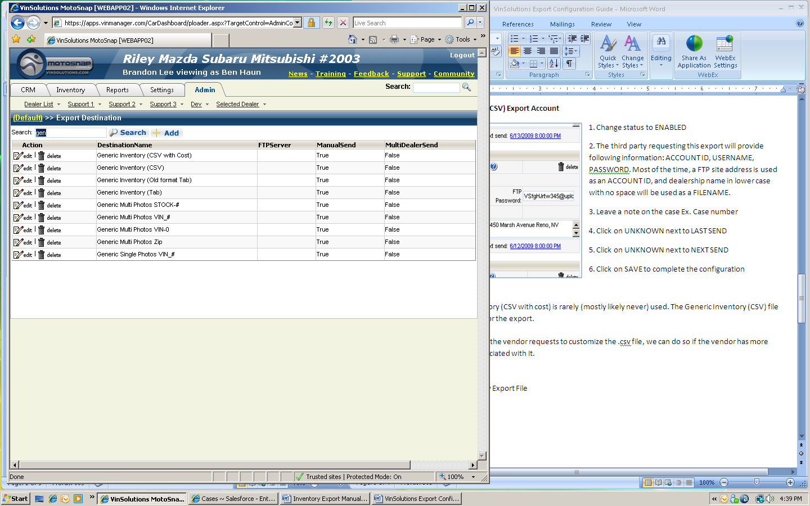 1. Go to ADMIN 🡪 SUPPORT1 🡪 EXPORTS 🡪 EXPORT DESTINATIONS

2. Search for GENERIC

**2**

**3**

**4**

3. Click on EDIT to customize a setting or click on DELETE to remove the record

4. Click on ADD to create a new record

5. Click on SAVE

**4. Generic Single Photos: Single Picture File Export**

1. Go to ADMIN 🡪 SUPPORT1 🡪 EXPORTS 🡪 EXPORT DESTINATIONS

2. Search for GENERIC

**2**

**3**

**4**

3. Click on EDIT to customize the setting

5. Click on SAVE

NOTE: If the dealership inventory has multiple pictures, this export will only send the first picture of the vehicle. If the vendor requires a specific picture of the inventory, the dealership must put the picture as its first picture. Otherwise, the vendor must import all pictures then pick out the picture manually

**5. Multiple Exports Under a Single File**

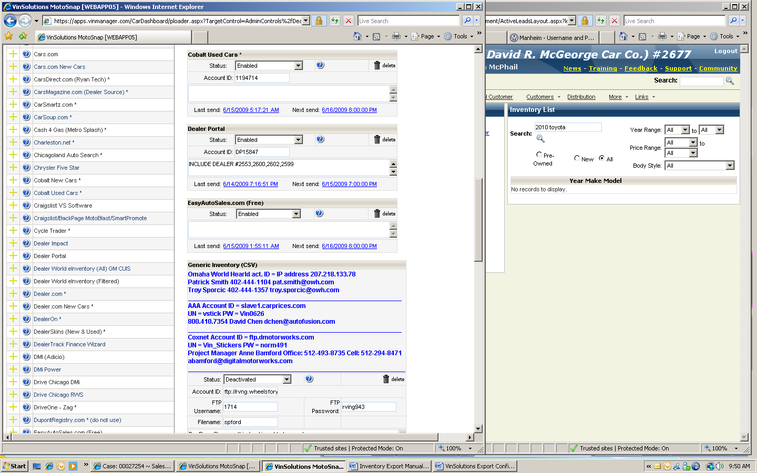1. Use INCLUDE statement to include multiple dealership inventories into a single export file. The INCLUDE statement format should be:

**DEALERSHIP NO. 2601**

**DEALERSHIP NO. 2553**

**3**

**1**

**2**

**2**

**4**

INCLUDE DEALER #____,____,____

INCLUDE DEALER in all capital letters with a space after each word then # sign followed by dealership numbers with no space between them. Dealership number s are separated by a comma

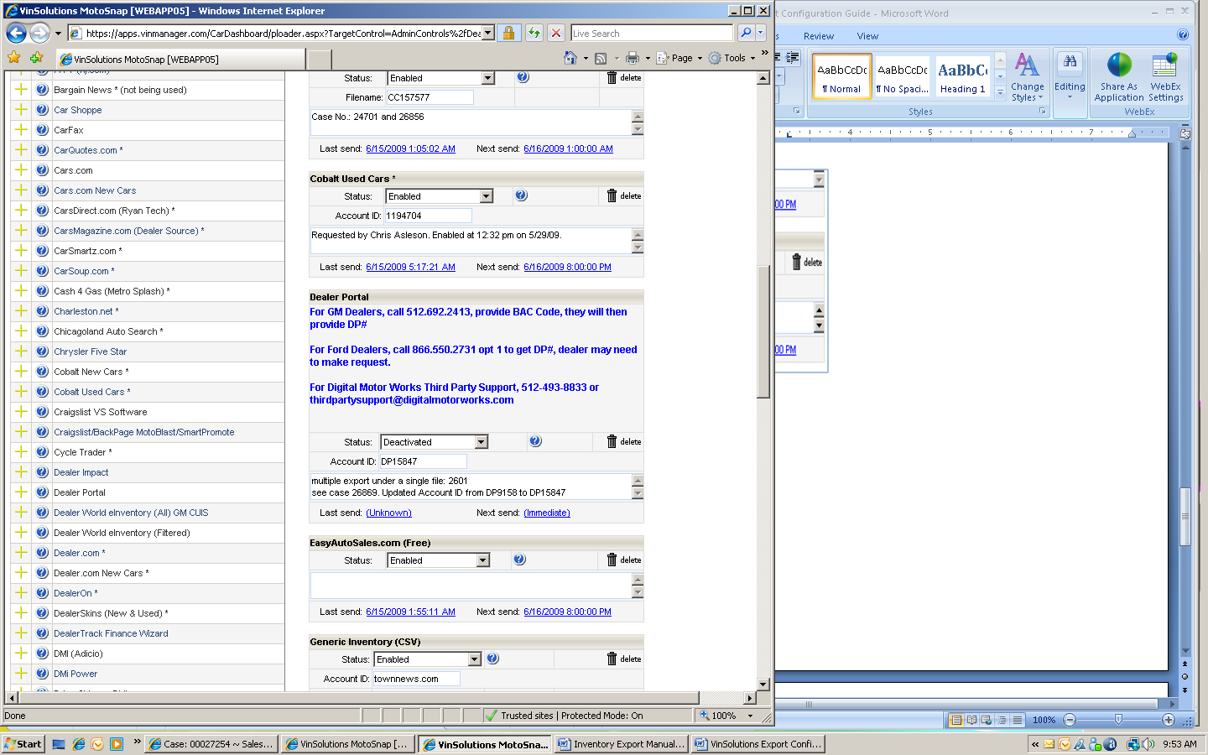

2. All dealership involved in this export shares a single ACCOUNT ID

3. The STATUS of export account for the dealerships that are included in the export should be set as DEACTIVATED

4. It is a good practice to leave a note of brief description with the dealership numbers involved in this export and case number it originated from

**6. Verifying Existing 3rd Party Name**

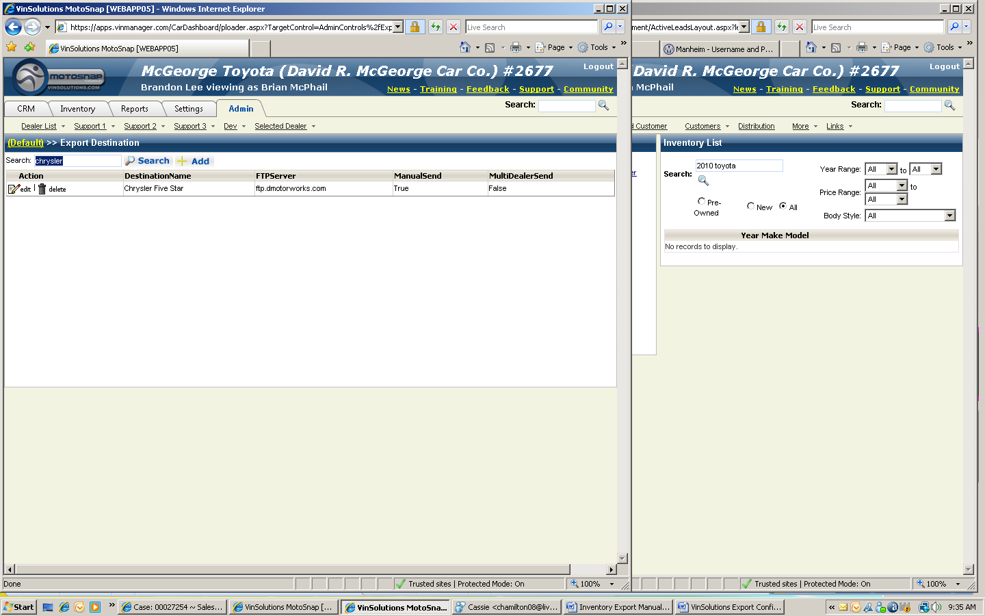1. Go to ADMIN 🡪 SUPPORT1 🡪 EXPORTS 🡪 EXPORT DESTINATIONS

**1**

**2**

**3**

2. Search the 3rd party name

3. Compare FTP Server address with existing records.

NOTE: In this specific example, Chrysler LLC submitted a request. There is no 3rd party named Chrysler LLC on destination list. From the screen left, it verified that Chrysler LLC and Chrysler Five Star have the same FTP Server address. Thus, Chrysler Five Star can be utilized

**7. Saving Export Configuration and Pushing for an immediate Data Transfer**

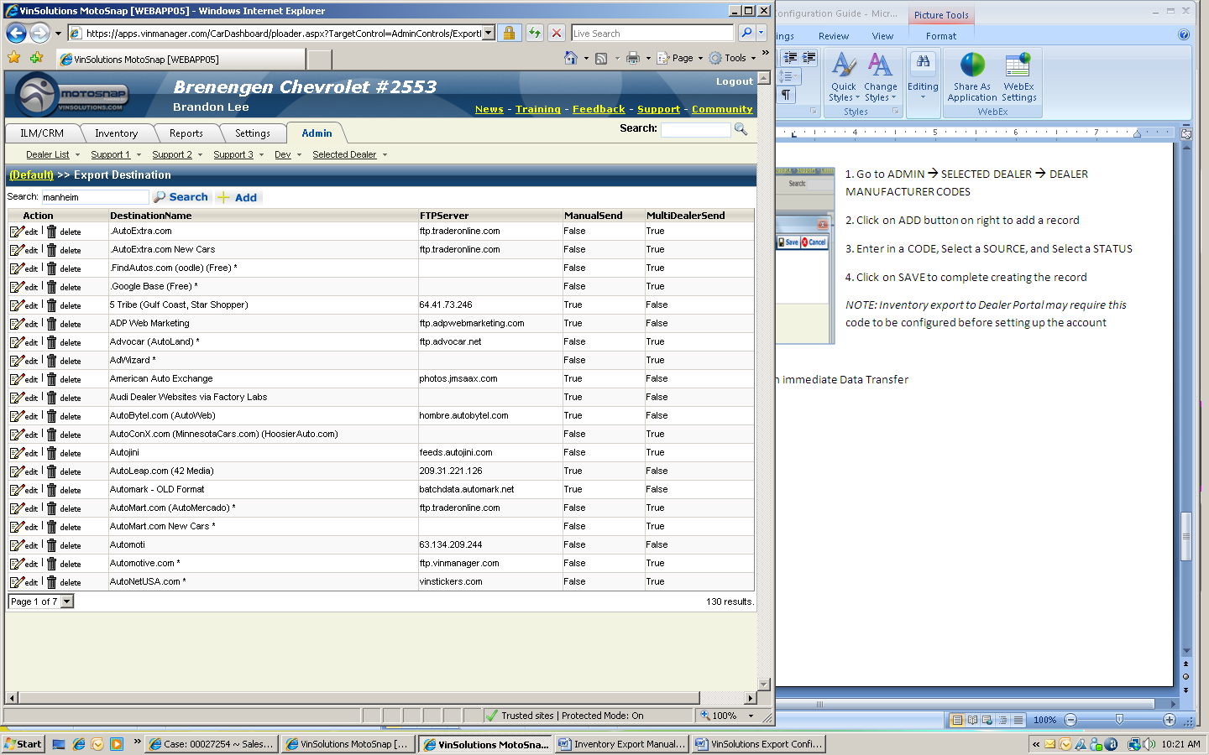1. Go to ADMIN 🡪 SUPPORT1 🡪 EXPORTS 🡪 EXPORT DESTINATIONS

**1**

**2**

**3**

2. Search the 3rd party name

3. Click on EDIT to open up the account settings page

Scroll down to find CLEAR LAST SEND TIME and CLEAR NEXT SEND TIME

4. Click on CLEAR LAST SEND TIME

The page refreshes

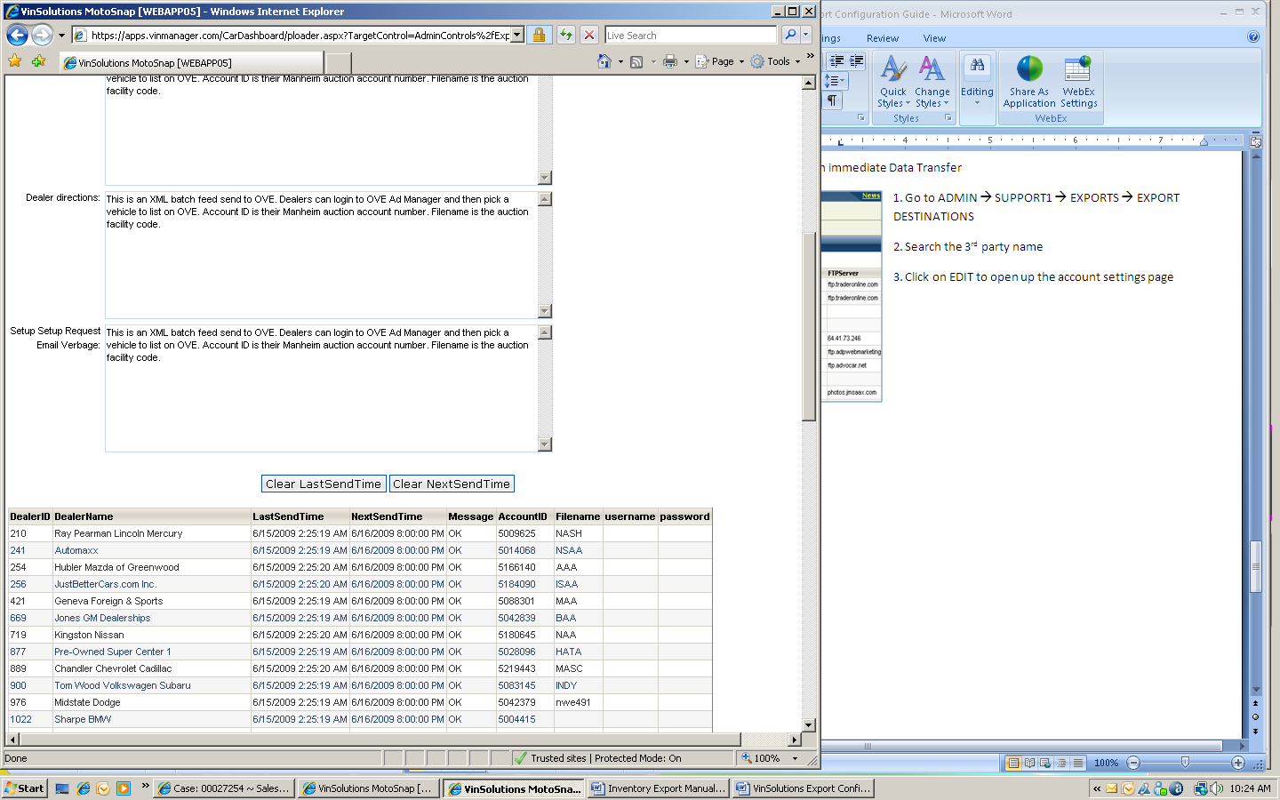5. Click on CLEAR NEXT SEND TIME

The page refreshes

6. Scroll back up and click on SAVE

NOTE: Manual push for an immediate export data transfer is a rare case. Consult with the management before performing this task

**5**

**4**

**8. Dealer Manufacturer Code (Dealer BAC)**

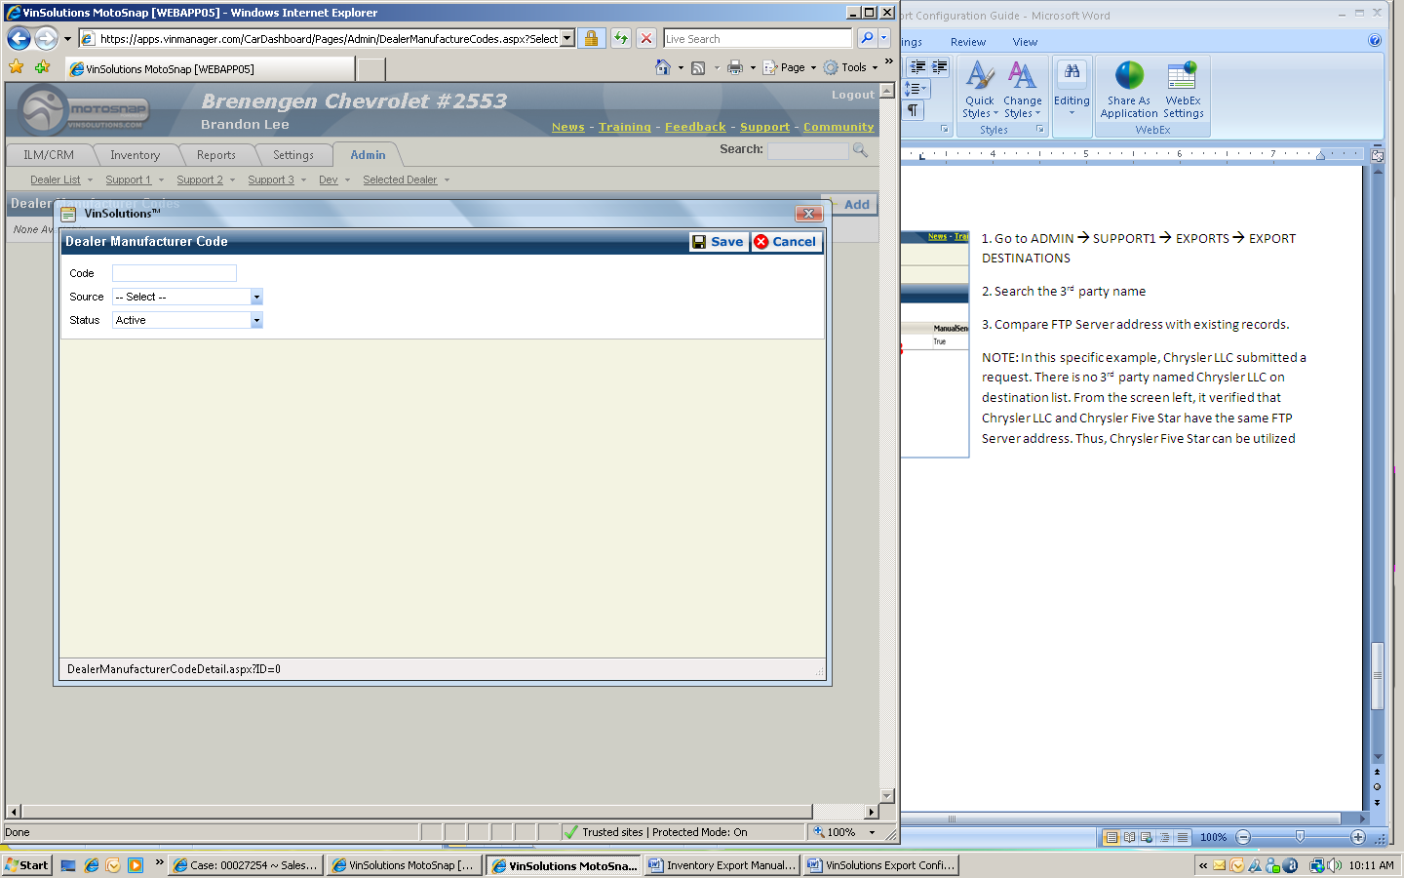1. Go to ADMIN 🡪 SELECTED DEALER 🡪 DEALER MANUFACTURER CODES

2. Click on ADD button on right to add a record

3. Enter in a CODE, Select a SOURCE, and Select a STATUS

**4**

**3**

4. Click on SAVE to complete creating the record

*NOTE: Inventory export to Dealer Portal may require this* code to be configured before setting up the account

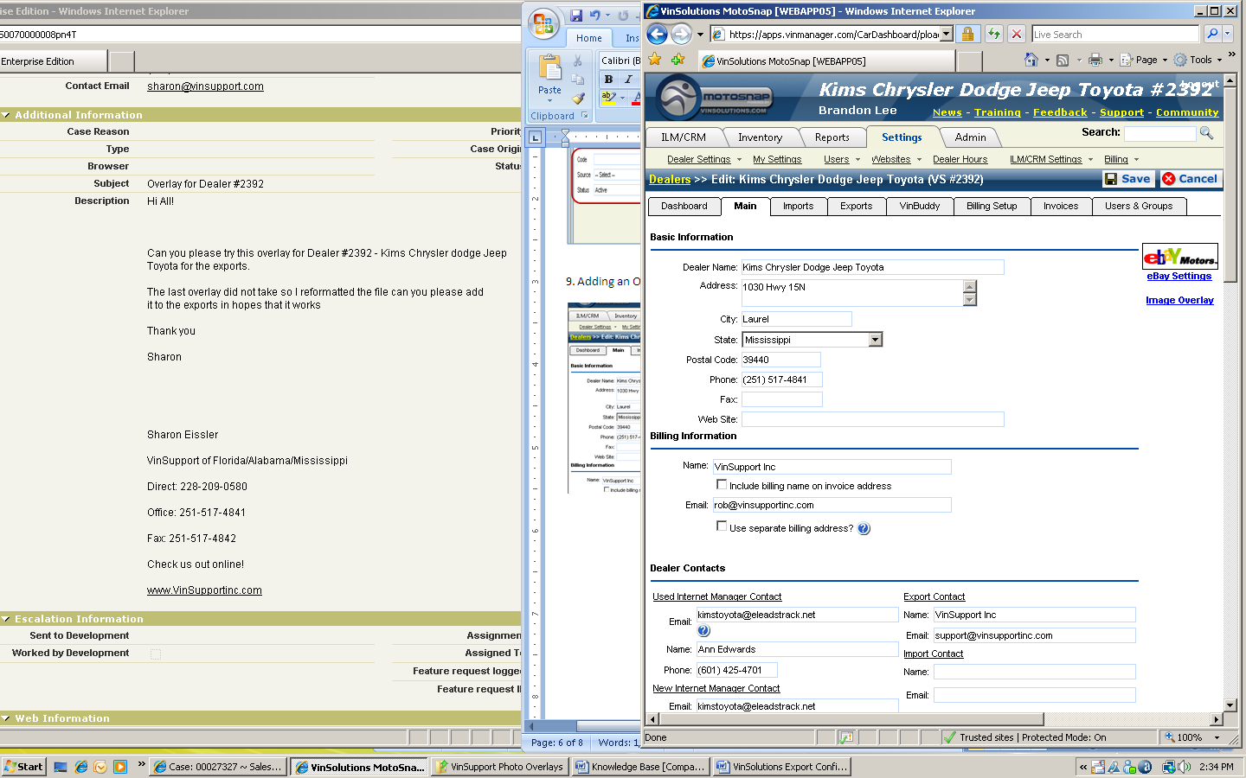9. Adding an Overlay file to Inventory Exports

1. Save a new overlay file on V:\Creative\Dealer Files\VinSupport Photo Overlays folder

**3**

**2**

NOTE: Remember the folder path since you will be uploading the file from this specific folder

2. Go to SETTINGS 🡪 DEALER SETTINGS 🡪 MAIN tab

3. Click on IMAGE OVERLAY link

4. A new image overlay edit window pops up

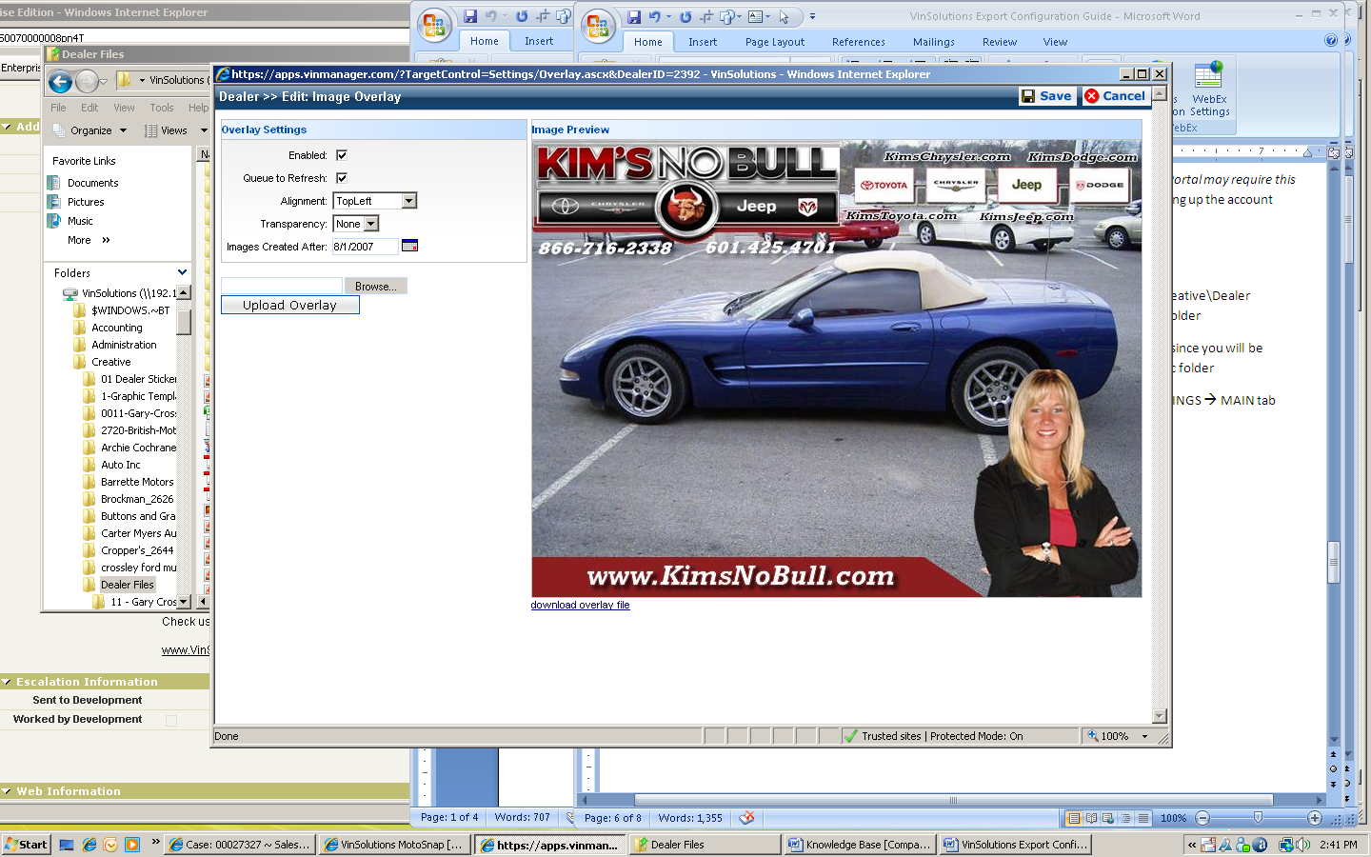

5. Check ENABLED checkbox

6. Check QUEUE TO REFRESH checkbox

**5**

**6**

**7**

**8**

**10**

7. Select desired options for the overlay

8. Click on BROWSE to locate the file stored in V:\ drive

9. Search and select/open the file

10. Click on UPLOAD OVERLAY button

11. Click on SAVE button to save the changes and exit the window

12. Click on SAVE button from MAIN tab window

**3rd Party Vendors Support Team Contact Number**

eBay Motors Data Team 1-866-322-9227

HomeNet IOL 1-877-738-3313

|  |  |  |  |  |  |
| --- | --- | --- | --- | --- | --- |
| **Destination** | **New** | **Used** | | **Generic** | **Instruction** |
|  |  |  | |  |  |
|  |  |  | |  |  |
| Autotrader |  | | |  | Use ACCOUNT ID Autotrader provides |
|  |  |  | |  |  |
|  |  |  | |  |  |
|  |  |  | |  |  |
|  |  |  | |  |  |
| Cars.com | Dealer must email or call Cars.com themselves to request that we send the data and authorize us Cars.com will email us once Cars.com processes the request. **CC# is used as the "filename" in the setup** Cars.com only processes files Tuesday-Friday  2/9 called cars.com and spoke to a support rep he told me that they now send 7 days a week and can take up to 24-48 hours before updated on site. | | |  | DO NOT FOREGET to include “CC” in front of the dealer ID number Cars.com provided to us. |
|  |  |  | |  |  |
| Coast Motor News |  | | | Yes | Use FTP Server Address, Username, Password provided from the vendor. The file name is the name of the dealership all in lowercase with no space between them |
|  |  |  | |  |  |
|  |  |  | |  |  |
| Dealer Portal | For GM Dealers, call 512.692.2413, provide BAC Code, they will then provide DP# For Ford Dealers, call 866.550.2731 opt 1 to get DP#, dealer may need to make request. For Digital Motor Works Third Party Support, 512-493-8833 or thirdpartysupport@digitalmotorworks.com | | |  | Enter DP # provided from the email received for Account ID  NOTE: Do Not Require BAC Setup |
|  |  |  | |  |  |
| DMi Adicio |  | | |  | There is no FTP Site Address field. Just enter Username and Password. |
|  |  |  | |  |  |
| DMi Power |  |  | |  |  |
|  |  |  | |  |  |
| GM CUV | As of October 20, 2008, the GM CUIS team can no longer process incoming source change requests. To make a source change request please have the dealer contact our Level 1 support at the GlobalConnect Help Desk.  GM CUIS Tech Support: 512-692-2413 | | |  | GM CUIS is no longer available.  Use GM CUV Certified and GM CUV Non-Certified account  Set up Dealer BAC code if required.  A single DP ID can be used to send both Certified and Non-Certified export feeds |
| GM CUIS |  |
|  |  |  | |  |  |
|  |  |  | |  |  |
| HomeNet | HomeNet ls also used for BZ Results and is the only site Mercedes will accept an inventory feed or photos from.  Dealer will have to set up an account with Homenet, iol@homenetinc.com Export is sent 4 times per day at 11am, 2pm, 5pm, and about 4am CST | | | No | WE MUST EMAIL iol@homenetinc.com OUR VS ID!!!  Hello,  We have a dealer that requested that VinSolutions/VinStickers send you their inventory data. We Will be sending you the inventory data for the following dealer, under the ID# .  Dealer Information: |
|  |  | |  |  |  |
|  |  | |  |  |  |
|  |  | |  |  |  |
|  |  | |  |  |  |
|  |  | |  |  |  |
|  |  | |  |  |  |
|  |  | |  |  |  |
|  |  | |  |  |  |
|  |  | |  |  |  |
|  |  | |  |  |  |