Using Parent Cases

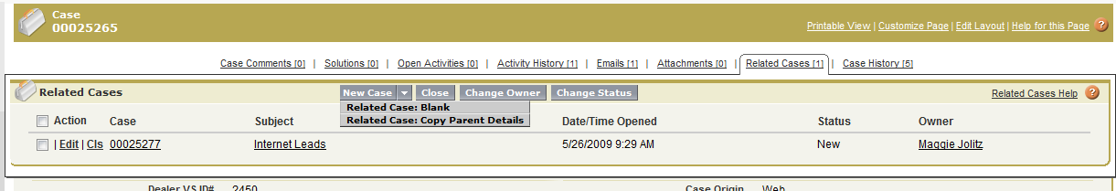

From the original case use the Hover “Related Cases” and select New Case- “Copy Parent Details.”

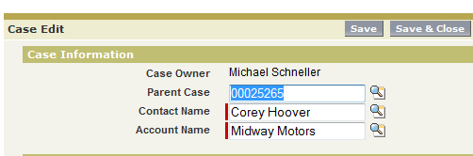

Change the Contact Name and Account Name and “Save.” The new case is now related to the Parent Case (first case that came in).

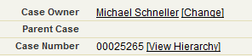

Click on View Hierarchy to view all child cases or use the “Related Cases” Hover

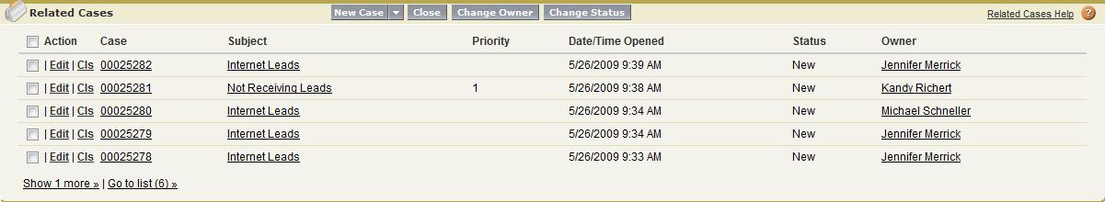

Related Cases View

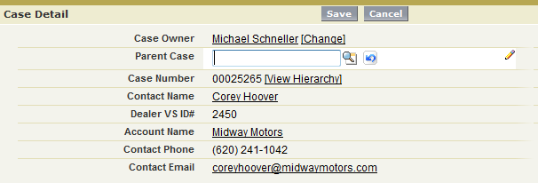

Linking a Case to a Parent

Use the Parent Case lookup to find the Parent Case Number. Once assigned, the new case will now show in the Related Case list of the Parent Case.

**Managing Related Cases**

To perform mass actions from the Related Cases related list, select the checkboxes next to the cases you wish to update, and click:

* **Close** to close the selected cases using the values you specify.
* **Change Owner** to assign the cases to the one user or queue you specify.
* **Change Status** to change the Status of the cases to the value you specify.