**How A Manager Determines Next Approver in Approval Workflow**

*For assistance, contact: TRAX Support (866) 233-5463, M-F, 8am-11pm EST or* [*support@beeline.com*](mailto:support@beeline.com)

Log into TRAX via Manager Center on the portal. Depress contractor’s name in “My To Do” section.

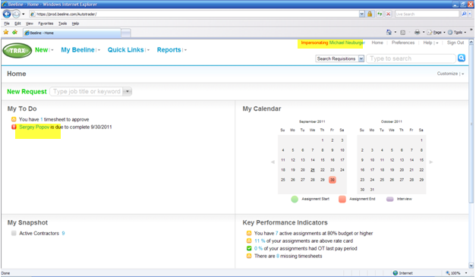

The highlighted step shows the group needing to approve/reject extension. Depress the highlighted step in the Approval in Progress section to determine the name of the person who needs to approve/reject.

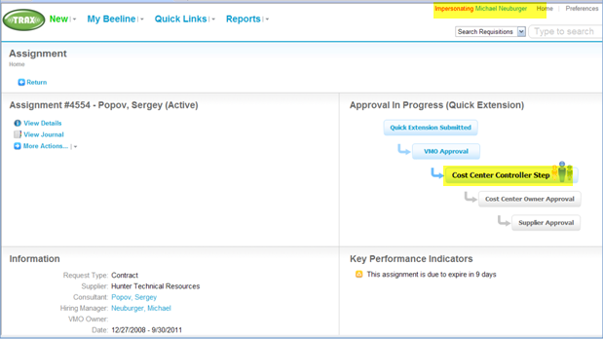

Depress “View Approvers”

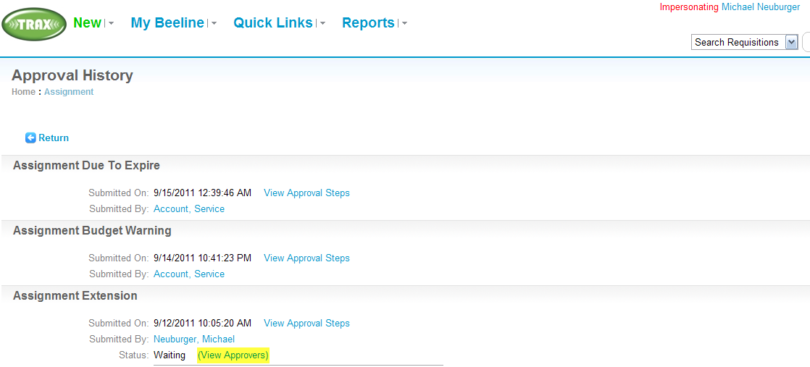

The person needing to approve/reject the extension will be listed at the bottom of the page. In this case, it is O Ajayi.

