**HOW TO CREATE AN AMENDMENT AND/OR EXTENSION**

A manager will need to change the manager/cost center if a CONTRACTOR is being moved. This is done via an Amendment. If the CONTRACTOR needs to be extended beyond their current TRAX end date, the manager will need to initiate an Extension. These two (Amendment/Extension) can be done separately or simultaneously.

*For assistance, contact: TRAX Support (866) 233-5463, M-F, 8am-11pm EST or* [*support@beeline.com*](mailto:support@beeline.com)

Note: To change the manger/cost center of an EMPLOYEE, make the change in PeopleSoft. The changes will be fed to TRAX automatically.

1. Log into TRAX via your manager portal (not time entry url). Your home page will display.

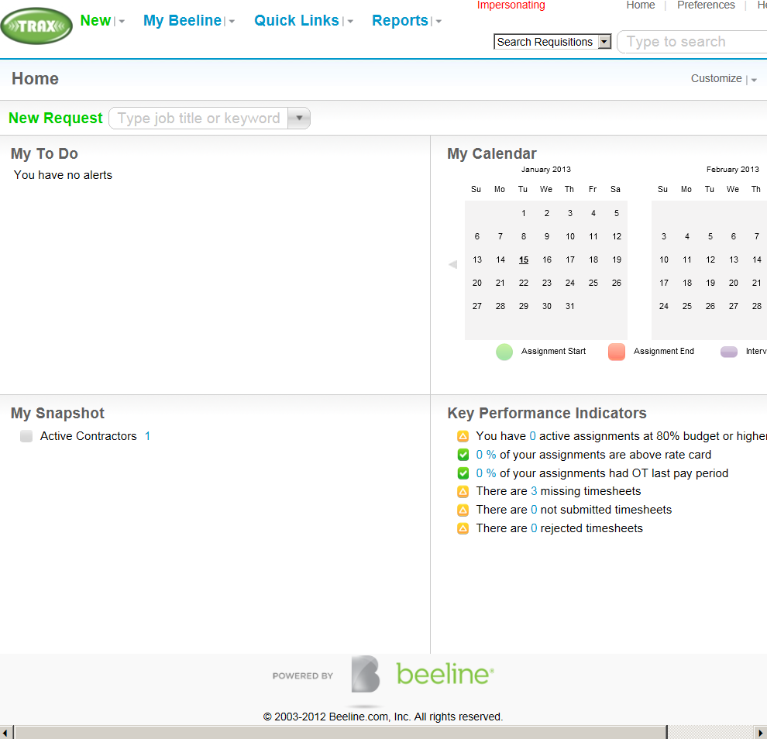

1. Select My Beeline > My Assignments

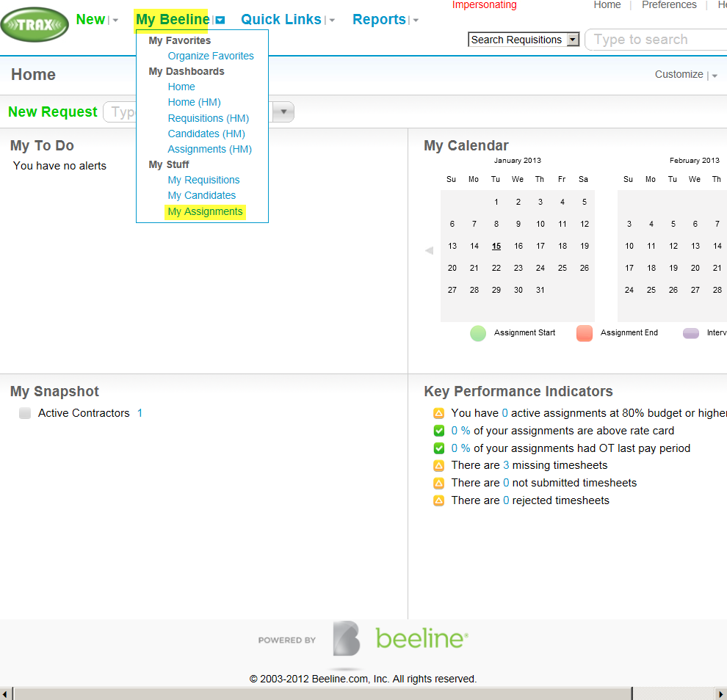

1. Depress Assignment’s Name

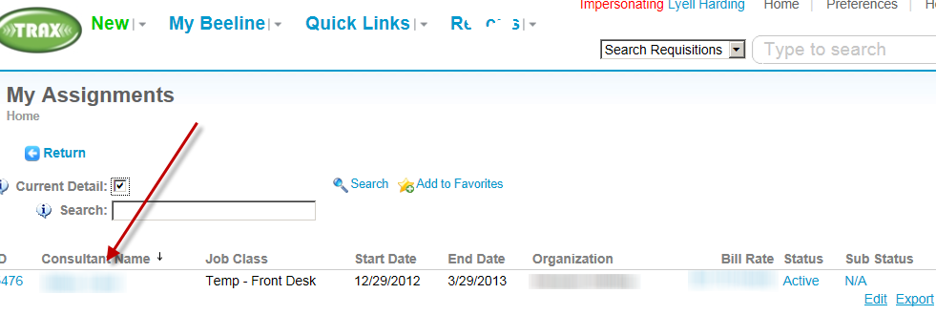

1. Choose “Amend” (if an Extension only is needed, choose Extend instead).

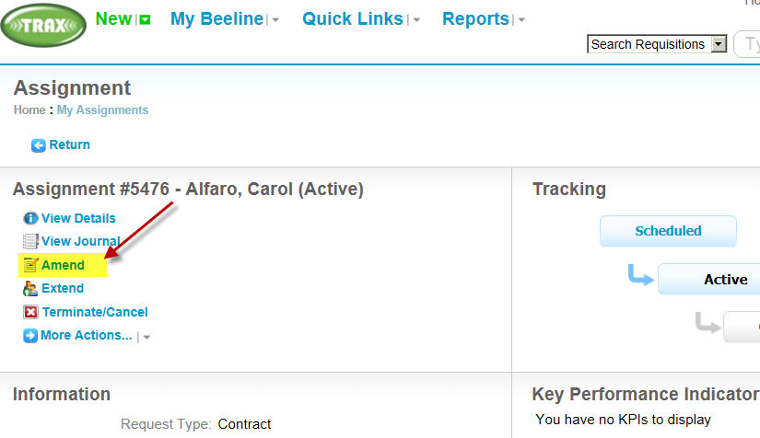

1. Choose “Amend” and “Effective Date” (best to choose a Sat date so timesheet is not split in middle of week). Next. (If an Extension is also needed, choose “Extend” and add the new end date).

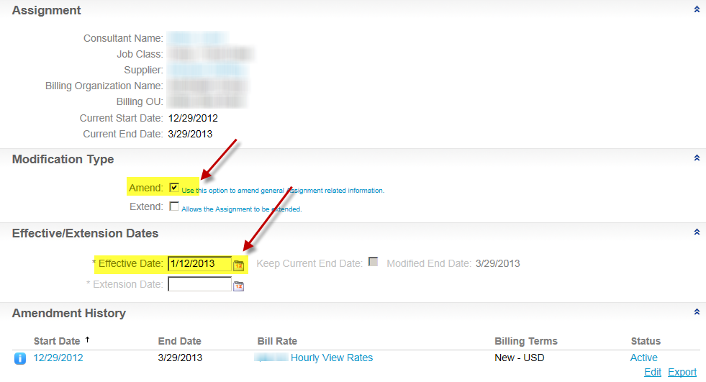

1. Select Reason, input Comments. Select correct Hiring Manager and/or Cost Center. Next.

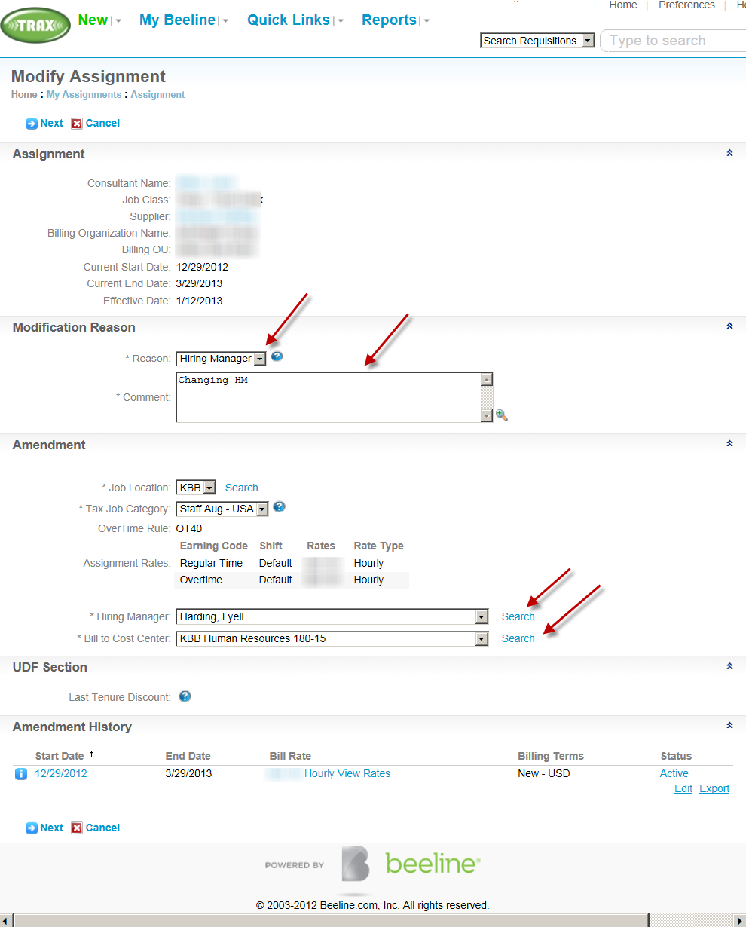

1. Select OK.

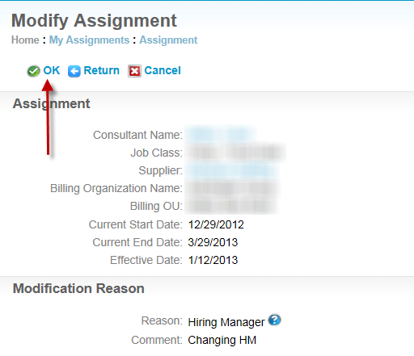

**For Amendments only**, only the Cost Center Controller (Finance) will need to approve in TRAX**. For Extensions or Amendments & Extensions**, the Cost Center Controller (Finance), Cost Center Owner (Sr Dir or above) and the Supplier will all need to approve in TRAX.