**HOW TO CREATE A REQUISITION**

**A manager (or the HR Recruiter) creates a requisition in TRAX when a contractor is needed.**

*For assistance, contact: TRAX Support (866) 233-5463, M-F, 8am-11pm EST or* [*support@beeline.com*](mailto:support@beeline.com)

1. Access the manager’s functionality in TRAX (not ‘submit timesheet’ link). Your home page appears.
2. Click the New Request drop-down arrow to select a job title or begin typing in the Job Title box to search for a job title by name. The auto suggestion/type ahead functionality recommends job titles that match what you type.

*To review the job description and rate for a job title, hover over the i-bubble.* 

1. Select a job title from the list of options. The Create Request screen appears. Click Next. The Create New Request: Update Details screen appears.

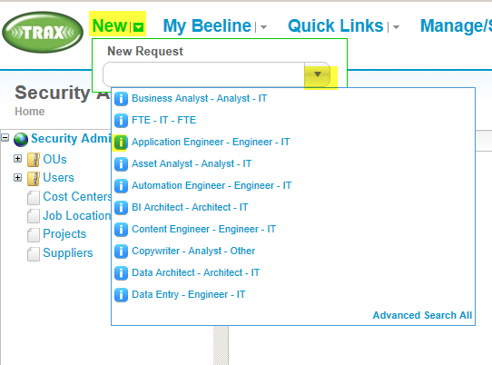

1. Complete all of the *required* (*) fields as indicated below.

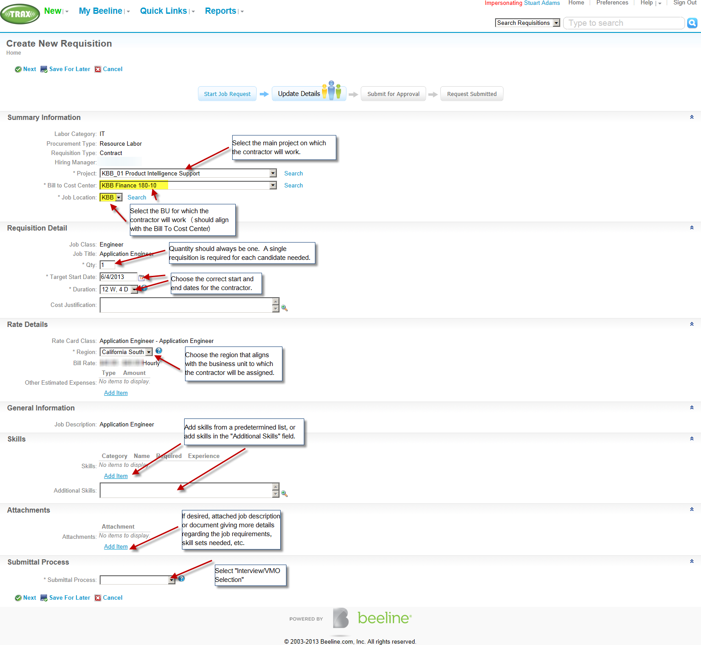

1. Click **Next**. The Create New Request: Submit for Approval screen appears.
2. Review the request details.

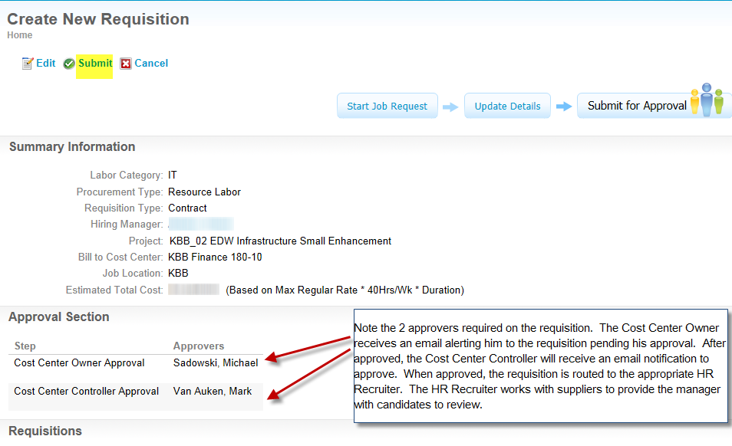

1. Click **Submit**. The Request Group Summary screen appears and displays, "Your Request Has Been Submitted."
2. The requisition is routed in TRAX to the Cost Center Owner then Cost Center Controller to approve. Once approved the requisition is routed in TRAX to the HR Recruiter who contacts the Suppliers to get candidates for the manager’s review. The HR Recruiter drives the process from here to hiring of the contractor in TRAX.
3. Once hired, the TRAX Sys Admin team sends a welcome letter to the contractor with pertinent TRAX info. The contractor’s manager is cc’d. The welcome letter contains instructions for the manager to assign the resource to the correct projects so time entry can begin.