**How to Determine a Project or Task Status**

*For assistance, contact: TRAX Support (866) 233-5463, M-F, 8am-11pm EST or* [*support@beeline.com*](mailto:support@beeline.com)

*Note: Projects and tasks are managed by Project Accounting. DO NOT make any changes to projects or tasks. If changes are needed or if you have questions, please contact zz.AT-Project Accounting@autotrader.com.

1. Select Quick Links > Time System.

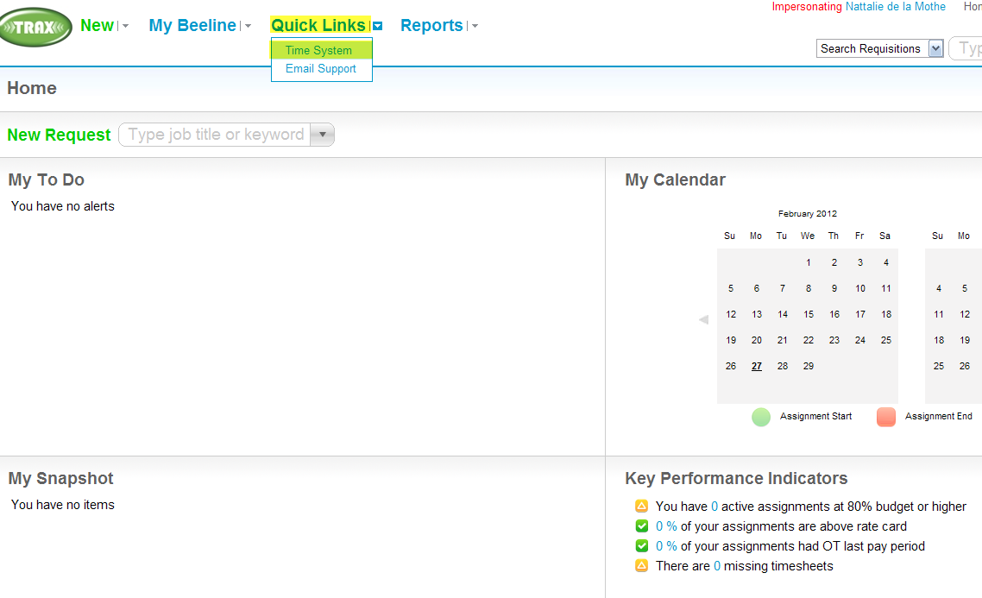

1. Select Projects > Project Mgmt > Project Teams.

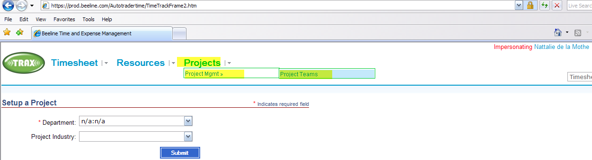

1. Select “Select Project”

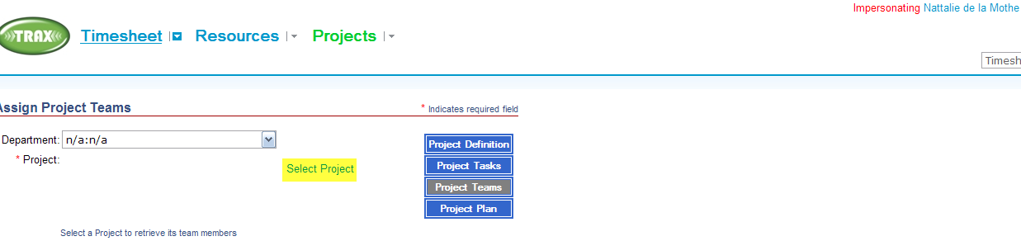

1. Enter project name or project name in Search. Select Search criteria. Select Search

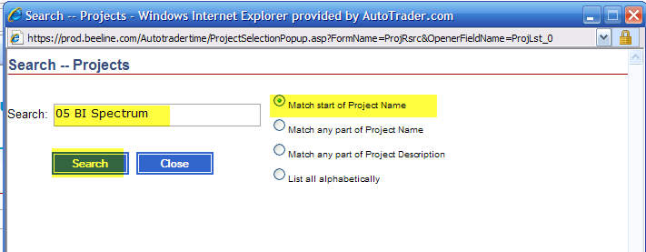

1. Select desired project.

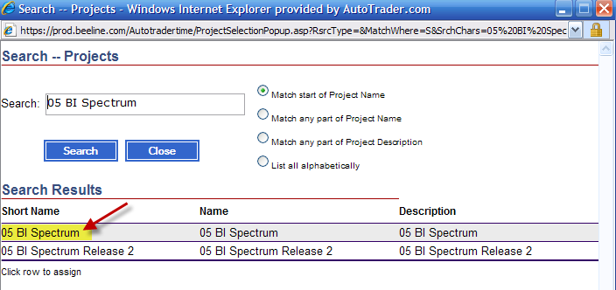

1. Select Project Definition.

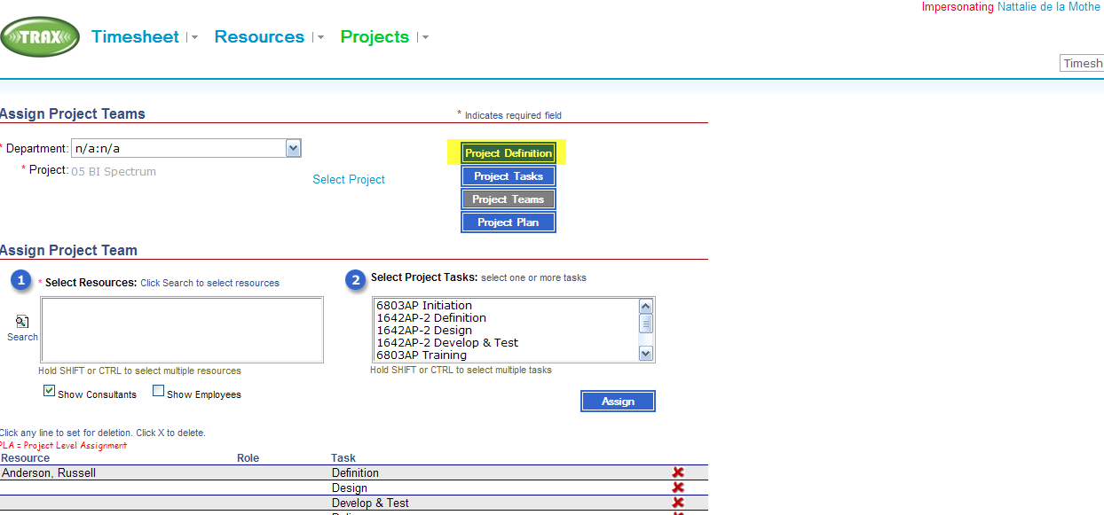

1. The Status field indicates the **project** status.

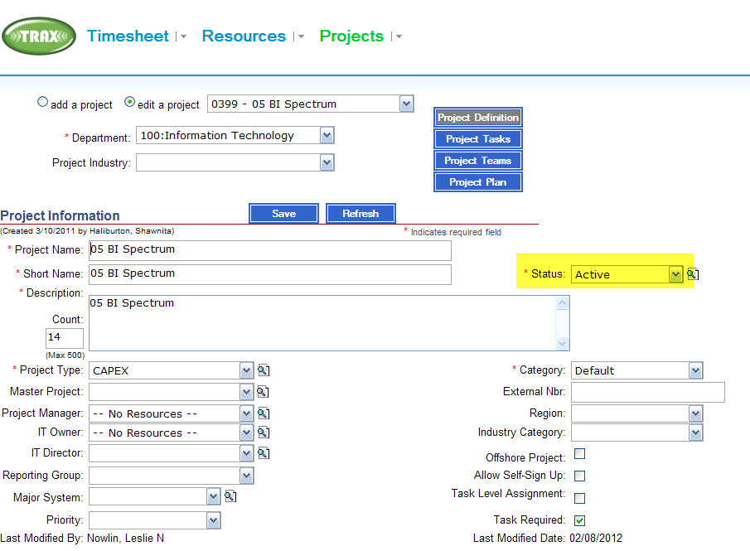

1. Select Project Tasks to see the status of each task. (No time can be charged to closed projects or tasks).

