**How To Extend an Expired Contractor (aka: Assignment)**

*For assistance, contact: TRAX Support (866) 233-5463, M-F, 8am-11pm EST or* [*support@beeline.com*](mailto:support@beeline.com)

1. **Select My Beeline > My Stuff > My Assignments.**

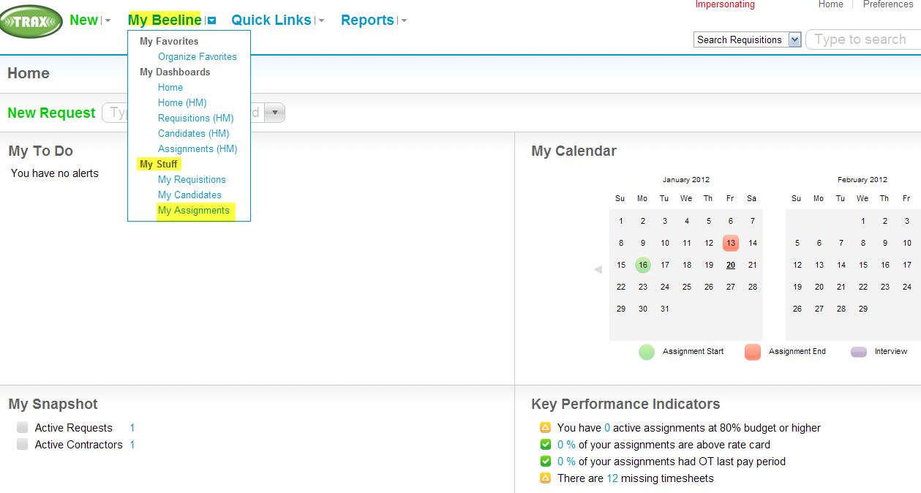

1. **Uncheck “Current” box.**  **Enter contractor’s name in search box. Depress “Search”.**

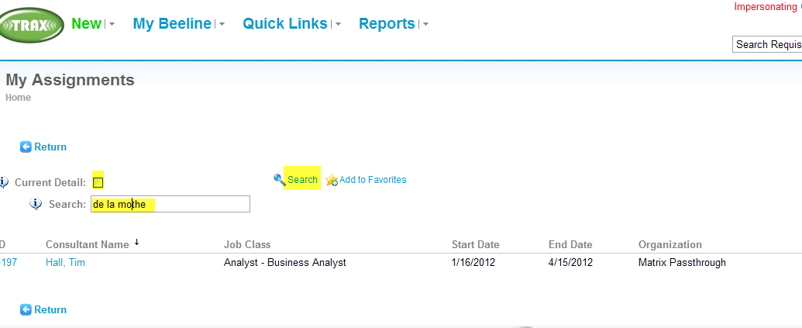

1. **Depress users name to open expired contractor.**

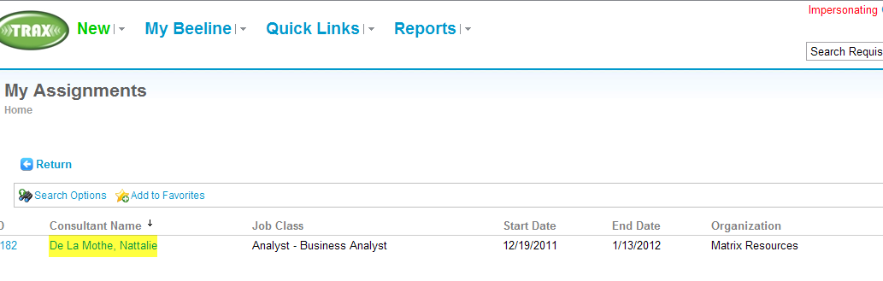

1. **Select “Extend”.**

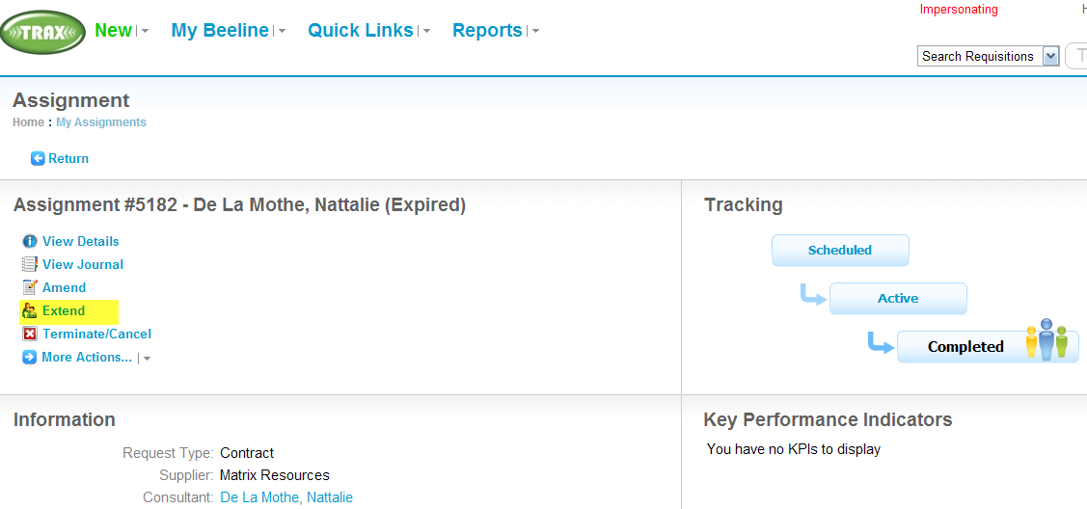

1. **Select appropriate reason. Enter comments. Input the new end date. Depress Next, Ok.**

**NOTE:** Bob Hadley is requiring that extension details be reviewed by Sr Directors before they approve an extension. Therefore, put these required extension details in the Comments section:

* 1. List of projects the contractor will be working on & estimated timeframe
  2. % of Capex vs Opex for each project for the contractor’s duration

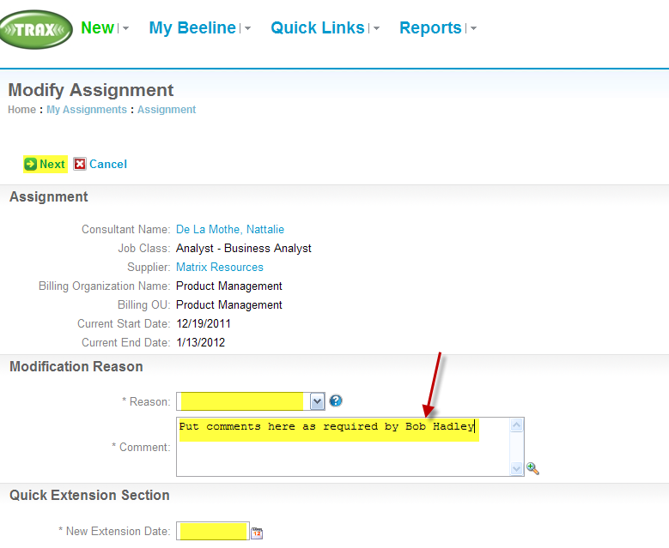

1. **This new extension will go through the approval process in TRAX (IT Finance > Sr Dir > Supplier).  When all have approved, this new extension will begin the day after the last extension expired. The contractor will be able to enter time in TRAX at this time.**