**How to Terminate a Contractor in TRAX (Instructions for Managers)**

***For assistance, contact TRAX Support:*** *(866) 233-5463, M-F, 8am-11pm EST or* [*support@beeline.com*](mailto:support@beeline.com)*, 24/7.*

**If a contractor leaves ON their scheduled TRAX end date:**

If a contractor leaves at their end date in TRAX, there is nothing for the manager to do except to ensure the contractor has entered all time.

**If contractor leaves BEFORE their scheduled TRAX end date in:**

When a contractor leaves before their end date in TRAX, the manager must terminate them in TRAX. Otherwise, “Missing” timesheets will accumulate weekly on the Mon & Tues Compliance Reports for every week up to the contractor’s end date in TRAX.

Once the Manager terminates the contractor in TRAX, TRAX no longer expects timesheets after their termination date. Therefore no “Missing” timesheets will appear on the Mon & Tues Compliance Reports.

*See instructions below for terminating a contractor when they leave prior to their scheduled end date in TRAX*.

**If contractor is missing time and they are no longer with ATC:**

If time is missing and the contractor is no longer here, “Missing” timesheet entries for this missing time will appear on the Mon & Tues Compliance Reports. The contractor’s Supplier must enter the time for the contractor in TRAX. The Supplier should contact TRAX Support if assistance is needed: (866) 233-5463, M-F, 8am-11pm EST or [support@beeline.com](mailto:support@beeline.com), 24/7. (Once this time is added by the supplier, the manager can approve.) Missing timesheet entries will then be removed from the Mon & Tues Compliance Reports.

**TO TERMINATE A CONTRACTOR IF THEY LEAVE BEFORE THEIR SCHEDULED TRAX END DATE:**

**Log in to TRAX using your manager access.**

**Select Beeline > My Assignments**

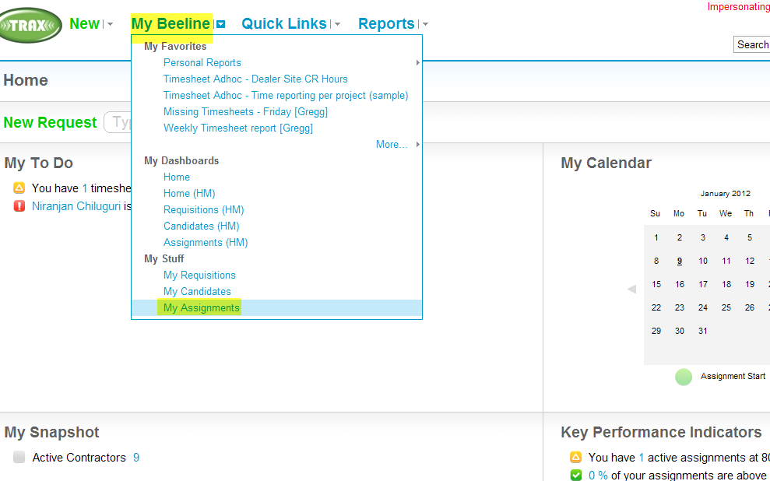

**Search for the contractor**

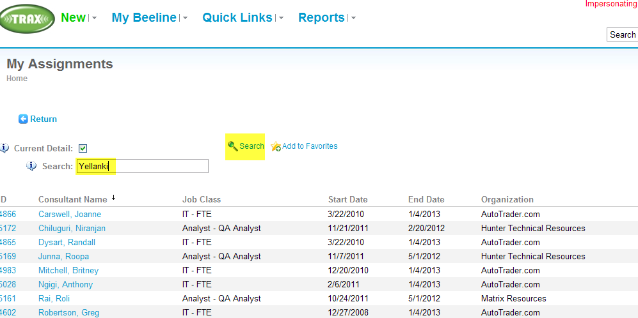

**Select Contractor’s Name**

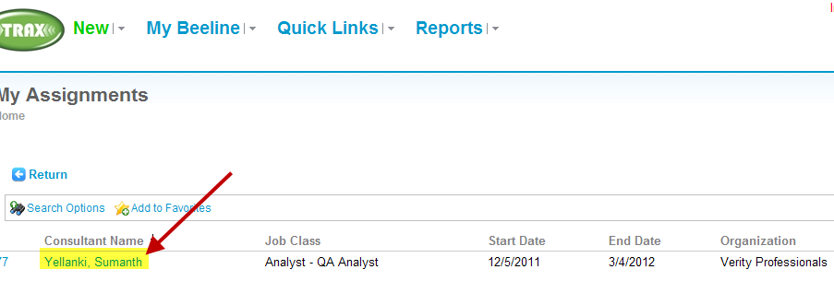

**Select Terminate/Cancel**

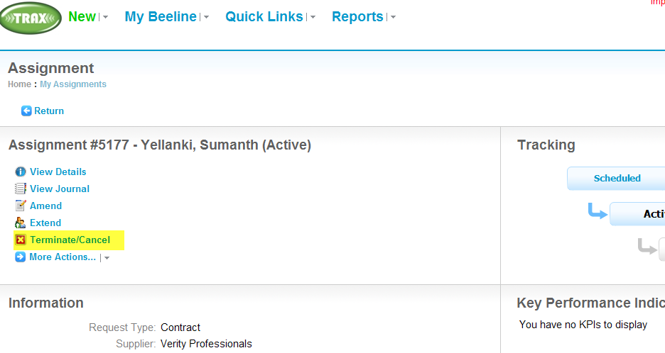

**Complete highlighted fields, then select Next**

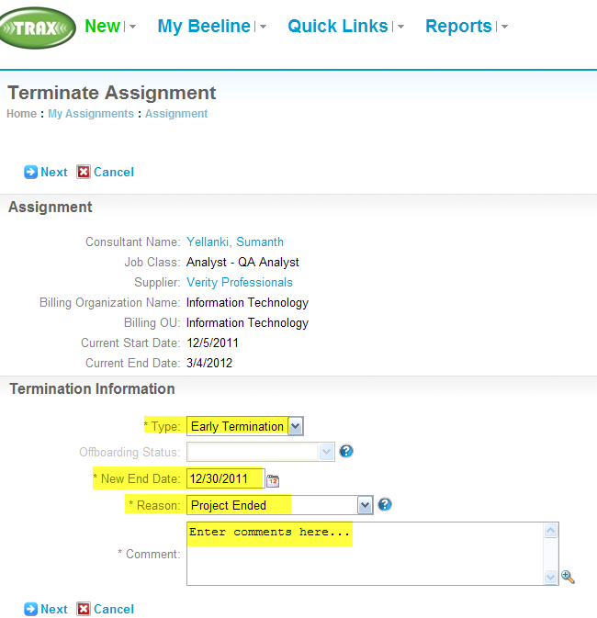

**Select OK**

