**Issue 1:** AdManager logo is not present at the top of the page



**Issue2:** Recent Items section should not be displayed in the left navigation in AdManager logging page

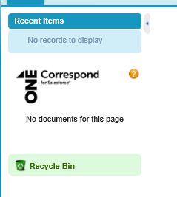

**Issue3:**

1. Below text should be in Bold, Black color and increase the font size of the text.

**What defines 'one AdManager number' (or a 'single job') in AdManager?**

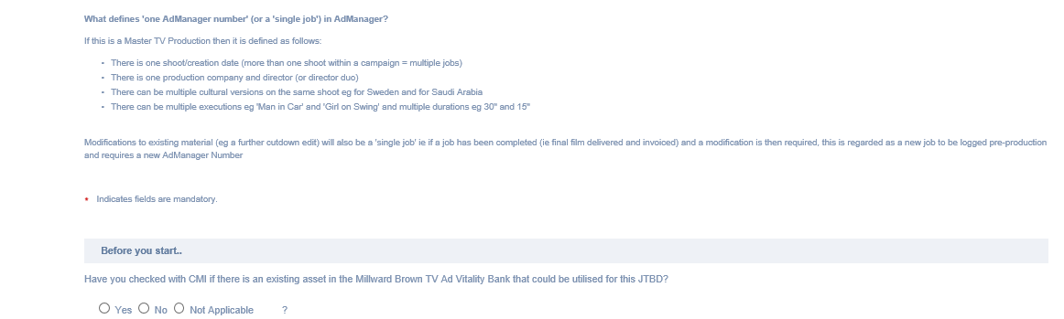

1. Remaining texts should be in black color.

**Issue4:** Extra ‘?’ special character is observed in ‘Before you start’ section

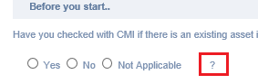

**Issue5:** All the Picklist values are not populating as per in the BRD Logging page v3 sheet

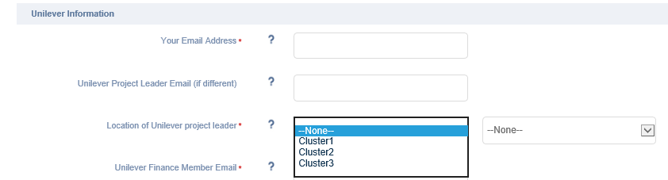

**Issue6:** Contact details should be in the left side of the page and [advertising.production@unilever.com](mailto:advertising.production@unilever.com) should be in hyperlink. The text of the contact details should be in light color except [advertising.production@unilever.com](mailto:advertising.production@unilever.com). (pls refer the BRD for more clarification)

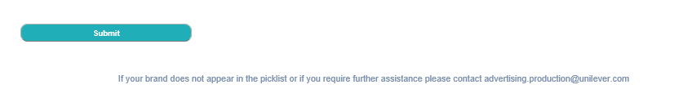

**Issue7:** Increase the size of the ‘Submit’ button as below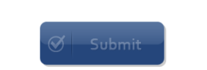

**Issue8:** Auto-populate text should be present in the ‘Budget allocated for this activity (enter all digits)’ field as well as remaining fields as per in the below expected result screen shot

**Actual Result:**



**Expected Result:**

