Penina Levine Is a Potato Pancake  by Rebecca O'Connell, illustrated by Majella Lue Sue  Roaring Brook Press, 2008 | 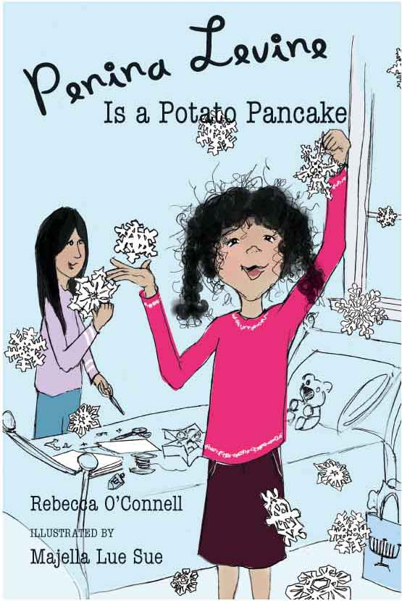

Book Discussion Questions
- Penina wants to put off opening Hanukkah gifts because she hasn’t finished making them for her family. Have you ever made holiday gifts for family or friends? What did you make? Was it hard? Did the process take longer than you expected? Were you pleased with the results?
- Penina and Zozo expect to miss Mrs. Brown when she leaves. Has there been a special teacher that you have known that you would miss? What subject did he or she teach? Was it a subject that you liked and were good at? Do you think it’s possible to really like a teacher who teaches something you don’t understand or like to study?
- Penina and Zozo have fun making up recipes for different kinds of pancakes. Have you ever tried to change one of your favorite foods by doing something different, like putting peanut butter on pizza or mixing apple juice and milk? What did you create—and how did it taste?
- Penina gets frustrated with her family because she feels like they don’t listen to her. Have you ever felt like you couldn’t communicate with your parents? What were you trying to tell them? Did you try to get your message across in another way, like writing a letter or talking with someone else in your family first? Whatever you tried, did it work?
- Penina’s favorite present is a copy of the Annotated Alice. This is a version of Alice in Wonderland and Through the Looking Glass that offers a lot of background information about how the book was written and what various sections of it might mean. If you could have an annotated copy of any book in the world, what would it be? What would you want to know about that book?
Email me! If your reading group is talking about Penina Levine Is a Potato Pancake, I’d be happy to be in on the discussion – virtually. Please email me your questions, and I’ll do my best to answer every one. It will be like having the author at your meeting.

www.rebeccaoconnell.com
rebecca@rebeccaoconnell.com

