Genomics and bioinformatics practical 2
Genome databases

In this practical we will start by looking at some genomics data, where to find it, stages of genome sequencing and assembly and then have a look at an annotated avian genome (the chicken). We won’t spend too long looking at this as the genome viewers are really complicated and we don’t have time to look at them properly. We will just have a basic look at how the annotation works https://www.ncbi.nlm.nih.gov/gdv

This site lists the mostly complete, mostly annotated genomes. Annotation means that specific data or data libraries are attached to the sequence. Have a play around seeing which ones are available.
Click on the chicken genome. Note that there aren’t that many well annotated avian genomes available on this site (and certainly not the blue tit genome). You can see that the genome is divided into chromosomes and most of the chromosomes are complete with few if any gaps.
Try clicking on chromosome 5. A rather complicated screen appears, and this is actually very simplified. Have a look at some of the ‘tracks’ such as genes at the top. Zoom in an out of the sequence using the scale bar, then click on the gear symbol at the bottom of the page to reveal the interactive display tool

Question 1: How many genes are present on chromosome 5?

There are 1418 genes in the chromosome 5 region.

Question 2: Each track is a dataset appended to the chromosomal sequence. How many tracks are there?

There are 519 tracks (bottom right).

If you want, you can have a play around with the display by clicking on tracks to display and those to ignore (click the tick symbol to make the track disappear). Only a relatively few (large vertebrate) genomes have reached this stage of completeness. Others are in more preliminary stages of sequencing and assembly. To view https://www.ncbi.nlm.nih.gov/datasets/genome

Use the search term to look at the number of avian genomes available (Aves)

Question 3: How many Avian genomes are available?

There are 2,442 genomes.

These genomes range from very preliminary (lots of short sequences but not much assembly (no annotation) through 1million bp contigs (little to some annotation) to some mostly complete chromosomes (usually, but not always annotated), to complete genomes as seen in the previous site.
Have a look to see which taxa you are interested are available as a potential resource in your upcoming projects for example.

We will look at the blue tit genome. Type in the latin name or blue tit into the search box.

Question 4: What is the most ‘complete’ blue tit genome and how complete is it? Hint: click on ‘actions’ in the top match and then ‘see in genome data viewer’ and also ‘view details’

A genome coverage of X40 means that most of the genome is present. However, it is present in 29,297 separate pieces! In my opinion this would be very usable if you were working on blue tit genotypes, evolution etc. If your taxon/taxa of interest is/are in a similar stage of completeness, then I would certainly be looking at how I could use the data.

The third one down is actually more complete in terms of sequence information (X80 coverage, 382 pieces) but is not annotated. I am happy to have a look at genomes of taxa you are interested in when walking around.

Microbiome analysis

We will now swap to microbiome data, obtained from Silwood Park. Nesting blue tits at Silwood were subjected to swabbing, in effect sampling the gut microbiomes of individual birds (or mostly the gut microbiome at any rate). The samples were then amplified and sequenced using 16S rDNA primers. Thousands of sequences were obtained.

A small subset of the sequences recovered are present in the ‘Microbiome sequences Cleaned’ file.
Open the file, select the top sequence and try to identify the species from which it originated. It is not easy….

Hint: do a BLASTn search.

Sequences: Do not paste this line into clustal F07/H35=nest box id. A=adult, C=Chick, number=no of seqs obtained

Question 5: What are most of the sequences from?

Most of the sequences are from uncultured bacteria.

Question 6: What is the top named taxon? What is its taxonomic classification? How precise can you be?

The top named taxon is bacteria, which is a very large group. It is difficult to be at all precise using environmental samples.

You can now run some specialised software to calculate the percentage identity between the two sequences: https://www.ebi.ac.uk/jdispatcher/psa

Launch GGEARCH2SEQ.
Click on DNA as the sequence type. Now paste your sequences into the two boxes

Question 7. How similar are the sequences to each other?
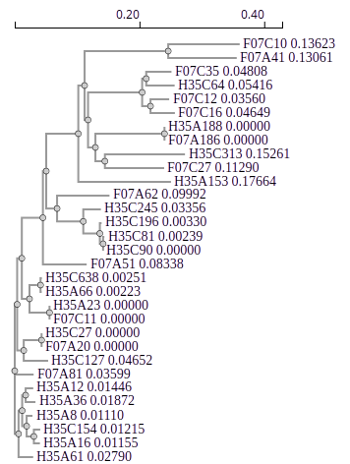
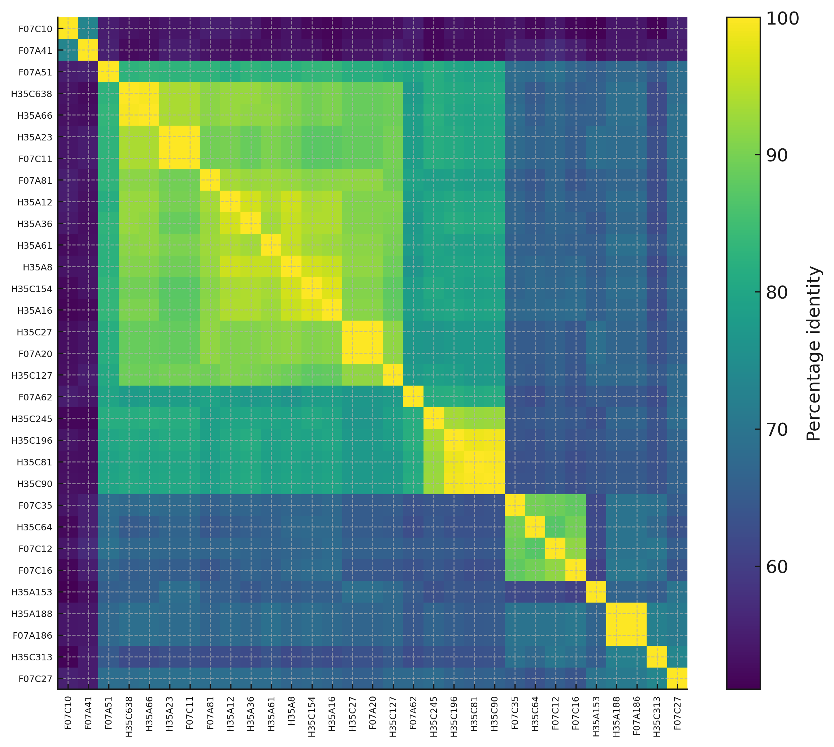
Clustal gives you sequence alignment as well as most likely phylogenetic tree (right). You can also download the percentage identity matrix and see how close sequences are from one another (left).

This is an uncorrected distance (i.e. it does not take into account multiple substitutions at the same site. To obtain a corrected distance we need to apply Jukes-Cantor or similar model : http://www.insilicase.com/Web/JukesCantor.aspx

Constructing another phylogeny
We will now construct another multiple alignment and a phylogeny.

The samples are derived from 2 nest boxes, with each nest box providing an adult sample and a chick sample. Each sample contained many bacterial sequences, from which I have selected a few at random.

Can we come up with a hypothesis of what we might expect the relationships of the samples to be? → The parental microbiome is transmitted to chicks in Blue tits.

Now run the samples using clustal as you did yesterday and display the phylogeny as yesterday also. It may help to use iTOL for visualization. https://itol.embl.de

Upload the tree and set the viewer to circular or unrooted. What do the results show? Is there anything of interest?

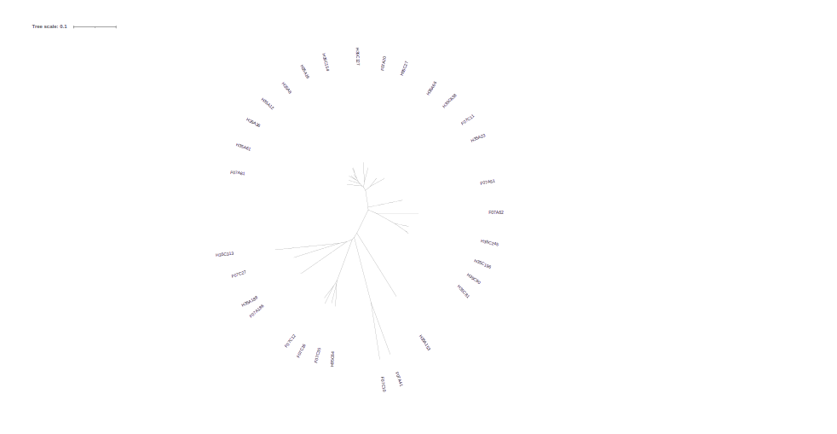
We obtained some gaps in the alignment.

If you want you can go to the following site and play with the gap opening and extension penalties to see what impact they have on the alignment. https://www.genome.jp/tools-bin/clustalw

