# User manual: TensionCam Application

The TensionCam Application is the ultimate tool for technicians operating on wind turbine. With an easy snapshot of a TensionCam nut, you’ll be able to find out the number of blobs in the nuts and total area of the pixels, enabling you to make corrections before it’s too late.

TensionCam App provides the technicians a safer work environment, minimizing risks and errors. The applications also creates an

## Requirements

The application is optimized for the following Android devices

* LG Nexus 4
* Sony Xperia Z

Both devices are running Jelly Bean (4.1 – 4.2 / API 16-17).

To ensure full functionality one of those devices, or devices with similar hardware and software specifications should be used.

## How to use

The application is limited to a few precise tasks, prohibiting the user from being overwhelmed with functionality that can deteriorate the performance. Therefore, it’s very user-friendly and equipped with large, self-explanatory buttons and messages.

### Starting screen

When starting the application, the user reach a starting screen that automatically opens the camera application after a few seconds.

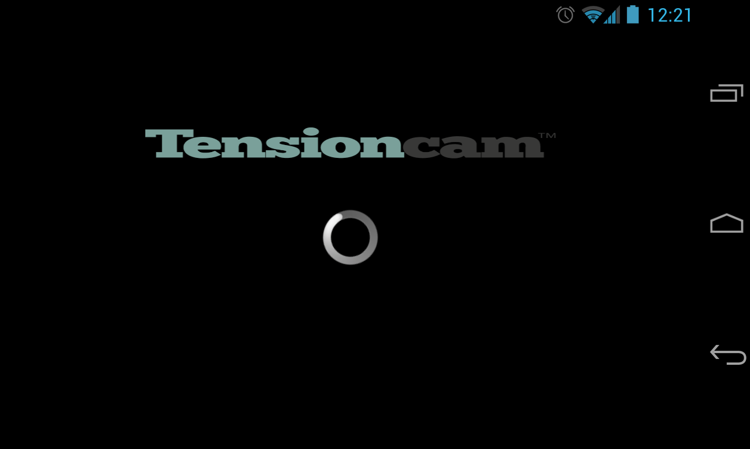

### Camera screen

The user can choose to take a picture, with or without flash, by pressing the camera button. It is not possible for the user to take several pictures, as each snapshot is unique with regard to light and movements.

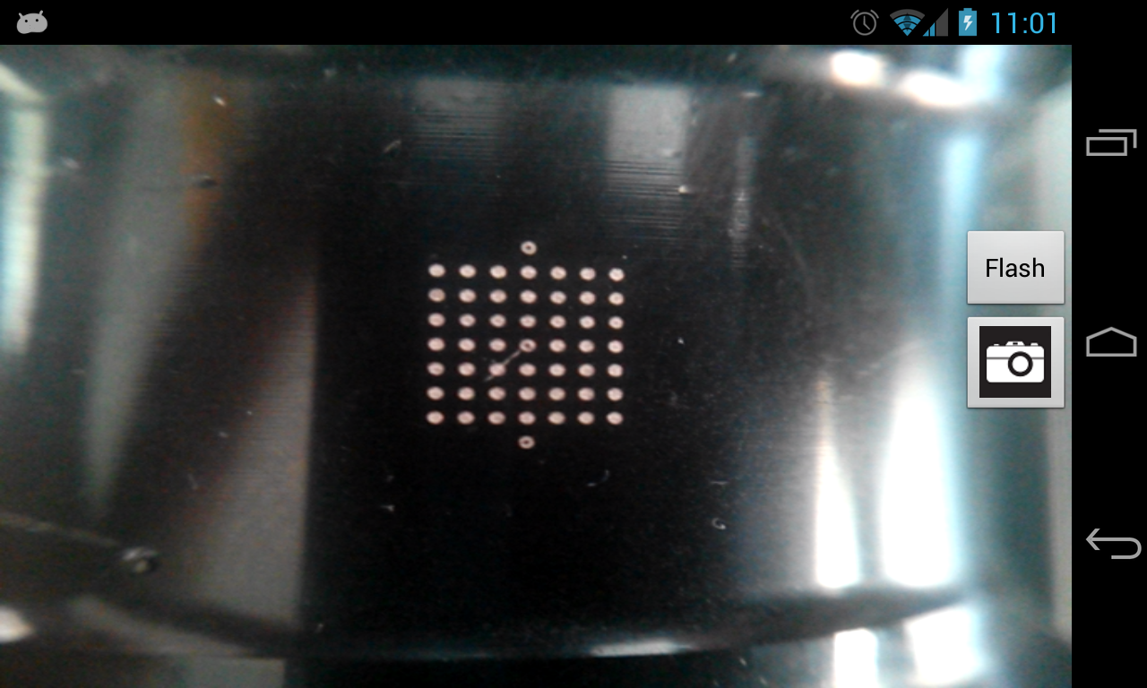

### Viewing screen

The user can view the taken picture and choose to discard and take a new picture by pressing *Take a new Picture* button, or progress by pressing the *Analyze* button.

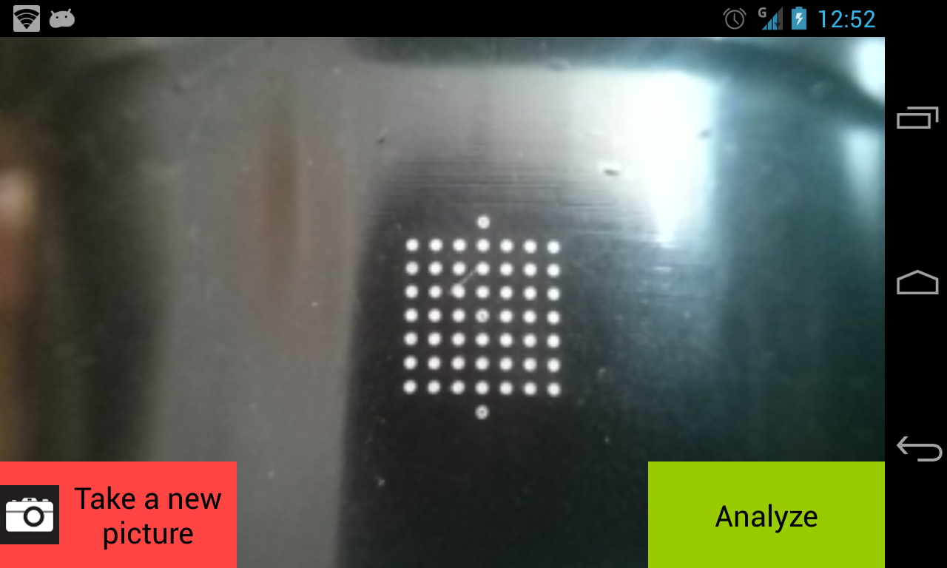

### Result screen

When the analyze is completed, the result is display and the user can here choose to take a new picture.

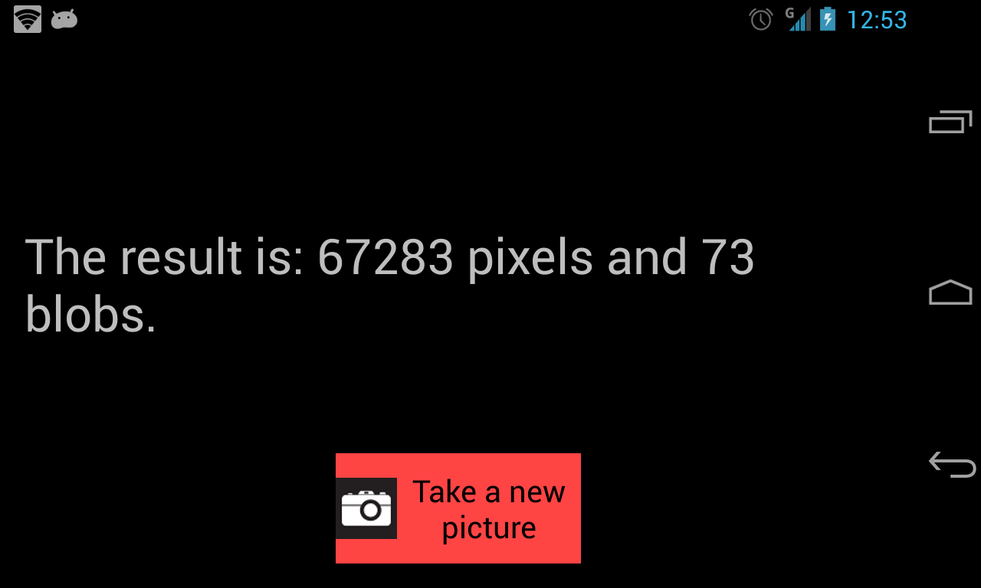

## Installing the application

Following steps should be done on your Android device in order to successfully install the application

1. Allow the device to install applications from unknown sources
   1. This setting is found in ‘Settings’ -> ‘Safety’
2. Download ‘TensionCamApp\_project.apk’ by using following link or QR-code  
   <https://www.dropbox.com/s/nu01qpm7cb8iy6j/TensionCamApp_project.apk>  
   C:\Users\Fredrik\Desktop\qrcode_tca.png
3. Open ‘TensionCamApp\_project.apk’ and press “Install”

## Uninstalling the application

To uninstall the application on your Android device, standard procedures should be followed. I.e. using the device’s default tool for app-removal is recommended.