TEST 1

Chapters 1, 2, 4, and 5

1. A description of different houses for sale includes the following variables. Which of the variables is categorical?
a. the square footage of the house
* b. whether or not the house has a finished basement
c. the monthly electric bill
d. All of the above

2. The following are some of the variables from a survey conducted by the U.S. Census Bureau. Which of the variables is quantitative?
a. the number of people living in a household
b. the total household gross income
c. the ages of household residents
* d. All of the above

Use the following to answer Questions 3 and 4.

A large university is divided into six colleges, with most students graduating from four of these colleges. The following bar chart gives the distribution of the percent graduating from the four most popular colleges in 2003.

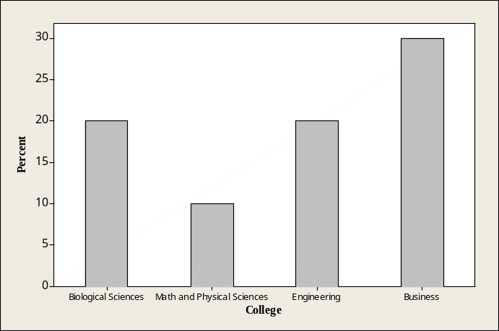

3. The percent of students graduating from either Engineering or Business is
a. approximately 30%.
b. approximately 40%.
* c. approximately 50%.
d. over 60%.

4. Could this distribution be displayed using a pie chart? Why or why not?

Use the following to answer Questions 12–14.

The histogram below shows the time visitors to a museum spent browsing an exhibit on a Saturday. There were 300 visitors that day. The following histogram is of the data collected.
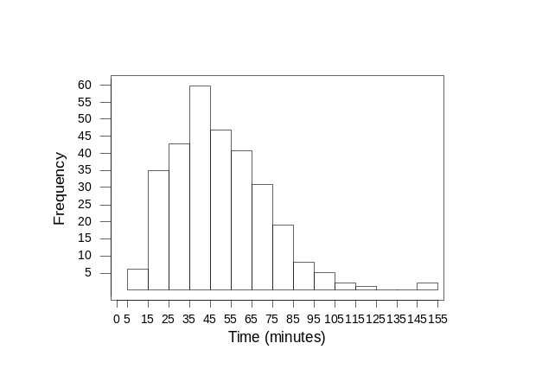

5. The number of visitors that spent less than 25 minutes at the museum that day is closest to
a. 25.
* b. 40.
c. 60.
d. 80.

6. The percent of visitors spending more than 85 minutes at the museum is closest to
* a. less than 5%.
b. about 20%.
c. about 30%.
d. over 40%.

7. The histogram
a. is skewed right.
b. has an outlier.
c. is symmetric.
* d. Both a and b

The following information is for Questions 17–19.

The stemplot below displays midterm exam scores for the 34 students taking a Calculus course. The highest possible test score was 100. The teacher declared that an exam grade of 65 or higher was good enough for a grade of “C” or better.

3 6 8
4 1 4 8
5 3 3 4 4
6 2 3 3 5 5 6 7
7 0 0 1 2 3 5 6 6 8 8 9
8 1 1 3 5
9 0 3 9

8. This stemplot is most similar to
a. a boxplot of the data.
b. a time plot of the data with the observations taken in increasing order.
* c. a histogram with class intervals 30 score < 40, 40 score < 50, etc.
d. reporting the five-point summary for the data, with the mean.

9. Which of the following statements is true?
a. All test scores were between 36 and 99.
b. Eleven students scored between 70 and 79.
c. The distribution of test scores is about symmetric.
* d. All of the above

Use the following to answer Questions 10–14.

A violin student records the number of hours she spends practicing during each of nine consecutive weeks.

6.2 5.0 4.3 7.4 5.8 7.2 8.4 1.2 6.3

10. What is the mean number of hours spent practicing per week during this period?
a. 6.15 hours
* b. 5.76 hours
c. 6.20 hours
d. 8.40 hours.

11. What is the median number of hours spent practicing per week during this period?
a. 6.15 hours
b. 5.76 hours
* c. 6.20 hours
d. 8.40 hours.

12. What is the first quartile for this data?
a. 5.00 hours
b. 5.76 hours
c. 7.20 hours
* d. 4.65 hours

13. What is the interquartile range (IQR) for this data?
a. 3.00 hours
* b. 2.65 hours
c. 3.20 hours
d. 1.65 hours

14. Considering the smallest data value (1.2) and using the 1.5 × IQR rule, we would
a. classify the value 1.2 as an outlier, because it is more than 1.5 × IQR’s below the first quartile.
* b. not classify the value 1.2 as an outlier because it is not more than 1.5 × IQR’s below the first quartile.
c. classify the value 1.2 as an outlier because it is more than 1.5 × IQR’s below the median.
d. classify the value 1.2 as an outlier because it is more than 1.5 × IQR’s below the mean.

Use the following to answer Questions 15–19.

The exam scores (out of 100 points) for all students taking an introductory Statistics course are used to construct the following boxplot.

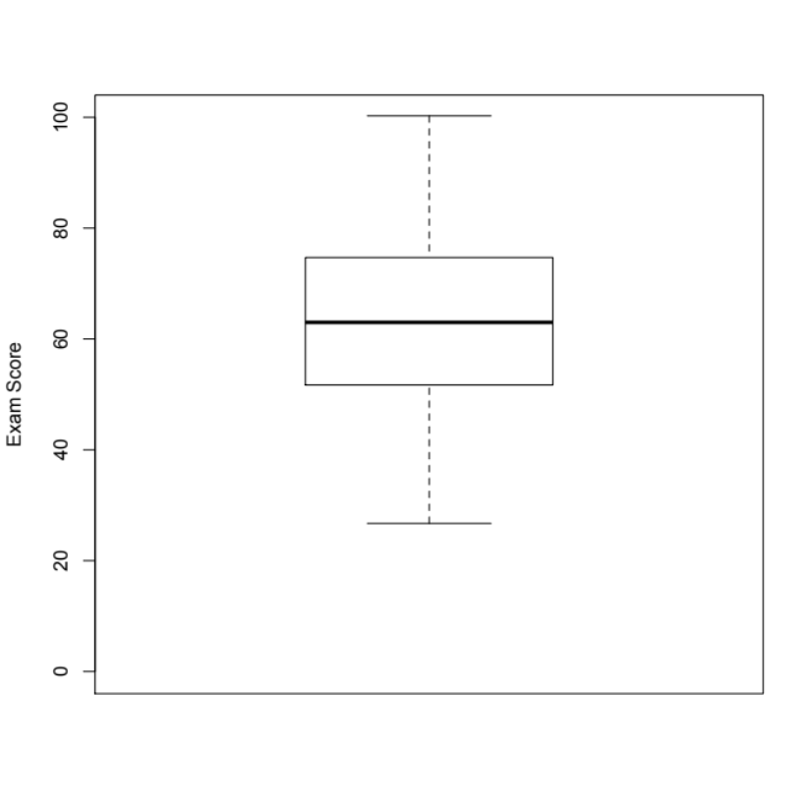
15. Based on this boxplot, the interquartile range is closest to
a. 10
* b. 25
c. 60
d. 80

16. Based on this boxplot, which of the following statements is true?
a. The distribution of scores is fairly symmetric.
b. About half the students scored below 63.
c. Nobody scored below 25.
* d. All of the above

17. If each person increased his or her score by 5 points then
a. the third quartile would increase by 5 points.
b. the median score would increase by 5 points.
c. the interquartile range would remain unchanged.
* d. All of the above.

18. About 25% of the students scores exceeded
a. 50.
b. 60.
* c. 75.
d. 85.

19. If 5 points were added to each score, then the standard deviation of the new scores would
a. be increased by 5.
b. be increased by 25.
c. be decreased by 5.
* d. remain unchanged.

20. Colleges often rely heavily on raising money for an “annual fund” to support operations. Alumni are typically solicited for donations to the annual fund, and studies suggest that annual income of an alum is a good predictor of the amount of money he or she would be willing to donate, and there is a reasonably strong, positive linear relationship between these variables. In the studies described,
a. Annual income is an explanatory variable.
b. The correlation between “alum income” and “size of alum’s donation” is positive.
c. Size of alum’s donation to the annual fund is the response variable.
* d. All of the above

21. Does exposure to classical music (through instrument lessons or concert attendance) improve children’s scholastic performance? In a study, researchers measured the amount of exposure to classical music for many children, along with their scores on the state’s academic proficiency exam. The explanatory variable in this study is
a. The type of instrument a child plays.
b. The child’s score on the state’s proficiency exam.
* c. The amount of a child’s exposure to classical music.
d. Whether a child passed the state’s proficiency exam.

22. Do men with more children have higher blood pressure? In a study, blood pressures of men with more than three children were compared with those of men with three or fewer children. Which of the following is true for this study?
a. The response variable is blood pressure.
b. The explanatory variable is blood pressure.
c. The explanatory variable is number of children (“more than three” vs. “three or fewer”).
* d. Both a and c

23. Archaeologists often find only parts of ancient human remains. For example, they may find a small finger bone, called the metacarpal bone. Is it possible to predict the height of a human from the length of his or her metacarpal bone? To investigate, a researcher measures the heights and metacarpal lengths of 200 adults. In making the scatterplot, the researcher should
a. Plot the height of the person on the horizontal axis.
* b. Plot the metacarpal length on the horizontal axis.
c. Plot the metacarpal length on the vertical axis.
d. Use a plotting scale that makes the overall trend roughly linear.

Use the following to answer Questions 24-26.

The volume of oxygen consumed (in liters per minute) while a person is at rest and while he or she is exercising (running on a treadmill) was measured for each of 50 subjects. The goal is to determine if the volume of oxygen consumed during aerobic exercise can be estimated from the amount consumed at rest. The results are plotted below.

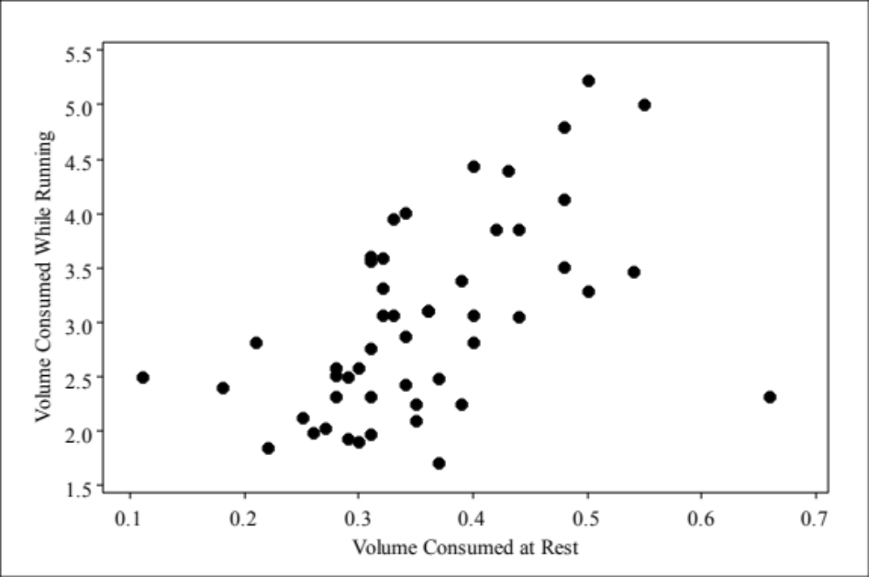

24. In this study, the explanatory variable is
* a. The volume of oxygen consumed at rest.
b. The volume of oxygen consumed while running.
c. The measuring instrument used to measure the volume of oxygen consumed.
d. It doesn’t matter which is considered the response. Either variable is appropriate.

25. The scatterplot suggests
a. There is a positive association between the volume of oxygen consumed at rest and while running.
b. There is an outlier in the plot.
* c. Both a and b
d. Neither a nor b

26. The strength of the correlation between the explanatory and response variable is
* a. Moderate
b. Strong
c. Weak
d. Cannot be determined by the plot

27. The form of the relationship in the following scatterplot might best be described as

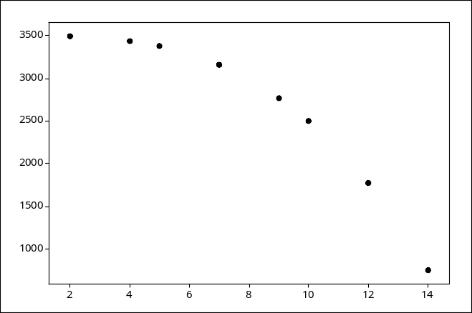

a. Negative and linear
* b. Curved
c. Clustered
d. None of the above

28. A student wonders if people of similar heights tend to date each other. She measures herself, her dormitory roommate, and the women in the adjoining rooms; then she measures the next man each woman dates. Here are the data (heights in inches).

Women 66 64 66 65 70 65
Men 72 68 70 68 74 69

Use your calculator: The correlation between women’s heights and their boyfriends’ heights is

a. 0.89 inches
b. 0.91 inches
* c. 0.91
d. None of the above

Use the following information to answer Questions 29-35.

In a study, nine tires of a particular brand were driven on a track under identical conditions. Each tire was driven a particular controlled distance (measured in thousands of miles), and afterward the tread depth was measured. Tread depth is measured in “mils.” Here, 1 mil is 0.001 inch. The least-squares regression line was computed, and added to a scatterplot of these data. On the plot, one data point is marked with an “X”. This data point will be referenced in Question 3.
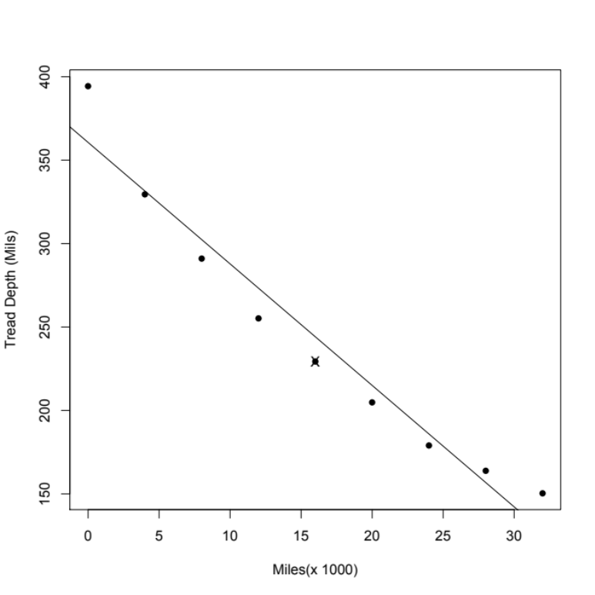

The equation of the least-squares regression line is:

Tread Depth = 360.64 – 11.39x (thousands of miles)

Also, r² = 0.953.

29. We might feel comfortable using the least-squares regression equation to predict tread depth for a tire driven
* a. roughly between 0 and 30 thousand miles.
b. roughly between 0 and 50 thousand miles.
c. more than 50 thousand miles.
d. cannot be determined from the information provided.

30. The least-squares line would predict that the tread depth of a tire driven 16 thousand miles would be
a. 260.5 mils.
* b. 178.4 mils.
c. 360.64 mils.
d. –181,879 mils.

31. The data value marked with “X” in the provided scatterplot has
* a. a negative value for the residual.
b. a positive value for the residual.
c. a zero value for the residual.
d. a zero value for the correlation.

32. The amount of miles driven on the tire is
a. the intercept.
b. the slope.
* c. the explanatory variable.
d. the response variable.

33. Which of the following statements is true?
a. About 95.3% of the variation in tread depth is explained by the regression on miles.
b. According to the least-squares regression line, the groove depth of a new tire (driven 0 miles) is predicted to be 360.64 mils.
c. According to the least-squares regression line, we would predict a decrease in groove depth of 11.39 mils for each 1000 miles driven on a tire.
* d. All of the above

34. Which of the following is true?
* a. The correlation between tread Depth and miles is –0.976.
b. 95.3% of the data points fall on the least-squares regression line.
c. The correlation between tread depth and miles is 0.976.
d. The data value closest to the asterisk (*) is highly influential.

35. Suppose the least-squares regression line for a set of data has slope 72.4. Now suppose we remove a point from the data, compute the least-squares regression line, and find that the new slope is 8.7. The point removed would be considered
a. robust.
* b. influential.
c. a residual.
d. a response.

36. A study of elementary school children, ages 6 to 11, finds a high positive correlation between shoe size x and score y on a test of reading comprehension. The observed correlation is most likely due to
* a. the effect of a lurking variable, such as age.
b. a mistake, because the correlation must be negative.
c. cause and effect (larger shoe size causes higher reading comprehension).
d. “reverse” cause and effect (higher reading comprehension causes larger shoe size).

37. The owner of a chain of supermarkets notices that there was a positive correlation between the sales of beer and the sales of ice cream over the course of the previous year. During seasons when sales of beer were above average, sales of ice cream also tended to be above average. Likewise, during seasons when sales of beer were below average, sales of ice cream also tended to be below average. The owner is curious whether the observed association is due to a cause-and-effect relationship between eating ice cream and desiring beer. To investigate this, the owner should use
a. the least-squares regression line.
b. the correlation coefficient.
c. the square of the correlation coefficient.
* d. a well-designed experiment.

38. The 2000 census collected data on the number of births to single teens and the number of juvenile violent crime arrests in each of the 50 states. A scatterplot of the number of births to single teens versus the number of juvenile violent crimes for each of the 50 states is given below.

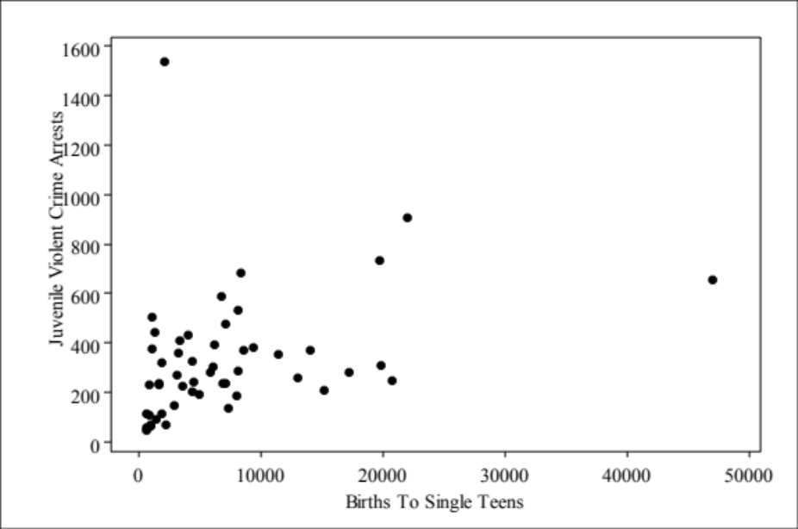

Which of the following statements holds?
* a. The observation at the far right side of the plot is influential.
b. There is clear evidence of negative association between births to single teens and juvenile violent crime arrest.
c. The equation of the least-squares line for this plot would be approximately y = 10 – 2x.
d. The correlation coefficient for this data is 0.99.

39. It is a fact that since the 1960s, atmospheric CO₂ levels have increased steadily, as have obesity rates. We can conclude that
a. higher CO₂ levels lead to greater obesity rates.
* b. there may be a lurking variable (such as greater car ownership and increased reliance on car use) that simultaneously impacts both variables in this study. Correlation doesn’t imply causation.
c. the correlation between “CO₂ level” and “obesity rate” is negative.
d. both (b) and (c) are true, whereas (a) is false.

40. John’s parents recorded his height at various ages up to 66 months. Below is a record of the results.

Age (months) 36 48 54 60 66
Height (inches) 35 38 41 43 45

John’s parents decide to use the least-squares regression line of John’s height on age based on the data in the previous problem to predict his height at age 21 years (252 months). We conclude
a. John’s height, in inches, should be about half his age, in months.
b. The parents will get a fairly accurate estimate of his height at age 21 years because the data are clearly correlated.
* c. such a prediction could be misleading because it involves extrapolation.
d. All of the above

