# Statistical Analysis with the TI-30 Calculator

## One-variable Statistics

Enter the following dataset, X, into the calculator:

X: 74 81 76 90 81

|  |  |  |
| --- | --- | --- |
|  | **Screen Output** | **Description** |
| [2nd]STAT | 1-VAR 2-VAR | STAT is the second function of the [DATA] key. The STAT function prompts for the number of variables. Default is 1-VAR. Selection is indicated by dotted underline. Use arrow keys to select 1-VAR if not selected. |
| [ENTER] |  | Only the cursor appears in the display, but the calculator is in STAT mode for entering data. |
| [DATA] | X1= | Prompts for first value in the dataset. |
| [7][4] | X1=74 | Type the first value in the dataset, ‘74’. |
| [🞃] | FRQ=1 | Prompts for the frequency of the previously entered value. Default frequency is 1. The dataset value ‘74’ occurs only once. |
| [🞃] | X2= | Prompts for the next value in the dataset. |
| [8][1] | X2=81 | Type the second value in the dataset, ‘81’. |
| [🞃] | FRQ=1 | Prompts for the frequency of the previously entered value. Default frequency is 1. |
| [2] | FRQ=2 | Type the number of times the previously entered value occurs in the dataset. The dataset value ‘81’ occurs twice. |
| [🞃] | X3= | Prompts for the next value in the dataset. |
| [7][6] | X3=76 | Type the next value in the dataset, ‘76’. |
| [🞃] | FRQ=1 | Prompts for the frequency of the previously entered value. Default frequency is 1. The dataset value ‘76’ occurs only once. |
| [🞃] | X4= | Prompts for the next value in the dataset. |
| [9][0] | X4=90 | Type the next value in the dataset, ‘90’. |
| [🞃] | FRQ=1 | Prompts for the frequency of the previously entered value. Default frequency is 1. The dataset value ‘90’ occurs only once. |
| [STATVAR] | n $\overline{x}$ sx σx Σx Σx2  5 | Six descriptive statistics are calculated and available for display. The first statistic is n with its value displayed in the lower right corner of the screen. The last two are not visible until the right arrow key is pressed four times. |
| [🞂]  OR  [🞀] | n $\overline{x}$ sx σx Σx Σx2  80.4 | Pressing the right and left arrow keys toggles through the six statistics. The value of the active statistic, indicated with an underline, appears in the lower right corner of the screen. |
| [2nd]  EXIT STAT | EXIT ST: Y N | EXIT STAT is the second function of the [STATVAR] key. The EXIT STAT function prompts for confirmation to exit:   * Y clears the dataset and returns to normal calculator mode. * N retains the dataset but displays the cursor to allow normal calculator activity.   Use arrow keys to select  Y or N. |
| [ENTER] |  | Only the cursor appears in the display. If selected N above, the dataset remains in memory until STAT is exited with Y. Until then, press [STATVAR] to access the dataset statistics. |

## Two-variable Statistics

Enter the following datasets, X and Y, into the calculator:

X: 74 81 76 90 81

Y: 85 87 80 99 95

The above datasets are paired, i.e., each value in the X dataset corresponds to one value in the Y dataset, specifically the first X value corresponds to the first Y, the second X to the second Y, and so on. The datasets must be entered in order to maintain the integrity of the pairs.

|  |  |  |
| --- | --- | --- |
| **Keystrokes** | **Screen Output** | **Description** |
| [2nd] STAT | 1-VAR 2-VAR | STAT is the second function of the [DATA] key. The STAT function prompts for the number of variables. Default is 1-VAR. Selection is indicated by dotted underline. Use arrow keys to select 2-VAR. |
| [ENTER] |  | Only the cursor appears in the display, but the calculator is in STAT mode for entering data. |
| [DATA] | X1= | Prompts for first value in the X dataset. |
| [7][4] | X1=74 | Type the first value in the X dataset, ‘74’. |
| [🞃] | Y1=1 | Prompts for first value in the Y dataset. Default value is 1 to guarantee that each X has a corresponding Y. The value of Y1 is not 1 so change the value to reflect the correct one. |
| [8][5] | Y1=85 | Type the first value in the Y dataset, ‘85’. |
| [🞃] | X2= | Prompts for second value in the X dataset. |
| [8][1] | X2=81 | Type the second value in the X dataset, ‘81’. |
| [🞃] | Y2=1 | Prompts for second value in the Y dataset. Default value is 1 to guarantee that each X has a corresponding Y. The value of Y2 is not 1 so change the value to reflect the correct one. |
| [8][7] | Y2=87 | Type the second value in the Y dataset, ‘87’. |
| [🞃] | X3= | Prompts for third value in the X dataset. |
| [7][6] | X3=76 | Type the third value in the X dataset, ‘76’. |
| [🞃] | Y3=1 | Prompts for third value in the Y dataset. Default value is 1 to guarantee that each X has a corresponding Y. The value of Y3 is not 1 so change the value to reflect the correct one. |
| [8][0] | Y3=80 | Type the third value in the Y dataset, ‘80’. |
| [🞃] | X4= | Prompts for forth value in the X dataset. |
| [9][0] | X4=90 | Type the forth value in the X dataset, ‘90’. |
| [🞃] | Y4=1 | Prompts for forth value in the Y dataset. Default value is 1 to guarantee that each X has a corresponding Y. The value of Y4 is not 1 so change the value to reflect the correct one. |
| [9][9] | Y4=99 | Type the forth value in the Y dataset, ‘99’. |
| [🞃] | X5= | Prompts for fifth value in the X dataset. |
| [8][1] | X5=81 | Type the fifth value in the X dataset, ‘81’. |
| [🞃] | Y5=1 | Prompts for fifth value in the Y dataset. Default value is 1 to guarantee that each X has a corresponding Y. The value of Y5 is not 1 so change the value to reflect the correct one. |
| [9][5] | Y5=95 | Type the fifth value in the Y dataset, ‘95’. |
| [STATVAR] | n $\overline{x}$ sx σx sy σy Σx Σx2 Σy Σy2 Σxy a b r x´ y´  5 | Seventeen descriptive statistics are calculated and available for display. The first statistic is n with its value displayed in the lower right corner of the screen. Only the first four are visible until the right arrow key is pressed to move the selection forward. |
| [🞂]  OR  [🞀] | n $\overline{x}$ sx σx sy σy Σx Σx2 Σy Σy2 Σxy a b r x´ y´  70.33333333 | Pressing the right and left arrow keys toggles through the seventeen statistics. The value of the active statistic, indicated with an underline, appears in the lower right corner of the screen. |
| [2nd]  EXIT STAT | EXIT ST: Y N | EXIT STAT is the second function of the [STATVAR] key. The EXIT STAT function prompts for confirmation to exit:   * Y clears the dataset and returns to normal calculator mode. * N retains the dataset but displays the cursor to allow normal calculator activity.   Use arrow keys to select  Y or N. |
| [ENTER] |  | Only the cursor appears in the display. If selected N above, the dataset remains in memory until STAT is exited with Y. Until then, press [STATVAR] to access the dataset statistics. |

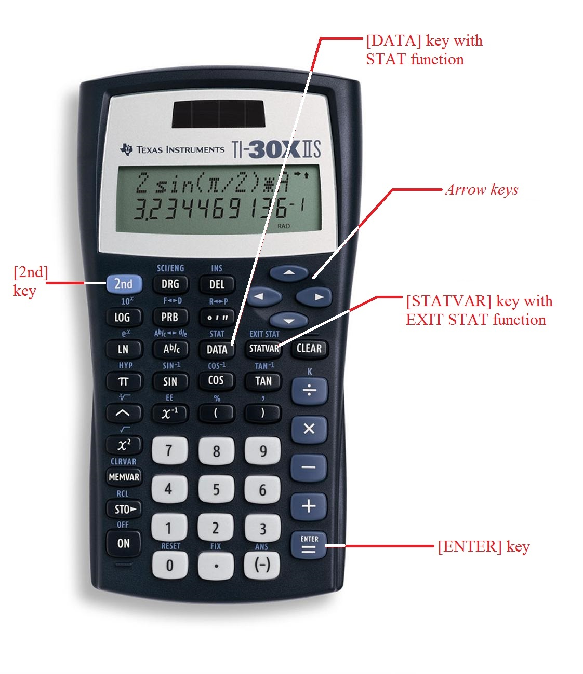

TI30 image downloaded from the following site on 12/18/14  
<http://www.schoolmart.com/texas-instruments-ti-30x-iis-calculator-class-pack.aspx>