## 

## **Module 2-Project: Benefit-Cost Analysis of Construction Projects**

## 

## **Thuy Nhu Thao Tran**

## **COLLEGE OF PROFESSIONAL STUDIES, NORTHEASTERN UNIVERSITY**

## ***ALY6050 - Introduction to Enterprise Analytics***

## **Instructor: Adam Jones**

## **March 02, 2025**

# Introduction

The report presents a benefit-cost analysis of two dam construction projects, Dam #1 and Dam #2, by using the Monte Carlo simulation. The analysis evaluates the benefit-cost ratio of both projects, compares the distributions, and provides recommendations based on these results. I used R for simulation to present the results, which included descriptive statistics, histograms, and a Chi-squared goodness-of-fit test.

# Analysis

## Part 1: Creation and Analysis of a Monte Carlo Simulation:

**Objective:** Generate 10,000 benefit-cost ratios for Dam #1 and Dam #2 with uniform distributions for both benefits and expenses.

**Results:**

* Dam #1:

**Mean benefit-cost ratio:** 1.3799729

**Standard Deviation:** 0.2033286

* Dam #2

**Mean benefit-cost ratio:** 1.3742108

**Standard Deviation:** 0.2155127

**Interpretation:** The mean benefit-cost ratio for Dam #1 is slightly higher than that of Dam #2. This result indicates Dam #1 is marginally more favorable. The standard deviations suggest similar variance in benefit-cost ratios for both projects.

**A tabular frequency distribution:** The table below shows the number of simulations that fit into each bin for the benefit-cost ratios of Dam #1 (a₁) and Dam #2 (a₂).

| **Bin** | **Frequency_Alpha1** | **Frequency_Alpha2** |
| --- | --- | --- |
| (0.81, 0.97] | 85 | 136 |
| (0.97, 1.13] | 920 | 1070 |
| (1.13, 1.28] | 2332 | 2401 |
| (1.28, 1.44] | 2968 | 2752 |
| (1.44, 1.59] | 2159 | 1988 |
| (1.59, 1.75] | 1061 | 1105 |
| (1.75, 1.9] | 385 | 422 |
| (1.9, 2.06] | 82 | 117 |
| (2.06, 2.21] | 8 | 9 |

**Visualizations:** Showing both dams nearly normally distributed, the remaining benefit-cost ratios all cluster around the mean.

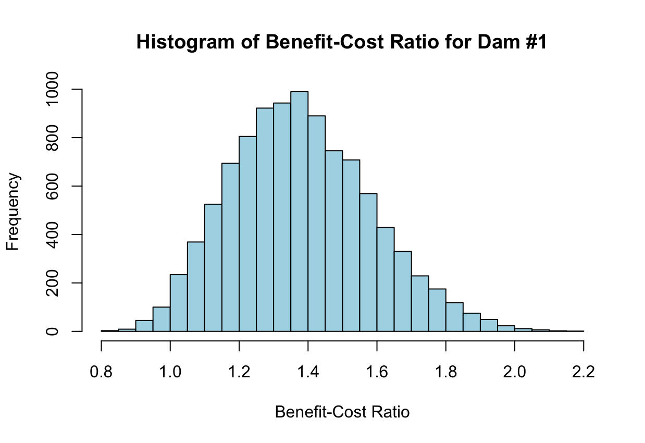

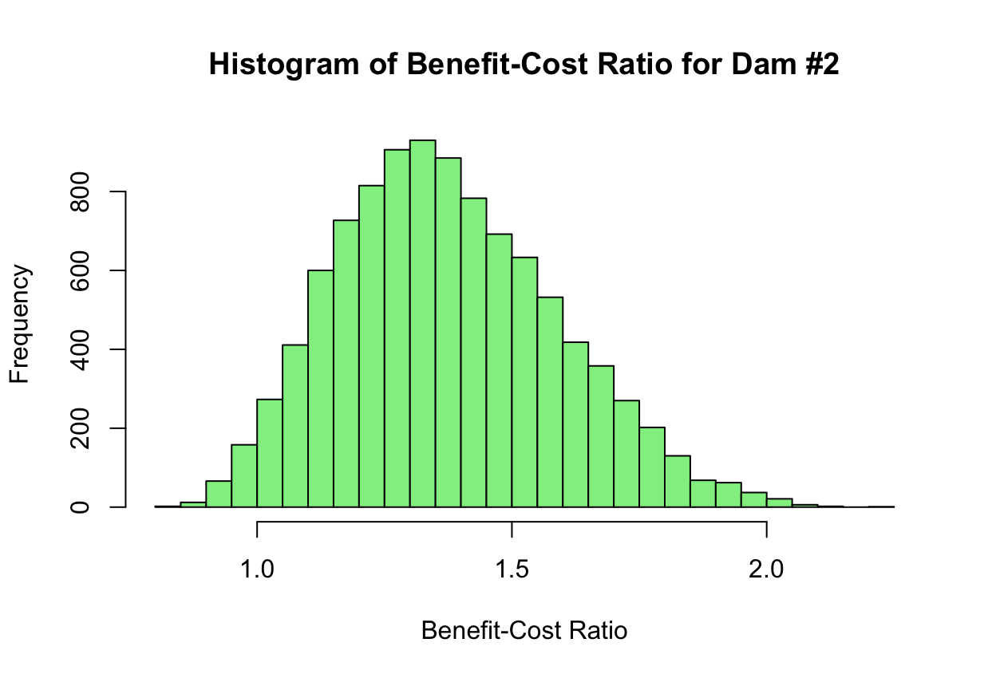

**Table: Descriptive Statistics of Dam #1 Project**

| **Dam #1 Project** | **Observed** | **Theoretical** |
| --- | --- | --- |
| Mean of the Total Benefits | 29.5168857 | 29.600000 |
| SD of the Total Benefits | 3.2489746 | 3.241913 |
| Mean of the Total Cost | 21.5867050 | 21.600000 |
| SD of the Total Cost | 2.0366183 | 2.041650 |
| Mean of the Benefit-cost Ratio | 1.3799729 | X |
| SD of the Benefit-cost Ratio | 0.2033286 | X |

**Table: Descriptive Statistics of Dam #2 Project**

| **Dam #2 Project** | **Observed** | **Theoretical** |
| --- | --- | --- |
| Mean of the Total Benefits | 30.3463198 | 30.300000 |
| SD of the Total Benefits | 3.3052948 | 3.283799 |
| Mean of the Total Cost | 22.3552506 | 22.350000 |
| SD of the Total Cost | 2.4445710 | 2.431221 |
| Mean of the Benefit-cost Ratio | 1.3742108 | X |
| SD of the Benefit-cost Ratio | 0.2155127 | X |

**Key Takeaways:**

* Dam #1 is more advantageous than Dam #2 due to its slightly superior mean benefit-cost ratio.
* Both projects have similar risk profiles, as seen by their identical standard deviations.
* The simulation findings are reliable since they closely correspond with the theoretical predictions.

## Part 2: Analysis of a probability distribution

**Objective:**

* Choose a theoretical probability distribution that aligns with the benefit-cost ratios (α₁) for Dam #1.
* Utilize the Chi-squared Goodness-of-Fit Test to compare the observed distribution of α₁ with the theoretical distribution.
* Analyze the outcomes and explain the reasoning behind the selection of the distribution.

**A theoretical frequency table:** The theoretical frequency table compares the observed frequencies of α₁ with the expected frequencies derived from the fitted normal distribution.

| **Bin** | **Observed_Frequency** | **Theoretical_Frequency** |
| --- | --- | --- |
| (0.81, 0.97] | 85 | 191.228413 |
| (0.97, 1.13] | 920 | 831.913848 |
| (1.13, 1.28] | 2332 | 2072.003382 |
| (1.28, 1.44] | 2968 | 2958.593053 |
| (1.44, 1.59] | 2159 | 2423.312713 |
| (1.59, 1.75] | 1061 | 1138.213833 |
| (1.75, 1.9] | 385 | 306.213102 |
| (1.9, 2.06] | 82 | 47.098865 |
| (2.06, 2.21] | 8 | 4.132301 |

**Output:**

Chi-squared Statistic (X-squared): 183.33

Degrees of Freedom (df): 8

P-value: < 2.2e-16

**Interpretation:**

1. Chi-squared statistic (183.33):

This high number indicates that there is a significant difference between the observed and expected frequencies.

1. Degrees of Freedom (8):

The output indicates 8 degrees of freedom, suggesting that the test's calculations did not estimate any parameters. This is a small difference but does not influence the overall interpretation.

1. P-value (<2.2e-16):

The p-value is very low, almost zero, which means that the distribution shown by α₁ (the benefit-cost ratios for Dam #1) is not at all like a normal distribution in theory.

**Key Takeaways:**

The results of the Chi-squared test show that the normal distribution doesn't fit the benefit-cost ratios of Dam #1 well enough.

**The rationale for my choice of the probability distribution**

The normal distribution was chosen as the model for α₁ because its histogram was roughly symmetric and bell-shaped, which are critical features of a normal distribution. The chi-square test shows that the normal distribution doesn't work well for α₁. This means that there are things that aren't normal, like skewness or outliers.

## Part 3: Comparison of the results

|  | alpha1 | alpha2 |
| --- | --- | --- |
| Minimum | 0.81450147 | 0.82756734 |
| Maximum | 2.17688212 | 2.21230558 |
| Mean | 1.37997288 | 1.37421077 |
| Median | 1.36842968 | 1.35533586 |
| Variance | 0.04134251 | 0.04644571 |
| Standard Deviation | 0.20332857 | 0.21551266 |
| Skewness | 0.33297991 | 0.37459897 |
| P(α > 2) | 0.00200000 | 0.00300000 |
| P(α > 1.8) | 0.02850000 | 0.03270000 |
| P(α > 1.5) | 0.27250000 | 0.27400000 |
| P(α > 1.2) | 0.80210000 | 0.77510000 |
| P(α > 1) | 0.98430000 | 0.97620000 |
| P(α > α2) | 0.51250000 | 0.48750000 |

**Interpretation of the Results:**

* Means and Medians:
  + The mean benefit-cost ratio for Dam #1 estimated at 1.37997 is just slightly more than the estimate for Dam #2 at 1.37421.
  + The median benefit-cost ratio for Dam #1 estimated at 1.36843 is also slightly more than the estimate for Dam #2 at 1.35534.
* Variability:
  + The standard deviation for Dam #1 (0.20333) is somewhat lower than that of Dam #2 (0.21551), suggesting that Dam #1 exhibits slightly less variability in its benefit-cost ratios.
* Skewness:
  + Both dams exhibit positive skewness, indicating that the distributions are right-skewed. Dam #2 has a little greater skewness (0.37460) than Dam #1 (0.33298).
* Probabilities:
  + The probability of surpassing certain thresholds (e.g., P(α>1.5)) is very similar for both dams.
  + The likelihood that α₁ > α₂ is 51.25%, suggesting that Dam #1 has a somewhat greater possibility of achieving a superior benefit-cost ratio compared to Dam #2.

1. **Recommendation to Management**

According to the analysis:

* Dam #1 has a slightly superior mean benefit-cost ratio and reduced variability in comparison to Dam #2.
* The likelihood of Dam #1 surpassing Dam #2 is 51.25%.
* Consequently, Dam #1 is recommended for construction because of its somewhat superior performance and reduced risk.

**A comparison of simulation outcomes:**

Dam #1 (α₁) has a slightly higher mean (1.37997 vs. 1.37421) and smaller variability (standard deviation of 0.20333 vs. 0.21551). Furthermore, Dam #1 has a 51.25% chance of having a greater benefit-cost ratio than Dam #2, which strengthens the recommendation for Dam #1.

**Probability of α > α₂ in the conclusion:**

As I mentioned above, Dam #1 has a 51.25% chance of outperforming Dam #2, which reinforces the recommendation for Dam #1 owing to its somewhat greater performance and lower risk.

# Conclusion

This report presented a complete methodology for carrying out a benefit-cost analysis of two dams, namely Dam #1 and Dam #2, using Monte Carlo simulation. The result indicates that Dam #1 has a slightly higher mean benefit-cost ratio (1.37997) than Dam #2 (1.37421), with lower variability in benefit-cost ratios. In addition to this, there is also a 51.25% probability that Dam #2 will perform better than Dam #1. Therefore, a recommendation is made for construction on Dam #1 considering its marginal advantage and lower risk compared to Dam #2. This will give useful input for decision-making among parties concerned who are ready to commit resources to the project with the highest chances of success.