**REPORT PODEM**

*XIAN WU/* [*xwu317@gatech.edu*](mailto:xwu317@gatech.edu)

**Algorithm:**

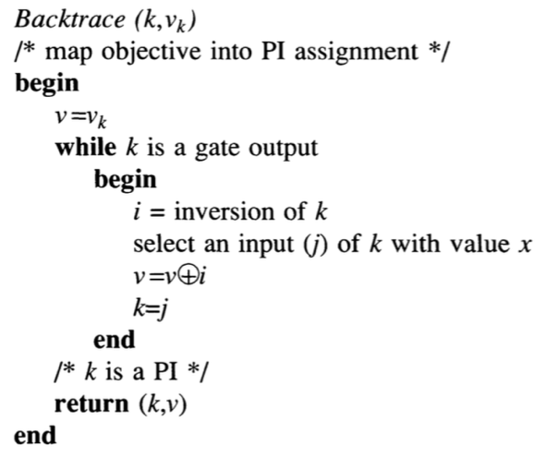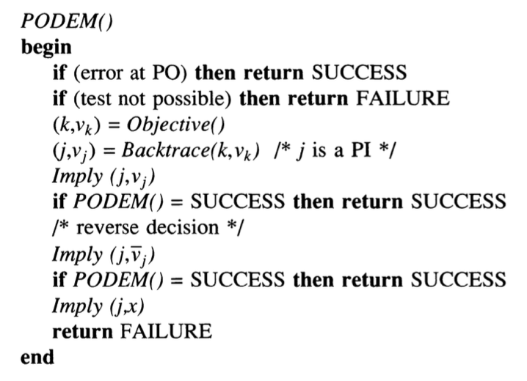

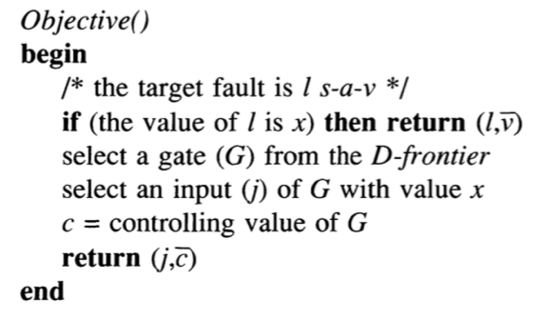

If_success ()

**Begin**

**If** (any outputs equal D or D’)

return true

**else**

return false

**end**

/* if not successful, then if_fail is called, the fault is L s-a-v */

If_fail ()

**begin**

if ( value(L) == v )

return true

if ( D-frontier is empty)

return true

if (outputs are all

known as 0/1)

return true

return false

**end**

Imply (j,vj)

/* the first task is to run the circuit with input vector PIs after change PIs[j] t0 vj , here the only difference with project1 is that the logic operation involves the 5 values : {0,1,x,D,D’} */

**Begin**

PIs[j] = vj

***Run the circuit with PIs as input vector***

/* the second task is to add gates to the D-frontier */

**for** each gate:

**if** (any inputs equal D or D’)

**if** (the output is x)

add this gate to D-frontier

**end for**

**end**

**Result:**

(X means 0 or 1)

|  |  |
| --- | --- |
| **Fault** | **S27** |
| 16/0 | X0X10X0 |
| 10/1 | X00XXX0 |
| 12/0 | 1XXX1XX |
| 18/1 | 11X101X |

|  |  |
| --- | --- |
| **Fault** | **S298f_2** |
| 70/1 | 01X1XXXXXXXXXX0XX |
| 73/0 | 111XXXXXXXXXXX0XX |
| 26/1 | XX1X1XXX0XXXXXXXX |
| 92/0 | X10101XXXXXX0X0XX |

|  |  |
| --- | --- |
| **Fault** | **S344f_2** |
| 166/0 | 01X00XXXXX011XX0XXXXXXXX |
| 71/1 | 10XXXXXXXXXXXXXXXXXXXXXX |
| 16/0 | 10XXXXXXXXXXXXXDXXXXXXXX |
| 91/1 | 111XXXXXXXXXXXXXXXXXXXXX |

|  |  |
| --- | --- |
| **Fault** | **S349f_2** |
| 25/1 | XXXXXXXXXXXXXXX1XXXXXXXX |
| 51/0 | 00XXXXXXXXXXXXX0XXXXXXXX |
| 105/1 | 01X1000XXX01XX10XXXXXXXX |
| 7/0 | XXXXXX1XXXXXXXXXXXXXXXXX |