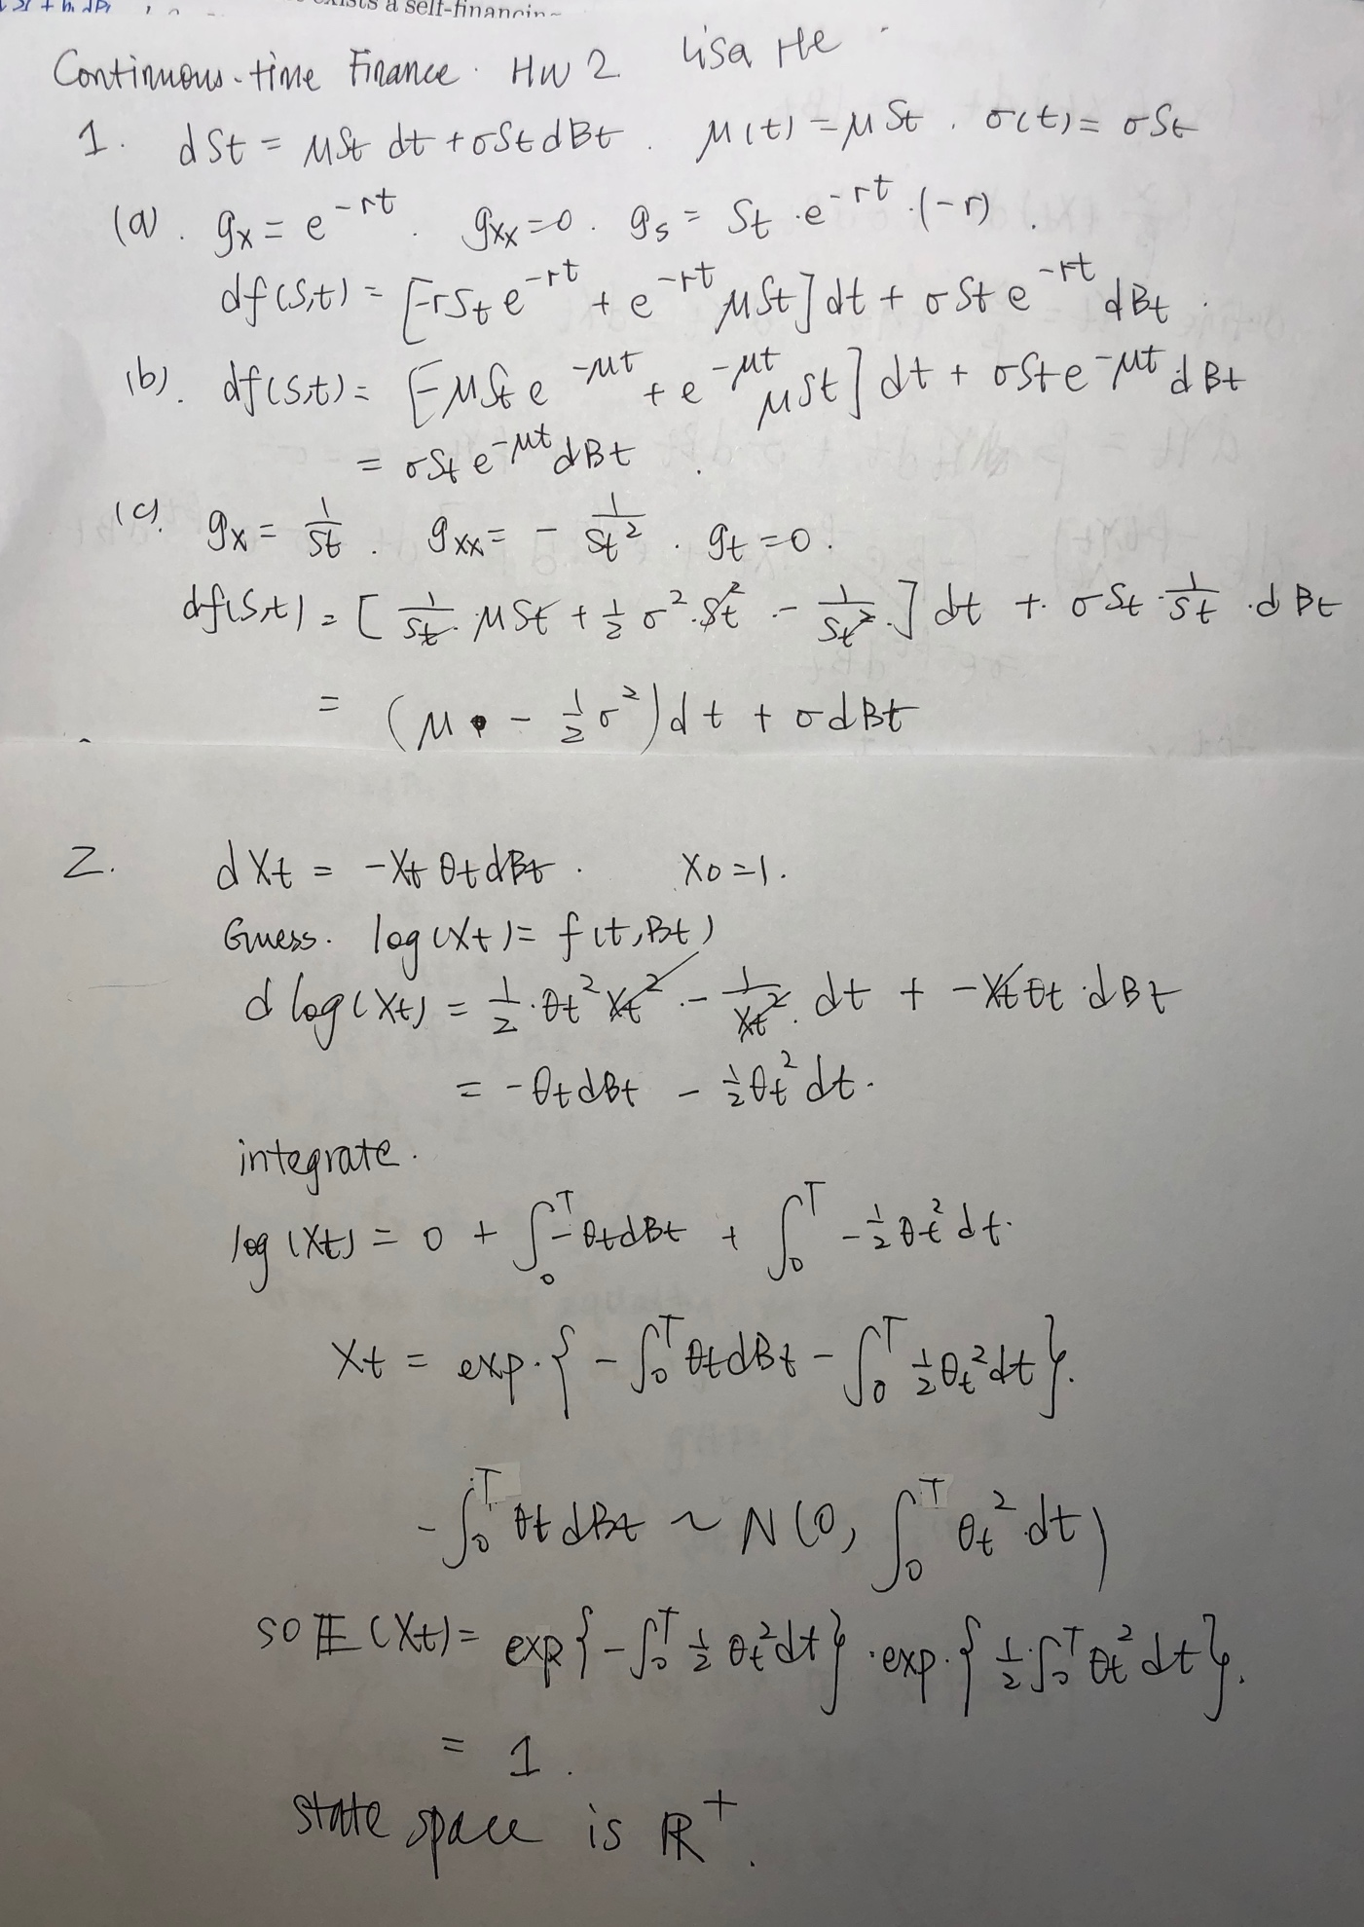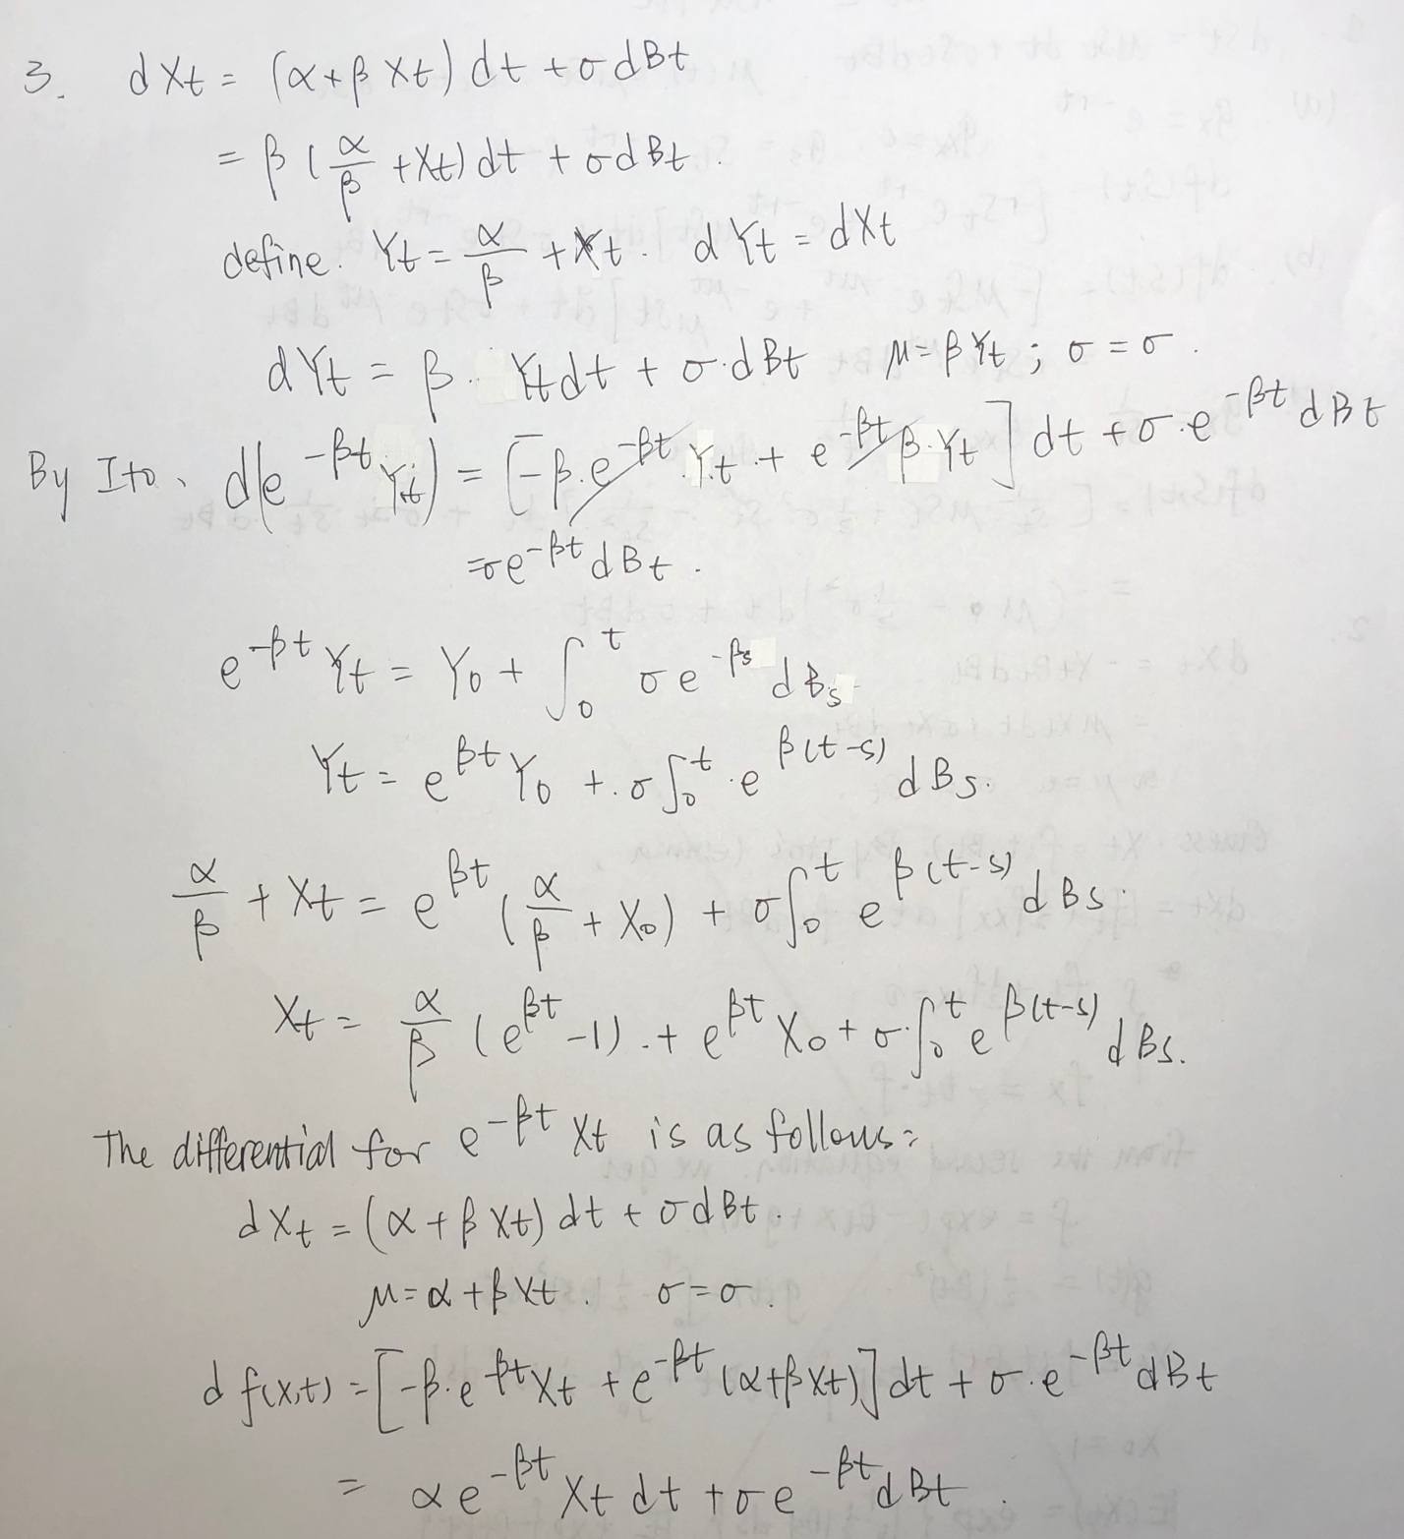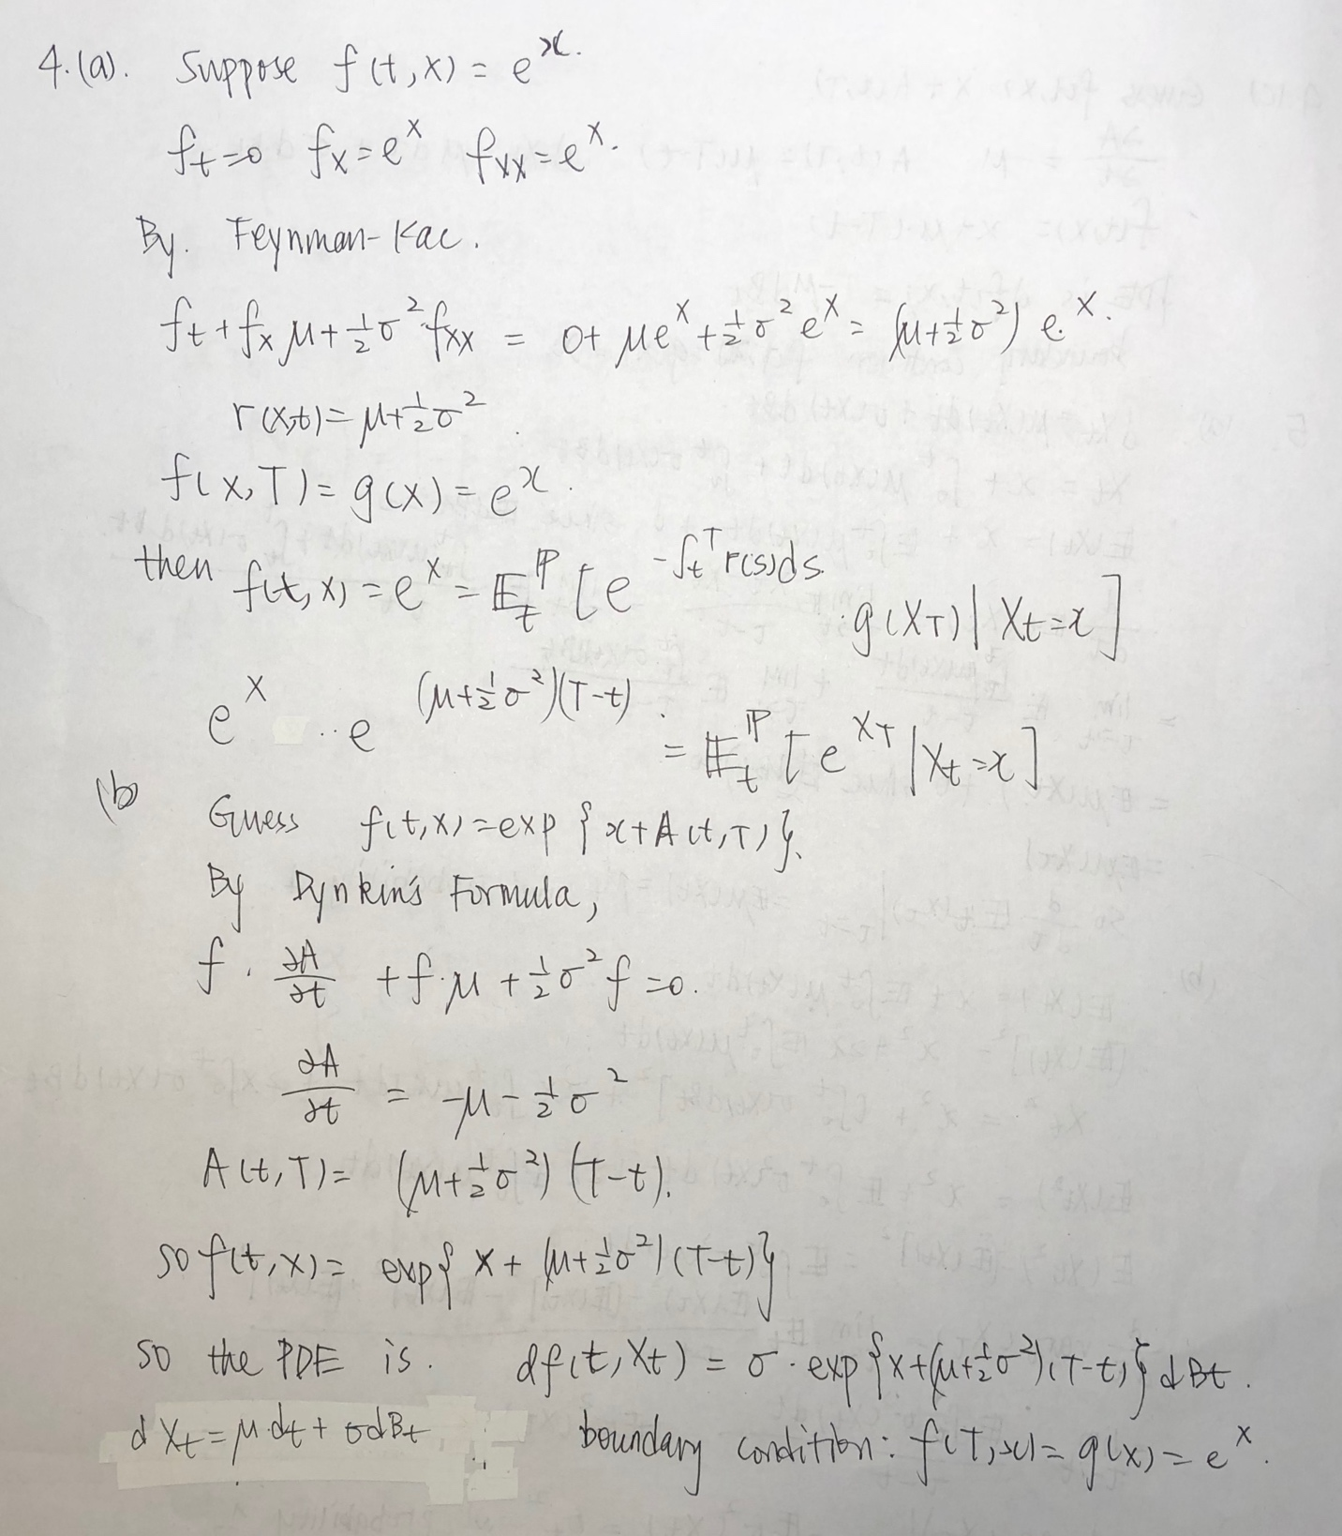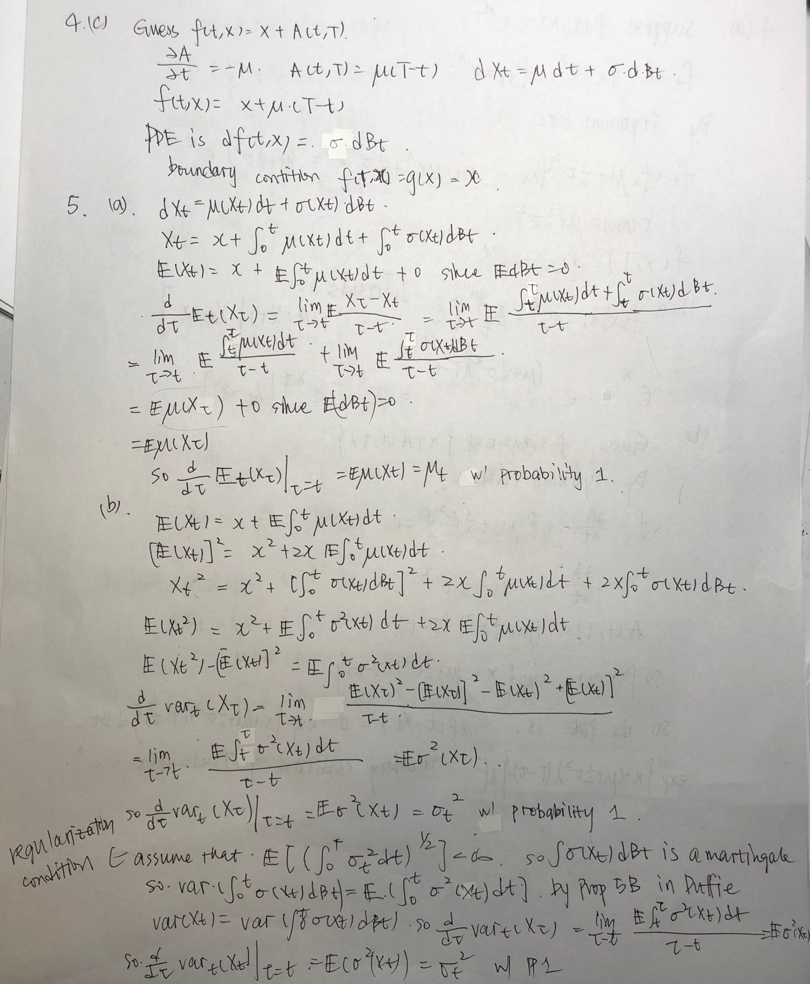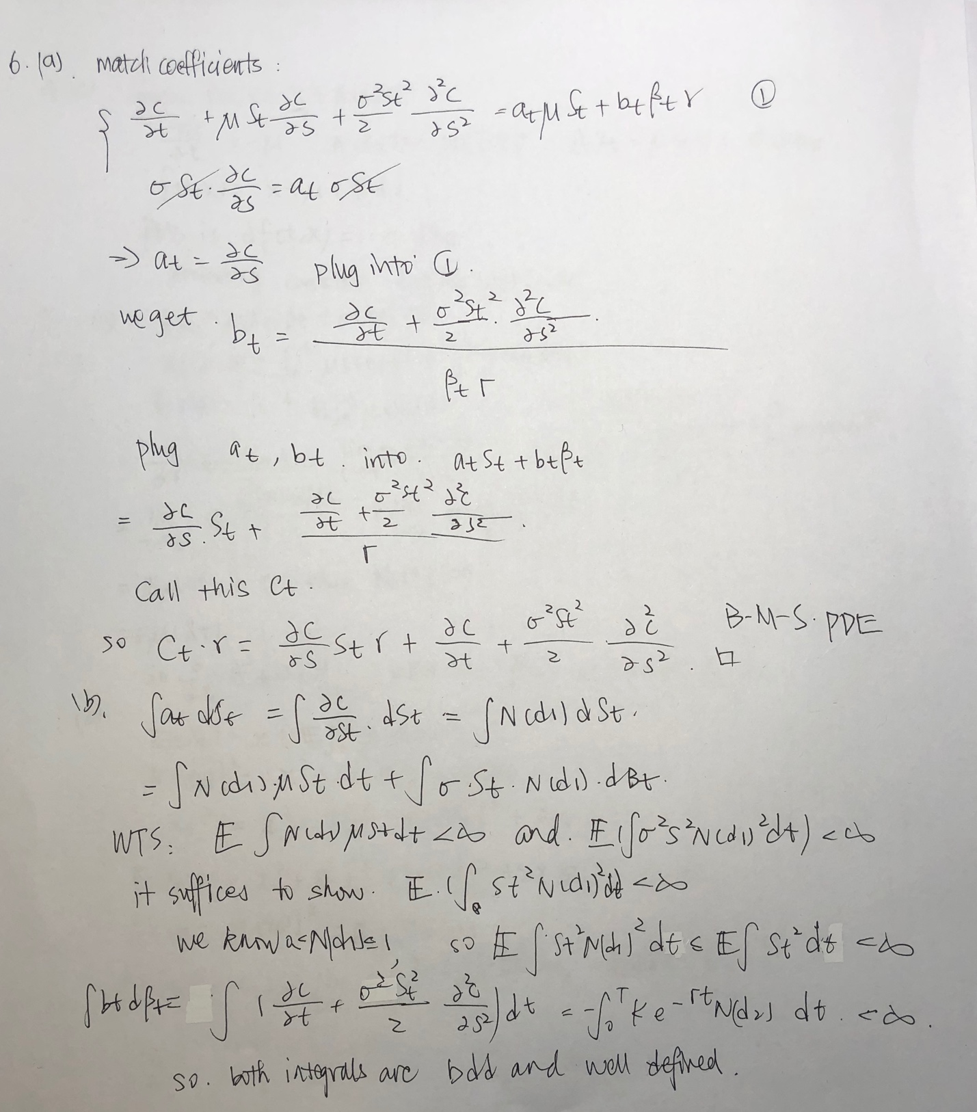Hw2prob7

Lisa He

r<- 0.05  
sig <-.25  
K<-100  
S0<-100  
mT<-1/4  
d1 <- (log(S0/K)+(r+sig**2/2)*mT)/(sig*sqrt(mT))  
d2<- d1 - sig*sqrt(mT)  
C<- S0*pnorm(d1)-K*exp(-r*mT)*pnorm(d2)

C is 5.5984

maxN <-1000000  
mcest <-c()  
for (N in seq(from=1000,to=maxN+1000,by=10000)){  
ST<- S0*exp((r-.5*sig^2)*mT+sig*rnorm(N,0,sqrt(mT))) - K  
sumC <-0  
for( i in 1:N){  
 if (ST[i] >0){  
 sumC <- sumC + ST[i]*exp(-r*mT)  
 }  
}  
mcest[N]<- sumC/N  
}

for (N in seq(from=1000,to=maxN+1000,by=10000)){  
 if (mcest[N]>5.5884&mcest[N]<5.6084) {  
 print(N)  
 }  
}

## [1] 71000  
## [1] 81000  
## [1] 131000  
## [1] 141000  
## [1] 161000  
## [1] 171000  
## [1] 201000  
## [1] 211000  
## [1] 221000  
## [1] 231000  
## [1] 241000  
## [1] 261000  
## [1] 271000  
## [1] 331000  
## [1] 341000  
## [1] 361000  
## [1] 371000  
## [1] 381000  
## [1] 391000  
## [1] 401000  
## [1] 421000  
## [1] 431000  
## [1] 451000  
## [1] 481000  
## [1] 491000  
## [1] 501000  
## [1] 511000  
## [1] 521000  
## [1] 531000  
## [1] 541000  
## [1] 571000  
## [1] 581000  
## [1] 591000  
## [1] 631000  
## [1] 641000  
## [1] 651000  
## [1] 701000  
## [1] 721000  
## [1] 741000  
## [1] 751000  
## [1] 761000  
## [1] 771000  
## [1] 781000  
## [1] 791000  
## [1] 801000  
## [1] 811000  
## [1] 821000  
## [1] 831000  
## [1] 841000  
## [1] 851000  
## [1] 861000  
## [1] 881000  
## [1] 891000  
## [1] 901000  
## [1] 911000  
## [1] 921000  
## [1] 931000  
## [1] 941000  
## [1] 951000  
## [1] 971000  
## [1] 981000  
## [1] 991000

We need at least 71000 simulations to get a close enough estimate.

N<-71000  
mcestc <-c()  
ST<- S0*exp((r-.5*sig^2)*mT+sig*rnorm(N,0,sqrt(mT))) - K  
sumC <-0  
for( i in 1:N){  
 if (ST[i] >0){  
 sumC <- sumC + ST[i]*exp(-r*mT)  
 }  
 if (ST[i]<0){  
 ST[i]<-0  
 }  
}  
mcestc<- sumC/N  
se<- sqrt(var(ST)/N)  
print(se)

## [1] 0.03174086

when doing 710000 simulations, the standard error is 0.03154979