prob2

Lisa He

2/9/2019

## R Markdown

This is an R Markdown document. Markdown is a simple formatting syntax for authoring HTML, PDF, and MS Word documents. For more details on using R Markdown see <http://rmarkdown.rstudio.com>.

When you click the **Knit** button a document will be generated that includes both content as well as the output of any embedded R code chunks within the document. You can embed an R code chunk like this:

DBV <- read_excel("/Users/Lisa/Documents/Econometrics/ass1/DBV.xlsx")  
names(DBV)= c("Date", "Open","High"," Low","Close","Volume","Adj")  
attach(DBV)  
dbv_ts<-ts(DBV,start = 1, frequency = 1)  
# Growth rates:  
log.dbv <- log(dbv_ts)  
r_dbv <- diff(log.dbv)  
head(log.dbv)

## Time Series:  
## Start = 1   
## End = 6   
## Frequency = 1   
## Date Open High \tLow Close Volume Adj  
## 1 20.87095 3.216874 3.218876 3.214868 3.218876 9.517825 3.174079  
## 2 20.87102 3.222071 3.223266 3.218876 3.220075 11.203679 3.175278  
## 3 20.87110 3.216874 3.217675 3.214466 3.216874 9.775654 3.172077  
## 4 20.87117 3.217675 3.218476 3.216072 3.218076 12.333146 3.173279  
## 5 20.87124 3.219276 3.220075 3.218476 3.218876 12.899220 3.174079  
## 6 20.87147 3.218876 3.220075 3.216874 3.219276 9.622450 3.174479

head(r_dbv)

## Time Series:  
## Start = 2   
## End = 7   
## Frequency = 1   
## Date Open High \tLow Close  
## 2 7.453509e-05 0.005196853 0.0043903881 0.004008021 0.0011993205  
## 3 7.452953e-05 -0.005196853 -0.0055911488 -0.004409749 -0.0032012831  
## 4 7.452398e-05 0.000801202 0.0008006806 0.001605821 0.0012016424  
## 5 7.451842e-05 0.001600681 0.0015994005 0.002403847 0.0008003202  
## 6 2.235220e-04 -0.000399920 0.0000000000 -0.001601883 0.0003999200  
## 7 7.449622e-05 0.001598761 0.0003994408 0.001601883 -0.0003999200  
## Volume Adj  
## 2 1.6858541 0.0011993327  
## 3 -1.4280250 -0.0032012688  
## 4 2.5574915 0.0012016090  
## 5 0.5660741 0.0008003271  
## 6 -3.2767698 0.0003999653  
## 7 0.2709872 -0.0003999653

dim(r_dbv)

## [1] 2330 7

plot(r_dbv[,5])

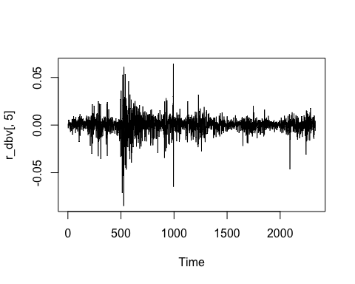

hist(r_dbv[,5])

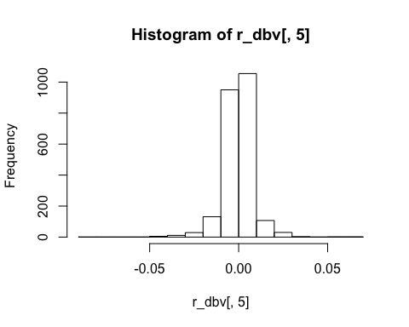

my_T<- 2330  
my_skew<-skewness(r_dbv[,5])  
skew_t <- my_skew/sqrt(6/my_T)  
#skew_t is -16.9339 whose absolute value is greater than 1.96, so we reject the null hypothesis  
  
my_kurt <-kurtosis(r_dbv[,5])  
kurt_t <-(my_kurt)/sqrt(24/my_T)  
#kurt_t is 131.615 whose absolute value is greater than 1.96, so we reject the null hypothesis  
jarque.bera.test(r_dbv[,5])

##   
## Jarque Bera Test  
##   
## data: r_dbv[, 5]  
## X-squared = 17646, df = 2, p-value < 2.2e-16

#p-value < 2.2e-16 so reject the null

## Including Plots

You can also embed plots, for example:

GSPC <- read_excel("/Users/Lisa/Documents/Econometrics/ass1/GSPC.xlsx")  
names(GSPC)= c("Date", "Open","High"," Low","Close","Volume","Adj")  
attach(GSPC)

## The following objects are masked from DBV:  
##   
## Low, Adj, Close, Date, High, Open, Volume

GSPC_ts<-ts(GSPC,start = 1, frequency = 1)  
# Growth rates:  
log.GSPC <- log(GSPC_ts)  
r_GSPC <- diff(log.GSPC)  
head(log.GSPC)

## Time Series:  
## Start = 1   
## End = 6   
## Frequency = 1   
## Date Open High \tLow Close Volume Adj  
## 1 20.87095 7.181425 7.192445 7.178988 7.190201 21.72030 7.190201  
## 2 20.87102 7.190186 7.197884 7.189394 7.197697 21.70660 7.197697  
## 3 20.87110 7.197525 7.200485 7.195592 7.197877 21.73457 7.197877  
## 4 20.87117 7.197854 7.200634 7.195750 7.199589 21.59783 7.199589  
## 5 20.87124 7.199790 7.200335 7.197166 7.197323 21.54456 7.197323  
## 6 20.87147 7.197301 7.199335 7.193145 7.193926 21.49082 7.193926

head(r_GSPC)

## Time Series:  
## Start = 2   
## End = 7   
## Frequency = 1   
## Date Open High \tLow Close  
## 2 7.453509e-05 0.0087614173 0.0054389752 0.0104064021 0.0074961151  
## 3 7.452953e-05 0.0073390971 0.0026002227 0.0061982038 0.0001795701  
## 4 7.452398e-05 0.0003293054 0.0001492882 0.0001574339 0.0017118783  
## 5 7.451842e-05 0.0019359091 -0.0002985076 0.0014160653 -0.0022656719  
## 6 2.235220e-04 -0.0024898072 -0.0010005646 -0.0040211208 -0.0033968847  
## 7 7.449622e-05 -0.0033744044 -0.0001718288 -0.0023933758 0.0020935009  
## Volume Adj  
## 2 -0.01370482 0.0074961151  
## 3 0.02797396 0.0001795701  
## 4 -0.13674633 0.0017118783  
## 5 -0.05327029 -0.0022656719  
## 6 -0.05374031 -0.0033968847  
## 7 0.21927063 0.0020935009

dim(r_GSPC)

## [1] 2330 7

plot(r_GSPC[,5])

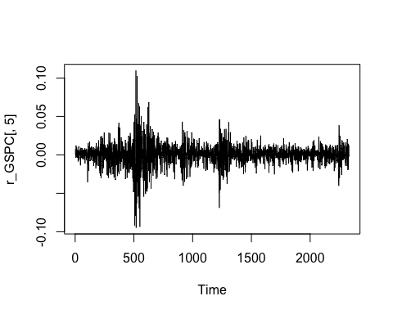

hist(r_GSPC[,5])

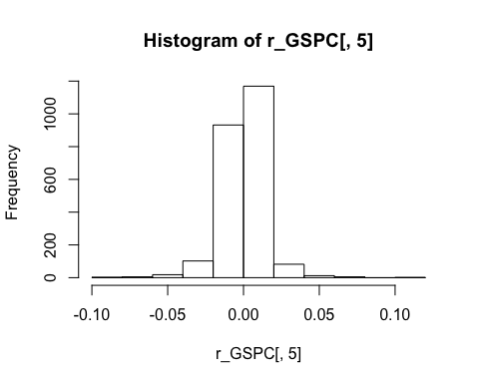

my_T<- 2330  
my_skew2<-skewness(r_GSPC[,5])  
skew_t2 <- my_skew2/sqrt(6/my_T)  
#skew_t2 is -6.38153 whose absolute value is greater than 1.96, so we reject the null hypothesis  
  
my_kurt2 <-kurtosis(r_GSPC[,5])  
kurt_t2 <-(my_kurt2)/sqrt(24/my_T)  
#kurt_t2 is 96.4317 whose absolute value is greater than 1.96, so we reject the null hypothesis  
  
jarque.bera.test(r_GSPC[,5])

##   
## Jarque Bera Test  
##   
## data: r_GSPC[, 5]  
## X-squared = 9360.7, df = 2, p-value < 2.2e-16

#p-value < 2.2e-16 so reject the null

logrDBV <-r_dbv[,5]  
logrGSPC <-r_GSPC[,5]  
my_model<-lm(logrDBV~logrGSPC)  
summary(my_model)

##   
## Call:  
## lm(formula = logrDBV ~ logrGSPC)  
##   
## Residuals:  
## Min 1Q Median 3Q Max   
## -0.069545 -0.003080 0.000239 0.003311 0.058668   
##   
## Coefficients:  
## Estimate Std. Error t value Pr(>|t|)   
## (Intercept) -0.0001153 0.0001367 -0.843 0.399   
## logrGSPC 0.4323363 0.0101522 42.585 <2e-16 ***  
## ---  
## Signif. codes: 0 '***' 0.001 '**' 0.01 '*' 0.05 '.' 0.1 ' ' 1  
##   
## Residual standard error: 0.006598 on 2328 degrees of freedom  
## Multiple R-squared: 0.4379, Adjusted R-squared: 0.4376   
## F-statistic: 1814 on 1 and 2328 DF, p-value: < 2.2e-16

g_model <-glm(logrDBV~logrGSPC)  
summary(g_model)

##   
## Call:  
## glm(formula = logrDBV ~ logrGSPC)  
##   
## Deviance Residuals:   
## Min 1Q Median 3Q Max   
## -0.069545 -0.003080 0.000239 0.003311 0.058668   
##   
## Coefficients:  
## Estimate Std. Error t value Pr(>|t|)   
## (Intercept) -0.0001153 0.0001367 -0.843 0.399   
## logrGSPC 0.4323363 0.0101522 42.585 <2e-16 ***  
## ---  
## Signif. codes: 0 '***' 0.001 '**' 0.01 '*' 0.05 '.' 0.1 ' ' 1  
##   
## (Dispersion parameter for gaussian family taken to be 4.3538e-05)  
##   
## Null deviance: 0.18031 on 2329 degrees of freedom  
## Residual deviance: 0.10136 on 2328 degrees of freedom  
## AIC: -16781  
##   
## Number of Fisher Scoring iterations: 2

#rob_model <- lmrob(logrDBV~logrGSPC)  
#summary(rob_model)  
my_model %>%   
 vcovHC() %>%   
 diag() %>%   
 sqrt()

## (Intercept) logrGSPC   
## 0.0001375697 0.0182961682

Under OLS assumptions, the standard error of the intercept is 0.0001367 and that of the slope is 0.0101522. Allowing for non-normalities, the standard error of the intercept is 0.0001367 and that of the slope is 0.0101522. the heteroskedastic standard error of the intercept is 0.0001375697 and that of the slope is 0.0182961682.

The White standard errors are larger than the classic OLS standard errors because the homoskedasticity-only standard errors are only valid of the errors are homoskedastic and that the White standard errors are valid whether or not the errors are heteroskedastic. Therefore, the White standard errors are more general and more conservative.