prob1

Lisa He

N<-1000  
a<-1  
A<-3  
pois <- rpois(N, 0.05)  
sumpois <- cumsum(pois)  
my_mean <- rep(0, N)  
  
for (i in 1:N){  
 my_mean[i] <- (a+sumpois[i])/(A+i)  
   
}  
   
  
plot(my_mean, type = "l")

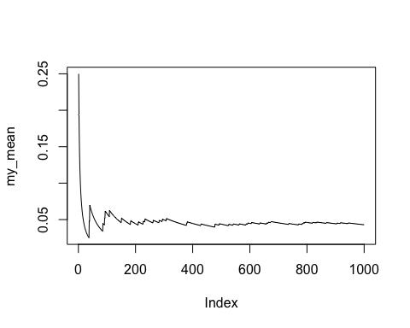

It doesn't look odd to me. The mean start off close to the mean i set which is 1/A = 1/3 and then it jumps up and slowly goes down and eventually converges to lambda = 0.05