Using Iterators
ou got to see how range adaptors and ranged algorithms work. Most ranged algorithms, such as sort() are likely implemented on top of iterator-based algorithms. Even when working with ranges, you still need to use iterators such as ostream_iterator. And sometime, iterators are easier to use than ranges, such as initializing a vector. This Exploration visits the iterators and algorithms that offer an alternative to ranges.

Transforming Data
Several programs that you’ve read and written have a common theme: copying a sequence of data, such as a vector or string, and applying some kind of transformation to each element (converting to lowercase, doubling the values in an array, and so on). The standard algorithm, transform, is ideal for applying an arbitrarily complex transformation to the elements of a sequence.
For example, recall Listing 10-5, which doubled all the values in an array. Listing 23-1 presents a new way to write this same program, but using transform.
Listing 23-1. Calling transform to Apply a Function to Each Element of an Array
#include <algorithm>
#include <iostream>
#include <iterator>
#include <vector>

int times_two(int i)
{
return i * 2;
}

int plus_three(int i)
{
return i + 3;
}

int main()
{
std::vector<int> data{std::istream_iterator<int>(std::cin),
std::istream_iterator<int>()};

std::transform(data.begin(), data.end(), data.begin(), times_two);
std::transform(data.begin(), data.end(), data.begin(), plus_three);

std::copy(data.begin(), data.end(),
std::ostream_iterator<int>(std::cout, "\n"));
}
The transform function takes four arguments: the first two specify the input range (as start and one-past-the-end iterators), the third argument is a write iterator, and the final argument is the name of a function. Like other iterator-based algorithms, transform is declared in the <algorithm> header.
Regarding the third argument, as usual, it is your responsibility to ensure the output sequence has enough room to accommodate the transformed data. In this case, the transformed data overwrite the original data, so the start of the output range is the same as the start of the input range. The fourth argument is just the name of a function that you must have declared or defined earlier in the source file. In this example, the function takes one int parameter and returns an int. The general rule for a transform function is that its parameter type must match the input type, which is the type of the element to which the read iterators refer. The return value must match the output type, which is the type to which the result iterator refers. The transform algorithm calls this function once for each element in the input range. It copies to the output range the value returned by the function.
Notice that this version of the program makes an extra pass over the range in order to apply two transformations. The ranged version of the program could perform both transformations in one pass. In order to make a single pass, you need a single function, so you could write one function that multiplies by two and then adds three. In the next Exploration, you will learn a better way to do the same thing.
Rewriting the word-counting program is straightforward. The program is essentially the same as Listing 22-2. The difference is the sanitize() function. Listing 22-3 shows the ranged version. Listing 23-2 shows the iterator version.
Listing 23-2. Sanitizing a String by Transforming and Filtering It
/** Test whether to keep a letter.
* @param ch the character to test
* @return true to keep @p ch because it may be a character that makes up a word
*/
bool keep(char ch)
{
return std::isalnum(ch, std::locale{});
}

/** Convert to lowercase.
* @param ch the character to test
* @return the character converted to lowercase
*/
char lowercase(char ch)
{
return std::tolower(ch, std::locale{});
}

/** Sanitize a string by keeping only alphabetic characters.
* @param str the original string
* @return a santized copy of the string
*/
std::string sanitize(std::string_view str)
{
std::string result{};
std::copy_if(str.begin(), str.end(), std::back_inserter(result));
std::transform(result.begin(), result.end(), result.begin(), lowercase);
return result;
}
The copy_if function acts as a filter, copying only characters that pass the predicate. Those characters are then added to the result string. But before returning, the result string is transformed in place to lowercase. As you can see, the iterator version of sanitize() is not bad. It is clear and direct, albeit with plenty of repetition and noise that interferes slightly with the clarity. Again, the function makes an additional pass over the data. Avoiding the extra pass using iterators is more difficult than using ranges.
Another the sanitize() function can work is to pass a std::string instead of a string_view. As noted earlier, this requires making a copy of the string, but the sanitize function is doing that anyway. Let’s take a look at how sanitize could work if it is given a string to work with.
Instead of filtering, non-letters must be deleted from the string. Then it can be transformed in place, which we already know how to do. The remove_if() algorithm seems to remove characters that match a predicate, but does it, really?
Figure 23-1 illustrates how remove_if() works with a before and after view of a string. Notice how the remove_if() function does not alter the size of the string. Instead, it rearranges the string so that it appears to remove characters, and it returns the position that must be the new end of the string. But iterators cannot modify the size of the string, so it is up to the caller to do that. In this respect, working with iterators can be clumsy.
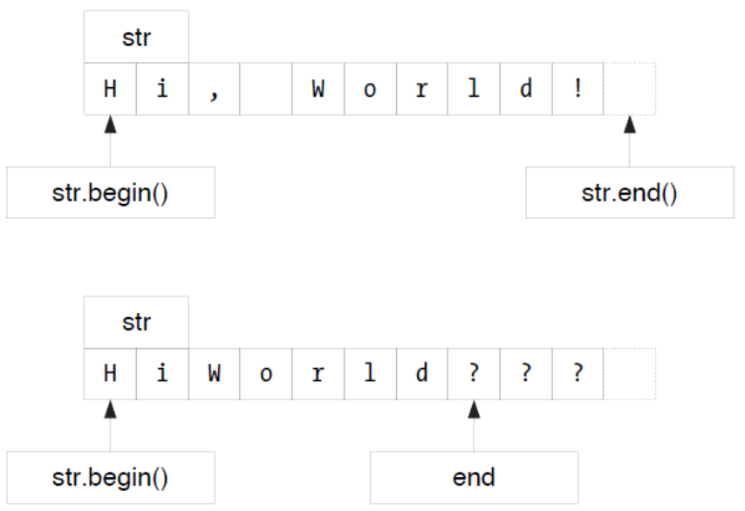
Figure 23-1. Removing elements from a sequence
And what about the characters left at the end of the string? They are junk. That is why you must call erase() after remove_if(). Take a look at Listing 23-3 to see how remove_if() works in code.
Listing 23-3. Sanitizing a String by Transforming It
/** Test for non-letter.
* @param ch the character to test
* @return true if @p ch is not a character that makes up a word
*/
bool non_letter(char ch)
{
return not std::isalnum(ch, std::locale());
}

/** Convert to lowercase.
* Use a canonical form by converting to uppercase first,
* and then to lowercase.
* @param ch the character to test
* @return the character converted to lowercase
*/
char lowercase(char ch)
{
return std::tolower(ch, std::locale());
}

/** Sanitize a string by keeping only alphabetic characters.
* @param str the original string
* @return a santized copy of the string
*/
std::string sanitize(std::string str)
{
// Remove all non-letters from the string, and then erase them.
str.erase(std::remove_if(str.begin(), str.end(), non_letter),
str.end());

// Convert the remnants of the string to lowercase.
std::transform(str.begin(), str.end(), str.begin(), lowercase);

return str;
}
The erase member function takes two iterators as arguments and erases all the elements within that range. The remove_if function returns an iterator that points to one-past-the-end of the new string, which means it also points to the first position of the elements to be erased. Passing str.end() as the end of the range instructs erase to get rid of all the removed elements.
The remove/erase idiom is common in C++, so you should get used to seeing it, at least until everyone starts to use C++ 20 ranges. The standard library has several remove-like functions, all of which work the same way. It takes a little while to get used to this approach, but once you do, you will find it quite easy to use.

Sorting With Iterators
Now that you’ve seen how iterators work, it should be easy to modify Listing 22-4 to use iterators instead of ranges. Compare your solution with Listing 23-4.
Listing 23-4. Sorting into Descending Order
#include <algorithm>
#include <iostream>
#include <iterator>
#include <vector>

/** Predicate for sorting into descending order. */
int descending(int a, int b)
{
return a > b;
}

int main()
{
std::vector<int> data{ std::istream_iterator<int>(std::cin),
std::istream_iterator<int>()) };

std::sort(data.begin(), data.end(), descending);

std::copy(data.begin(), data.end(), std::ostream_iterator<int>(std::cout, "\n"));
}
Expanding a range into a begin/end pair is an easy transformation. What about the palindrome example? How easy is that? Convert Listing 22-5 to use iterators.
This is tougher. There is no filtering for iterators. Algorithms such as copy_if must store the copied characters somewhere. Using iterator algorithms requires making a new string (ot half a string). Alternatively, you can skip the algorithms altogether and just use iterators. Listing 23-5 shows my version of is_palindrome() function using a reverse iterator.
Listing 23-5. Testing for Palindromes
/** Determine whether @p str is a palindrome.
* Only letter characters are tested. Spaces and punctuation don't count.
* @param str the string to test
* @return true if @p str is the same forward and backward
*/
bool is_palindrome(std::string_view str)
{
if (str.empty())
return true;
for (auto left{str.begin()}, right{str.end() - 1}; left < right;) {
if (not letter(*left))
++left;
else if (not letter(*right))
--right;
else if (*left != *right)
return false;
else {
++left;
--right;
}
}
return true;
}
By eliminating empty strings immediately, the for loop can initialize right with end() - 1, that is, the position of the actual last character. Each time through the loop, either the left or the right iterator advances until both point to letters. Then the letters are compared, and the iterators are moved. If the string has an even number of letters, the iterators might pass each other, but as long as they point to valid positions in the string, the < operator is safe to use.
In a large program, the predicate or transformation function might be declared far from where it is used. Often, a predicate is used only once. By defining a function just for that predicate, it makes your program harder to understand. The human reader must read all the code to ensure that the predicate truly is called in only one place. It would be nice if C++ offered a way to write the predicate in the place where it is used, and thereby avoid these problems. Read the next Exploration to learn how to achieve this in C++ 20.

