Arrays and Vectors

Now that you understand the basics, it is time to start moving on to more exciting challenges. Let’s write a real program, something nontrivial but still simple enough to master this early in the book. Your job is to write a program that reads integers from the standard input, sorts them into ascending order, and then prints the sorted numbers, one per line.
At this point, the book has not quite covered enough material for you to solve this problem, but it is instructive to think about the problem and the tools you may need to solve it. Your first task in this Exploration is to write pseudo-code for the program. Write C++ code where you can and make up whatever you need to tackle the problem.
_____________________________________________________________
_____________________________________________________________
_____________________________________________________________
_____________________________________________________________
_____________________________________________________________
_____________________________________________________________
_____________________________________________________________
_____________________________________________________________
_____________________________________________________________
_____________________________________________________________
_____________________________________________________________
_____________________________________________________________
_____________________________________________________________
_____________________________________________________________
_____________________________________________________________
_____________________________________________________________
_____________________________________________________________
_____________________________________________________________
_____________________________________________________________

Vectors for Arrays
You need an array to store the numbers. Given only that much new information, you can write a program to read, sort, and print numbers, but only by hand-coding the sort code. Those of you who suffered through a college algorithms course may remember how to write a bubble sort or quick sort, but why should you need to muck about with such low-level code? Surely, you say, there’s a better way. There is: the C++ standard library has a fast sort function that can sort just about anything. Jump straight into the solution in Listing 9-1.
Listing 9-1. Sorting Integers
1 #include <algorithm>
2 #include <iostream>
3 #include <ranges>
4 #include <vector>
5
6 int main()
7 {
8 std::vector<int> data{}; // initialized to be empty
9 int x{};
10
11 // Read integers one at a time.
12 while (std::cin >> x)
13 // Store each integer in the vector.
14 data.emplace_back(x);
15
16 // Sort the vector.
17 std::ranges::sort(data);
18
19 // Print the vector, one number per line.
20 for (int element : data)
21 std::cout << element << '\n';
22 }
The program introduces several new features. Let’s start at line 8 and the type called vector, which is a resizable array type. The next section explains it to you.

Vectors
Line 7 defines the variable data, of type std::vector<int>. C++ has several container types, that is, data structures that can contain a bunch of objects. One of those containers is vector, which is an array that can change size. All C++ containers require an element type, that is, the type of object that you intend to store in the container. In this case, the element type is int. Specify the element type in angle brackets: <int>. That tells the compiler that you want data to be a vector and that the vector will store integers.
What’s missing from the definition?
_____________________________________________________________
The vector has no size. Instead, the vector can grow or shrink while the program runs. (If you know that you need an array of a specific, fixed size, you can use the type array. You will use vector much more often than array in most programs.) Thus, data is initially empty. Like std::string, vector is a library type, and it has a well-defined initial value, namely, empty, so you can omit the {} initializer if you wish.
You can insert and erase items at any position in the vector, although the performance is best when you add items only at the end or erase them only from the end. That’s how the program stores values in data: by calling emplace_back, which adds an element to the end of a vector (line 14). The “back” of a vector is the end, with the highest index. The “front” is the beginning, so back() returns the last element of the vector, and front() returns the first. Don’t call these functions if the vector is empty; that yields undefined behavior. A member function that you might find yourself calling often is size(), which returns then number of elements in the vector.
As you can tell from the std:: prefix, the vector type is part of the standard library and is not built into the compiler. Therefore, you need #include <vector>, as shown on line 4. No surprises there.
All the functions mentioned so far are member functions; that is, you must supply a vector object on the left-hand side of the dot operator (.) and the function call on the right-hand side. Another kind of function does not use the dot operator and is free from any particular object. In most languages, this is the typical kind of function, but sometimes C++ programmers call them free functions, to distinguish them from member functions. Line 17 shows an example of a free function, std::sort.
How would you define a vector of strings?
_____________________________________________________________
Substitute std::string for int to get std::vector<std::string>. You can also define a vector of vectors, which is a kind of two-dimensional array: std::vector<std::vector<int>>. (Prior to C++ 11, you needed to insert a space between the closing angle brackets, so you will see older code written that way. But in C++ 11, you no longer needed to concern yourself with that syntax oddity.)

Ranges and A lgorithms
The std::sort function sorts stuff, as you can tell from the name. In some other object-oriented language, you might expect vector to have a sort() member function. Alternatively, the standard library could have a sort function that can sort anything the library can throw at it. The C++ library falls into the latter category.
The sort() function can sort almost anything that has a begin() and an end() . An additional requirement is to be able to access specific elements of the data. To get the third element, use data. at(2) because indexing is zero-based. That is, data.front() is similar to data.at(0) and data.back() is like data.at(data.size() - 1) .
Stay Safe
When you read C++ programs, you will most likely see square brackets (data[n]) used to access elements of a vector. The difference between square brackets and the at member function is that the at function provides an additional level of safety. If the index is out of bounds, the program will terminate cleanly. On the other hand, using square brackets with an invalid index will result in undefined behavior: you don’t know what will happen. Most dangerous is that your program will not terminate but will continue to run with the bad data. That’s why I recommend using at.
The sort() function can put any range of data into order as long as two elements can be compared and put in order. It has many other sibling functions to perform a wide variety of operations on data, from binary_search() , which can quickly find a value in a sorted vector or shuffle () , which puts a vector into random order.
The sort, binary_search, and shuffle functions are called algorithms in the C++ standard library. A C++ algorithm can operate on vectors, other containers, and many other types. An algorithm performs some operation on a range of data. The range can be a vector, or it could be only part of a vector. It might not be stored in a container at all. The only requirements for a range is to have a beginning, an end, and a way to get from the beginning to the end.
F or a vector and other containers, the begin() member function returns the beginning of the range and the end() member function returns the end of the range. The value that begin() returns is called an iterator because you use it to iterate over the values of the range. An iterator offers an indirect means of accessing the values in the range. Given an iterator named (in a burst of creativity) iterator , you would use *iterator to obtain the value that iterator points to. The ++ operator advances an iterator so it points to the subsequent value in the range, as in ++iterator . To tell when an iterator reaches the end of the range, it uses a special marker for the end of the range. This marker does not denote any specific value in the range so it can mark the end of an empty range. The only thing you can do with this marker is to compare it with an iterator to determine whether the iterator has reached the end of the range. Naturally enough, data.end() returns this special end marker, called a sentinel . Assembling these pieces yields the following for loop to iterate over the elements of data:
for (std::vector<int>::iterator iter{data.begin()}; iter != data.end(); ++iter)
{ int element = *iter; std::cout << element << '\n'; }
And that is quite a mouthful. Don’t worry that it doesn’t make any sense yet because there’s an easier way. T he for loop on line 1 8 of Listing 9-1 does the same thing, much more simply. It iterates over the elements of data , and assigns each successive element to the variable element . Because this style of for loop iterates over a range, it is usually called a ranged for loop . Figure 9-1 illustrates the nature of the begin iterator and end sentinel for the data vector.

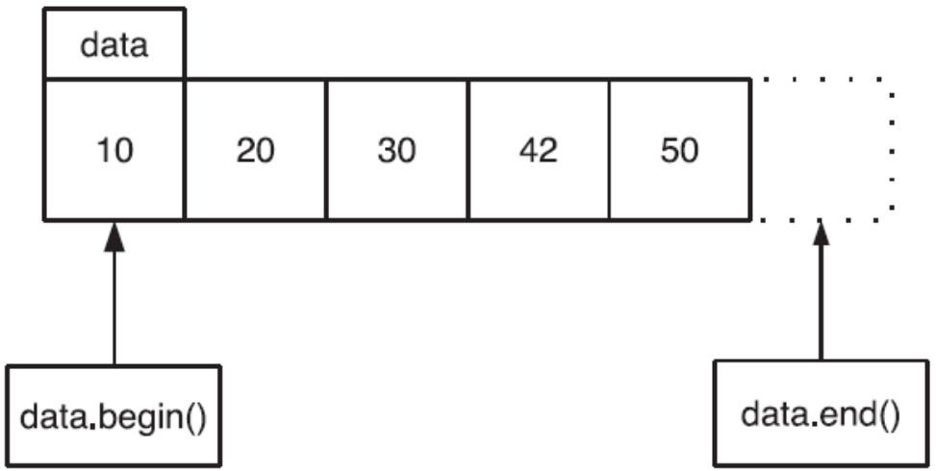

Figure 9-1. Iterators pointing to positions in a vector
What is the value of data.begin() if data.size() is zero?
_____________________________________________________________
That’s right. If the vector is empty, data.begin() returns the same value as data.end(), and that value is a special sentinel value that you are not allowed to dereference. In other words, *data.end() results in undefined behavior. Because you can compare two iterators or an iterator with a sentinel, one way to determine if a vector is empty is to test, as demonstrated in the following code:
data.begin() == data.end()
A better way, however, is to call data.empty(), which returns true if the vector is empty and false if the vector contains at least one element.
Ranges and iterators have many uses beyond accessing elements of a vector, and you will see them used often in this book, for input, output, and more, starting with the next Exploration.

