# Laboratorio 5: Menus

<https://developer.android.com/guide/topics/ui/menus.html?hl=es-419>

## Crear un proyecto nuevo llamado “MenusApp”

**Crear un directorio “menu” y dentro un “Menu resource file” llamado main.xml:**

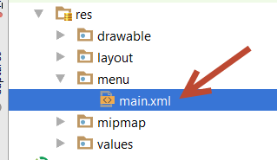

**Contenido de main.xml**

<menu xmlns:android="http://schemas.android.com/apk/res/android"

xmlns:app="http://schemas.android.com/apk/res-auto"

xmlns:tools="http://schemas.android.com/tools">

<item

android:id="@+id/action_home"

android:orderInCategory="100"

android:title="Inicio"

app:showAsAction="ifRoom" />

<item

android:id="@+id/action_takepicture"

android:orderInCategory="101"

android:title="Tomar Foto"

android:icon="@android:drawable/ic_menu_camera"

app:showAsAction="ifRoom" />

<group android:checkableBehavior="single">

<item

android:id="@+id/action_day_view"

android:orderInCategory="201"

android:title="Vista diaria"

app:showAsAction="ifRoom" />

<item

android:id="@+id/action_week_view"

android:checked="true"

android:orderInCategory="202"

android:title="Vista semanal"

app:showAsAction="ifRoom" />

<item

android:id="@+id/action_month_view"

android:orderInCategory="203"

android:title="Vista Mensual"

app:showAsAction="ifRoom" />

</group>

<group android:checkableBehavior="all">

<item

android:id="@+id/action_toggle"

android:orderInCategory="301"

android:title="Modo offline"

app:showAsAction="never"/>

</group>

<item

android:id="@+id/action_about"

android:orderInCategory="999"

android:title="Acerca de"

android:icon="@android:drawable/ic_menu_help"

app:showAsAction="never" />

</menu>

**Crear MainActivity**

**Java Activity File**

public class MainActivity extends AppCompatActivity {

@Override

protected void onCreate(Bundle savedInstanceState) {

super.onCreate(savedInstanceState);

setContentView(R.layout.activity_main8);

}

@Override

public boolean onCreateOptionsMenu(Menu menu) {

getMenuInflater().inflate(R.menu.main, menu);

return super.onCreateOptionsMenu(menu);

}

@Override

public boolean onOptionsItemSelected(MenuItem item) {

int id = item.getItemId();

switch (id){

case R.id.action_home:

Toast.makeText(this, "Regresando al inicio...", Toast.LENGTH_SHORT).show();

return true;

case R.id.action_takepicture:

Toast.makeText(this, "Tomando una foto...", Toast.LENGTH_SHORT).show();

return true;

case R.id.action_day_view:

item.setChecked(true);

Toast.makeText(this, "Vista diaria activada...", Toast.LENGTH_SHORT).show();

return true;

case R.id.action_week_view:

item.setChecked(true);

Toast.makeText(this, "Vista semanal activada...", Toast.LENGTH_SHORT).show();

return true;

case R.id.action_month_view:

item.setChecked(true);

Toast.makeText(this, "Vista mensual activada...", Toast.LENGTH_SHORT).show();

return true;

case R.id.action_toggle:

if(item.isChecked()){

item.setChecked(false);

Toast.makeText(this, "Modo offline desactivado...", Toast.LENGTH_SHORT).show();

}else{

item.setChecked(true);

Toast.makeText(this, "Modo offline activado...", Toast.LENGTH_SHORT).show();

}

return true;

case R.id.action_about:

Toast.makeText(this, "Acerca de...", Toast.LENGTH_SHORT).show();

return true;

}

return super.onOptionsItemSelected(item);

}

}

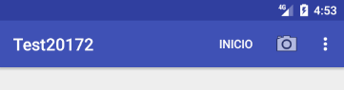

## Menú PopUP

**Agregar las dependencias de cardview-v7 y design**

implementation 'com.android.support:design:26.1.0'

implementation 'com.android.support:cardview-v7:26.1.0'

**Recurso res/drawable/ic_menu_dots.xml**

<?xml version="1.0" encoding="utf-8"?>

<vector xmlns:android="http://schemas.android.com/apk/res/android"

android:height="24dp"

android:width="24dp"

android:viewportWidth="24"

android:viewportHeight="24">

<path android:fillColor="#666" android:pathData="M12,16A2,2 0 0,1 14,18A2,2 0 0,1 12,20A2,2 0 0,1 10,18A2,2 0 0,1 12,16M12,10A2,2 0 0,1 14,12A2,2 0 0,1 12,14A2,2 0 0,1 10,12A2,2 0 0,1 12,10M12,4A2,2 0 0,1 14,6A2,2 0 0,1 12,8A2,2 0 0,1 10,6A2,2 0 0,1 12,4Z" />

</vector>

**PoupMenu: res/menu/popup.xml**

<?xml version="1.0" encoding="utf-8"?>

<menu xmlns:android="http://schemas.android.com/apk/res/android"

xmlns:app="http://schemas.android.com/apk/res-auto">

<item android:id="@+id/menu_favority"

android:title="Favorito" />

<item android:id="@+id/menu_share"

android:title="Compartir" />

</menu>

**Modificamos el activity_main.xml**

**XML Layout File**

<?xml version="1.0" encoding="utf-8"?>

<LinearLayout xmlns:android="http://schemas.android.com/apk/res/android"

xmlns:app="http://schemas.android.com/apk/res-auto"

xmlns:tools="http://schemas.android.com/tools"

android:layout_width="match_parent"

android:layout_height="match_parent"

android:orientation="vertical">

<android.support.v7.widget.CardView

android:layout_width="match_parent"

android:layout_height="wrap_content"

android:layout_margin="16dp">

<RelativeLayout

android:layout_width="match_parent"

android:layout_height="wrap_content"

android:padding="16dp">

<ImageButton

android:id="@+id/menu_icon"

android:layout_width="wrap_content"

android:layout_height="wrap_content"

android:layout_alignParentEnd="true"

android:background="@null"

app:srcCompat="@drawable/ic_menu_dots"

android:onClick="showPopup"/>

<TextView

android:layout_width="match_parent"

android:layout_height="wrap_content"

android:layout_toStartOf="@+id/menu_icon"

android:textSize="20dp"

android:text="Texto de ejemplo"/>

</RelativeLayout>

</android.support.v7.widget.CardView>

</LinearLayout>

**Java Activity File (**Agreamos el método showPoup**)**

public void showPopup(View view){

PopupMenu popup = new PopupMenu(this, view);

// Inflate the menu from xml

popup.getMenuInflater().inflate(R.menu.popup, popup.getMenu());

// Setup menu item selection

popup.setOnMenuItemClickListener(new PopupMenu.OnMenuItemClickListener() {

public boolean onMenuItemClick(MenuItem item) {

switch (item.getItemId()) {

case R.id.menu_favority:

Toast.makeText(MainActivity.this, "La nota ha sido guardada", Toast.LENGTH_SHORT).show();

return true;

case R.id.menu_share:

Toast.makeText(MainActivity.this, "La nota ha sido compartida", Toast.LENGTH_SHORT).show();

return true;

default:

return false;

}

}

});

// Show the menu

popup.show();

}

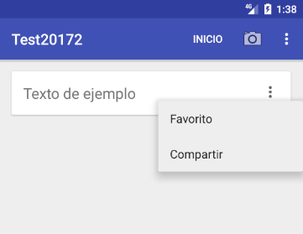

## Menú Contextual

**ContextualMenu: res/menu/contextual.xml**

<?xml version="1.0" encoding="utf-8"?>

<menu xmlns:android="http://schemas.android.com/apk/res/android"

xmlns:app="http://schemas.android.com/apk/res-auto">

<item android:id="@+id/menu_favority"

android:title="Favorito" />

<item android:id="@+id/menu_share"

android:title="Compartir" />

</menu>

**Modificamos el activity_main.xml (Añadimos solo lo resaltado)**

<?xml version="1.0" encoding="utf-8"?>

<LinearLayout xmlns:android="http://schemas.android.com/apk/res/android"

xmlns:app="http://schemas.android.com/apk/res-auto"

xmlns:tools="http://schemas.android.com/tools"

android:layout_width="match_parent"

android:layout_height="match_parent"

android:orientation="vertical">

<android.support.v7.widget.CardView

android:id="@+id/cardview"

android:layout_width="match_parent"

android:layout_height="wrap_content"

android:onClick="demo"

android:layout_margin="16dp">

…

**Modificamos el MainActivity class (Añadimos solo lo resaltado)**

public class MainActivity extends AppCompatActivity {

@Override

protected void onCreate(Bundle savedInstanceState) {

super.onCreate(savedInstanceState);

setContentView(R.layout.activity_main8);

CardView cardview = (CardView)findViewById(R.id.cardview);

registerForContextMenu(cardview);

// registerForContextMenu(listview);

}

@Override

public void onCreateContextMenu(ContextMenu menu, View v, ContextMenu.ContextMenuInfo menuInfo) {

getMenuInflater().inflate(R.menu.contextual, menu);

super.onCreateContextMenu(menu, v, menuInfo);

}

@Override

public boolean onContextItemSelected(MenuItem item) {

// AdapterView.AdapterContextMenuInfo info = (AdapterView.AdapterContextMenuInfo) item.getMenuInfo();

switch (item.getItemId()) {

case R.id.menu_favority:

Toast.makeText(MainActivity.this, "La nota ha sido guardada", Toast.LENGTH_SHORT).show();

return true;

case R.id.menu_share:

Toast.makeText(MainActivity.this, "La nota ha sido compartida", Toast.LENGTH_SHORT).show();

return true;

default:

return super.onContextItemSelected(item);

}

}

…

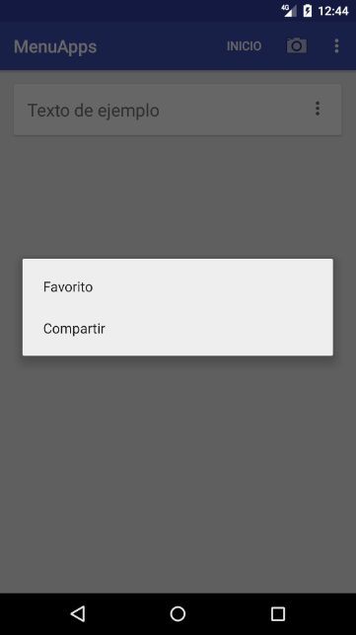

**Tener presionado el cardview por 3 segundos**

## Menú Modo de Acción Contextual

**ModoAccionContextualMenu: res/menu/action.xml**

<?xml version="1.0" encoding="utf-8"?>

<menu xmlns:android="http://schemas.android.com/apk/res/android">

<item

android:id="@+id/action_save"

android:title="Guardar"

android:icon="@android:drawable/ic_menu_save" />

<item

android:id="@+id/action_share"

android:title="Compartir"

android:icon="@android:drawable/ic_menu_share" />

<item

android:id="@+id/action_delete"

android:title="Eliminar"

android:icon="@android:drawable/ic_menu_delete" />

</menu>

**Modificamos el MainActivity class (Añadimos solo lo resaltado)**

public class Main8Activity extends AppCompatActivity {

@Override

protected void onCreate(Bundle savedInstanceState) {

super.onCreate(savedInstanceState);

setContentView(R.layout.activity_main8);

CardView cardview = (CardView)findViewById(R.id.cardview);

// registerForContextMenu(cardview);

// registerForContextMenu(listview);

cardview.setOnLongClickListener(new View.OnLongClickListener() {

// Called when the user long-clicks on someView

public boolean onLongClick(View view) {

if (mActionMode != null) {

return false;

}

// Start the CAB using the ActionMode.Callback defined above

mActionMode = Main8Activity.this.startActionMode(mActionModeCallback);

view.setSelected(true);

return true;

}

});

}

private ActionMode mActionMode = null;

private ActionMode.Callback mActionModeCallback = new ActionMode.Callback() {

// Called when the action mode is created; startActionMode() was called

@Override

public boolean onCreateActionMode(ActionMode mode, Menu menu) {

// Inflate a menu resource providing context menu items

mode.getMenuInflater().inflate(R.menu.action, menu);

return true;

}

// Called each time the action mode is shown. Always called after onCreateActionMode, but

// may be called multiple times if the mode is invalidated.

@Override

public boolean onPrepareActionMode(ActionMode mode, Menu menu) {

return false; // Return false if nothing is done

}

// Called when the user selects a contextual menu item

@Override

public boolean onActionItemClicked(ActionMode mode, MenuItem item) {

switch (item.getItemId()) {

case R.id.action_save:

Toast.makeText(Main8Activity.this, "Guardando la nota...", Toast.LENGTH_SHORT).show();

mode.finish(); // Action picked, so close the CAB

return true;

case R.id.action_share:

Toast.makeText(Main8Activity.this, "Compartiendo la nota...", Toast.LENGTH_SHORT).show();

mode.finish(); // Action picked, so close the CAB

return true;

case R.id.action_delete:

Toast.makeText(Main8Activity.this, "Eliminando la nota...", Toast.LENGTH_SHORT).show();

mode.finish(); // Action picked, so close the CAB

return true;

default:

return false;

}

}

// Called when the user exits the action mode

@Override

public void onDestroyActionMode(ActionMode mode) {

mActionMode = null;

}

};

…

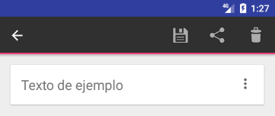

**Tener presionado el cardview por 3 segundos**

## Menú Modo de Acción Contextual Multiselección

### Creamos un nuevo activity **MultiChoiceActivity**

**Activity layout res/layout/activity_multi_choice.xml**

<?xml version="1.0" encoding="utf-8"?>

<LinearLayout xmlns:android="http://schemas.android.com/apk/res/android"

xmlns:app="http://schemas.android.com/apk/res-auto"

xmlns:tools="http://schemas.android.com/tools"

android:layout_width="match_parent"

android:layout_height="match_parent"

android:orientation="vertical">

<ListView

android:id="@+id/listview"

android:layout_width="match_parent"

android:layout_height="wrap_content"/>

</LinearLayout>

**Activity class MultiChoiceActivity class**

public class MultiChoiceActivity extends AppCompatActivity {

private ListView listView;

@Override

protected void onCreate(Bundle savedInstanceState) {

super.onCreate(savedInstanceState);

setContentView(R.layout.activity_multi_choice);

listView = (ListView) findViewById(R.id.listview);

ArrayAdapter<String> adapter = new ArrayAdapter<String>(this,android.R.layout.simple_list_item_multiple_choice);

adapter.add("Nota 1");

adapter.add("Nota 2");

adapter.add("Nota 3");

adapter.add("Nota 4");

adapter.add("Nota 5");

listView.setAdapter(adapter);

// Mode Action Contextual

listView.setChoiceMode(ListView.CHOICE_MODE_MULTIPLE_MODAL);

listView.setMultiChoiceModeListener(new AbsListView.MultiChoiceModeListener() {

@Override

public boolean onCreateActionMode(ActionMode mode, Menu menu) {

// Inflate the menu for the CAB

mode.getMenuInflater().inflate(R.menu.action, menu);

return true;

}

@Override

public boolean onPrepareActionMode(ActionMode mode, Menu menu) {

// Here you can perform updates to the CAB due to an invalidate() request

return false;

}

@Override

public void onItemCheckedStateChanged(ActionMode mode, int position, long id, boolean checked) {

// Here you can do something when items are selected/de-selected,

// such as update the title in the CAB

}

@Override

public boolean onActionItemClicked(ActionMode mode, MenuItem item) {

// Reading selected items

List<String> notes = new ArrayList<String>();

int len = listView.getCount();

SparseBooleanArray checked = listView.getCheckedItemPositions();

for (int i = 0; i < len; i++){

if (checked.get(i)) {

notes.add(String.valueOf(listView.getAdapter().getItem(i)));

}

}

// Respond to clicks on the actions in the CAB

switch (item.getItemId()) {

case R.id.action_save:

Toast.makeText(MultiChoiceActivity.this, "Guardando la notas " + TextUtils.join(", ", notes) + "...", Toast.LENGTH_SHORT).show();

mode.finish(); // Action picked, so close the CAB

return true;

case R.id.action_share:

Toast.makeText(MultiChoiceActivity.this, "Compartiendo la nota " + TextUtils.join(", ", notes) + "...", Toast.LENGTH_SHORT).show();

mode.finish(); // Action picked, so close the CAB

return true;

case R.id.action_delete:

Toast.makeText(MultiChoiceActivity.this, "Eliminando la nota " + TextUtils.join(", ", notes) + "...", Toast.LENGTH_SHORT).show();

mode.finish(); // Action picked, so close the CAB

return true;

default:

return false;

}

}

@Override

public void onDestroyActionMode(ActionMode mode) {

// Here you can make any necessary updates to the activity when

// the CAB is removed. By default, selected items are deselected/unchecked.

}

});

}

}

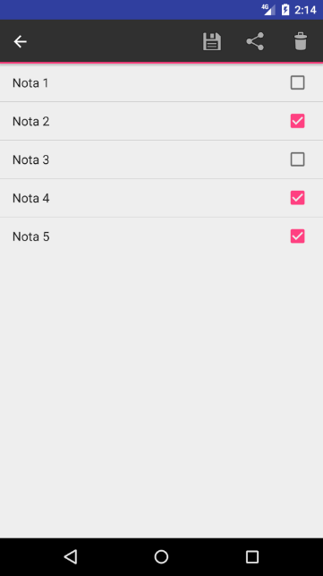

## Bottom Navigation

**Agregar las dependencias de design y crear un nuevo activity “DashboardActivity”**

implementation 'com.android.support:design:26.1.0'

**Menu res/menu/bottom.xml**

<?xml version="1.0" encoding="utf-8"?>

<menu xmlns:android="http://schemas.android.com/apk/res/android">

<item

android:id="@+id/menu_home"

android:title="Home"

android:icon="@android:drawable/ic_menu_gallery" />

<item

android:id="@+id/menu_camera"

android:title="Camera"

android:icon="@android:drawable/ic_menu_camera" />

<item

android:id="@+id/menu_search"

android:title="Search"

android:icon="@android:drawable/ic_menu_share"

/>

<item

android:id="@+id/menu_notification"

android:title="Notification"

android:icon="@android:drawable/ic_menu_send" />

<item

android:id="@+id/menu_more"

android:title="More"

android:icon="@android:drawable/ic_menu_more" />

</menu>

**Activity Layout res/layout/activity_dashboard.xml**

<?xml version="1.0" encoding="utf-8"?>

<RelativeLayout xmlns:android="http://schemas.android.com/apk/res/android"

xmlns:app="http://schemas.android.com/apk/res-auto"

xmlns:tools="http://schemas.android.com/tools"

android:layout_width="match_parent"

android:layout_height="match_parent">

<android.support.design.widget.BottomNavigationView

android:id="@+id/bottom_navigation"

android:layout_width="match_parent"

android:layout_height="wrap_content"

android:layout_alignParentBottom="true"

app:itemBackground="@color/colorPrimary"

app:itemIconTint="@android:color/white"

app:itemTextColor="@android:color/white"

app:menu="@menu/bottom" />

</RelativeLayout>

**Activity Class DashboardActivity.class**

public class DashboardActivity extends AppCompatActivity {

@Override

protected void onCreate(Bundle savedInstanceState) {

super.onCreate(savedInstanceState);

setContentView(R.layout.activity_dashboard);

BottomNavigationView bottomNavigationView = (BottomNavigationView)findViewById(R.id.bottom_navigation);

bottomNavigationView.setOnNavigationItemSelectedListener(new BottomNavigationView.OnNavigationItemSelectedListener() {

@Override

public boolean onNavigationItemSelected(@NonNull MenuItem item) {

switch (item.getItemId()) {

case R.id.menu_home:

Toast.makeText(DashboardActivity.this, "Go home section...", Toast.LENGTH_SHORT).show();

break;

case R.id.menu_camera:

Toast.makeText(DashboardActivity.this, "Go camera section...", Toast.LENGTH_SHORT).show();

break;

case R.id.menu_search:

Toast.makeText(DashboardActivity.this, "Go share section...", Toast.LENGTH_SHORT).show();

break;

case R.id.menu_notification:

Toast.makeText(DashboardActivity.this, "Go notification section...", Toast.LENGTH_SHORT).show();

break;

case R.id.menu_more:

Toast.makeText(DashboardActivity.this, "Go more sections...", Toast.LENGTH_SHORT).show();

break;

}

return true;

}

});

}

}

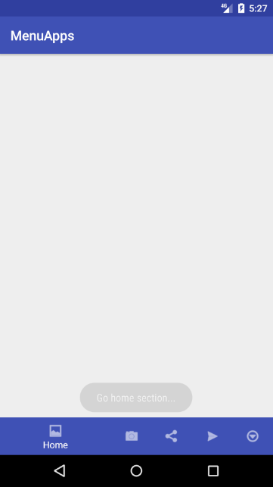

## Drawer Navigation

**Agregar las dependencias de design en caso no la tenga y crear un nuevo activity “HomeActivity”**

implementation 'com.android.support:design:26.1.0'

**Drawable res/drawable/ic_menu.xml**

<?xml version="1.0" encoding="utf-8"?>

<vector xmlns:android="http://schemas.android.com/apk/res/android"

android:width="26dp"

android:height="26dp"

android:viewportWidth="26"

android:viewportHeight="26">

<path

android:fillColor="#ffffff"

android:pathData="M 0 4 L 0 6 L 26 6 L 26 4 L 0 4 z M 0 12 L 0 14 L 26 14 L 26 12 L 0 12 z M 0 20

L 0 22 L 26 22 L 26 20 L 0 20 z" />

</vector>

**Menu res/menu/navigation.xml**

<menu xmlns:android="http://schemas.android.com/apk/res/android">

<group

android:id="@+id/group_nav_main"

android:checkableBehavior="single">

<item

android:id="@+id/nav_home"

android:checked="true"

android:icon="@android:drawable/ic_menu_myplaces"

android:title="Home" />

<item

android:id="@+id/nav_calendar"

android:icon="@android:drawable/ic_menu_my_calendar"

android:title="Calendar" />

<item

android:id="@+id/nav_gallery"

android:icon="@android:drawable/ic_menu_gallery"

android:title="Gallery" />

<item

android:id="@+id/nav_locations"

android:icon="@android:drawable/ic_menu_mapmode"

android:title="Locations" />

</group>

<group

android:id="@+id/group_nav_system"

android:checkableBehavior="single">

<item

android:id="@+id/nav_settings"

android:icon="@android:drawable/ic_menu_manage"

android:title="Settings" />

<item

android:id="@+id/nav_logout"

android:icon="@android:drawable/ic_lock_power_off"

android:title="Logout" />

</group>

</menu>

**Activity res/layout/home_activity.xml**

<?xml version="1.0" encoding="utf-8"?>

<android.support.v4.widget.DrawerLayout

xmlns:android="http://schemas.android.com/apk/res/android"

xmlns:app="http://schemas.android.com/apk/res-auto"

xmlns:tools="http://schemas.android.com/tools"

android:id="@+id/drawer_layout"

android:layout_width="match_parent"

android:layout_height="match_parent"

android:fitsSystemWindows="true">

<!-- Bloque Contenido -->

<RelativeLayout

android:id="@+id/main_content"

android:layout_width="match_parent"

android:layout_height="match_parent">

</RelativeLayout>

<!-- Menú Deslizante -->

<android.support.design.widget.NavigationView

android:id="@+id/nav_view"

android:layout_width="wrap_content"

android:layout_height="match_parent"

android:layout_gravity="start"

android:fitsSystemWindows="true"

app:menu="@menu/navigation" />

</android.support.v4.widget.DrawerLayout>

**Activity HomeActivity.java**

public class HomeActivity extends AppCompatActivity {

private DrawerLayout drawerLayout;

@Override

protected void onCreate(Bundle savedInstanceState) {

super.onCreate(savedInstanceState);

setContentView(R.layout.activity_home);

// Set DrawerLayout

drawerLayout = (DrawerLayout) findViewById(R.id.drawer_layout);

// Set drawer toggle icon

final ActionBar ab = getSupportActionBar();

if (ab != null) {

ab.setHomeAsUpIndicator(R.drawable.ic_menu);

ab.setDisplayHomeAsUpEnabled(true);

}

// Set NavigationItemSelectedListener

NavigationView navigationView = (NavigationView) findViewById(R.id.nav_view);

navigationView.setNavigationItemSelectedListener(new NavigationView.OnNavigationItemSelectedListener() {

@Override

public boolean onNavigationItemSelected(MenuItem menuItem) {

// Do action by menu item id

switch (menuItem.getItemId()){

case R.id.nav_home:

Toast.makeText(HomeActivity.this, "Go home...", Toast.LENGTH_SHORT).show();

break;

case R.id.nav_calendar:

Toast.makeText(HomeActivity.this, "Go calendar...", Toast.LENGTH_SHORT).show();

break;

case R.id.nav_gallery:

Toast.makeText(HomeActivity.this, "Go gallery...", Toast.LENGTH_SHORT).show();

break;

case R.id.nav_locations:

Toast.makeText(HomeActivity.this, "Go locations...", Toast.LENGTH_SHORT).show();

break;

case R.id.nav_settings:

Toast.makeText(HomeActivity.this, "Go settings...", Toast.LENGTH_SHORT).show();

break;

case R.id.nav_logout:

Toast.makeText(HomeActivity.this, "Do logout...", Toast.LENGTH_SHORT).show();

break;

}

// Close drawer

drawerLayout.closeDrawer(GravityCompat.START);

return true;

}

});

}

@Override

public boolean onOptionsItemSelected(MenuItem item) {

switch (item.getItemId()) {

case android.R.id.home: // Option open drawer

if(!drawerLayout.isDrawerOpen(GravityCompat.START))

drawerLayout.openDrawer(GravityCompat.START); // Open drawer

else

drawerLayout.closeDrawer(GravityCompat.START); // Close drawer

return true;

}

return super.onOptionsItemSelected(item);

}

}

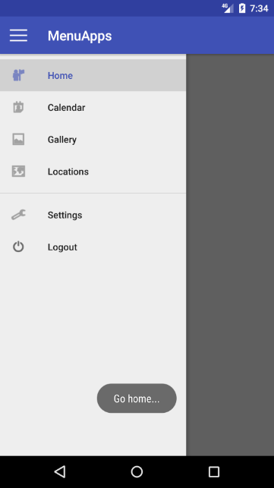

## Drawer Navigation with header

**Drawable res/drawable/ic_profile.xml**

<vector android:height="24dp" android:viewportHeight="64.0"

android:viewportWidth="64.0" android:width="24dp" xmlns:android="http://schemas.android.com/apk/res/android">

<path android:fillColor="#4F5D73" android:pathData="M32,32m-32,0a32,32 0,1 1,64 0a32,32 0,1 1,-64 0"/>

<path android:fillAlpha="0.2" android:fillColor="#231F20" android:pathData="M43.9,47.54c-3.82,-1.66 -5.22,-4.24 -5.64,-6.47c2.75,-2.21 4.94,-5.76 6.15,-9.57c1.24,-1.58 1.96,-3.23 1.96,-4.62c0,-0.95 -0.35,-1.65 -0.95,-2.16c-0.2,-8.11 -5.94,-14.61 -13.04,-14.71C32.32,10.01 32.27,10 32.21,10c-0.02,0 -0.04,0 -0.06,0c-7.05,0.04 -12.78,6.41 -13.13,14.41c-0.88,0.53 -1.39,1.3 -1.39,2.47c0,1.64 0.99,3.63 2.66,5.45c1.19,3.33 3.12,6.38 5.5,8.44c-0.35,2.29 -1.7,5.04 -5.7,6.78c-2.16,0.94 -6.11,1.78 -7.81,2.65c4.36,4.77 12.62,7.77 19.59,7.8l0.1,0C31.98,58 31.99,58 32,58c7.01,0 15.32,-3.01 19.71,-7.81C50.01,49.32 46.06,48.48 43.9,47.54z"/>

<path android:fillColor="#FFFFFF" android:pathData="M43.9,45.54c-3.82,-1.66 -5.22,-4.24 -5.64,-6.47c2.75,-2.21 4.94,-5.76 6.15,-9.57c1.24,-1.58 1.96,-3.23 1.96,-4.62c0,-0.95 -0.35,-1.65 -0.95,-2.16C45.21,14.62 39.47,8.11 32.38,8.01C32.32,8.01 32.27,8 32.21,8c-0.02,0 -0.04,0 -0.06,0c-7.05,0.04 -12.78,6.41 -13.13,14.41c-0.88,0.53 -1.39,1.3 -1.39,2.47c0,1.64 0.99,3.63 2.66,5.45c1.19,3.33 3.12,6.38 5.5,8.44c-0.35,2.29 -1.7,5.04 -5.7,6.78c-2.16,0.94 -6.11,1.78 -7.81,2.65c4.36,4.77 12.62,7.77 19.59,7.8l0.1,0C31.98,56 31.99,56 32,56c7.01,0 15.32,-3.01 19.71,-7.81C50.01,47.32 46.06,46.48 43.9,45.54z"/>

</vector>

**Layout res/layout/navigation_header.xml**

<LinearLayout xmlns:android="http://schemas.android.com/apk/res/android"

xmlns:app="http://schemas.android.com/apk/res-auto"

xmlns:tools="http://schemas.android.com/tools"

android:layout_width="match_parent"

android:layout_height="192dp"

android:background="@drawable/bg_drawer"

android:gravity="bottom"

android:orientation="vertical"

android:padding="16dp"

android:theme="@style/ThemeOverlay.AppCompat.Dark">

<ImageView

android:id="@+id/menu_photo"

android:layout_width="64dp"

android:layout_height="64dp"

android:layout_marginBottom="16dp"

android:scaleType="centerCrop"

app:srcCompat="@drawable/ic_profile" />

<TextView

android:id="@+id/menu_fullname"

android:layout_width="match_parent"

android:layout_height="wrap_content"

android:textAppearance="@style/TextAppearance.AppCompat.Body1"

android:textStyle="bold"

tools:text="Erick Benites"/>

<TextView

android:id="@+id/menu_email"

style="@style/Widget.AppCompat.Spinner"

android:layout_width="match_parent"

android:layout_height="wrap_content"

android:textAppearance="@style/TextAppearance.AppCompat.Body1"

tools:text="ebenites@tecsup.edu.pe"/>

</LinearLayout>

**Modificar HomeActivity layout res/layout/activity_home.xml (agregar solo lo resaltado)**

<?xml version="1.0" encoding="utf-8"?>

<android.support.v4.widget.DrawerLayout

xmlns:android="http://schemas.android.com/apk/res/android"

xmlns:app="http://schemas.android.com/apk/res-auto"

xmlns:tools="http://schemas.android.com/tools"

android:id="@+id/drawer_layout"

android:layout_width="match_parent"

android:layout_height="match_parent"

android:fitsSystemWindows="true">

<!-- Pantalla Principal -->

<android.support.design.widget.CoordinatorLayout

android:layout_width="match_parent"

android:layout_height="match_parent">

<!-- Barra de título -->

<android.support.design.widget.AppBarLayout

android:layout_width="match_parent"

android:layout_height="wrap_content"

android:theme="@style/ThemeOverlay.AppCompat.Dark.ActionBar">

<android.support.v7.widget.Toolbar

android:id="@+id/toolbar"

android:layout_width="match_parent"

android:layout_height="?attr/actionBarSize"

android:background="?attr/colorPrimary"

app:popupTheme="@style/ThemeOverlay.AppCompat.Light"/>

</android.support.design.widget.AppBarLayout>

<!-- Bloque Contenido -->

<RelativeLayout

android:id="@+id/main_content"

android:layout_width="match_parent"

android:layout_height="match_parent"

app:layout_behavior="@string/appbar_scrolling_view_behavior">

</RelativeLayout>

</android.support.design.widget.CoordinatorLayout>

<!-- Menú Deslizante -->

<android.support.design.widget.NavigationView

android:id="@+id/nav_view"

android:layout_width="wrap_content"

android:layout_height="match_parent"

android:layout_gravity="start"

android:fitsSystemWindows="true"

app:headerLayout="@layout/navigation_header"

app:menu="@menu/navigation" />

</android.support.v4.widget.DrawerLayout>

**Modificar HomeActivity class HomeActivity.java (agregar solo lo resaltado)**

public class HomeActivity extends AppCompatActivity {

private DrawerLayout drawerLayout;

@Override

protected void onCreate(Bundle savedInstanceState) {

super.onCreate(savedInstanceState);

setContentView(R.layout.activity_home);

// Setear Toolbar como action bar

Toolbar toolbar = (Toolbar) findViewById(R.id.toolbar);

setSupportActionBar(toolbar);

// Set DrawerLayout

drawerLayout = (DrawerLayout) findViewById(R.id.drawer_layout);

// Set drawer toggle icon

// final ActionBar ab = getSupportActionBar();

// if (ab != null) {

// ab.setHomeAsUpIndicator(R.drawable.ic_menu);

// ab.setDisplayHomeAsUpEnabled(true);

// }

ActionBarDrawerToggle toggle = new ActionBarDrawerToggle(this, drawerLayout, toolbar, android.R.string.ok, android.R.string.cancel);

drawerLayout.addDrawerListener(toggle);

toggle.syncState();

// Set NavigationItemSelectedListener

NavigationView navigationView = (NavigationView) findViewById(R.id.nav_view);

….

// Change navigation header information

ImageView photoImage = (ImageView) navigationView.getHeaderView(0).findViewById(R.id.menu_photo);

photoImage.setBackgroundResource(R.drawable.ic_profile);

TextView fullnameText = (TextView) navigationView.getHeaderView(0).findViewById(R.id.menu_fullname);

fullnameText.setText("Erick Benites");

TextView emailText = (TextView) navigationView.getHeaderView(0).findViewById(R.id.menu_email);

emailText.setText("ebenites@tecsup.edu.pe");

}

….

}

**Modificar AndroidManifest.xml (agregar solo lo resaltado)**

<?xml version="1.0" encoding="utf-8"?>

…

<activity android:name=".**HomeActivity**" android:theme="@style/AppTheme.NoActionBar">

…

**Res/values/style.xml**

<style name="AppTheme.NoActionBar">

<item name="windowActionBar">false</item>

<item name="windowNoTitle">true</item>

<item name="android:windowTranslucentStatus">true</item>

<item name="android:windowTranslucentNavigation">true</item>

</style>

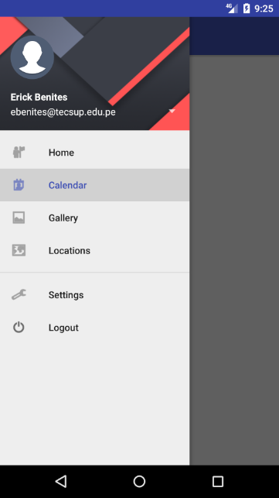

**Librería adicional: Para fotografías que no son circulares usar la librería:**

<https://github.com/hdodenhof/CircleImageView>

## Fragments

Son regiones embebidas dentro de un activity, pueden cambiar su contenido “inflando” diferentes layouts de forma independiente a las demás y poseen su propio siclo de vida.

<https://developer.android.com/guide/components/fragments.html?hl=es-419>

Creamos 3 Fragments:

### FirstFragment

**Fragment layout**

<RelativeLayout xmlns:android="http://schemas.android.com/apk/res/android"

xmlns:tools="http://schemas.android.com/tools"

android:layout_width="match_parent"

android:layout_height="match_parent"

android:background="@android:color/holo_green_light">

<TextView

android:id="@+id/textview"

android:layout_width="match_parent"

android:layout_height="match_parent"

android:gravity="center"

android:textSize="32sp"

android:text="First Fragment" />

</RelativeLayout>

**Fragment class**

public class FirstFragment extends Fragment {

private static final String TAG = FirstFragment.class.getSimpleName();

public FirstFragment() {

}

@Override

public void onCreate(Bundle savedInstanceState) {

super.onCreate(savedInstanceState);

Log.d(TAG, "onCreate");

}

@Override

public View onCreateView(LayoutInflater inflater, ViewGroup container, Bundle savedInstanceState) {

Log.d(TAG, "onCreateView");

View view = inflater.inflate(R.layout.fragment_first, container, false);

return view;

}

@Override

public void onAttach(Context context) {

super.onAttach(context);

Log.d(TAG, "onCreateView");

}

@Override

public void onDetach() {

super.onDetach();

Log.d(TAG, "onCreateView");

}

}

### SecondFragment

**Fragment layout**

<RelativeLayout xmlns:android="http://schemas.android.com/apk/res/android"

xmlns:tools="http://schemas.android.com/tools"

android:layout_width="match_parent"

android:layout_height="match_parent"

android:background="@android:color/holo_orange_dark">

<TextView

android:id="@+id/textview"

android:layout_width="match_parent"

android:layout_height="match_parent"

android:gravity="center"

android:textSize="32sp"

android:text="Second Fragment" />

</RelativeLayout>

**Fragment class**

public class SecondFragment extends Fragment {

private static final String TAG = SecondFragment.class.getSimpleName();

private String param1;

public SecondFragment() {

}

@Override

public void onCreate(Bundle savedInstanceState) {

super.onCreate(savedInstanceState);

Log.d(TAG, "onCreate");

// Get argument param1 if exists

if (getArguments() != null) {

this.param1 = getArguments().getString("param1");

}

}

@Override

public View onCreateView(LayoutInflater inflater, ViewGroup container, Bundle savedInstanceState) {

Log.d(TAG, "onCreateView");

View view = inflater.inflate(R.layout.fragment_second, container, false);

TextView textView = (TextView)view.findViewById(R.id.textview);

textView.setText(textView.getText() + "\nParam1: " + param1);

return view;

}

}

### ThirdFragment

**Fragment layout**

<RelativeLayout xmlns:android="http://schemas.android.com/apk/res/android"

xmlns:tools="http://schemas.android.com/tools"

android:layout_width="match_parent"

android:layout_height="match_parent"

android:background="@android:color/holo_blue_dark">

<TextView

android:id="@+id/textview"

android:layout_width="match_parent"

android:layout_height="match_parent"

android:gravity="center"

android:textSize="32sp"

android:text="Third Fragment" />

</RelativeLayout>

**Fragment class**

public class ThirdFragment extends Fragment {

// Nombre de parámetro declarado como constante

private static final String ARG_PARAM1 = "param1";

// Atributo param1

private String param1;

public ThirdFragment() {

}

// Como buena práctica definimos un método fáctory 'newInstance' que reciba los parámetros requeridos 'param1'

public static ThirdFragment newInstance(String param1) {

ThirdFragment fragment = new ThirdFragment();

Bundle args = new Bundle();

args.putString(ARG_PARAM1, param1);

fragment.setArguments(args);

return fragment;

}

@Override

public void onCreate(Bundle savedInstanceState) {

super.onCreate(savedInstanceState);

if (getArguments() != null) {

param1 = getArguments().getString(ARG_PARAM1);

}

}

@Override

public View onCreateView(LayoutInflater inflater, ViewGroup container, Bundle savedInstanceState) {

View view = inflater.inflate(R.layout.fragment_third, container, false);

TextView textView = (TextView)view.findViewById(R.id.textview);

textView.setText(textView.getText() + "\nParam1: " + param1);

return view;

}

}

### MainActivity

**Activity layout**

<?xml version="1.0" encoding="utf-8"?>

<LinearLayout xmlns:android="http://schemas.android.com/apk/res/android"

xmlns:app="http://schemas.android.com/apk/res-auto"

xmlns:tools="http://schemas.android.com/tools"

android:layout_width="match_parent"

android:layout_height="match_parent"

android:orientation="vertical"

android:padding="16dp">

<LinearLayout

android:layout_width="match_parent"

android:layout_height="wrap_content"

android:orientation="horizontal"

android:paddingBottom="16dp">

<Button

android:layout_width="match_parent"

android:layout_height="wrap_content"

android:layout_weight="1"

android:text="Fragment 1"

android:onClick="showFirstFragment"/>

<Button

android:layout_width="match_parent"

android:layout_height="wrap_content"

android:layout_weight="1"

android:text="Fragment 2"

android:onClick="showSecondFragment"/>

<Button

android:layout_width="match_parent"

android:layout_height="wrap_content"

android:layout_weight="1"

android:text="Fragment 3"

android:onClick="showThirdFragment"/>

</LinearLayout>

<RelativeLayout

android:id="@+id/content"

android:layout_width="match_parent"

android:layout_height="match_parent">

</RelativeLayout>

</LinearLayout>

**Activity class**

public class MainActivity extends AppCompatActivity {

@Override

protected void onCreate(Bundle savedInstanceState) {

super.onCreate(savedInstanceState);

setContentView(R.layout.activity_main);

}

public void showFirstFragment(View view){

// Get FragmentManager

FragmentManager fragmentManager = getSupportFragmentManager();

// Create FirstFragment

Fragment fragment = new FirstFragment();

// Replace content

fragmentManager.beginTransaction().replace(R.id.content, fragment).addToBackStack("tag").commit();

}

public void showSecondFragment(View view){

// Get FragmentManager

FragmentManager fragmentManager = getSupportFragmentManager();

// Create FirstFragment

Fragment fragment = new SecondFragment();

// Send 'param1' argument to Fragment

Bundle args = new Bundle();

args.putString("param1", "Hello Fragment!");

fragment.setArguments(args);

// Replace content

fragmentManager.beginTransaction().replace(R.id.content, fragment).addToBackStack("tag").commit();

}

public void showThirdFragment(View view){

// Get FragmentManager

FragmentManager fragmentManager = getSupportFragmentManager();

// Create FirstFragment with factory

Fragment fragment = ThirdFragment.newInstance("Hello Again!");

// Replace content

fragmentManager.beginTransaction().replace(R.id.content, fragment).addToBackStack("tag").commit();

}

}

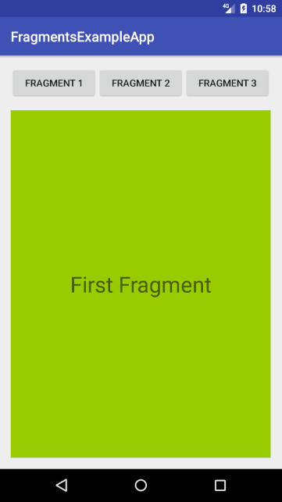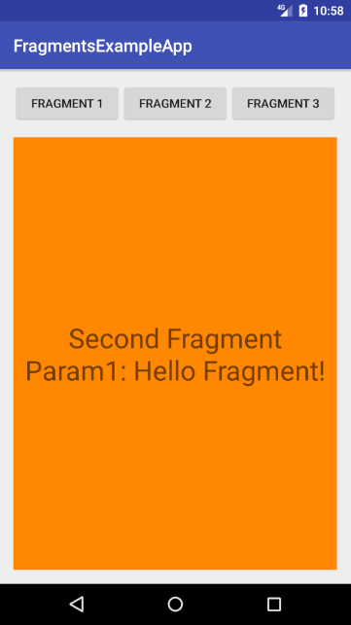

**Ejercicio Calificado:**

Probar las siguientes librerías dentro del ejemplo:

<https://github.com/roughike/BottomBar>

<https://github.com/wasabeef/awesome-android-ui/blob/master/pages/Menu.md>

<https://github.com/mikepenz/MaterialDrawer>