Task-1
Data Structures Implementation in C
_________________________________________________________________________ 1. Stack
Objective: To implement stack data structure using C language.
________________________________________________________________________
Tools Used:
GCC
VS Code
GitHub
_________________________________________________________________________

Algorithm:
1 Start
2 Initialize stack
3 Push element
4 Pop element
5 Display stack
6 Stop
_________________________________________________________________________

Code:
#include<stdio.h>

#define SIZE 5

int stack[SIZE];
int top = -1;

void push(int value)
{
if(top == SIZE-1)
{
printf("Stack Overflow\n");
}
else
{
top++;
stack[top] = value;
printf("Inserted: %d\n", value);
}
}

void pop()
{
if(top == -1)
{
printf("Stack Underflow\n");
}
else
{
printf("Deleted: %d\n", stack[top]);
top--;
}
}

void display()
{
printf("Stack Elements:\n");

for(int i=top;i>=0;i--)
{
printf("%d\n", stack[i]);
}
}

int main()
{
push(15);
push(25);
push(35);

display();

pop();

display();

return 0;
}
_________________________________________________________________________
Output :
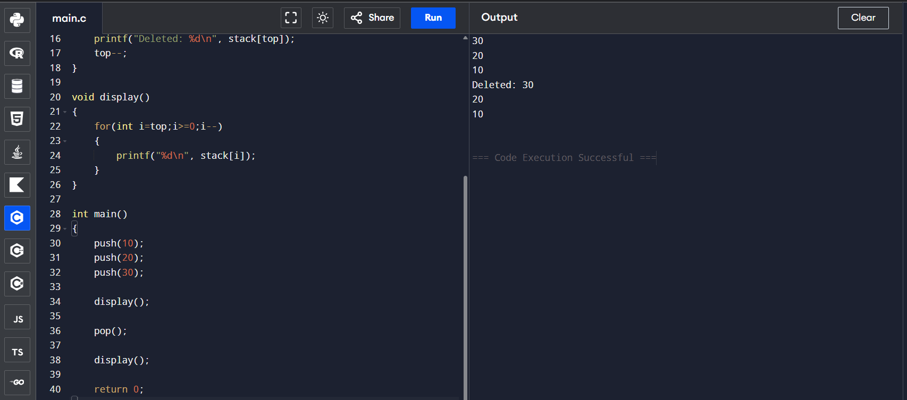

___________________________________________________________________
2.Queue

Objective : The objective of this program is to implement a queue data structure using C programming language and perform operations such as enqueue, dequeue and display.

_________________________________________________________________________________Algorithm :
- Start the program.
- Initialize queue array with front and rear variables.
- Insert elements into the queue using enqueue operation.
- Remove elements from the queue using dequeue operation.
- Display queue elements.
- Stop the program.
_________________________________________________________________________________
Code : #include <stdio.h>

#define SIZE 5

int queue[SIZE];
int front = -1;
int rear = -1;

// Insert (Enqueue)
void enqueue(int value)
{
if(rear == SIZE-1)
{
printf("Queue Overflow\n");
}
else
{
if(front == -1)
front = 0;

rear++;
queue[rear] = value;
printf("Inserted: %d\n", value);
}
}

// Delete (Dequeue)
void dequeue()
{
if(front == -1 || front > rear)
{
printf("Queue Underflow\n");
}
else
{
printf("Deleted: %d\n", queue[front]);
front++;
}
}

// Display
void display()
{
printf("Queue Elements:\n");

for(int i=front;i<=rear;i++)
{
printf("%d\n", queue[i]);
}
}

int main()
{
enqueue(5);
enqueue(10);
enqueue(15);

display();

dequeue();

display();

return 0;
}
___________________________________________________________________
Output : 


